ArcGIS 10.8.1 Student Digital Download Edition:

Instructions for installing ArcMap 10.8.1 on a Window’s PC
Revised August 26, 2020
Installing ArcGIS Desktop 10.8.1 Digital Distribution Student Edition 1
Sign into your ESRI Account 1
Activate your Student Digital Download Code 3
Download and Install the Software 4
Additional Resources for ArcMap 11

Installing ArcGIS Desktop 10.8.1 Digital Distribution Student Edition
You will need to have received an ESRI student digital download code. If you are in a GIS class, you professor has a code for you. If you are not in a class but would like to install the software, please email us at DataLab-support@elist.tufts.edu to request a code. Support for the ArcGIS Desktop Education Edition is available at http://esri.com/evalhelp.

Before Installing ArcGIS for Desktop:
- Check the system requirements to make sure your computer has the hardware and software required.
  - ArcMap requires Microsoft .NET Framework 4.5 and Microsoft Internet Explorer version 9 or newer. Before running the installation program for ArcMap, ensure that your machine meets these prerequisites. The install guide provides an overview of installing and setting up ArcMap and links to detailed resources, including system requirements.
  - ArcGIS Pro requires Microsoft .NET Framework 4.5.1 and Microsoft Internet Explorer version 10 or newer. Before running the installation program for ArcGIS Pro, ensure that your machine meets these prerequisites. The Install Guide for ArcGIS Pro provides an overview of installing and setting up ArcGIS Pro and links to detailed resources, including system requirements.
- If you have ArcMap version 10.1 or later installed, you do not need to uninstall it before installing a later version of 10.x; the ArcGIS setup package will detect and upgrade your software.
- If you have ArcMap version 10.0 or earlier installed, please uninstall it using the Uninstall Utility (download below) before installing the newer version.

Sign into your ESRI Account
This first section is only necessary if you have never accessed ArcGIS Online (AGOL) or any online ESRI product before. If you have logged into to AGOL before, you do not need to do this step.
- You will need to log in to our Tufts Organization’s account one time so an account is created in your name Go to www.esri.com
- Click on the Sign In link at the top right of the page.
- Click on Sign in with Your ArcGIS organization’s URL. Do NOT click sign in with ArcGIS Login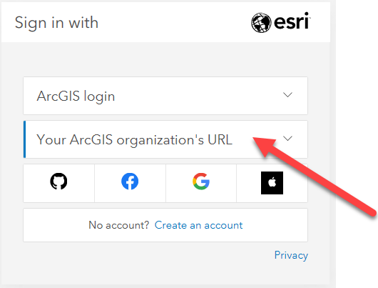
- Enter tuftsgis as the organizations URL so it looks like the following image. If this is your personal computer, you can check remember this URL and it will be faster next time.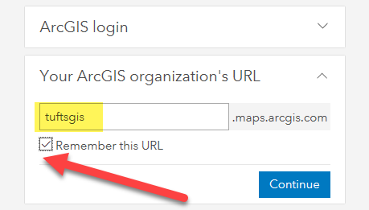
- You will then be prompted to log in with TUFTS UNIVERSITY. Press the blue Tufts button.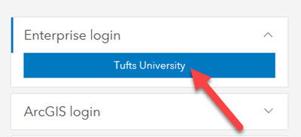
- Now you will log in with your Tufts Username (UTLN) and password. You will need to also go through duo authentication. Press Login.
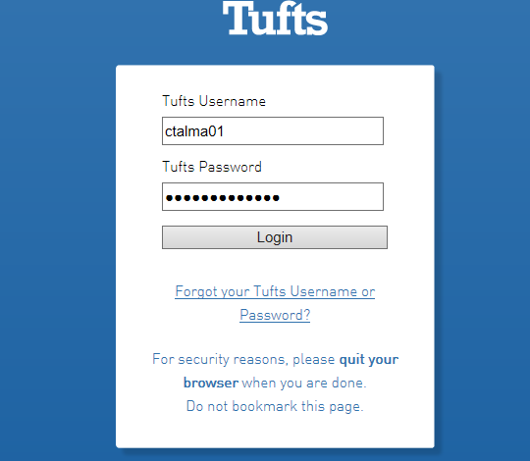
An AGOL account has now been created within our Tufts University organization account that is associated with your Tufts Username.

Activate your Student Digital Download Code
- Visit http://www.esri.com/EducationEdition
- Click on I have an ESRI Account. You will log in the same way you just did in the step above.
- Click on Sign in with Your ArcGIS organization’s URL. Do NOT click sign in with ArcGIS Login
- Enter tuftsgis as the organizations URL so it looks like the following image. If this is your personal computer, you can check remember this URL and it will be faster next time.
- You will then be prompted to log in with TUFTS UNIVERSITY. Press the blue Tufts button.
- Now you will log in with your Tufts Username (UTLN) and password. You will need to also go through duo authentication. Press Login.
- Enter the authorization code you have been given by your GIS Professor or the Data Lab Staff. The format of the code is similar to EVA123456789.
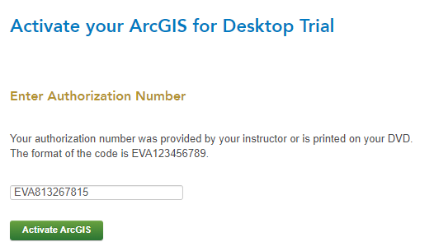
- Click Activate ArcGIS.

Download and Install the Software
- The newest version of ArcMap 10.8.1 and ArcGIS Pro 2.6 is not yet available through this ESRI site. Therefore, we have downloaded the software and made it available for you at this link. Go to the following link: https://tufts.box.com/s/1kdjeo8psz43lu2plhb5cn1l923gn8sm
- Click on the file ArcGIS_Desktop_1081_175110.exe and press Download to access the software installer.
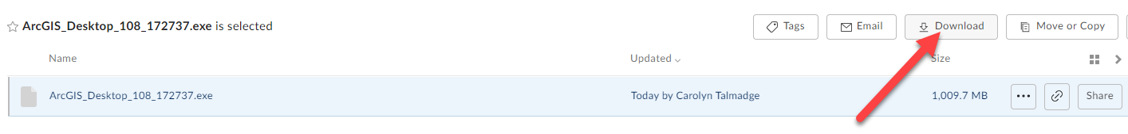
- Depending on the internet browser you’re using, the installation wizard might open automatically, it might save to the downloads bar at the bottom of chrome, or it might be saved to your downloads file.
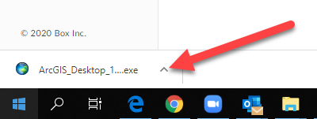
- Once it downloads, Run the installer wizard by double clicking the ArcGIS_Desktop_1081_175110 executable (.exe).
- Select a destination folder to extract the install files to and press Next. If you choose, you can automatically launch the setup after the files have been extracted by clicking the box “launch the setup program”.
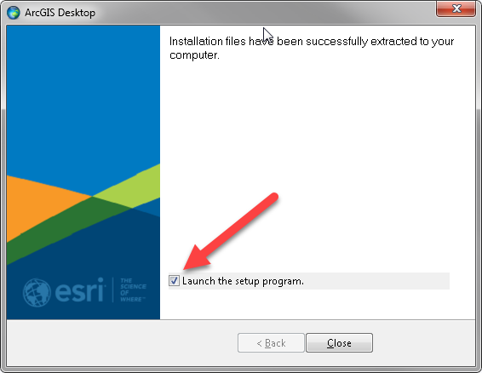
- Press YES when asked if you want to let ArcGIS make changes to your computer.
- Proceed through the setup installer options by clicking Next.
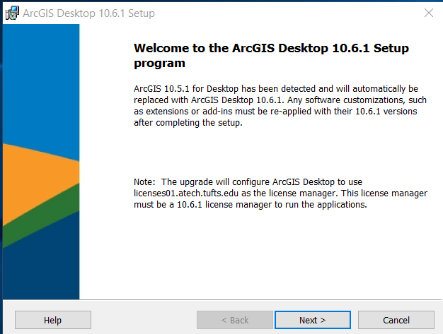
- Select the Complete installation type.
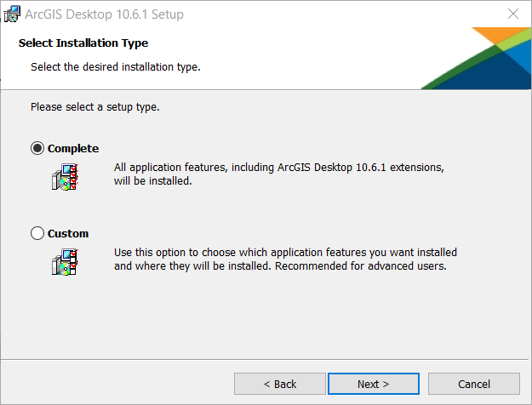
- Click next through all the prompts. You will see the software being installed and the progress bar. This may take several minutes.
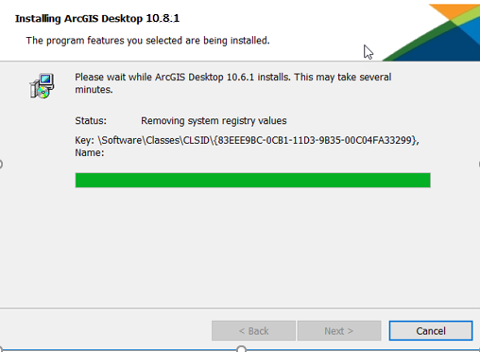
- After the files are installed, the Authorization Wizard will open and prompt you to choose a product to authorize. Select Advanced (ArcInfo) Single Use. Then click Authorize Now.
Note: If this authorization window does not automatically open, search for the program ArcGIS Administrator and it will open.
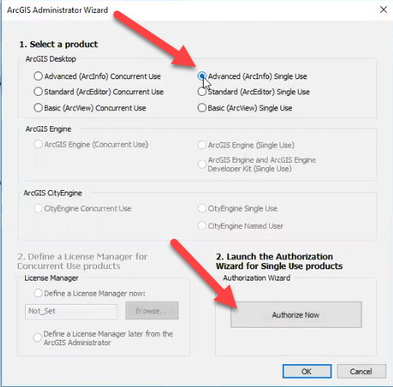
- Select “I have installed my software and need to Authorize it”.
- Select “Authorize with ESRI now using the Internet”.
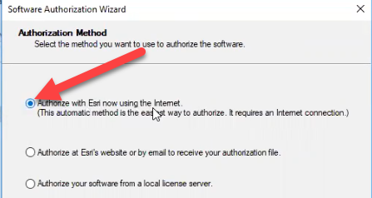
- Fill out your authorization information and press next.
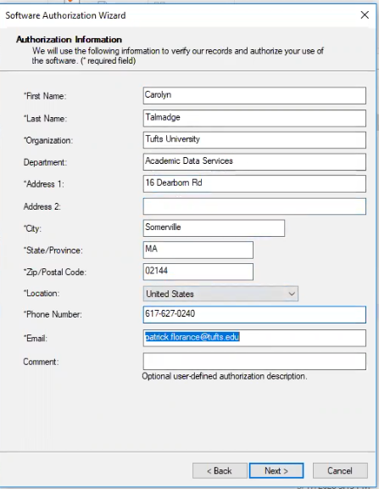
- Fill out your industry information and press next.
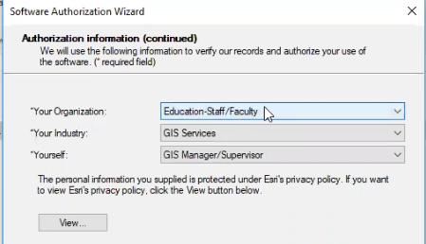
- Enter your activated code into the text box, as shown below. Press Next.
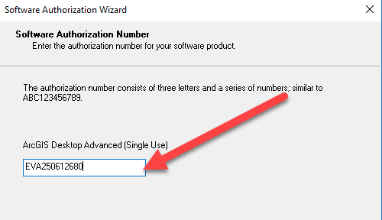
- Select “I do not want to authorize any extensions at this time.” Press Next.
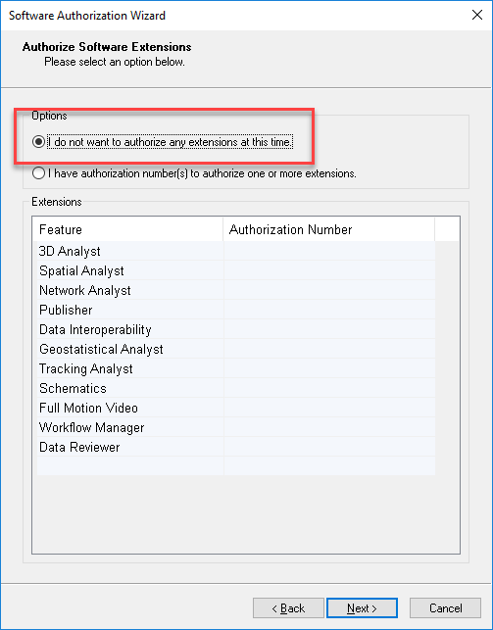
- Press Next again. You do not need to evaulate software extensions.
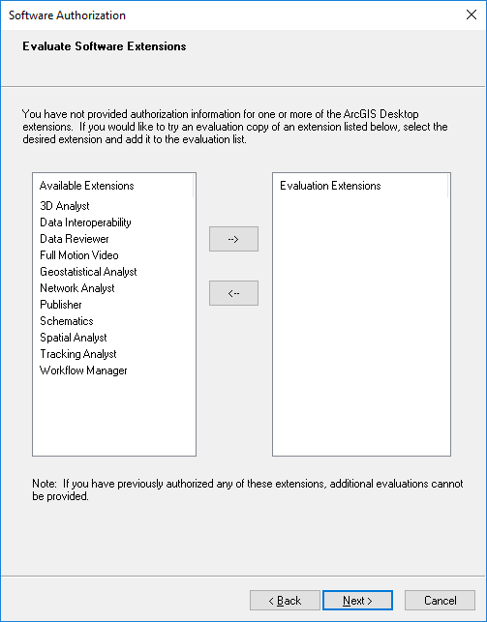
- Press finish once your software authorizes successfully.
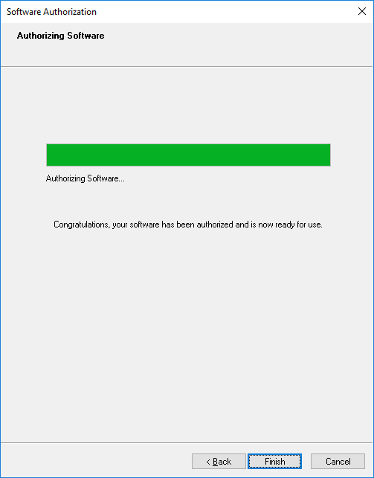
- Open ArcMap 10.8.1 to ensure that everything works. If it opens up to a blank map, you are good to go.
Support for the ArcGIS Desktop Education Edition is available at esri.com/trialhelp

Additional Resources for ArcMap
- For information on how to connect to Box in ArcMap, see these instructions: https://tufts.app.box.com/file/631995847090

- For Information on how to Install the VPN, Map the Network Drives and Connect to Folders in ArcMap, see these instructions: https://tufts.box.com/s/7wl2b3jxp309a962q6b8g1270kgm68ky

