Storing your files: How to migrate your H drive to Box

Written by Kyle Monahan on March 11th, 2020

Introduction
This tutorial teaches you how to migrate your H:/ drive files and store them in Tufts Box for remote access to your files.
The H:/ drive is the student GIS storage location. To mount your H:/ drive, see here: http://go.tufts.edu/mountdrive

This process is different for users in the Data Lab and those that are remote and on their personal machines (Mac or PC).

Please see the section below based on your location and computer operating system.

Contents
Introduction 1
If you are in the Data Lab 1
If you are on your personal laptop - Windows 2
If you are on your personal laptop - Mac 3

If you are in the Data Lab

You do not need to mount your H drive as it will automatically mount.

- We will create a single folder that contains all our files, titled “TuftsUsername_AllFiles” e.g. kmonah02_AllFiles.

- Copy all of your data folders from your H drive into the TuftsUsername_AllFiles folder.

- Right click on the TuftsUsername_AllFiles folder and go to 7Zip > Add to archive.

- In the 7zip window, choose archive format zip and press the three dots (…) to select your path.

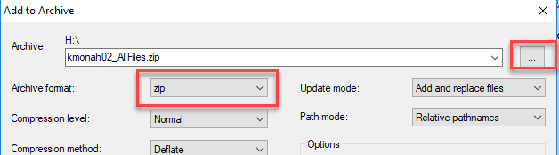

- Select your Desktop to store the files temporarily and click Open.

- Wait until the compression is complete.

- Open Chrome and login to Box: tufts.app.box.com

- Upload the TuftsUsername_AllFiles.zip file to your Tufts Box account.

If you are on your personal laptop - Windows

If you need to, mount your H drive. Instructions are here: http://go.tufts.edu/mountdrive

- First, take a look at your H:/ drive and make sure all your data are there.

- Now we need to zip the files. We will create a single folder titled “TuftsUsername_AllFiles” e.g. kmonah02_AllFiles.

- Copy all of your data folders from your H drive into the TuftsUsername_AllFiles folder you created.

- Right click on the TuftsUsername_AllFiles folder, which now contains all your data and copy it to your Desktop. This should take under 30 minutes.

- Right click on that folder and go to Send to > Compressed (zipped) folder.

- Wait until the compression is complete.

- Open Chrome and login to Box: tufts.app.box.com

- Upload the TuftsUsername_AllFiles.zip file to your Tufts Box account.

If you are on your personal laptop - Mac
If you need to, mount your H drive. Instructions are here: http://go.tufts.edu/mountdrive

- First, take a look at your H:/ drive and make sure all your data are there.

- Now we need to zip the files. We will create a single folder titled “TuftsUsername_AllFiles” e.g. kmonah02_AllFiles.

- Copy all of your data folders from your H drive into the TuftsUsername_AllFiles folder you created.

- Right click on the TuftsUsername_AllFiles folder, which now contains all your data and copy it to your Desktop. This should take under 30 minutes.

- Right click on that folder and go to Compress “TuftsUsername_AllFiles”.

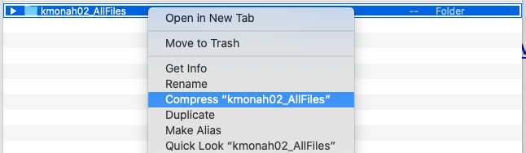

- Wait until the compression is complete.

- Open Chrome and login to Box: tufts.app.box.com

- Upload the TuftsUsername_AllFiles.zip file to your Tufts Box account.

