Mapping Network Drives from Home VIA the VPN for use in ArcMap & ArcGIS Pro
Updated August 26, 2020
Note: You do NOT need to use the VPN or map the network drives to use ArcMap. You ONLY need to go through these steps IF you want to access your M, H or S drive. If you have GIS data from your Canvas site or other places online, you can work directly from your Desktop, Documents or even BOX folder without going through the VPN and network drives!
If you would like to map the Tufts Network Drives to connect to the H, M or S Drives from your home, follow the instructions below and/or on our Data Lab Website. https://sites.tufts.edu/datalab/accounts-network-drives/

Installing the VPN – You only need to do this step the 1st time you use the VPN
To use the network drives in ArcMap on your personal computer from home, you must first run the VPN Client and then map a network drive
- Download and Install the VPN Client. This only needs to be completed the first time you are using the VPN client. You can access the installer for a Windows OS and Mac OS here. https://tufts.app.box.com/v/vpnsoftware

- Run the installer for the Windows VPN. When it completes, it might not look like anything has happened. But search for “Cisco Any Connect Secure Mobility Client” and launch the application by double clicking on it and the VPN client will appear.
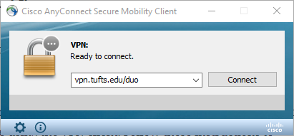
Note: After the initial launch from the start menu, from here on out, it will appear as a little icon in the bottom right of the screen by the clock and you can access it there.
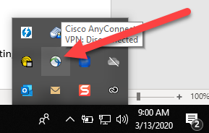

Launching and Signing into the VPN
- To log in and use the VPN, open the VPN client Cisco AnyConnect Secure Mobility Client by searching for the program or launching it from the status bar by the clock in the bottom right.
- Enter vpn.tufts.edu/duo in the VPN server field.
- Click Connect. An authentication window will appear. Enter your Tufts username (eg. jjumbo01) and password. In the field next to Duo Passcode or Authentication method, you have a few options:
- Type the word “push” – Duo will send you a push notification via the Duo mobile app on your smartphone.
- Type the word “phone” – Duo will call the phone number you have registered for verification.
- Enter Duo Passcode – Enter the six-digit passcode you are provided by the Duo mobile app on your smartphone.
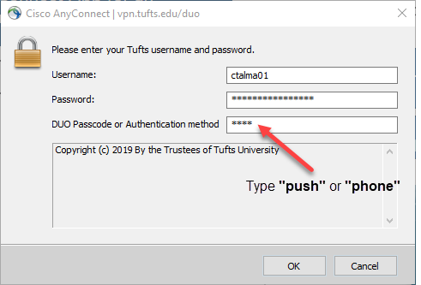
- Depending on which authentication method you chose, there may be some next steps:
- If you entered push, you will receive a push notification on the Duo mobile app on your smartphone. Click Approve to complete the login process.
- If you entered phone, you will receive a phone call at the number you have registered with Duo. When prompted, press any key to verify your login.
- If you entered a six-digit Duo Passcode correctly, you should be connected to the VPN.
- Once the connection is complete, the AnyConnect icon will appear on your status bar indicating you now have a secure link to the Tufts network with full access to all Tufts network resources. If you see this, you are good to go.
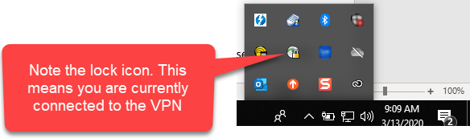

Mapping Network Drives once on the VPN
- Once you are running the VPN client, then you can map the Network Drives. Depending on which version of Windows the computer is running, Map a Network Drive as follows:
- Windows 10: Type “This PC” into the Search Bar →click on This PC on the left→ Click on Computer → Click Map Network Drive
- Windows 7: Go to Start → Computer → Map Network Drive tab
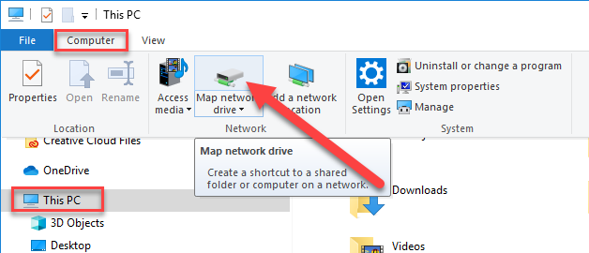

- In the Drive drop down, choose the drive letter that you want to map (H:, M:, or S:). In the Folder drop down, manually enter or copy and paste the pathway for that letter. Check the box for “Reconnect at sign-in” to automatically have this drive mapped.
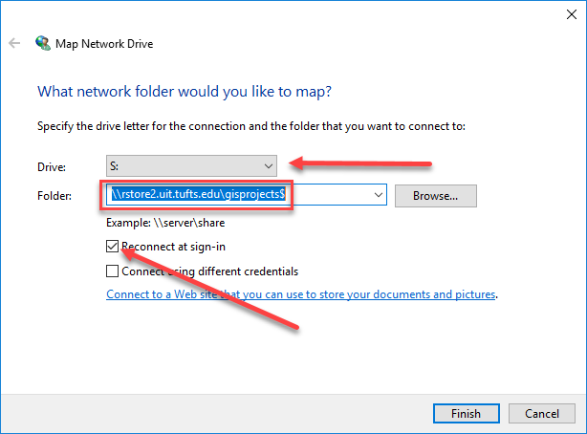
Note: Make sure there are no preceding spaces or spaces at the end of the path.
- For the M:\ drive enter: \\rstore1.uit.tufts.edu\tts_rsch_gis_dataset02$
- For the S:\ drive enter: \\rstore2.uit.tufts.edu\gisprojects$
- For the H:\ drive enter: \\rstore2.uit.tufts.edu\gisusers$\yourUTLN
(Example: \\rstore2.uit.tufts.edu\gisusers$\asmith01)
- Repeat these steps to continue adding more network drive connections.
- For the H drive, follow these extra steps. Once you’ve put in the path with YOUR UTLN as shown, there is an extra step with credentials:
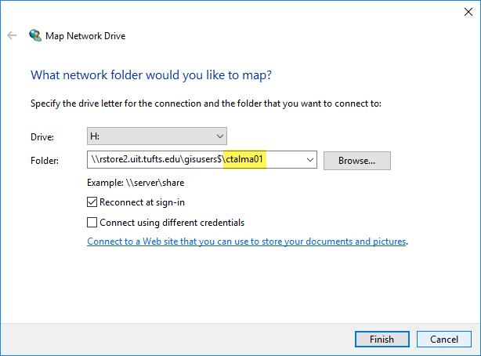

- After pressing finish, users will be prompted to enter their username (UTLN) and password in a new pop up window. Users must include “TUFTS\” before their username.
For instance: TUFTS\Asmith01
Note it is a BACKSLASH (found under the backspace key) NOT the forward slash (which is located next to shift).
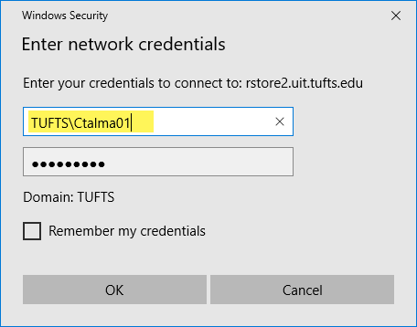
- Once you have successfully mapped the three GIS drives, go into each folder to make sure that it worked.

Connecting to Folders in ArcMap
Once your drives are connected in This PC, you can connect to these (and more) in ArcMap.
- When ArcMap opens, expand Catalog.
- Right click on Folder Connections and press Connect to Folder. 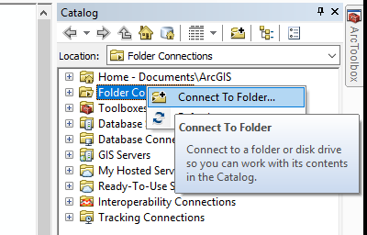
- Navigate to This PC and then click on your H drive once so it is selected. Press OK.
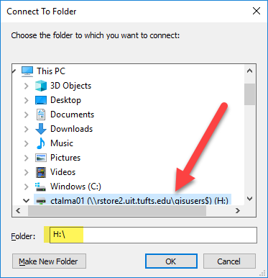
- Follow this process two more times to connect to the S and M Drive.
Note: You can also follow these steps to connect to other folders like your Desktop or Documents folder. When you are working from home, it might be easiest to work directly from these local folders.

Connecting to Folders in ArcGIS Pro
Once your drives are connected in This PC, you can connect to these (and more) in ArcGIS Pro.
- When ArcGIS Pro opens, click on the Catalog pane on the right.
- Find the folder titled Folder. Right click on it and press Add Folder Connection
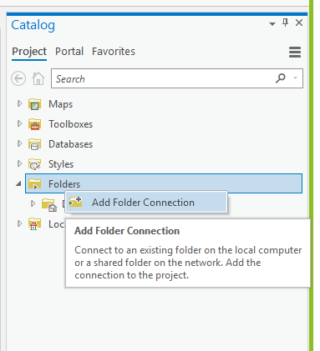
- In the Add Folder Connection Pop up, press Computer on the left, then then select the Drive you wish to connect to (in this case M).
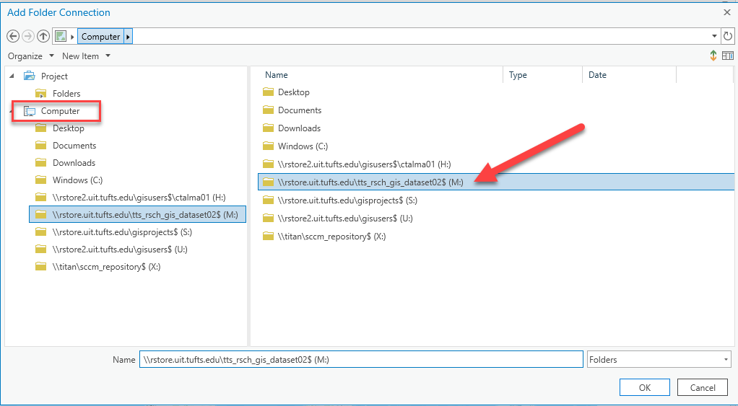
- Repeat these steps to connect to your H and S drive, and any other folder.

