Using Box for GIS and Remote Sensing
Written by Uku-Kaspar Uustalu in March 2020, updated August 25, 2020

Introduction
All Tufts University affiliates have access to free unlimited storage on Tufts Box. This guide provides instructions and tips for using Box Drive instead of personal network storage (the H-drive) for GIS and remote sensing projects.
More information on Box: https://it.tufts.edu/guides/box-data-storage-and-collaboration/what-box

Contents
Setting Up Box Drive on your Personal Computer 1
Using Box Drive on the VDI or a Lab Computer 3
General Caveats of Using Box Drive 4
Using Box Drive with ArcMap 4
Using Box Drive with ArcGIS Pro 6
Using Box Drive with QGIS 8
Using Box Drive with ENVI 8

Setting Up Box Drive on your Personal Computer

- Go to: https://www.box.com/resources/downloads/drive
- Download and install the version compatible with your operating system.

  - Detailed installation instructions:
https://support.box.com/hc/en-us/articles/360043697474-Installing-and-Updating-Box-Drive

- After finishing the installation, Box Drive will automatically launch and you should see the following:
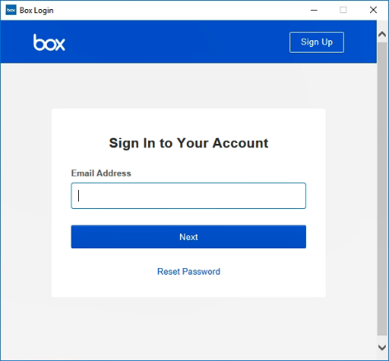

- Type in your Tufts email address and click Next.

- Log in with your Tufts username (UTLN) and password. You will also need to dual-factor authenticate.

- After you log in, Box Drive will display a brief walkthrough of its features. It might be useful to familiarize yourself with these. Use the Take Tour and Continue buttons to proceed.

- Once you have finished the walkthrough, you will be able to see all of your Box files in File Explorer (Windows) or Finder (MacOS):

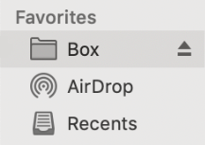

- The exact location (path) of your Box folder depends on your operating system:
Windows: C:\Users\USERNAME\Box
MacOS: ~/Box

- Once you have set up Box Drive on your personal computer, you will never have to do it again. Every time you start up your personal computer and log in, all of your Box files will automatically sync to your Box folder, as long as you have an internet connection.

Instructions on how to make Box content available offline:
https://support.box.com/hc/en-us/articles/360043697574-Making-Content-Available-Offline

More information on using Box Drive:
https://support.box.com/hc/en-us/articles/360043697494-Using-Box-Drive-Basics

Using Box Drive on the Remote Labs, TTS Virtual Lab or a Data Lab Computer

- After signing in, Box Drive should start automatically.
Please wait for about 20 seconds until you see the following login window:

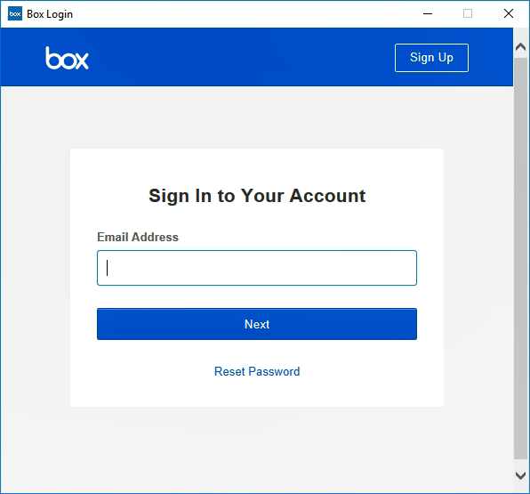

- Type in your Tufts email address and click Next.

- Log in with your Tufts username (UTLN) and password. You will also need to dual-factor authenticate.

- After you log in, Box Drive will display a brief walkthrough of its features. If you are unfamiliar with these, use the Take Tour and Continue buttons to proceed. Otherwise exit the walkthrough using the X symbol in the upper-right corner.

- Once you have finished the walkthrough, you will be able to see all of your Box files in File Explorer:

- The exact location (path) of your Box folder is as follows: C:\Users\USERNAME\Box

- You will need to repeat these steps every time you sign into the Remote Labs, Virtual Labs or a Data Lab computer. Note that if you close the Box login window before finishing the login process, you will be unable to access your Box content. To restart the Box login process, you must sign out of the computer/VDI and then sign in again.
- If you have been working in ArcMap or ArcGIS Pro and uploading data and MXDs to Box, make sure to confirm they have uploaded successfully before logging out of the VDI! If you log out too early, your work will be lost if it has not fully uploaded! To check if you work has successfully uploaded, you should do 2 things:
  - Check in the Box Windows Folder. If you see this icon, with the orange circle, it means the files are currently being uploaded. DO NOT LOG OUT.
  - Wait until you see the folder icon with the cloud, which means your files have fully uploaded. Once you see this icon, it is ok to log out.
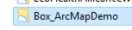
  - Alternatively, it is also a good idea (especially with really large geodatabases and rasters) that you check through the web browser Box folder. If everything is visible online in box, it means it has uploaded.

General Caveats of Using Box Drive

- No single file can be larger than 15 GB. Files larger than 15 GB will not be uploaded to Box.

  - Note that this does not apply to folders.

- Files are downloaded to Box Drive on-demand. This means that files will not be downloaded until you attempt to open them (click on them) or reference them in another program. Hence, opening large files or bringing them into various GIS applications might take longer than expected and feel sluggish.

  - To avoid this, you might want to consider making larger files available offline:
https://support.box.com/hc/en-us/articles/360043697574-Making-Content-Available-Offline

- Files deleted from Box Drive will not go to the Recycle Bin or Trash. Instead, they will be permanently deleted from the computer. However, they can be restored within 30 days at tufts.box.com/trash

- Files might take a while to upload to Box. When you sign out of the computer (or Remote Lab/TTS Virtual Lab), connection to Box will be terminated and any files in Box Drive that have not finished uploading will be lost. Always make sure all files have finished uploading before signing out or powering down. To do so, please refer to the status icons in Box Drive:

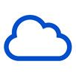 | Item has been uploaded to Box.
 | Item is available offline and has been uploaded to Box.
 | Item is in process of being uploaded to Box. Do not sign out or power down!
- More documented Box Drive limitations:
https://support.box.com/hc/en-us/articles/360043696454-General-Limitations-When-Using-Box-Drive

Using Box Drive with ArcMap
To access Box content in ArcMap, you must connect to your Box folder as follows

- In Catalog, click on Connect To Folder.

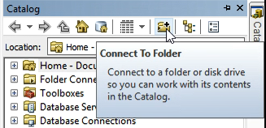

- Select Box and click OK.

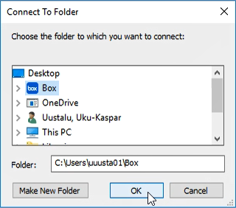

- You will now see all of your Box content under Folder Connections.

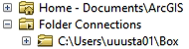

If you have a lot of content in your Box folder, it might take a while for it to open in Catalog. Please be patient.

Using Box Drive with ArcGIS Pro
To ensure your project and all related files are automatically saved to Box, set the location of your project to be in your Box folder when creating a new project.
Remember that your Box folder is located at C:\Users\USERNAME\Box
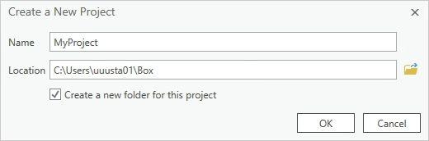

To access Box content within ArcGIS Pro, you need to add it to your Favorites as follows:
- In Catalog, go to Favorites.

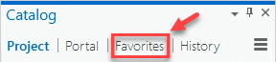

- Click on Add Item and then select Add Folder.

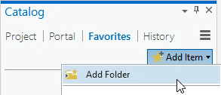

- Navigate to your Box folder at C:\Users\USERNAME\Box and click OK.

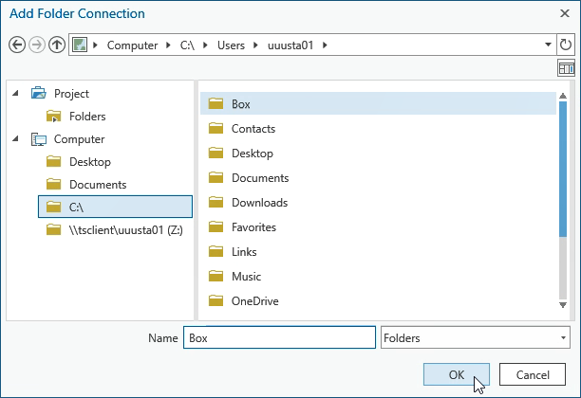

- If you are using ArcGIS Pro version 2.3 or above (personal computer, Data Lab computer, or the Remote Labs), you can now access all of your Box content under Favorites in Catalog.

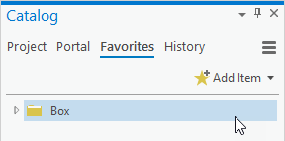

- If you are using ArcGIS Pro version 2.2 or below (TTS Virtual Lab), please follow these additional steps:

  - In Favorites, right-click on Box and select Add To Project.

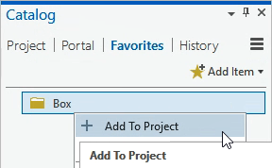

    - Optional: Right-click on Box again and select Add To New Projects.
This will add your Box folder to any new projects you might create.

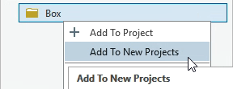

  - You can now access your Box content under Catalog > Project > Folders > Box.

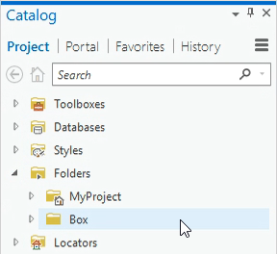

Using Box Drive with QGIS
DO NOT use Browser to access Box content in QGIS! This will cause QGIS to crash.
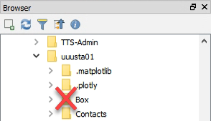

Instead, use Layer > Add Layer to bring in content from Box.
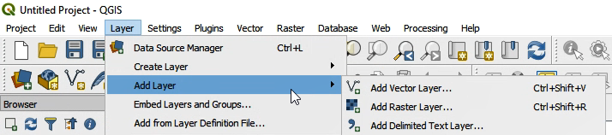

To save files to Box, specify your Box folder as the output location within applicable geoprocessing tools or use Right-Click > Export > Save As…

Using Box Drive with ENVI
Use ENVI as usual while keeping in mind the following:

- Read files from and save files to your Box folder as needed.
- Reading in large files from Box might take longer than expected. Be patient.
- Large files (like raster data) could take a while to upload to Box.

- Ensure all files have finished uploading before signing or powering down!

