# Tufts CTSI

**Register Now for Translational Science Day 2025 (*"Beyond Thoughts and Prayers: Translating Gun Policy Science into Action to Reduce Firearm Violence"*) on Friday, April 4!**

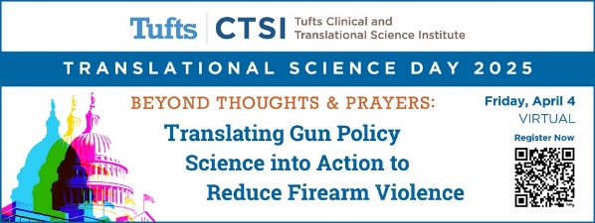Tufts CTSI is excited to announce that their virtual 2025 Translational Science Day symposium is scheduled for **Friday, April 4**!  
  
The theme of this year’s symposium is Beyond Thoughts and Prayers: Translating Gun Policy Science into Action to Reduce Firearm Violence. **The symposium is free to attend**, and [registration is now open](https://urldefense.com/v3/__https:/airtable.com/appGqgYjJO1D8i6wb/shrwaplKwXQWrsR32__;!!CYGGtyGZyw!FsSVYzCElv-IDL8qfEVqHCls9MG-jGSlL1m8lkcZphBJ2tT1vu-PYjg1bS-vSJI6lrTbdWXiv6mzeEgLxCYN5sQ$)!  
  
Featuring success stories at both the state and federal level, the symposium will explore how policymakers, academics, activists, and other stakeholders can help bridge the cultural and political divide to enact lasting and effective gun violence prevention policy. Together, we can change the contentious, overly simplistic way that gun policy is currently characterized in America.

Scheduled speakers include:

* [**Rob Wilcox**](https://www.tuftsctsi.org/wp-content/uploads/2025/01/Rob-Wilcox-.pdf)(Former Deputy Director of the Office of Gun Violence Prevention & Special Assistant to the President)
* [**Pastor Cory B. Brooks**](https://www.projecthood.org/ourceo) (CEO of Project HOOD)
* [**Christian Heyne**](https://www.bradyunited.org/about-us/our-team/brady-leadership/christian-heyne) (Vice President, Policy and Programs, Brady)
* [**Alia Harvey Quinn**](https://forcedetroit.org/crew/) (Founder and Executive Director, Force Detroit)
* [**Jocelyn Benson**](https://www.michigan.gov/sos/resources/the-secretary-of-state) (Michigan’s 43rd Secretary of State)
* [**Dr. Natasha Bagdasarian**](https://www.michigan.gov/mdhhs/inside-mdhhs/executive-staff-bios/dr-natasha-bagdasarian) (Chief Medical Executive, Michigan Department of Health and Human Services)
* [**Dr. Cedric Dark**](https://cedricdark.com/) (Emergency Physician and author of Under the Gun: An ER Doctor’s Cure for America’s Gun Epidemic)
* [**Michael Dandorph**](https://www.tuftsmedicine.org/about-us/our-leadership) (President and CEO, Tufts Medicine)

[**Be sure to bookmark the event website**](https://www.tuftsctsi.org/events/tsd2025/) to keep an eye out for symposium updates, speaker announcements, and more!