**INSTRUCTIONS FOR COMPLETION OF**

**MANDATORY EDUCATION REQUIREMENTS**

**Registering with CITI and Affiliating with Tufts University**

Go to <http://www.citiprogram.org>

Create an account by clicking on the “Register” button on the homepage.

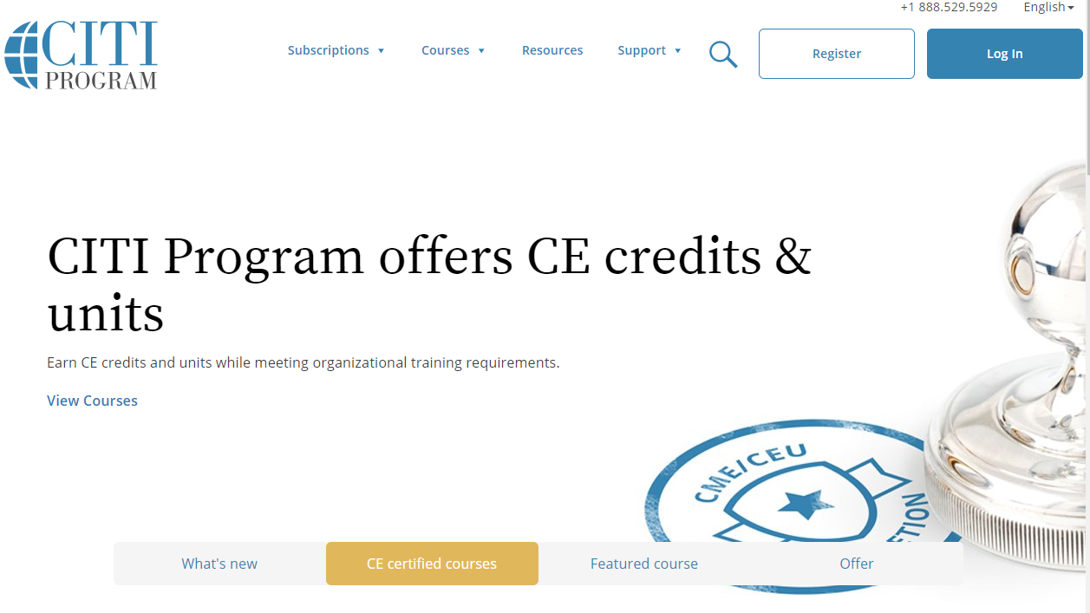

*Step 1:* Choose Tufts University/Tufts Medical Center as your Organizational Affiliation.

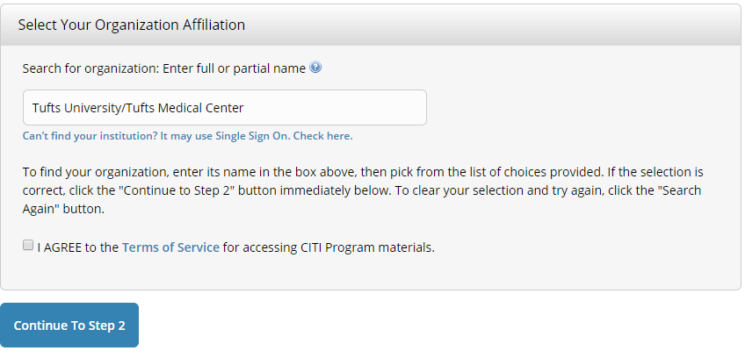

*Step 2:* This step requests that you enter your first and last name along with your email address. Please enter your name here as you would like it to appear on your completion report received at the end of the course. Be sure to use an email address that you can access so you can complete the registration process by verifying the automatically generated email. We recommend using your institutional email.

*Step 3:* Create a Username and Password for your account. Please follow the on screen instructions for the expected parameters of each field. Passwords are case sensitive. **Please retain your username and password; we do not have access to this information.**

*Step 4:* Complete your country of residence.

*Step 5:* You will be asked if you want to receive Continuing Education Unit (CEU) credit for completion of CITI courses. Select “**No**”.

*Step 6:* This step is institutional specific. You must complete each section marked with an asterisk. It is up to you if you wish to provide optional information.

Department: *Enter your “home” department. For students, please note if you are a pre-doctoral student, a post-doctoral student, or resident and your class year*

Research Role: *Please select the option from the drop-down menu that most-closely aligns with your role.*

Office Phone: *Please list your personal cell phone number*

*Step 7:* The questions in this step will enroll you in the CITI program courses. Please select the following answers:

Question 1: **Biomedical Researchers**

Question 2: **No**

Question 3: **No**

Question 4: **Not at this time**

Question 5: **No**

Click on “Finalize Registration”; this will bring you to the Main Menu of your account.

**Completing the Education Requirements**

*Step 1:* Click on the course name to begin the course.

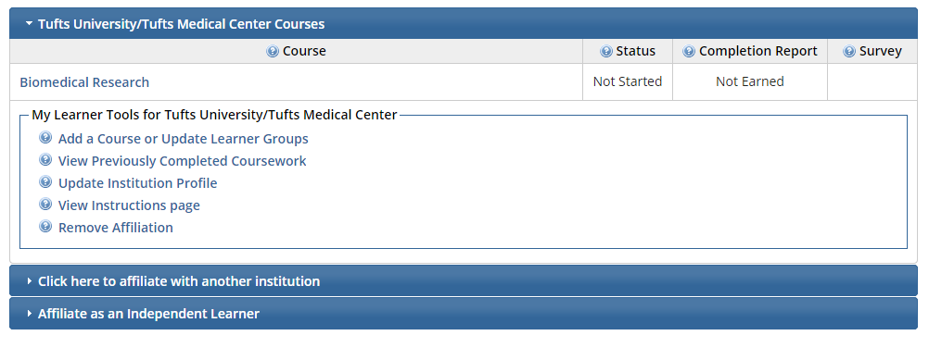

*Step 2:* Complete the Integrity Assurance Statement

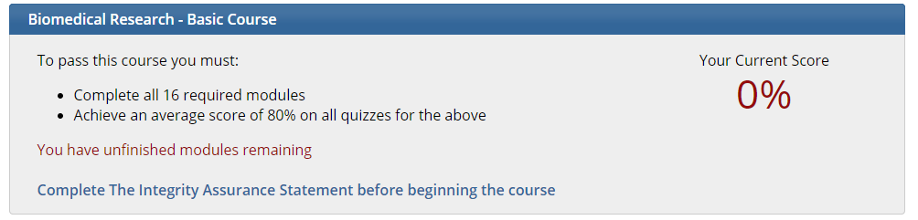

*Step 3:* Complete each of the required modules in the course to earn your completion certificate. Please note that the system requires you to complete the modules in order. You must achieve an average score of 80% to pass. You are not required to take the supplemental optional modules.

**Submitting your Completion Report**

It is required that you submit a copy of your completion report to James Kirchmeyer in Dental Research Administration. He will reply to confirm you have fulfilled the training requirements.

Click on View/Print and save your report as a PDF. Send this as an attachment to James.

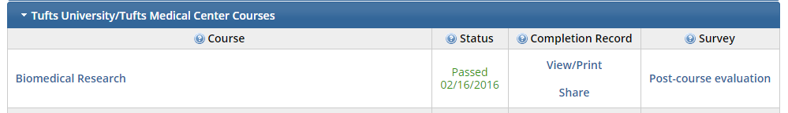

Print (or download) and retain a copy of the completion certificate for your personal records. Be sure to note the date that your certification was earned. Certification expires in 4 years minus 1 day. If you pass on 6/30/16, your certification expires on 6/29/17.

If you have any questions, please contact James Kirchmeyer directly at [James.Kirchmeyer@tufts.edu](mailto:James.Kirchmeyer@tufts.edu) or 617-636-0490

If you are having difficulty accessing your account information, or if you need to merge duplicate accounts, please contact CITI:

* + Call 305-243-7970; Select Option 1
  + Send an email to citisupport@med.miami.edu