INSTRUCTIONS FOR THE
FEDERAL CONFLICT OF INTEREST (FCOI) MINI COURSE

FCOI training is required for Investigators before engaging in federally-funded research, every four years thereafter, and immediately under designated circumstances.

To register for the course, go to http://www.citiprogram.org and log into your account that is affiliated with Tufts University/Tufts Medical Center.

Step 1: Under the main menu, select “Add a Course” under the “My Learner Tools for Tufts University/Tufts Medical Center.”
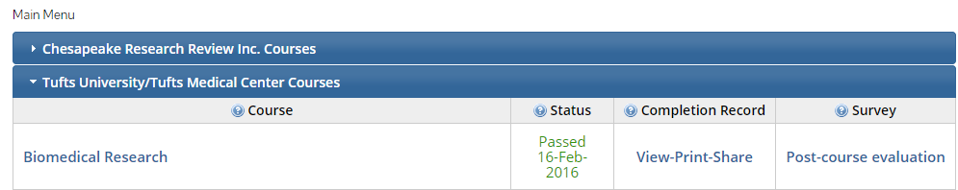
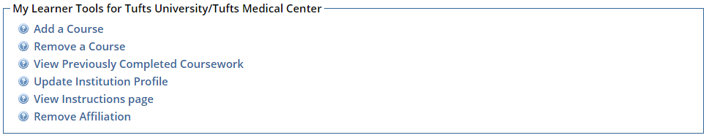

Step 2: There will be 5 questions to be completed in order to sign up for the course. Please select the following answers:

Question 1: Biomedical Researchers
Question 2: No
Question 3: No
Question 4: Not at this time
Question 5: Yes

Step 3: The Conflict of Interest course will appear under your list of courses on the main menu. Select the course, and it will bring you to the Integrity Assurance Statement and required 2 modules.
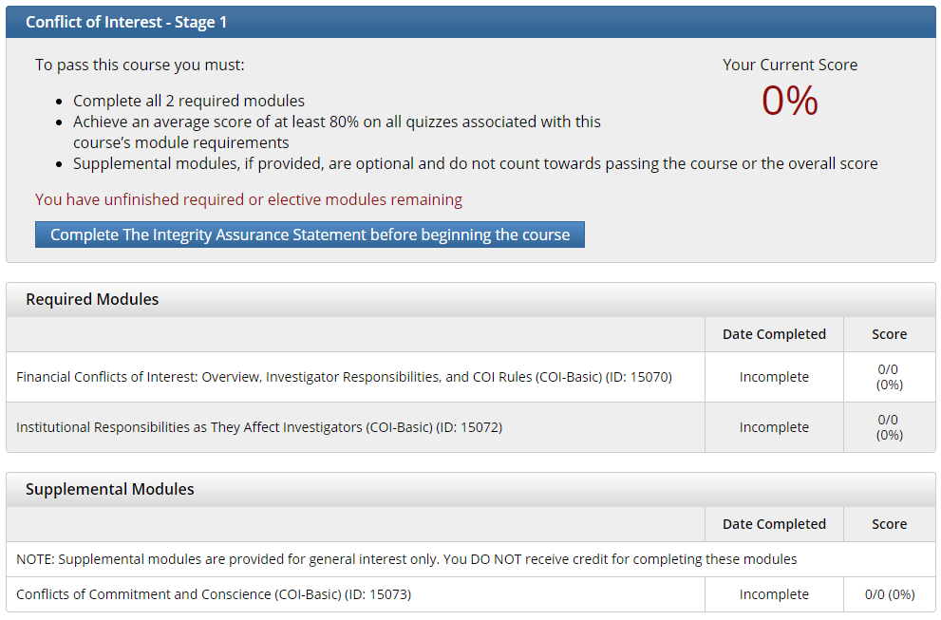

Step 4: Complete each of the required modules in the course to earn your completion certificate. Please note that the system requires you to complete the modules in order. You must achieve an average score of 80% to pass. You are not required to take the supplemental optional modules.

Step 5: Submit a copy of your completion report to James Kirchmeyer in Dental Research Administration. On the main menu, click on View/Print under the Completion Record column for the Conflict of Interest course and save your report as a PDF. Send this as an attachment to James. Print (or download) and retain a copy of the completion certificate for your personal records.

If you have any questions, please contact James Kirchmeyer directly at James.Kirchmeyer@tufts.edu or 617-636-0490
If you are having difficulty accessing your account information, or if you need to merge duplicate accounts, please contact CITI:
  - Call 305-243-7970; Select Option 1
  - Send an email to citisupport@med.miami.edu

