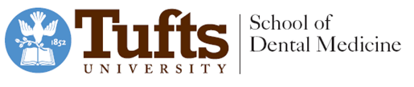

Dental Research Administration
Tufts University School of Dental Medicine
One Kneeland Street, DHS-1513
Boston, MA 02111

To Whom It May Concern,

This letter serves to confirm that the extracted teeth I am donating for use in materials research projects by pre-doctoral dental students have been collected in such a manner so that they are not identifiable. There is no way for the student researchers to connect the teeth that they use back to the individual patient that the tooth came from. I have collected these extracted, discarded teeth using a jar in a central location at my practice and have stored them according to infection control protocols.

Please feel free to contact me directly with any questions or requests for additional information.

Title_______________________________________________________________________________________

Organization Name____________________________________________________________________

Print Name____________________________________________________ Date____________________

Signature______________________________________________________ Date____________________

1 Kneeland Street, Room 833, Boston, MA 02111 ǀ Tel: 617.636.2115 ǀ Fax: 617.636.6511

