Recommendations re: Purchases to Increase Accessibility
MetroRock Littleton
July 2024
Fiona Kinmonth, OT/s with reference to the AIMFREE Professional Version

Low Commitment | Medium Commitment | High Commitment | Potential Facility Projects
Option for weight increments to be 5lbs or less on the cable machine | Portable ramps | Automatic doors | Record audio and/or video for gym policies and other posted information
Hand weights 2lbs or less | Access Trax or equivalent for more stable surface to use wheelchair on the mats | Power assist on doors | Tactile/3D map of facility
Wrist weights | Fully detachable/hand held shower head in women’s shower | Curb cut or permanent ramp at handicap parking space directly outside main entrance | Diversify images, literature/website, and language to be more inclusive of individuals with disabilities
Medicine balls |  |  | Remove bulletin board in locker room and replace with a curtain
Active Hands or equivalent |  |  | Extend shower area to include a private space for changing or transfering to shower seat
Slide board |  |  | Add handles to lower lockers

Product + Link | Description | Image
Active Hands  Off brand option (less sturdy, potentially not as user-friendly to put on, but may be fine for cardio equipment handles) | Assists in maintain grip on cardio equipment or handheld weights | 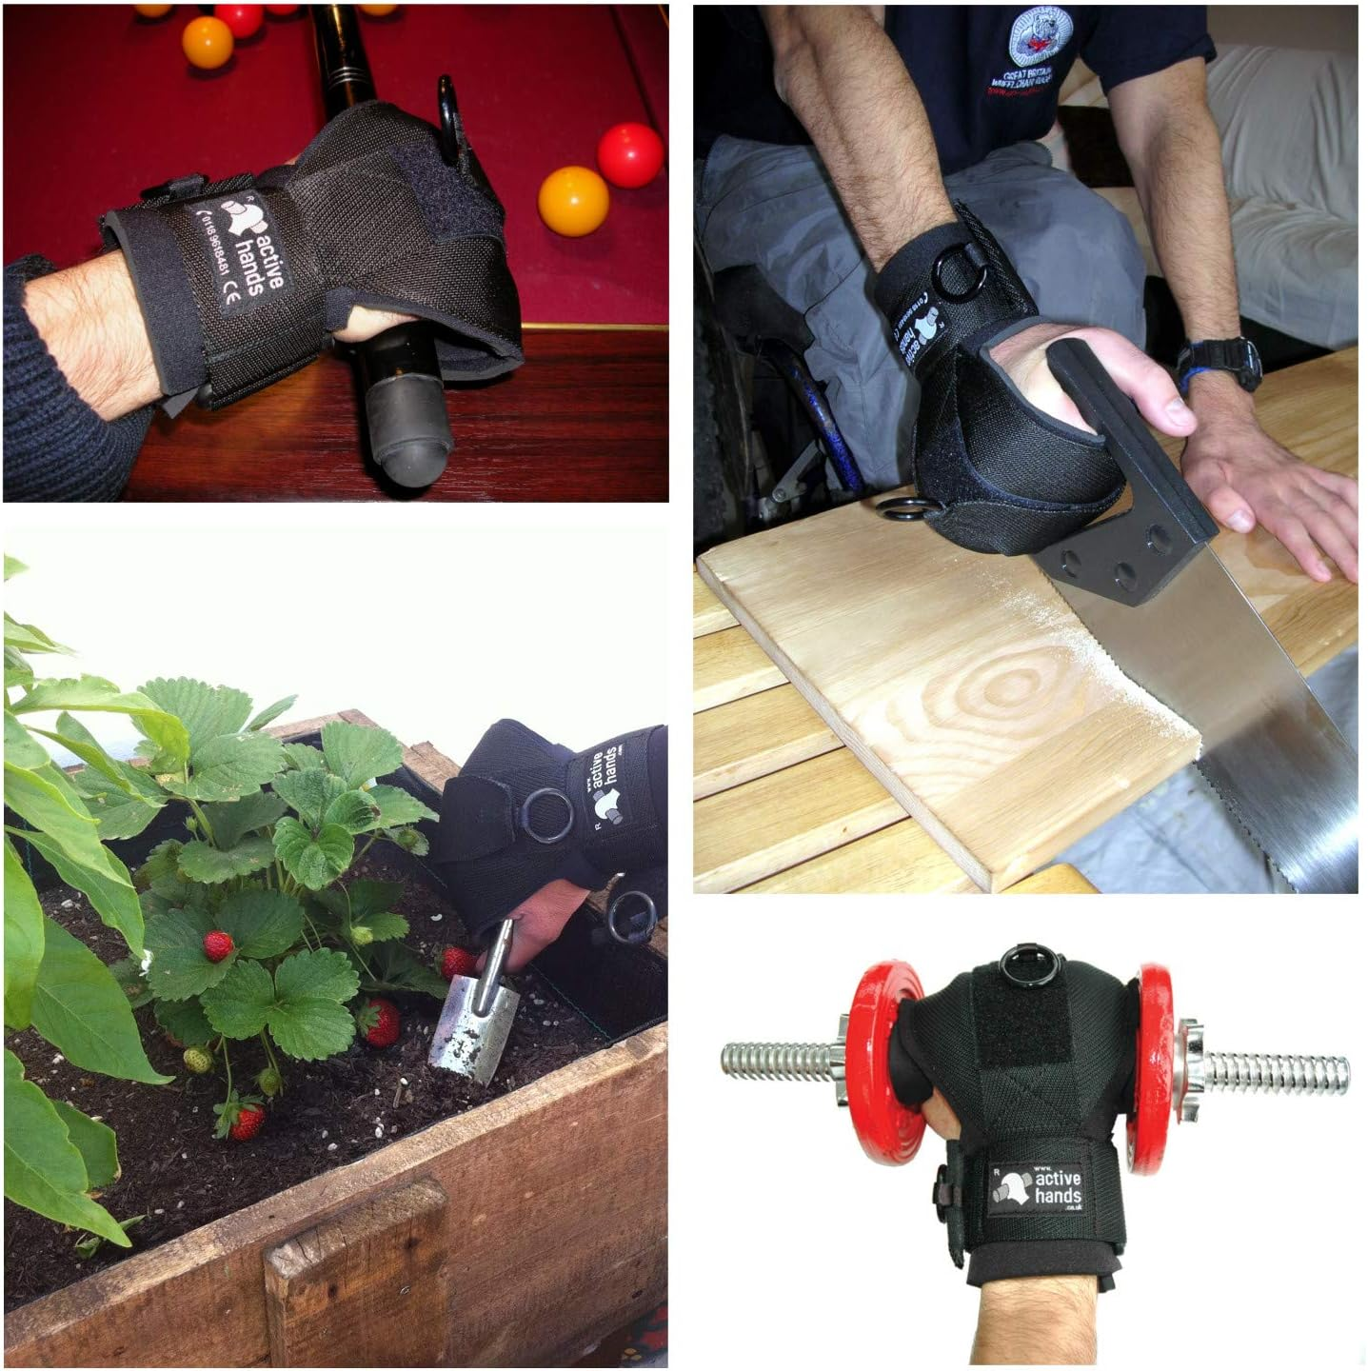
Slide board | Used to assist user in moving to/from wheelchair to another seat or chair.  Using a slide board: https://www.youtube.com/watch?v=IFUW7He43_g | 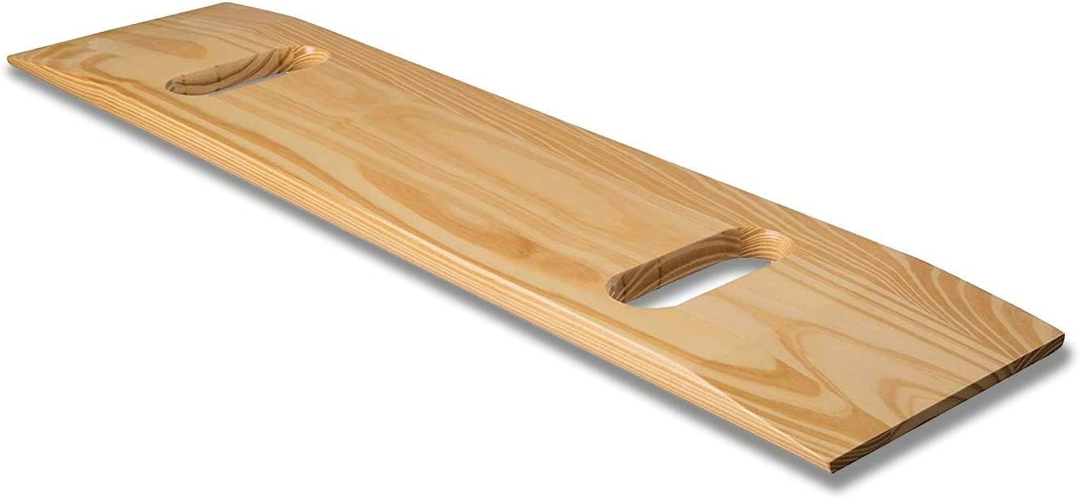
Product + Link | Description | Image
Portable ramps  *note: 1 foot of length is needed for every inch in rise  Ex: Clearing a 5 inch tall pad will require a 5 foot long ramp | Temporary, moveable ramp to assist individuals with mobility devices (wheelchairs, walkers) to move between changes in levels in the facility. | 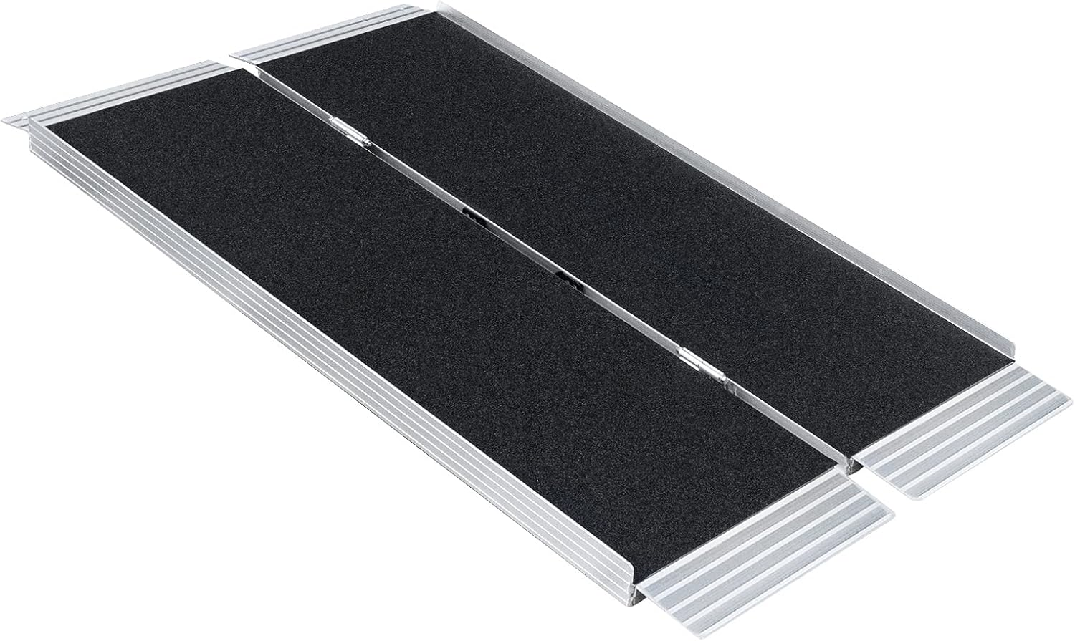
Access Trax or other alternative  Slip resistant drainage mat | Portable firm surface/walkway for wheelchair users to more easily navigate soft surfaces (such as the mats)  **note: make sure the mat is not too thin that it just warps into the pads as someone rolls over it; this defeats the purpose | 