ECE Senior Capstone Project *2018 Tech Notes*

Personal Plasma Water Filtration

**Bromate Detection Via Ion Chromatography and Inductively Coupled Plasma-Mass Spectroscopy**

*By Lisa Fantini, EP ’18*

__________________________________________________________________________________________________________

**Introduction**

***The Senior Design Problem and Solution***

One in every nine people lack access to potable water, and each year one million people die due to water-borne illnesses (World Health Organization). Our Senior Design group decided to address this issue by designing an inexpensive, energy-efficient water purifier.

Plasma-based technology provides an inexpensive and energy-efficient way of removing 100% of bacteria, viruses, and volatile organic compounds (VOC’s) from water. Large-scale plasma purification systems have already been implemented in parts of the world, such as Chile. The system in Chile disinfects 35 liters of water in five minutes, using less energy than a light bulb (Reuters 01:00-01:15). Our project’s aim was to design a small-scale version of this system.

As we began researching plasma-purification methods, we discovered one of their main issues: they can introduce harmful byproducts into the water. Plasma’s byproduct ozone may react with bromide, an innocuous compound commonly found in water sources, to produce bromate, a carcinogenic compound. Consequently, in order to assure that plasma treated water is safe to drink, its bromate levels must be tested. The maximum acceptable amount of bromate in drinking water is 10ug/L (European Commission, U.S. EPA, and the Japanese Ministry of Health, Labor and Welfare). Bromate concentrations

higher than this can lead to cancer, irreversible renal failure, deafness, birth defects and death. Therefore, it is critical to test plasma-treated waters for this substance.

***The Project Focus***

This project focused on a method to detect the amount of bromate in water. The method involves ion chromatography and Inductively Coupled Plasma Mass Spectroscopy (ICP-MS). Ion chromatography initially separates bromate from other compounds in the water. The ICP Mass Spectrometer detects bromate by generating a plasma and leading the particles to a quadrupole mass filter, which eliminates all non-bromate particles. Finally, an electron multiplier detects the bromate. I will outline and explain all of these steps in the following paragraphs. We learned that bromate detection is a lengthy and expensive process, impractical for small-scale plasma purification systems.

**Preparing the Solution for the ICP Mass Spectrometer**

***Obtaining the Sample***

The first step in bromate detection is to collect a small sample from the plasma-treated water. If the sample’s bromate concentration is below 10ug/L, then the plasma-treated water is safe to drink. Otherwise, it is unsafe and needs to be discarded.



***Isolating the Bromate: Ion Chromatography***

From this sample, haloacetic acids need to be removed, since these acids interfere with bromate detection. A chemical cartridge filter removes most of these acids.

The water sample is then poured into a thin, glass beaker (i.e, a column) with a small hole at the bottom. The different chemical compounds inside this column separate according to their densities, isolating the bromate. The bromate-portion of the column is deposited into the ICP Mass Spectrometer. Ion chromatography is not perfect however, and compounds with similar densities to bromate will still be present in the remaining solution.

***Creating a Plasma Torch to Ionize the Compounds***

The remaining solution has bromate and non-bromate particles. Therefore, we need to further isolate the bromate. Ionizing all of the particles facilitate bromate’s isolation by giving each type of particle a different charge.

A plasma, generated by applying a spark to argon gas, ionizes these particles. The ICP Mass Spectrometer maintains its source of plasma by running a radio frequency (RF) current through a coil. This RF current, which comes from a RF generator, introduces alternating magnetic fields, which cause the argon ions in the plasma to continuously collide with each other. The kinetic energy in these particle collisions sustains the ICP torch.

Pneumatic methods “nebulize” the bromate solution. The resulting mist enters the ICP plasma source, where the high-energy argon gas ionizes all compounds.

**Directing the Ions to the Mass Spectrometer**

Once the particles are ionized, a mass spectrometer can use its electric and magnetic fields to isolate the bromate. The bromate ions must first follow a path to the mass spectrometer.

***Creating a Vacuum in the Path***

Collisions can deflect ions out of the path. However, creating a low-pressure environment for these particles decreases these collisions. Such conditions achieve this precision of movement by increasing the mean free path (ie. the average distance particles travel between collisions). To achieve a mean free path of 1 meter, the bromate ions must move from 1-2 Torr (ie. atmospheric pressure) to 5*10-4 Torr. This low-pressure environment forms a vacuum and assures that the bromate reaches the mass spectrometer.

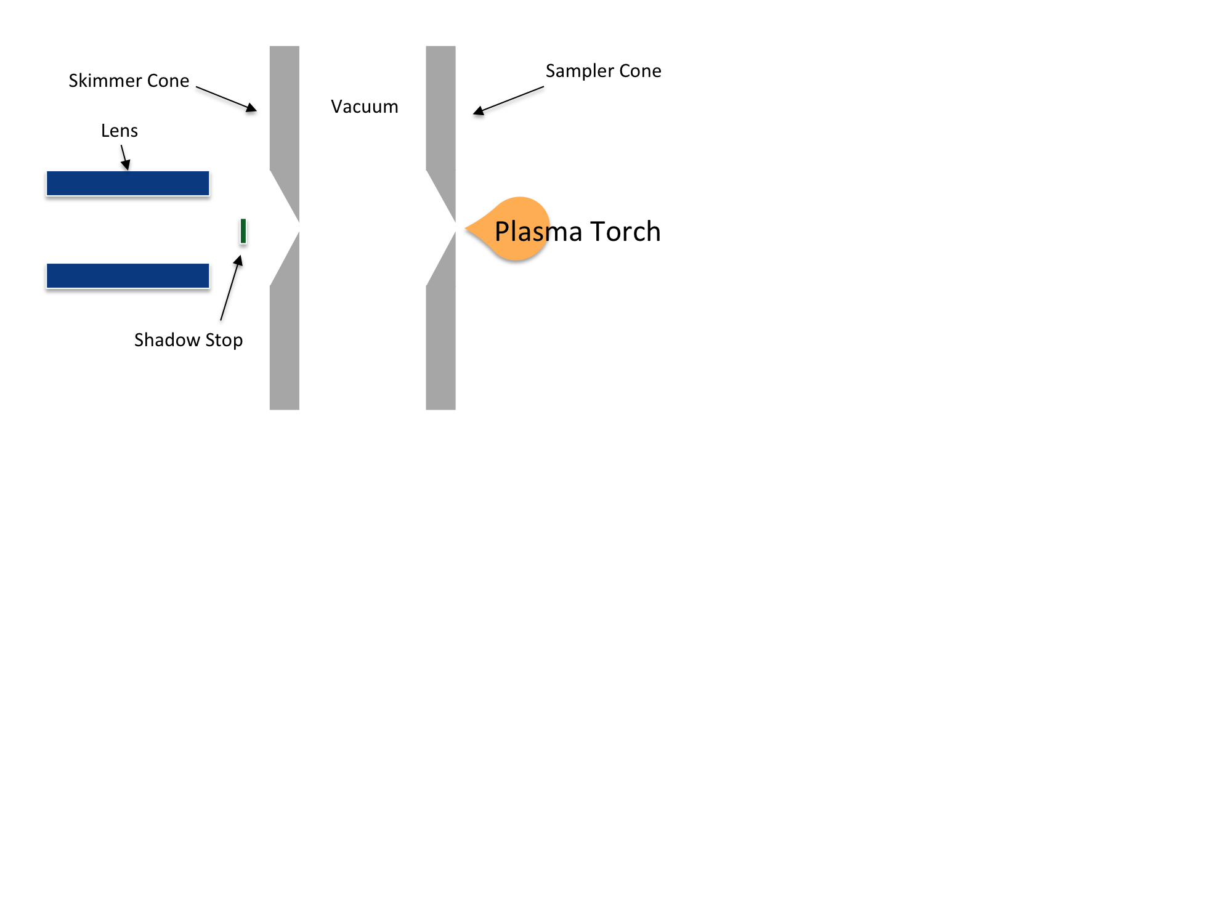

*Figure 1. The plasma torch feeds through the Sampler Cone’s small opening into the vacuum. (Image by Lisa Fantini).*

***Moving the Ions from Atmospheric Pressure to a Vacuum***

Moving the ions to a vacuum poses a challenge due to the possible loss of bromate ions. This loss could lead to testers believing that the water is safe to drink, when in reality the lack of bromate was caused by a faulty detection method. A small metallic disk with a 1-mm sized aperture between the vacuum and the ICP torch mitigates the loss of bromate. This metallic disk, shown in Figure 1, is referred to as a “sampler cone”.

The sampler cone leads bromate ions to the mass spectrometer. The aperture’s small size maintains the vacuum, but also creates a critical limitation. Since the aperture’s opening in the sampler cone is minuscule, dissolved solids in the water sample may block the opening. Blockage can occur when testing water from a swamp, pond, or puddle. These cases require additional filtration and dilution processes. Ideally, there should be less than 0.2% of solids inside of a water sample undergoing testing via ICP-MS.

The skimmer cone, shown in Figure 1, offers a gateway from the vacuum to the system’s electrostatic lenses. These positively charged lenses collimate the beam of ions that pass through the skimmer cone and focus them onto the mass spectrometer’s aperture.

**Arriving at the Mass Spectrometer portion of the ICP MS**

***Isolating Bromate Ions***

The mass spectrometer separates ions according to their mass-to-charge ratios. In this manner, bromate can be separated from other unknown compounds. This critical step assures that only bromate ions contribute to the bromate concentration measurement.

A quadrupole mass filter, which contains four electrically charged parallel cylinders, is oftent used as the mass spectrometer. Its four metal rods are 15-20 centimeters long, and 1 centimeter in diameter. Rods opposite to one another have the same AC voltage values. The magnitude and frequency of the voltage oscillations determine which ions pass through. Figure 2 shows a quadrupole filter. Maxwell’s equations determine the frequency and magnitude of the voltages needed.

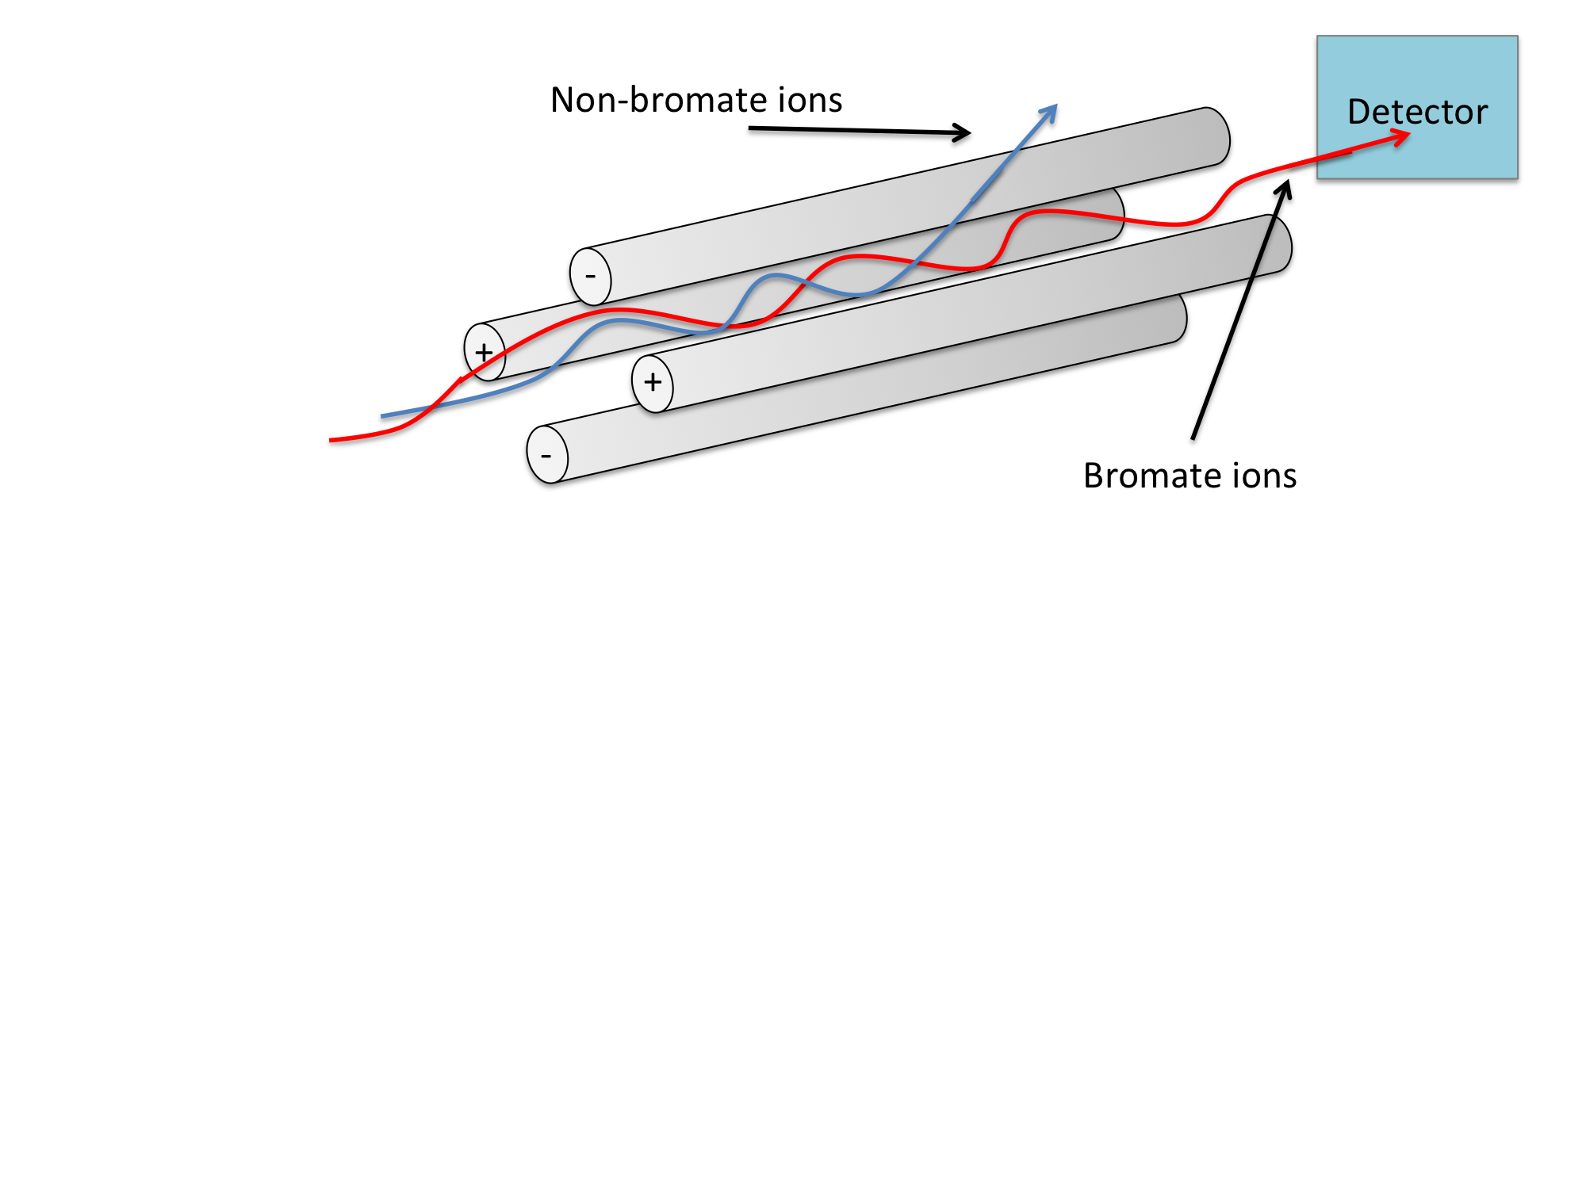

*Figure 2. A quadrupole mass filter isolates bromate ions by removing non-bromate ions (image by Lisa Fantini).*

***Detecting the Bromate Ions***

The final step of the bromate detection process is to count the number of bromate ions exiting the quadrupole filter. Together, the quantity of bromate ions and the amount of sample solution determine the bromate concentration of the water, and whether or not it is safe to drink. Electron multipliers count the bromate ions (Stanton et al., 1956). They contain secondary emission metals, which emit one to three electrons when struck by a charged and sufficiently energized particle. The secondary electrons emitted then strike another secondary emission metal, known as a dynode. Several dynodes repeat this process and cause an “electron avalanche.” After enough dynodes, a large amount of electrons trigger a metal anode, which records the bromate ion’s presence.

**Conclusion**

If a significant amount of bromide exists in water before a plasma treatment, the plasma will react with the bromide to form bromate, a carcinogenic compound. The amount of bromate ions and amount of fluid tested determine the concentration of bromate in the water. This concentration is essential to determining whether or not the water is safe to drink after the plasma treatment.

This lengthy and complicated procedure requires skilled users and thousands of dollars worth of equipment. It greatly complicates water-purification processes via plasma technology. However, when performed in large-scale systems, the benefits of plasma-purification technology overcome the complications and cost involved in bromate testing.

Since the detection of bromate is a chemical engineering problem, it lies outside the scope of our Senior Design project. However, hopefully one day, an easier way to detect the presence of bromate in water samples will simplify the problem plasma-treated water faces today.

**References**

1. Bruggeman, P. J., Kushner, M. J., Locke, B. R., Gardeniers, J. G. E., Graham, W. G., Graves, D. B., ... Zvereva, G. (2016). Plasma-liquid interactions: A review and*Technology*, *25*(5), [053002]. DOI: [10.1088/0963-0252/25/5/053002](http://dx.doi.org/10.1088/0963-0252/25/5/053002)

2. Diemer, J., and K. G. Heumann. 1997. “Bromide/Bromate Speciation by NTI-IDMS and ICP-MS Coupled with Ion Exchange Chromatography.” *Fresenius’ Journal of Analytical Chemistry* 357 (1): 74–79. <https://doi.org/10.1007/s002160050114>.

3. European Commission : CORDIS : Projects and Results : Laboratory and field methods for determination of bromate in drinking water. (n.d.). Retrieved March 30, 2018

4. *Progress on drinking water and sanitation: 2014 update*. (2014). Geneva, Switzerland: World Health Organization.

5. Reuters, Thomson. n.d. *Chilean Purifier Brings Clean Water to the Poor*. Accessed February 26, 2018. <https://www.reuters.com/video/2012/04/03/chilean-purifier-brings-clean-water-to-t?videoId=232831814&videoChannel=6>

6. Stanton, Henry E., William A. Chupka, and Mark G. Inghram. 1956. “Electron Multipliers in Mass Spectrometry; Effect of Molecular Structure.” *Review of Scientific Instruments* 27 (2): 109–109. <https://doi.org/10.1063/1.1715477>.