ECE Senior Capstone Project *2018 Tech Notes*

Personal Plasma Water Filtration

# DC Boost Conversion to Obtain High Voltages for Plasma Generation

*By Jon Manninen, ECE ‘18*

_____________________________________________________

**Introduction**

Applying energy to a molecule and exciting electrons to the point that they break free from the molecules form plasma. This process creates free-radicals such as ozone and also emits ultra-violet (UV) light, which have disinfecting properties and can destroy harmful pathogens in water[1]. High electric fields that are required to create plasma in water can be conveniently achieved using direct-current (D/C) boost converters.

**Generating Plasma**

There are two types of Plasma; thermal and non-thermal. Using electrical energy to excite the electrons creates non-Thermal plasma. For example, if you apply heat to ice, it becomes water. If you apply enough heat to water, it becomes a gas. Further heating of the gas will cause the ionization of the molecules, creating plasma. This process requires much more energy than non-thermal plasma. In portable applications, with energy provided by a battery, creating thermal plasma will not work

Non-Thermal plasma is created by using electrical energy to excite the electrons. Using electrical energy to excite the electrons creates non-Thermal plasma. These spare electrons then allow plasma to be conductive. The strength of the electric field, measure in Volts per unit length, is widely known as the “breakdown voltage”. The electrical potential that needs to be reached in order to produce plasma discharges in water is approximately ${1MV cm}^{-1}$ (MegaVolt per centimeter) [2]. This seems like something that would be unachievable, however, the scale is linear. Decrease the distance between electrodes to say 1mm and the breakdown voltage required would decrease to 10kV. This electric field must be pulsed in order to avoid boiling the water[7]..



**Creating High Potentials for Plasma Generation**

***Generating High Voltages in A/C***

One method of achieving this is through the use of alternating current (A/C). In order to convert a small direct current (D/C) potential into a high A/C potential from a portable battery, several issues arise.

The first issue is that in order to convert A/C to D/C, there must be a separate oscillator circuit, followed by an A/C Transformer. Oscillator circuits can be made light and small, but are complicated can become unstable if component values fluctuate. In addition, oscillating circuits require multiple switches. These switches are what fails more often than not. The less switches, the better. A/C transformers rely on heavy and bulky iron cores in order to pass power through one side to the other using magnetic induction.

There are several high frequency A/C transformers that are readily available. These transformers are lightweight and affordable for common household voltages, but in order to generate the voltage required to ionize atoms, these items get extremely pricey, and nearly impossible to construct without the latest and greatest manufacturing technology.

***DC Boost Conversion***

Direct current boost conversion circuits provide a simple and controllable alternative to alternating current. In theory, DC boost converters only require 5 components: A voltage source, inductor, capacitor, diode and a switch .

Capacitors and inductors both store energy. Inductors resist sudden changes in current. After an inductor has become fully charged using a DC source voltage, the circuit will be switched off and the inductor will do it’s best to resist this change in current by converting its stored magnetic energy into electrical current. This allows the flow of current through the diode to be stored in the capacitor. The Diode also ensures that current can only travel from the inductor to the capacitor and not feedback from the capacitor to the rest of the circuit, possibly causing damage to the power source. Below is a diagram of the basic theory behind DC boost conversion circuits.[6]

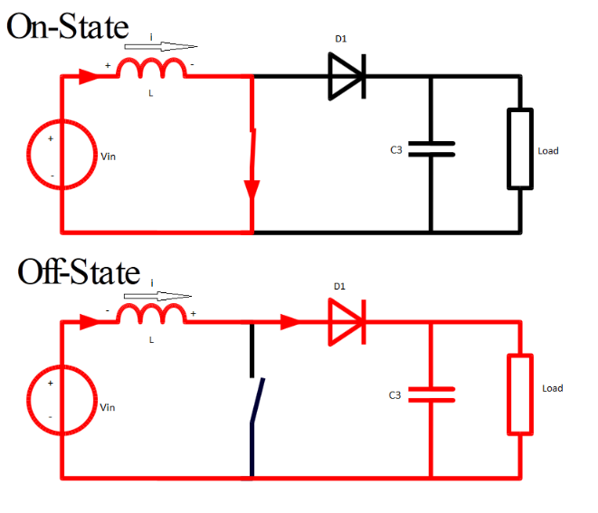

Figure 1: Basic DC Boost Cricuit [3]

The basic idea behind this circuit is to charge the capacitor up to the breakdown voltage of, in this case, water. Once this potential is reached, the capacitor will discharge its stored energy from one electrode to another. As mentioned above, that voltage is dependent on the distance between the electrodes [7]. Determining the output voltage is the first step in designing the converter.

` When choosing a capacitor value, knowing the output voltage needed, and the energy of each pulse, estimated at 1mJ [4], the capacitor will need to be able to store and discharge this amount of energy. Capacitor values are often limited in value, especially in high voltage applications. Capacitor voltage ratings should always be at least 10% higher than the expected output voltage.

Inductor values can be calculated using the following formula:[5]

$$L= \frac{V_{in}*(V_{out}-V_{in})}{∆i_{L}*f_{s}*V_{out}}$$

Where $f_{s}$ is the minimum switching frequency and $∆i_{L}$ is the estimated inductor ripple current. The ripple current is not a concern of ours for this application.

The frequency of the pulses is to be chosen by the designer. In the case of plasma generation in water, the pulse frequency should be at least 20 kHz but finding higher frequency (>1MHz) is difficult and expensive.

A diode should be selected by voltage rating, to ensure the high potential on the capacitor side of the circuit will not cause the diode to breakdown and avalanche. The function of the diode in this circuit is to direct the current released from the inductor to the capacitor and not allow a high voltage to be fed back into the power source.

Certain values of the chosen components need to be balanced between equations listed above. The design and construction of a DC Boost Converter circuit, like many other circuits, may require compromise based on availability of high voltage parts, energy storage of energy storing devices and pulse frequency. A resistor can be put in place between the diode and capacitor in order to slow the charging process if additional tweaking to the circuit is needed. With a resistor of the circuit the time constant relates to the capacitor and resistor values as $τ=RC$. However, resistors will dissipate power from the circuit and in designing a portable unit, keeping the power consumption low will mean more water treated between battery charges. The specific goal is to keep power consumption below 10 Watts. Below is a picture of plasma generation in both air and water using a 3.6-7kV DC boost converter. Note that the water discharge was only able to be seen in the dark.

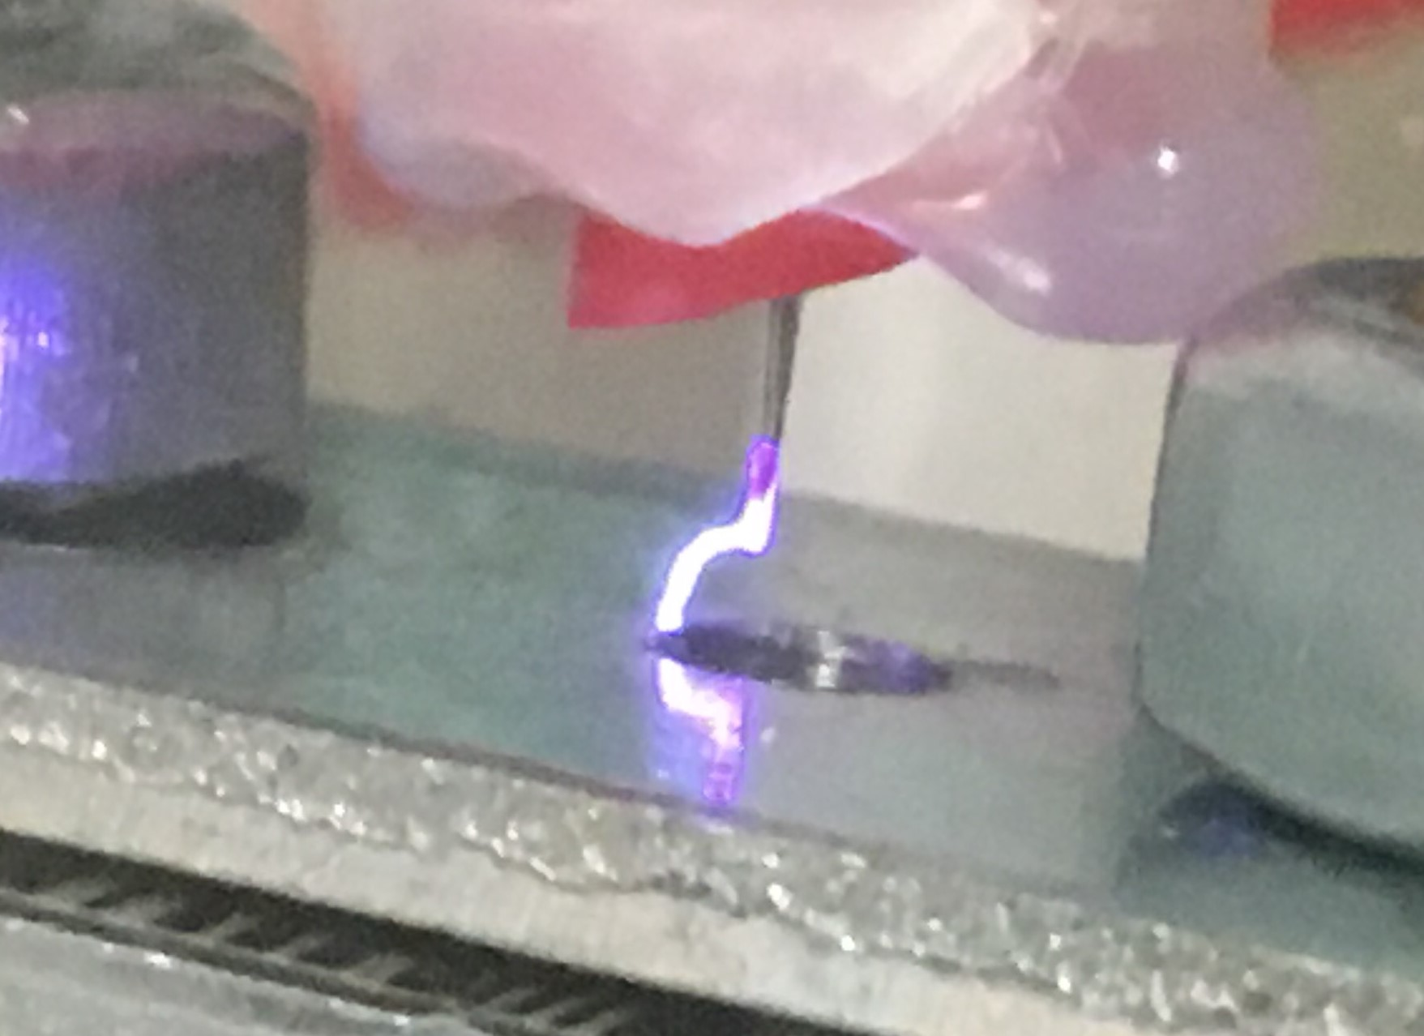

Figure 2: plasma discharge in air



Figure 2: Plasma Discharge in Water

**Conclusion**

In order to create plasma in water, a strong electric field is required. DC Boost Conversion Circuits provide a relatively inexpensive and widely customizable solution. DC boost converters are a proven technology used in every day applications in electronics and communications equipment. For a portable water filtration system using plasma as a purification process, DC Boost Converters provide the most practical way to achieve the necessary potential to create the electric field.

**References**

# [1] Anto Tri Sugiarto; Takayuki Ohshima, “Active species formation of pulsed plasma in water with ring-to-cylinder reactor type electrode”, [2015 International Conference on Automation, Cognitive Science, Optics, Micro Electro-Mechanical System, and Information Technology (ICACOMIT)](http://ieeexplore.ieee.org.ezproxy.library.tufts.edu/xpl/mostRecentIssue.jsp?punumber=7437035), Issue Date: [29-30 Oct. 2015](http://ieeexplore.ieee.org.ezproxy.library.tufts.edu/xpl/tocresult.jsp?isnumber=7440135),

[2] Nayab Pervez, Abdur Rashid, Adil Habib Alam, Analysis of HV Plasma Corona Reactor Treatment System for Industrial Waste Water; COMSATS Institute of Information Technology, Abbottabad, Pakistan.

[3] Dors, Miroslaw, “Plasma for Water Treatment”, <http://www.plastep.eu>

[4] Anonymous, “Boost Converter with Arduino” [www.Reibot.com](http://www.Reibot.com)

[5] Hauke, Brigitte , “Basic Calculation of a Boost Converter’s Power Stage”, Texas Instruments Application report 2014

[6] K. I. Hwu and W. C. Tu, “High-Voltage Boost Converter”, Department of Electrical Engineering, National Taipei University of Technology, Taiwan, IEEE PEDS 2011

[7] Changqi You and Mengqi Wang, “An Isolated High-Voltage High-Frequency Pulsed Power Converter for Non-Thermal Plasma Ozone Generation”, IEEE