ECE Senior Capstone Project *2018 Tech Notes*

Personal Plasma Water Filtration

***Plasma Physics***

*By Kenny Yau, ECE ‘18*

_____________________________________________________

**Introduction**

The first three states of matter – solid, liquid, and gas – are differentiated by increasing levels of energy that reduce the intermolecular forces present between individual atoms or molecules. Plasma is the 4th state of matter, coming after gas. It has so much energy that some of its atoms or molecules become ionized (where electrons break free from the nucleus), giving plasma its conductive nature. In general, a plasma consists of a stream of positively charged ions, electrons, and neutrals. This stream gives rise to important properties that make it useful in many applications. One such property is the emission of UV light. Our senior design project uses the UV light generated by a nonthermal plasma to purify water. It was therefore of paramount importance this year that we learned the physics behind the creation of plasma and understood the mechanism by which plasma interacts with bacteria and viruses. These processes are the topics of the rest of this paper.

**How to Create a Plasma**

***Breakdown***

The process by which a gas turns into a plasma is called breakdown, and it starts with free electrons that are already floating around. At any given moment, gases have a certain concentration of free electrons and ions due to cosmic rays from interstellar space. Nonthermal plasmas are created by applying a high voltage across an air gap. The applied electric field from the high voltage gives energy to these free electrons, which collide into neighboring molecules and cause some electrons on those molecules to escape as well. These new electrons then collide into other atoms, causing more electrons to escape their molecules. The effect keeps on multiplying and is aptly named an avalanche; in the context of avalanches created during gas ionization, it is called a Townsend avalanche.

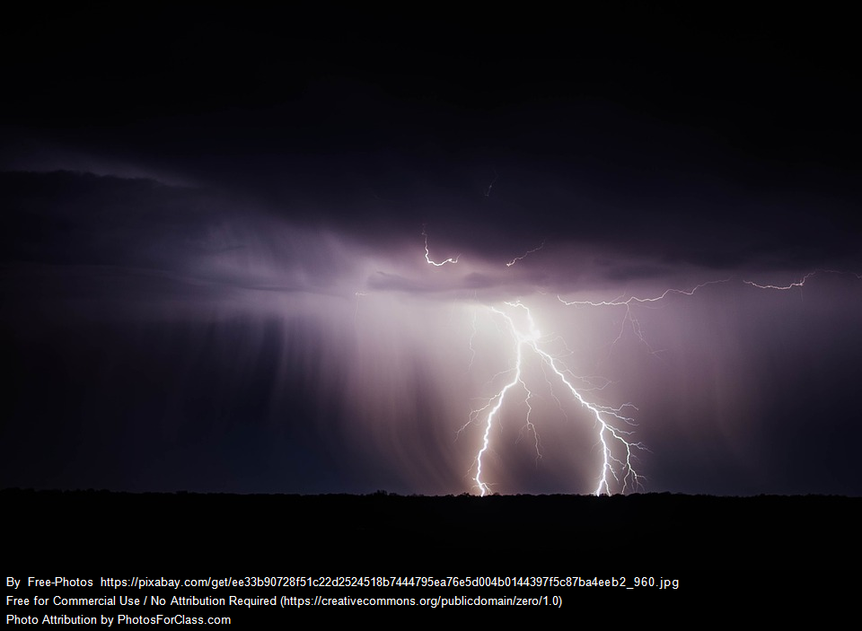

*Figure 1. Lightning is a well-known form of plasma that arcs when the voltage between the clouds and the ground becomes great enough*

***Parameters that control breakdown***

For a given gas, the breakdown voltage is a function that depends on the pressure of the gas and the voltage applied to the gas. This function is called the Paschen curve, and it was developed empirically in the 19th century. Each gas has its own Paschen curve, but they are all similar in shape, with a unique characteristic that there exists a minimum breakdown voltage. The breakdown voltage is expressed as a voltage per unit length: the longer the distance between the high voltage (HV) and ground electrode, the higher the voltage needs to be. The breakdown voltage for air is about 30MV/m at a pressure of 1 atm; thus, electrodes at sea level that are 1 meter apart would need to have a potential difference of 30,000,000V to cause air to break down and start conducting. Conversely, the electrodes would only need to have a potential difference of 30,000V if the they were 1mm apart. Still high, but much more doable.



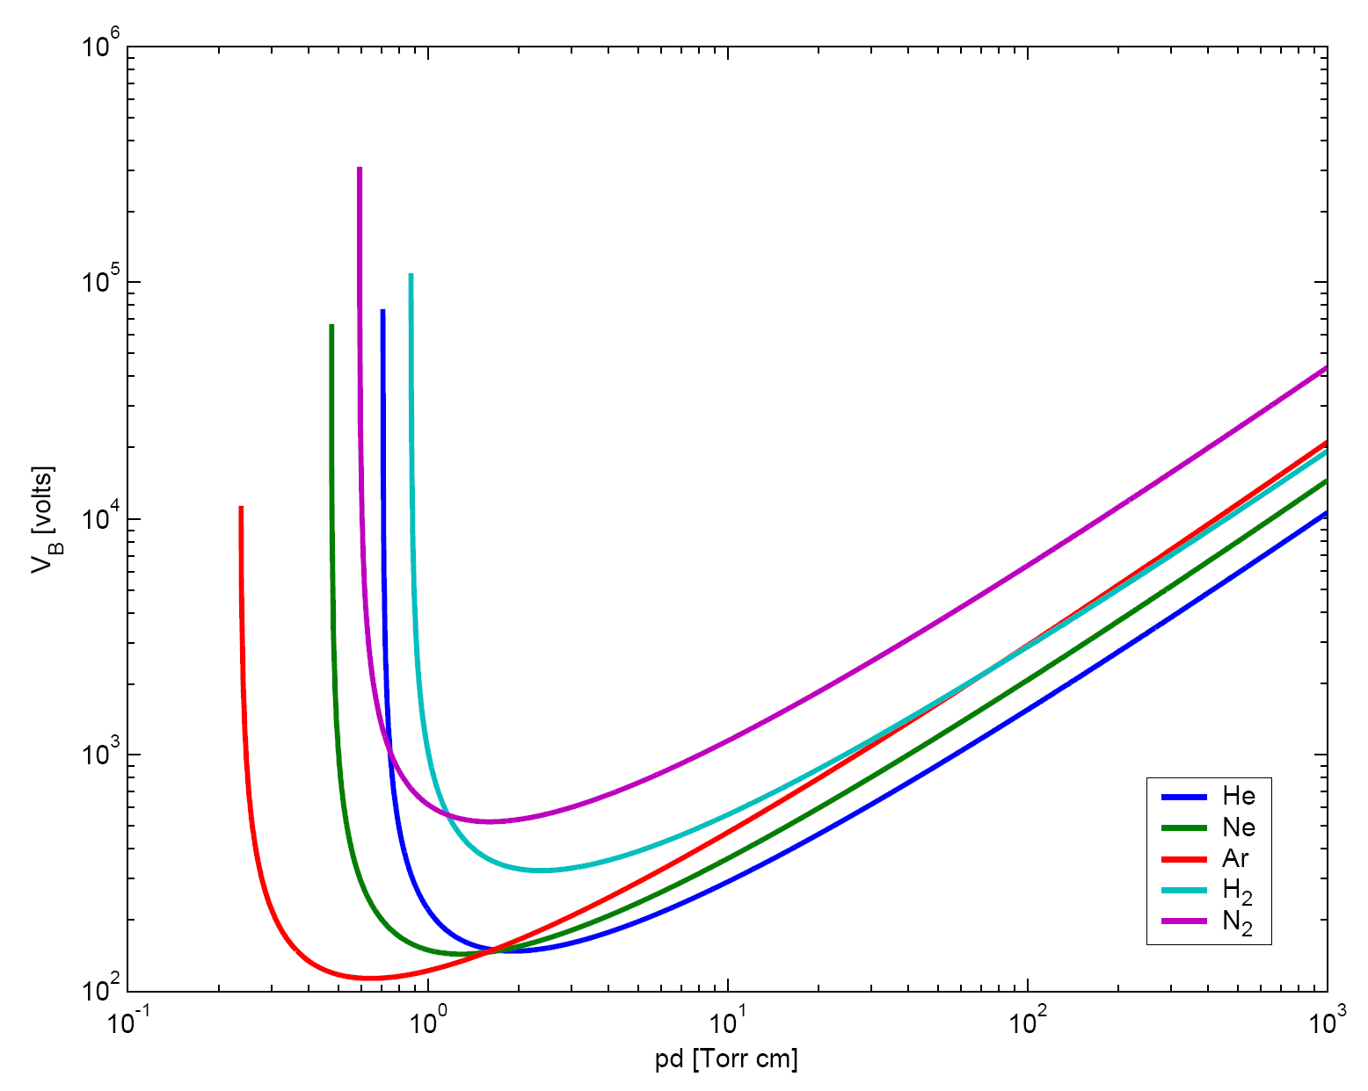

*Figure 2. Paschen Curves for a number of gases, with breakdown voltage as a function of gas pressure. Note that each curve has a minimum breakdown voltage.*

More specifically, the breakdown voltage for a gas depends on the ratio of the electric field E to the gas density N. Called the reduced electric field, it is denoted as E/N and has units of Townsends (1 Td = 10^-21V/m^2). One can therefore either increase the electric field applied to a gas or lower the density of the gas to reduce the requirements for arcing a plasma. The first method is what happens when the applied voltage is increased: a higher applied voltage creates a larger electric field. The second method has found prolific use in certain types of lamps; the gases in lamps have a low enough density that makes arcing plasma much easier.

***Ways to lower breakdown voltage***

A lower breakdown voltage means lower power requirements and possibly cheaper components, factors that ultimately translate to a more reliable and more inexpensive product. Clearly, controlling the reduced electric field is important for our project. Changing the gas density is hard, so we look to controlling the electric field. One way to do so is to change the electrode shape. The electric field is related to the distribution of charges; the higher the charge density, the greater the electric field. Because the surface charge density of a metal conductor is inversely proportional to the radius of curvature (the smaller the radius, the higher the charge density for a given amount of charge), the electric field is also inversely proportional to the electrode’s radius of curvature. A common electrode configuration, therefore, is to use a sharp electrode for the anode to concentrate the electric field on the tip, which helps lower the breakdown voltage.

**Plasma in Water**

***Breakdown in water***

The mechanism for turning water into plasma still follows the process mentioned earlier, but there are two schools of thought on what that gas is. One is that the high electric field first breaks down gas dissolved in water, and the resulting plasma breaks down surrounding water molecules. The other is that the applied voltage turns the water near the anode into a vapor which then turns into a plasma. Either case explains why the breakdown voltage of water can be of the same order of magnitude as that of air, even though water is a liquid with a much higher density and specific heat.

. 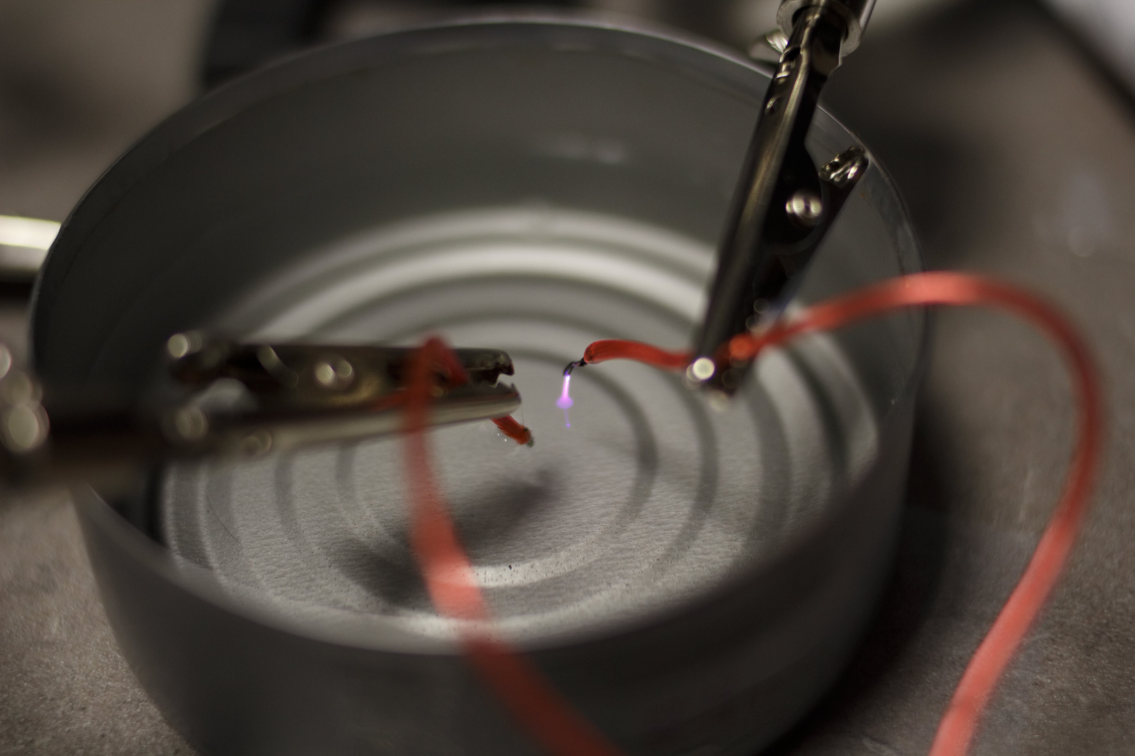

*Figure 3. Early prototype of creating a plasma. Here, the ground lead was in the water, while the high-voltage lead (7kV) was above water. The plasma could arc from the HV lead to the water because the water was essentially a part of the circuit.*

***Chemical Species***

The collision of electrons with molecules of water create several chemical species that are highly reactive and are what make plasma usefulness in water purification. Electrons break water molecules into its constituent elements hydrogen and oxygen. Importantly, the hydrogen and oxygen are left as single atoms, which are highly reactive, instead of diatomic molecules. The hydrogen and oxygen go on to react with other hydrogen and oxygen atoms to create ozone (O3), hydroperoxyl (HO2), hydrogen peroxide (H2O2), and hydroxide ions (OH-). Collectively known as free radicals, these chemical species are partially responsible for the disinfecting properties of plasma: they react with bacteria and volatile organic compounds in water, breaking them down until only carbon and water remain.

***UV Light***

UV light is also responsible for the creation of free radicals. Free electrons excite bound electrons to a higher energy state. As those excited electron returns to their ground states, they release the energy difference between the two states as UV light. UV light emitted from the plasma generates additional ozone and therefore also generates OH radicals. Interestingly, UV light (specifically UV 254) causes double bonds to form between pyrimidine molecules (e.g. cytosine and thymine) in strands of DNA, rendering the DNA irreplicable.

Collectively, all these byproducts of plasma are called plasma deliverables. Plasma deliverables creation and water disinfection via UV decreases with increasing water turbidity (how murky the water is).

***Efficacy***

Plasma treatment of water provides many advantages over other methods of treating water. As agents of disinfecting water, radicals are 50% stronger and act 3,000 times faster than chlorine. The absence of chlorine means the taste of water is not affected; however, this does mean that the treated water loses its residual protection due to lingering chlorine. Plasma can be generated with just electricity, a source of energy which is readily available through solar or mechanical means, and this makes it a viable method of water treatment in almost any context.

**Conclusion**

Plasma’s inherent nature as a collection of ionized gas particles makes it particularly suited as a method to purify water via electrical means so that it is safe to drink. This is a sustainable way to power water purification, and the availability in which we can obtain enough energy to purify said water makes it a particularly salient solution as applied in developing or emergency contexts. Indeed, plasma technology to purify water is already being deployed in Chile in larger-scale plants, and it remains to be seen at what scale this technology can also be deployed at.

**References**

1. Bondarenko, Daniel, Hossam A. Gabbar, and C. A. Barry Stoute. “Safety Design of Experimental Plasma Generation Systems.” *Journal of Loss Prevention in the Process Industries* 47, no. Supplement C (May 1, 2017): 140–50. https://doi.org/10.1016/j.jlp.2017.02.024.

2. Bruggeman, P. J., M. J. Kushner, B. R. Locke, J. G. E. Gardeniers, W. G. Graham, D. B. Graves, R. C. H. M. Hofman-Caris, et al. “Plasma–liquid Interactions: A Review and Roadmap.” *Plasma Sources Science and Technology* 25, no. 5 (2016): 053002. https://doi.org/10.1088/0963-0252/25/5/053002.

3. Daniel HHO Hydrogen Donatelli. *Plasma Water Sanitation System Educational Video*. Accessed November 11, 2017. https://www.youtube.com/watch?v=_OI0lMy7m18.

4. Machala, Zdenko, Igor Jedlovsky, and Viktor Martisovits. “DC Discharges in Atmospheric Air and Their Transitions.” *IEEE Transactions on Plasma Science* 36, no. 4 (August 2008): 918–19. https://doi.org/10.1109/TPS.2008.922488.

5. “Plasma Water Treatment” Accessed November 19, 2017. http://www.plastep.eu/fileadmin/dateien/Events/2011/110725_Summer_School/Plasma_water_treatment.pdf.

6. Misra, N N, Oliver Schlüter, and P. J Cullen. *Cold Plasma in Food and Agriculture: Fundamentals and Applications*, 2016. <http://www.sciencedirect.com/science/book/9780128013656>

Images:

Figure 1: CC0 Creative Commons License

Figure 2: Derivative work by Harlock81

<https://commons.wikimedia.org/wiki/File:Paschen_Curves.PNG>

original work by Wikigian

<https://commons.wikimedia.org/wiki/File:Paschen.jpg>

Licensed under CC3.0

Figure 3: Author’s own photo