ECE Senior Capstone Project *2023 Tech Notes*

***Survey of the STRETCH RE1 in Assistive Robotics***

*By Willy Lin ECE ’23*

_____________________________________________________

**Introduction**

For the senior design project, we are using the Hello-Stretch RE1 robot to assist around the Joyce Cummings Center at Tufts University (JCC). Our plan is to first make a proof of concept using the fourth floor of the JCC. The robot will be able to take commands on an attached tablet device, where visitors and students can use an app to click on the location that they want to go. In this survey, we will explore the different uses of the Hello-Robot Stretch RE1 as well as the field of assistive robotics.

**Assistive and Socially Interactive Robots**

Assistive mobile (both SIR and AR) robots hold great promise for promoting independence for people with various kinds of disabilities. For example, a very commonly known service robot is the iRobot Roomba, which is able to vacuum different areas autonomously. Although it doesn’t have the ability to do complex tasks, it is able to clean the house in place of a human. There is also a misconception of the field of assistive robotics that limits them to assist people with physical disabilities through physical interaction. This definition is flawed as there is now more researched conducted in the field of Human-Robot Interaction (HRI) that involves using robot in social scenarios, which has coined the term Socially Interactive Robots (SIR)1. Socially Interactive Robots are robots that are robots whose purpose is to socially interact with a human, rather than using teleoperating to assist in HRI. Such examples are robots that are able to be hold conversations with humans and being able to play games like chess and checkers. They could also be caretakers in and out of the home/hospital for patients that prefer to have no human contact. There are some ethical concerns in use cases for SIR such as deception, autonomy, justice, and non-maleficence. In this case, the term deception is when SIR robots become more than just robots. There has been cases where socially interactive robots have been used for individuals with cognitive disorders as they can therapeutically interact with them. In these cases, the patient could have a growing attachment to a robot which is not a human being or a real caretaker 2. In addition, robots are in capable of emotions, so any attachment cannot be reciprocated. There is also a growing concern that patients treated using SIR will no longer be able to interact with humans the same way. Thus, there are distinctions between Assistive Robotics and Socially Interactive Robots. Here, we will be discussing both AR and SIR as the Stretch has been used in both cases.

**Design of Hello-Robot Stretch RE1**

In a paper published by the creators of Stretch, the Stretch was first created for the purpose of a compact and affordable indoor robot that is capable of performing tasks in human environments. For this reason, the Stretch is made at a weight of 23 kg, so it is difficult for adults to pick up and move around, and an arm capable of reaching a max shoulder height of 50th percentile of females and males. This inclusive design will allow the robot to serve most people. There are also two modes of operation: navigation mode and manipulation mode. Navigation mode will allow the robot to move freely while having the arm tucked, and manipulation mode will slow the robot and be able to stretch the arms for tasks for object manipulation. There are also sensors on the robot, mainly a LIDAR, Intel RealSense D435i an RGB-D camera, and IMU. The camera unit can also move 346 degrees and tilt 115 degrees. The attached arm is also able to be stretch out 52 cm, and the move base can move forward and backward with both wheels and perform left and right actions with one wheel turning. The end of the arm also has a wrist and gripper attached and the wrist has 3 degrees of freedom and being able to robot 330 degrees.

**Uses of the Stretch RE1**

The Stretch robot was used in a study to test its functions by manipulating fifteen different common household objects, which are: metal tongs, pot lid, small frying pan, towel, cooking pot, vertical microwave handle, vertical refrigerator handle, horizontal cabinet handle, long sleeve shirt, winter jacket, sponge, granola, metal water bottle, etc. The study concluded that the Stretch using a 3D printed hook which can be made at a low cost can be used to manipulate all the described items using a controller. The results of this study are important because the objects used in the study are common everyday items that the robot would likely interact with in an everyday scenario. If the robot was unable to perform simple tasks such as manipulating common everyday objects, it could not be used as an assistive robot. There are also similar studies on using the stretch to do laundry, writing on a whiteboard, and gathering ingredients.

Another study using the Stretch involved simulating emotion through physical touch3. In this study, the Stretch robot was used to mimic human touch through patting or holding a human’s hand. The purpose is to study if robots are able to be emotional support caretakers. It is also to study whether humans will perceive robots as warm, caring, and competent. The significance of this study is to allow robots to work as therapeutic companions as well as conducting medical exams based on patient preferences. The result of this study is that the robot elicited a positive response from humans and improved the perception of robots as caregivers. However, it is important that the advancement of this technology wouldn’t manipulate human emotions. This result of this study could be concerning, as robotic caretakers will become exceedingly humanlike.

Other studies include using reinforcement learning for autonomous navigation. Autonomous robot navigation is an ongoing challenge that researchers have to face. In a real world setting there, the environment is never perfect and there could be factors that could continuously change the environment the robot is in. It is not like a lab environment where every factor is controlled. So, it is difficult for robots to navigate in scenarios that have a lot of people. This paper used deep reinforcement learning for the robot to learn how to navigate in high occupancy spaces like in crowds. A high level explanation is that reinforcement learning is a field of machine learning/AI that involves the robot learning through rewards. In training, the robot will gather experiences and the robot will receive a reward based on the action is taken. If it crashed into a person, it will receive a negative reward and if it navigates past the person it will receive a positive reward. The robot learns by slowly gathering more positive rewards over time and eventually learn that it should not hit humans and plan a trajectory to go around the human.



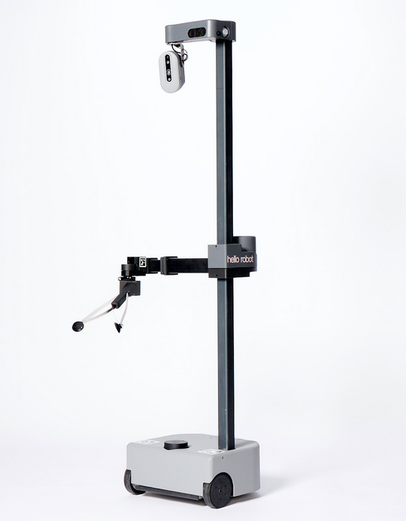

*Figure 1. Stretch RE1*

**Conclusion**

In conclusion, the Hello-Robot Stretch RE1 can be used in a variety of scenarios in both the field of assistive robotics and also general human-robot interaction research. However, it is important to consider the ethical dilemmas of using robots socially. In our case, we will be using the Stretch for the purpose of navigation like a tour guide, so there will be no ethical concerns. However, there will be hazards that we will have to consider, such as collision with objects and humans.

**References**

[1]Kadylak, Travis, Megan A. Bayles, Leonardo Galoso, Maxwell Chan, Harshal Mahajan, Charles C. Kemp, Aaron Edsinger2, and Wendy A. Rogers. "A human factors analysis of the Stretch mobile manipulator robot." In *Proceedings of the Human Factors and Ergonomics Society Annual Meeting*, vol. 65, no. 1, pp. 442-446. Sage CA: Los Angeles, CA: SAGE Publications, 2021.

[2]Kemp, Charles C., Aaron Edsinger, Henry M. Clever, and Blaine Matulevich. "The design of Stretch: A compact, lightweight mobile manipulator for indoor human environments." In *2022 International Conference on Robotics and Automation (ICRA)*, pp. 3150-3157. IEEE, 2022.

[3]Akmandor, Neşet Ünver, Hongyu Li, Gary Lvov, Eric Dusel, and Taşkın Padır. "Deep Reinforcement Learning based Robot Navigation in Dynamic Environments using Occupancy Values of Motion Primitives." *arXiv preprint arXiv:2208.08034* (2022).

[4]Feil-Seifer, David, and Maja J. Mataric. "Defining socially assistive robotics." In *9th International Conference on Rehabilitation Robotics, 2005. ICORR 2005.*, pp. 465-468. IEEE, 2005.

[5]A. Mazursky, M. DeVoe and S. Sebo, "Physical Touch from a Robot Caregiver: Examining Factors that Shape Patient Experience," *2022 31st IEEE International Conference on Robot and Human Interactive Communication (RO-MAN)*, 2022, pp. 1578-1585, doi: 10.1109/RO-MAN53752.2022.9900549