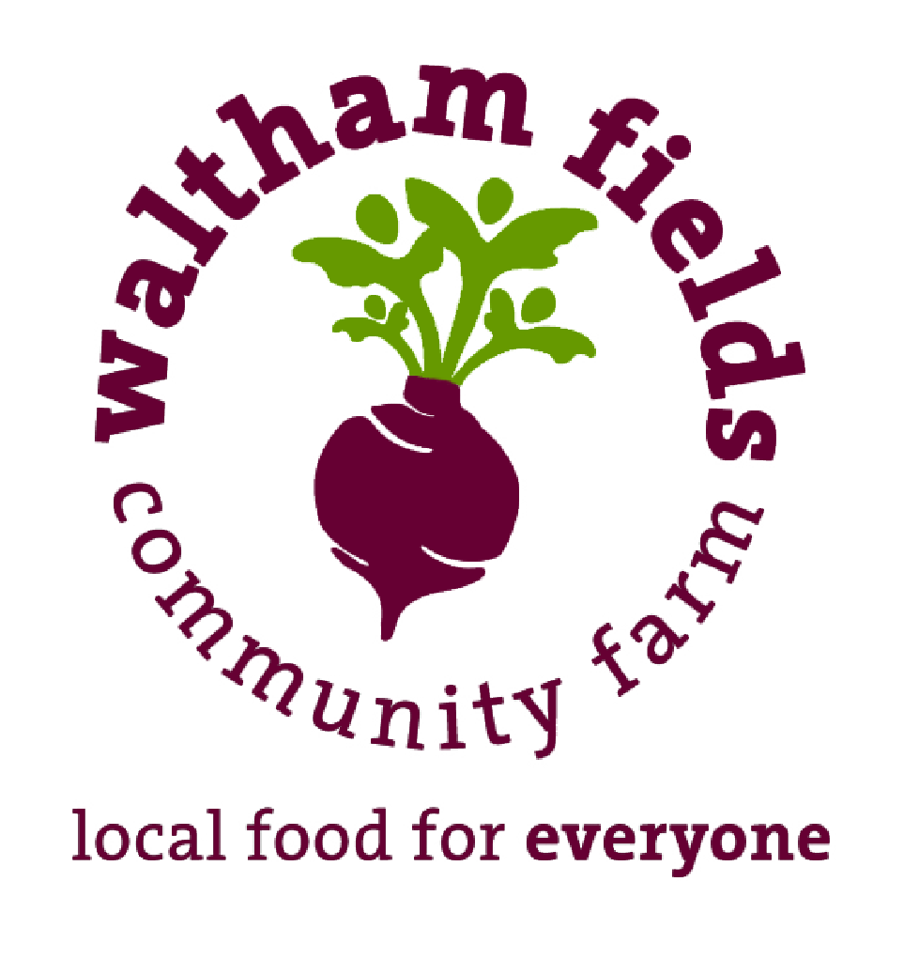
Waltham Fields Community Farm
Job Announcement
Field Crew 2021

Waltham Fields Community Farm (WFCF) seeks motivated crew members for our 2021 Field Crew! WFCF is a non-profit organization in its 26th year running a mixed vegetable farm & educational and food access programs just outside of Boston. We adhere strictly to organic methods to manage 15 acres of farmland. The Field Crew works to support our farming operations, helping to supply food to our 400-share CSA program, our Mobile Outreach Program, as well as distributions to our food access partners,Waltham Public Schools and various events throughout the season.

The Work: The Field Crew works alongside farm staff in all aspects of vegetable production including greenhouse work, transplanting, harvest, cultivation, irrigation set up, and other field tasks on our three separate sites of operation (two in Waltham, one in Weston). Full-time and part-time positions are available.

COVID-19 Note: WFCF requires strict adherence to COVID-19 precautions and protocols which are in accordance with the CDC, MA and local Health Department guidance, and we expect all of our employees to as well. To keep everyone safe, employees are required to wear masks properly at all times on the farm, adhere to our Standard Operating Procedures and maintain 6 ft. distance from others whenever possible. All participants and staff must complete a COVID-19 health screening before each day.

All WFCF staff have altered our personal lives since the onset of the pandemic in order to reduce risk of transmission. We expect our crew members to have done the same and to continue vigilance with the understanding that your behaviors outside of work have the potential to impact everyone in this community. We are taking precautions to protect you and expect the same respect and care in return.

Qualifications: We seek individuals who are hardworking, enthusiastic, able to do fast-paced physical work on a team, and who love to be outside and get dirty. A sense of humor is a requirement. Applicants should be able to sustain focus through repetitive tasks with an upbeat and positive attitude, be prepared to do strenuous physical work in all weather conditions and have a reliable form of transportation. Crew members will be trained on proper techniques and approaches to all tasks. Previous experience is not required, but a robust work ethic and the ability to work as a team with strong communication and listening skills are important. If you don’t have any background in farmwork, please describe other applicable experience in your cover letter. Please note: farm work is very physically demanding. Candidates should be able to repeatedly lift up to 40 pounds, should have an awareness of body mechanics and their own physical capabilities and limits. A Zoom interview is required.

Compensation: $15/hour plus produce from the farm. Staff receive a 20% discount at our farm store.

Hours/Dates: Please note that there are both full-time and part-time positions available with different starting and ending dates.

- Full-Time
  - Two positions available starting May 24, 2021 and ending September 24th, 2021. Must commit to the full 18-week period.
  - Monday-Friday, 8am-4pm (35 hours per week with a one hour unpaid lunch break). In the case of extreme weather, there may not be work available for all or part of the day.

- Part-Time
  - Four positions available starting May 24th, 2021 and ending August 13th, 2021. Must commit to the full 13-week period.
  - Monday-Friday, 8am-12pm (20 hours per week). In the case of extreme weather, there may not be work available for all or part of the day.

To Apply: Please send a resume & letter of interest to Johanna Flies, Assistant Farm Manager at johanna@communityfarms.org

WFCF is committed to a policy of non-discrimination and equal opportunity for all employees and qualified applicants without regard to race, color, national origin, religion, gender, gender identity, gender expression, sex, sexual orientation, sexual identity, marital status, disability, age, citizenship status, familial status, ancestry, veteran status, or any other characteristic protected under applicable law.

