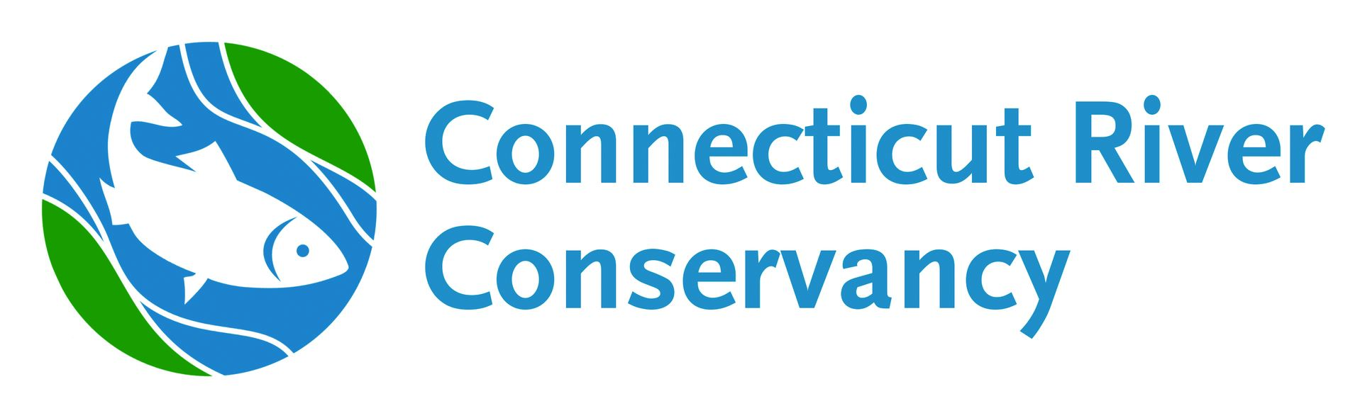

2021 Water Quality Monitoring Program Assistant – Western MA

Position Objective: Assist with the coordination of volunteer river monitoring programs in western Massachusetts.
Position Period: May 20 – September 20 (preferred), June 1 – August 31 (required)
Major Tasks: Coordinate and/or assist with coordinating volunteer water quality monitoring programs for the Connecticut River Conservancy and other watershed associations in western Massachusetts; work with volunteers; manage supply distribution; water sample collection and analysis; sample transportation; basic data entry, handling and analysis; and other ongoing program support. May create and present public outreach programs on water quality issues as time allows.
Training provided: Introduction to WQ monitoring and parameters, basic water sampling and quality control techniques, working with volunteers, field and lab sample analysis, basic data handling and analysis
Detailed Tasks to be Performed:
- Volunteer Coordination
  - Assist with and lead volunteer training
  - Determine volunteer availability to schedule regular samplers, back up samplers, and assign sites
  - Update and maintain spreadsheet or database with volunteer contact information
  - Prepare and provide supplies to volunteers prior to sample dates
  - Maintain quality control sampling schedule
  - Send regular e-mails to volunteers regarding upcoming sampling events, results, etc.
- Pick-up samples at drop-off locations or staff collection rendezvous stations on sampling days
  - Verify completeness of all field sheets
  - Receive samples and monitor sample temperatures
  - Track and document Chain of Custody
  - Conduct conductivity and other tests as needed
- Transport samples to labs within required hold times if necessary
  - Travel to lab in Greenfield from Springfield and/or Northampton
  - Deliver samples and Chain of Custody forms to labs and log in
  - Assist with sample processing and analysis (as needed)
  - Collect equipment and supplies for next sampling dates
  - File field data sheets and Chain of Custody forms in office on return
- Data input and management
  - Using spreadsheet software (Excel, Sheets, etc.) – log in samples, sites, field notes, on-site data (air and water temp’s) and analyzed parameters (e.g. conductivity)
  - Download state, CRC, and USGS flow data, review and transfer to database
  - Distribute results to media outlets, partners & volunteers
  - Maintain hard copy files and back-up all electronic work
  - Assist with or perform updates of GIS map of WQMP sites (optional)
  - Create graphs for data sets as time allows
- Conduct Stormwater or Source Tracking Monitoring Projects (time/weather dependent)
  - Create and follow a sampling plan for a specific area of concern
  - Use meters provided in a stormwater toolbox kit to run samples in the field
  - Collect samples to be processed at the lab
  - Compile results and determine if further investigation is needed
- Provide education and outreach (as time allows)
  - Staff table events
  - Attend association meetings as needed for WQ program
- Work with Monitoring Coordinator or River Steward as needed
- Special project of personal interest if time allows.

Required Skills: Excellent written, verbal, and online communication; proficiency in Microsoft Office; online data processing and collaboration using cloud services; high attention to detail and self-motivation; previous work with volunteers and/or in a lab setting a plus.
Compensation: Reimbursement for miles traveled in the course of job duties at the current rate per mile. Personal vehicle and internet access required.
Work Schedule: Full days Wednesdays & Thursdays for monitoring beginning mid-June. Schedule can be variable at other times.
Expected time commitment: 20 - 25 hrs./week.

