**Summer Field Opportunity: Forestry / Fire Field Technician**

**Job description:** I am a PhD student, seeking help in collecting data for a fire history reconstruction project for my dissertation. The project will involve using dendrochronology to characterize forest stand structure and to determine when past fires occurred across a few different mountain ranges in southern Idaho and northern Utah. The successful candidate will spend the summer with me extensively hiking the subalpine backcountry (off trail), sampling forest plots (DBH, tree heights, damage, mortality agents), collecting tree core samples using an increment borer, and assisting in the sampling of partial cross sections of fire-scarred trees and logs using a chainsaw. Applicants should be interested in and prepared for a physically demanding and adventurous field campaign—we will comprehensively traverse entire swaths of forest across rugged and steep terrain looking for fire scars and collecting samples if trees are structurally sound.

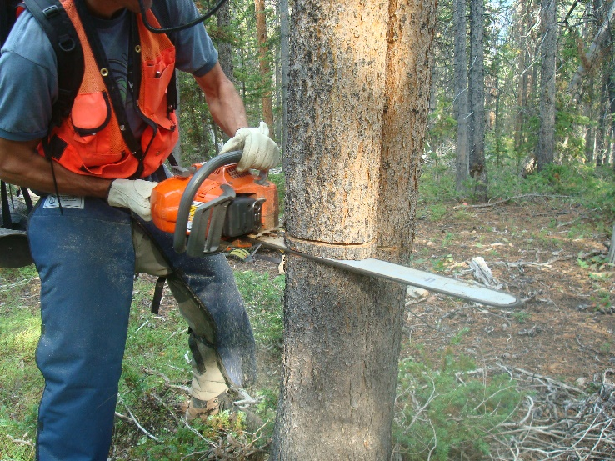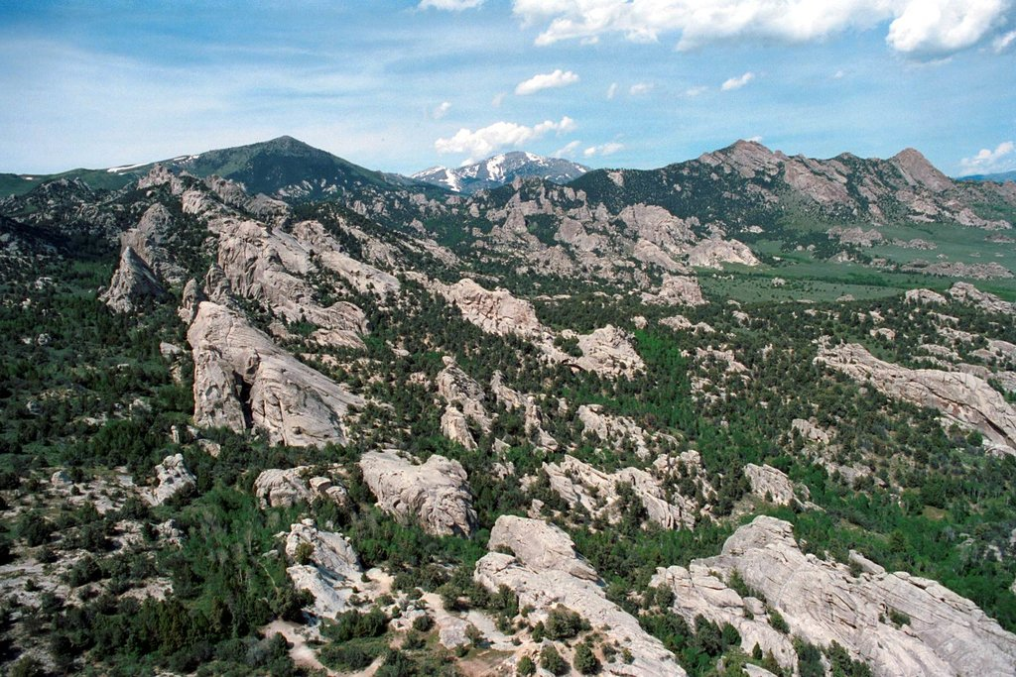

**Salary:** $12/hour with potential for up to $15 for applicants with extensive chainsaw experience

**Timeframe:** June 1-August 15

**Schedule:** 5, 80-hour work trips, consisting of 8 consecutive days of work (10-hour days), followed by 6 days off. Possibility for a 6th 80-hour trip, depending on interest and funding. During field trips, we will establish a camp near the field site and remain in the area

**Qualifications:**

* Willingness and interest in (and ideally: excitement towards) rugged and physically demanding field work
* Ability to hike for up to 10 hours per day and carry heavy wood samples in a pack across steep and uneven terrain
* Good communication skills required; willingness to address work-related concerns and ailments to foster best possible working conditions amid a small field team
* Interest in striving for a good attitude even when physical conditions become uncomfortable (e.g., rain, wind, muscle soreness)
* Ability to learn basic forest measurement techniques (including navigation by GPS, linear tape, diameter tape, hypsometer, etc) and adopt best field data collection practices
* Following all field safety protocols, particularly during chainsaw activity, and COVID-19 safety protocols in the field is required
* Active drivers’ license is required and the successful applicant must complete a USU driving safety training to drive government vehicles

**Top candidates** will have prior field experience and **ideal candidates** **will additionally have experience with a chainsaw** and interest in using one in the field to help with sampling. If you are interested in learning about subalpine forests and their disturbance processes and having an exciting summer tromping through the backcountry with every other week off to recreate in between work trips, please apply on Aggie Handshake: “Fire and Forestry Field Technician” #XXXXXXX. Applications received by April 10th will be given priority.

**Contact:** Erika Blomdahl (erika.blomdahl@usu.edu)