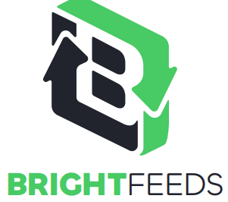

Job Description: Data Analytics and Automation Analyst
Location: Hartford Connecticut, some flexibility on working remotely
Start date: Spring 2022
Company Description:
Bright Feeds converts food waste to nutritious animal feed pellets for hogs and chickens, a market of more than 100 million tons per year, using innovative technology.

Bright Feeds is launching the first animal feed plant in the state of Connecticut and is expected to be operational in Q2 of 2022. Bright Feeds plans to roll out plants in Massachusetts and in Rhode Island over the next three years and ultimately, to expand the company nationally. The Bright Feeds plant in CT will account for only 1% of food waste in the New England region so there is plenty of room to grow both regionally and nationally.

While the conversion of food waste to animal feed has been around for a while, it is based on very old technology and is very underpenetrated. Bright Feeds has pioneering new technology that is efficient, environmentally friendly and highly profitable. There is a lot of food waste that needs to be processed – estimated that 30% of regular trash (non-recycling solid waste) is food waste. The vast majority goes to incinerators and landfill, which is extremely costly, inefficient, and polluting, contributing more than 10% of global greenhouse gas emissions. Converting food waste to animal feed saves the environment, frees up resources for human food (over 50% of arable land is used to grow feed for animals), saves money for municipalities and is quite profitable.

Role Description:
Bright Feeds is looking to hire a data analytics and automation analyst to help create and manage its processes to store/ analyze data and automate its blending processes.
Key responsibilities will include:
- Maintaining a database of food waste received including its nutrient composition so that the company can build up its data set and perform analysis
- Working with the company’s animal feed sales team to understand feed markets to include in the data set
- Analysis of company data to find ways to optimize its blending processes to increase feed revenue
- Developing algorithms based on data analysis to divert food waste to different storage bins/tanks and create blends from these bins/tanks
- Aiding in lab set up/ testing to ensure the company’s feed meets the guaranteed analysis promised to feed buyers
- Working with equipment operators based on understanding of feed market to make judgement calls on food waste blending decisions before the company’s processes are fully automated

The ideal candidate will have:
- Technical expertise: Data analysis skills and capable of developing algorithms to optimize the company’s blending processes with expertise in computational languages such as Python and Matlab
- Comfortable working near machinery: Willingness to work with plant operators to ensure optimal blending processes are instituted
- Strong communication skills: Ability to report into company management as well as interact with company operators
- Strong organizational skills: Ability to organize infrastructure that will allow the company’s data analysis/ automation capabilities to scale as the team size of the data and automation group grows

