**FISH ECO-EVOLUTIONARY RESEARCH INTERNSHIP**

We are seeking an intern to support exciting new experimental research testing how genetic drift and gene flow affect adaptation and population persistence in the face of novel environmental stressors. Led by Drs. Sarah Fitzpatrick, Jessica Judson, and Gideon Bradburd from Michigan State University and Dr. Betsie Rothermel at Archbold Biological Station, this NSF-funded research seeks to understand the impact of gene flow on the genomic rescue and adaptive potential of small, inbred populations in the face of climatic change. The intern will live and work at Archbold Biological Station in south-central Florida, where they will play a key role in initiating planned experiments with eastern mosquitofish (*Gambusia holbrooki*). The intern will also conduct independent research under the guidance of the postdoctoral researcher stationed at Archbold. The duration of the internship is approximately 7 months, with a desired start date of **March 1, 2022. We will offer some flexibility in start date for excellent candidates.**

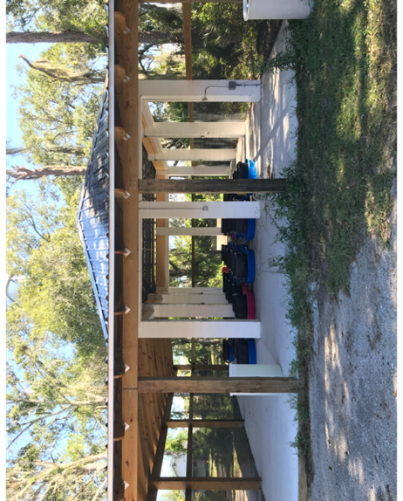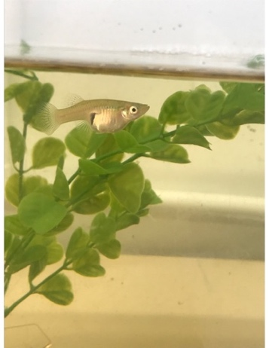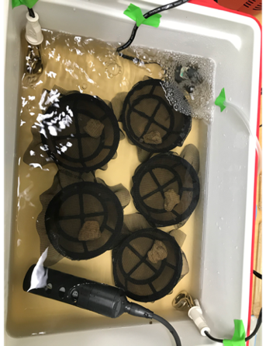

**Duties of the position include**:

* Caring for eastern mosquitofish in both indoor (laboratory) and outdoor tanks
* Conducting monthly censuses of outdoor mesocosms, including water quality monitoring
* Running lab trials to test heat tolerance of mosquitofish with different genetic backgrounds
* Assisting with set-up and maintenance of an array of large, experimental tanks
* Assisting with mark-recapture and processing of mosquitofish (weighing, measuring, elastomer marking, fin clipping)
* Participating in education & outreach activities

**Who should apply?**

Recent graduates with an undergraduate degree in **biology, environmental science, or a related field** seeking training and experience in a research setting, particularly those contemplating graduate school

**Traits of a successful intern include:**

* **Highly motivated and enthusiastic about living and working in a rural field-station setting**
* **Previous field and laboratory experience, particularly with fish; must be familiar with freshwater fish care (please specifically address your skills with fish in cover letter)**
* **Detail-oriented with respect to following sampling protocols and managing data**
* **Proactive communicator with other team members**
* **Capable of doing physically demanding work in the hot, humid subtropical climate of southern Florida**
* **Coursework in statistics, as well as familiarity with genetic methods for conservation, are also advantageous**

**Expectations**

* The intern can expect to work an average of 20 hours per week assisting with the NSF-funded mosquitofish research, typically but not always Monday–Friday.
* The remaining time will be devoted to designing and implementing an independent, field- or laboratory-oriented project related to mosquitofish biology (options include behavior, physiology, or other approved topics)
* There will be opportunities to assist with other long-term monitoring and research projects in Archbold’s Herpetology & Restoration Ecology program, as well as lead environmental education activities for children attending summer camp.
* Occasional evening and weekend hours may be required, particularly with respect to fish care.

**Benefits of an Archbold internship include:**

* Research interns receive lodging at the Station (**shared housing, no pets**) and a weekly stipend of $245
* Completion of an independent research project will hone your skills in every aspect of scientific research, from experimental design and data collection to oral and written presentations
* Interaction with accomplished research faculty, Drs. Sarah Fitzpatrick and Betsie Rothermel, who can give insight into two distinct academic paths (faculty at R1 institution and research faculty at an independent biological station, respectively), and close interaction with a postdoctoral researcher who will provide guidance on independent research and opportunities for professional development and outreach
* Experiences that will strengthen your future graduate school or job applications
* Opportunities to explore exciting Florida ecosystems and natural areas during your free time

**How to apply:**

* Applicants must have U.S. citizenship or current authorization to work in the U.S.
* Email the following (preferably as one attachment in PDF format) to Dr. Jessica Judson ([judsonj2@msu.edu](mailto:brothermel@archbold-station.org)), including ‘Intern position’ in subject line:

1) Cover letter describing your qualifications and indicating your availability

2) Current resumé or CV, including GPA and a list of relevant coursework

3) Contact information for three references, at least two of which should come from academics

* Deadline to apply is **January 16th**

Visit the Archbold website for more information on the station and internship:

http://www.archbold-station.org/

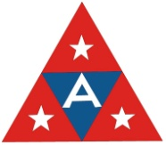Visit the Fitzpatrick Lab website for more information on the mosquitofish research: http://swfitz.com/research.php

*Archbold is an equal opportunity employer and encourages applications from*

*members of underrepresented groups*