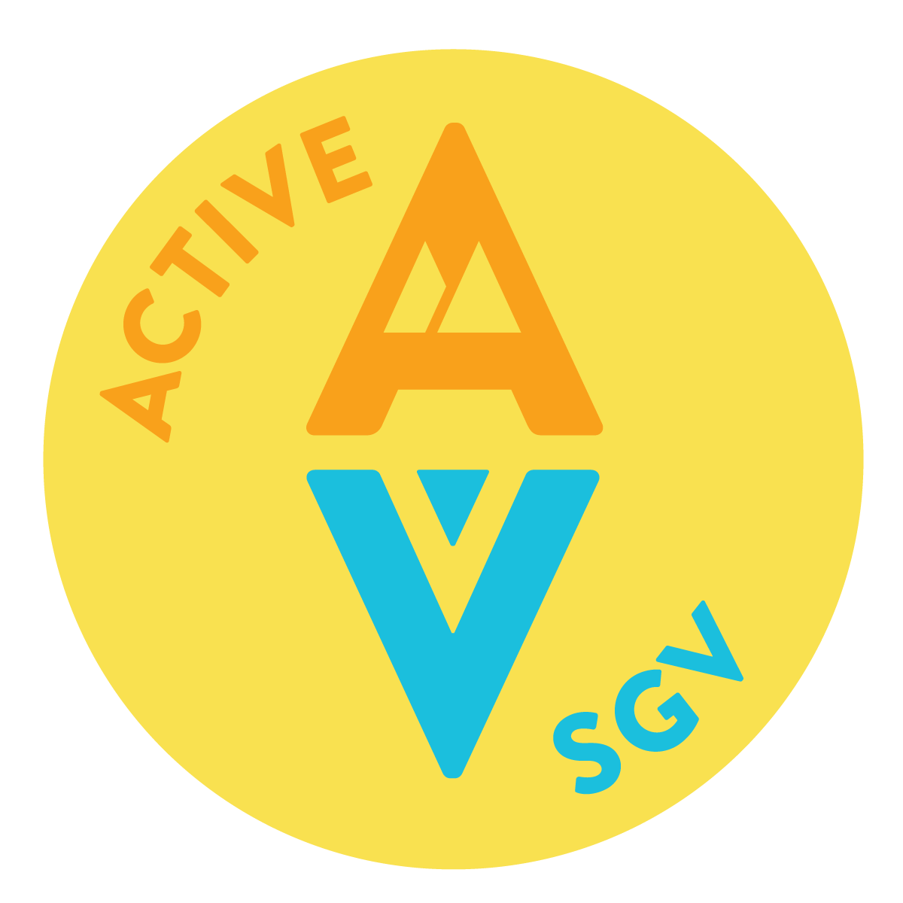
Active San Gabriel Valley
Summer 2022 Internship
Active San Gabriel Valley (ActiveSGV) is a community-based environmental justice and public health non-profit headquartered in the City of El Monte, CA. Our mission is to create a more sustainable, equitable, and livable San Gabriel Valley. We envision a San Gabriel Valley where people of all ages, incomes, abilities, and backgrounds have the opportunity to thrive. The San Gabriel Valley is stronger through the creation of quality jobs, living wages, employment mobility, a strong economy, clean water and air, accessible parks, stable and affordable housing, safe and efficient transportation, and a healthy built environment that supports sustainability. As such, ActiveSGV is committed to diversity, equity, and inclusion in our work, aiming to eliminate barriers so our communities can lead happier, healthier lives. As part of our commitment to gender equality, mental health and wellbeing, and the environment, ActiveSGV has instituted a flexible 32 hour work week for all full-time employees. We welcome people of all backgrounds and aim to maintain a culture of respect, openness, learning, integrity, honesty, and a sense of fun. For more information, visit us at www.ActiveSGV.org
Location, Housing, and Transportation
ActiveSGV is headquartered at the Jeff Seymour Family Center (10900 Mulhall St., El Monte, CA 91731) and provides programming and services across the San Gabriel Valley, a diverse sub-region of 2.3 million residents east of the City of Los Angeles. Unfortunately we are unable to provide housing at this time but can assist with locating housing and offer interns free use of a high quality Trek e-bike (or a standard bike if preferred) during their time with us.
Position Description
ActiveSGV summer interns have the opportunity to plug into a wide array of environmental justice, urban planning, healthy homes / building decarbonization, green streets / parks / open space, open streets, e-bike share, tactical urbanism, advocacy at the local/regional/state level, and other community-based projects and programs our agency leads in east Los Angeles County. Depending on specific area(s) of interest, selected interns will carry out a variety of tasks including but not be limited to conducting outreach at community events, helping plan and support agency events/workshops/classes, providing live testimony at public meetings (e.g., CA state legislature, Metro Board of Directors, Air Quality Management District), and taking on significant roles in projects and other tasks as assigned by the Executive Director.
Interns must be self-motivated, possess the ability to interact positively and effectively with colleagues, city staff, elected officials, and community members; be able to interact respectfully with people of all cultural and socioeconomic backgrounds; be willing to take public and active transit to/from events; and be passionate about the organization's mission. ActiveSGV interns have the opportunity to gain direct experience in organizing, outreach, and advocacy efforts.
Essential Duties & Responsibilities
- Enthusiastic and positive energy.
- Take on project-specific tasks that support program implementation.
- Support projects with challenging tasks that allow an opportunity for learning and professional growth.
- Help with set-up and break-down of special events.
- Work well in a team environment and communicate effectively.
- Respect and maintain the confidentiality of ActiveSGV’s volunteers, employees, partners, and donors.
- Other duties specifically around coordination of special events, or as assigned.
Preferences
- Flexible schedule; must be available some nights and weekends
- Be enrolled in a community college or university
- Bilingual (Spanish, Vietnamese, Cantonese, Mandarin)
Requirements & Time Commitment
- Must present a professional appearance and a friendly manner
- Must be dependable and punctual
- Be courteous and personable when dealing with colleagues and community members
- Be self-directed, willing to take initiative, and detail-oriented
- Respect and maintain the confidentiality of ActiveSGV volunteers, partners, and donors
- Computer skills and basic experience with Google Drive, Canva, SurveyMonkey
- Must be able to commit a minimum of 10 hours per week, 100 hours total, within a 6 month period (May - October)
Compensation & Benefits
- This internship position is unpaid.
- Environmental justice, public health, and active transportation work experience.
- Letters of recommendation.
- ActiveSGV T-shirts, stickers, and swag.
- Free entrance to special SGV and Los Angeles County events.
- FREE BIKE FROM THE SGV BIKE CENTER
- Free E-bike usage
- Knowing you helped create a better San Gabriel Valley!
How to Apply
Please submit a cover letter and CV via email (wes@activeSGV.org) to Special Programs Director Wes Reutimann by March 1, 2022.

