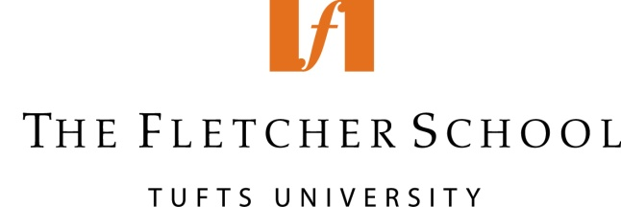

Spring Break Study Trip to Moscow

Program Summary

Dates: March 15-25, 2018

Participants: 15 Fletcher master’s students, with priority given to current students in the course “Contemporary Issues in U.S.-Russian Relations”

Application Process: Submission of cover letter and resume, December 5, 2017

Funding: Fletcher will cover flights, hotel, and a per diem for expenses

Program: The program will consist of three main parts:

- Policy Workshop with MGIMO University Students

Fletcher students will work with 15 MGIMO University master’s students to jointly study two contemporary issues in U.S.-Russian relations: cyber security and the North Korean crisis. Over the course of four days, the students will then work together to prepare jointly a policy proposal for the United States and Russia to address both issues.

- Meetings and Guest Lectures with Russian Experts

Fletcher students will participate in meetings with Russian academics, think-tank experts, and government officials. Fletcher students will have the opportunity to help design the agenda for meetings and guest lectures.

- Cultural and Historical Events

The program will include several cultural events and visits to historical sites (e.g., the Kremlin) to introduce participants to Russian culture and history. Student participants will also have input on the schedule of cultural and historical events. Participants will also have free time to experience Moscow.

