Using MATLAB: How to install MATLAB on your personal computer and getting started
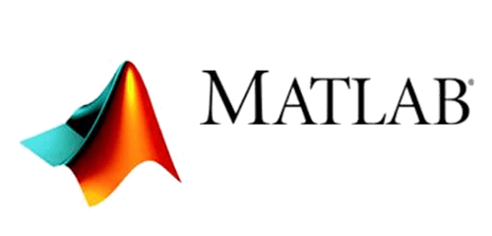

Written by Kyle Monahan on October 8th, 2019

Introduction
MATLAB is a statistical programming and software, developed by MathWorks. In this tutorial, we will provide instructions for installing MATLAB and getting started with learning about the program. MATLAB is available in computer labs such as the Data Lab for use by the Tufts community. If you would like it on your personal or Tufts-owned computer, you will need to purchase a license.

For up-to-date information on MATLAB, see the Access Tufts article: https://access.tufts.edu/matlab

Installing MATLAB on a Tufts-owned or personal computer
To install MATLAB, you can purchase a license.

- Go to the Tufts MathWorks Login Page
- Log in with Tufts Username and Tufts Password
- You will be redirected to either create a MathWorks Account or to log in to your MathWorks account
  - Create A MathWorks Account
    - Complete the requested fields in the Account Creation page (User ID is optional). Do not use your Tufts Password when creating a MathWorks account
    - Click Create
    - You will be redirected to the software download page
- Or log in to Your MathWorks Account. You will then be redirected to the software download page
- Need help getting started? Check out MATLAB Onramp to learn MATLAB in just 2 hours. https://www.mathworks.com/learn/tutorials/matlab-onramp.html

Use MATLAB on the research cluster
MATLAB is available on the research cluster. You can request a cluster account by going to research.uit.tufts.edu and submitting the application form.

Before accessing MATLAB on the cluster, please contact Tufts Technology Services at 617-627-3376 or it@tufts.edu for an assessment of whether or not your computer’s display meets MATLAB X-Windows support requirements. On occasion, the TTS Service Desk may need to make configuration changes for compatibility.

Learning MATLAB
To get started with MATLAB, take a look at the following links:

- Getting Started: For getting started check out the MATLAB tutorials (be sure to login as above):
https://www.mathworks.com/services/training.html

- Online Training: In addition, we have access to tutorials from Tufts Lynda campus (now LinkedIn Learning):
  - Learning MATLAB: https://www.linkedin.com/learning/learning-matlab-2/welcome?u=2193697
  - MATLAB 2018 Essential Training: https://www.linkedin.com/learning/matlab-2018-essential-training/use-matlab-for-data-calculation?u=2193697

- Tufts Data Lab: Recordings and instructional materials on similar statistical software are available on the Tufts Data Lab website: https://sites.tufts.edu/datalab/learning-statistics/stats-online-tutorials/

- Further Questions: Reach out to Kyle Monahan, Senior Data Science Specialist anytime with questions on how to access and use MATLAB for your research project: DataLab-Support@elist.tufts.edu

