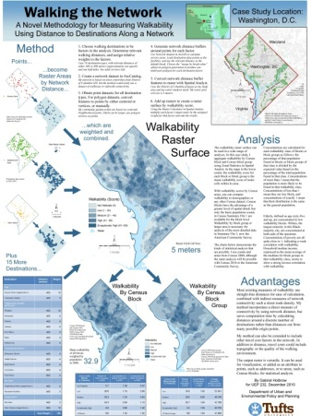
Designing and Creating your GIS Poster
Revised 12/4/2014

First think about your audience and purpose then design your poster! Here are instructions for setting up your poster using MS Publisher. There are also instructions for converting your Publisher file to a PDF for printing by a Lab Assistant. This can be done in the GIS lab if you have an account, or the lab assistant can help you.

Using MS Publisher
Your poster size should be 30”x40”. It can be landscape or portrait orientation, whichever you think is best. But tell Publisher that the orientation is PORTRAIT regardless – if you want the poster to be in Landscape mode, leave it set to Portrait, but set the WIDTH=40 inches, and HEIGHT=30 inches and the result will be a landscape oriented poster)

Launch MS Publisher: Start > All Programs > Microsoft Office > Publisher

Setting up document size and orientation
- Once you open the program, you will be in the File – New window to define the size of your document. Choose More Blank Page Sizes

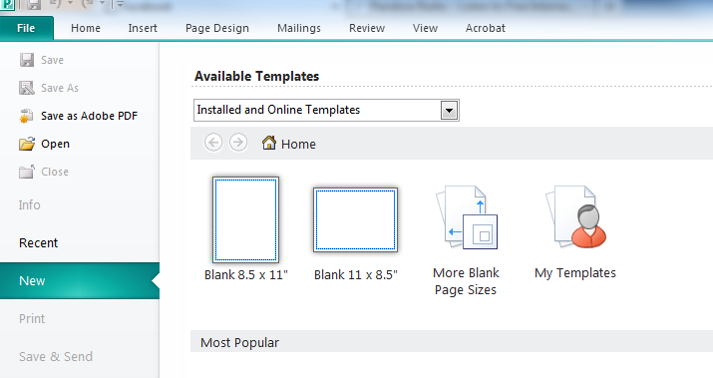
- Under Custom, click on Create New Page Size
- Set width and height: for a landscape-oriented poster, set width to 40 inches, height to 30 inches; opposite for Portrait-oriented posters. Leave orientation to PORTRAIT regardless. Then press OK

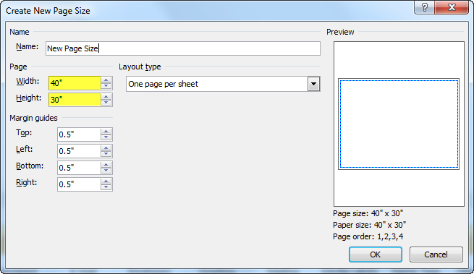

- Click twice on the New Page Size icon for the 40” x 30” page size you just created. This will open a new document.

Setting up columns
- Go to Page Design tab and click on Guides to see the options window.
- Then click on Grid and Baseline Guides to open the Layout Guides box.

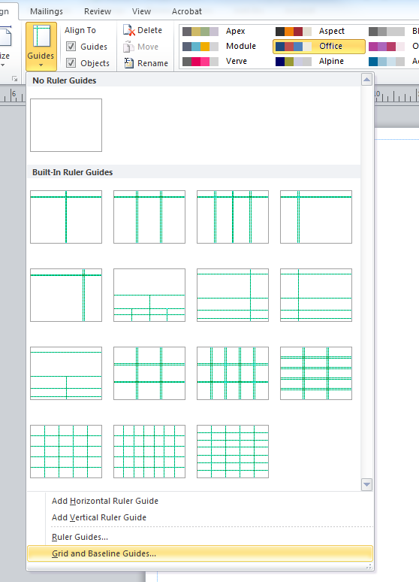

- Go to Margin Guides: Use 0.50” all around (leave Two-page master unchecked)

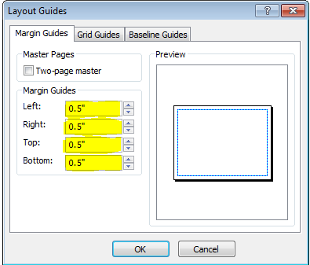

- Then under Grid Guides> Columns, choose 12, and set the spacing at 0.75” (if it's grayed out, click first on the “Rows” box below it).Then click OK

Save! (to your H: drive or USB) Save every few minutes as you create your poster!

Adding text to your poster
You can write all the text for your poster in a Microsoft Word document ahead of time. Then, when you are ready, you can simply insert the text file by following the instructions below. This is easier than creating multiple text boxes on your poster and trying to type it in there.

- Create 3 text boxes that span the length of the columns (click on the draw text box tool, pictured above.)

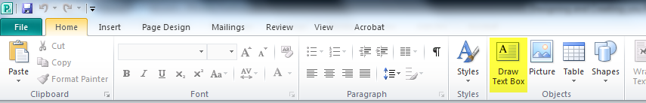

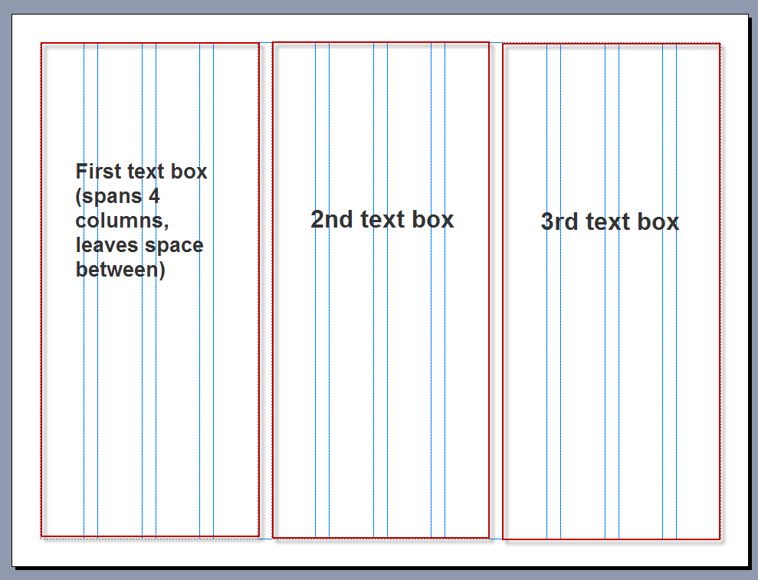

- To add text into the first text box, you first place the cursor in the text box and select Insert file (for example, “My poster content.doc” found in S:\GIS Poster Workshop\Exercise files folder)

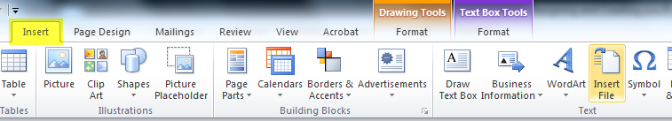

- To link text boxes together, so that text flows from one into the next, click in the text box you want to be the first text box on your poster. Then in Text Box Tools: Format click Create Link. A pitcher will appear, then click in the text box you want as the next one on your poster.

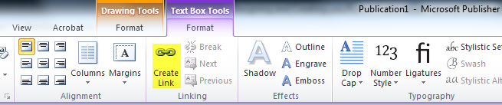

- Now make the font size a more appropriate size for a poster (At least 22pts for text; larger for headings and titles – see the Fontsize.doc example in S:\GIS Poster Workshop)
  - Select the text as you would in Microsoft Word
  - Change the font size to 22 pts

Adding images to your poster
- Go to Insert -Picture from file icon

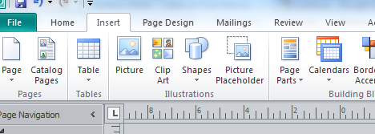

- Select image; it will be inserted into your publisher document.
- Right click on the image and choose Format Picture…then go to Layout tab

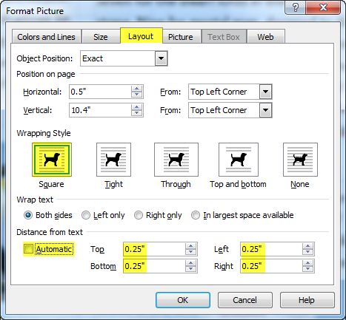

  - In Wrapping style select square
  - Then define the distance from text: uncheck “Automatic” and enter a distance, 0.25 on all sides is a good starting distance.

Adding title and captions to your poster, maps, tables or other graphics
This works for any type of text you wish to add (title, captions, etc). Create a text box and add text. It should wrap other text around it automatically, but if it doesn’t, you can right-click on it and go to “Format Text Box” and change the Layout options the same as you did for pictures.

Tables
You have a few options with tables. You can:
- Copy and paste them from Word or Excel through Insert File described above.
- Insert Table from the Insert toolbar, and then either enter the table values directly or copy them from Word or Excel.

Whichever option you choose, because your poster is so much bigger than a normal page, the size of the table will probably be too small. You can drag the edges to make it the right size.
- Remember to increase the font size within the table as necessary by selecting all the cells in the table (drag cursor from one corner to the other) and changing the font size.
- To format the table, select the table, right-click on it and choose Format table. If text isn’t wrapping around the table already, set the layout options as with pictures above.

Note: you can also use Snag-it to add a table to the poster as a graphic, but then you won’t be able to format the content of the table.

Formatting text
- Go to the Text Box Tools: Format tab to format a header. Highlight the text, then change color, size and style.
- To apply the same formatting to another header, right-click on the formatted header, and in the formatting toolbar that pops up, click on the Format Painter icon (). Then highlight the other header to “apply” the style.

Using the Tufts logo
If you wish to put the Tufts logo on your poster, please use one of the official logos – you can get these from the S: drive under S:\GIS Poster Workshop\Tufts Logos or online from http://publications.tufts.edu/brand-guides-and-logos/download-logos/

Required for all posters:
Your name
Data source and date citations
Date of poster
Class

After Finishing Your Poster…

Converting to PDF
The easiest way to do this is to go to File > Save As.
In the save as box, enter the name of your file. Then, change the “Save as Type” to PDF (.pdf). Once you hit save, the poster should open as a pdf. This should have all the proper size information.

Note: Make sure to closely look over your document. Sometimes, things shift when you save as a pdf.
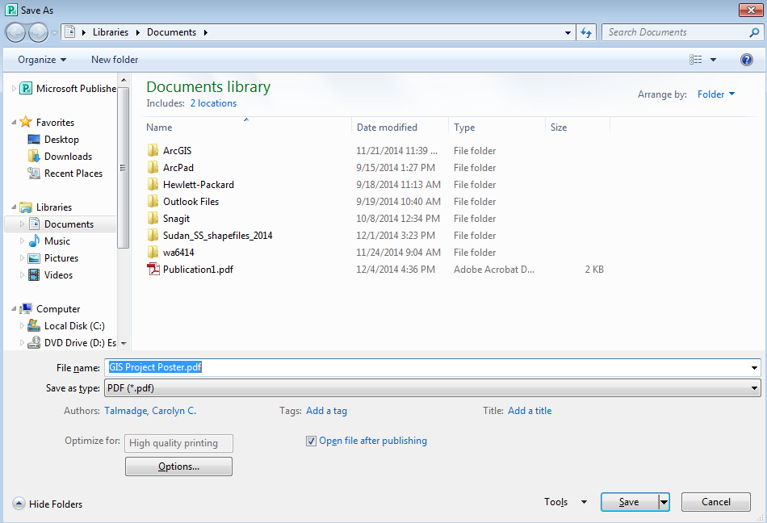

IF things do happen to move or look incorrect, you can use this method for saving as a PDF:
First, go to the File tab and click Print on the left column. Under the Printer heading, select from the dropdown menu “Adobe PDF” if it is not already chosen. Then directly below to the right, click “Printer Properties.” This should open the Adobe PDF Document Properties window. On the Adobe PDF Settings tab, there will be a button on the right “Add.” Click “Add” and replace the Paper Names field with “GIS Poster.” Change the height and width to your 40 inches x 30 inches dimensions. Then click “Add/Modify” and click “Ok” to the Adobe PDF Document Properties window. Under the Settings heading below Printer, there should be another dropdown menu with “Letter” or another page size selected. Choose “GIS Poster” from this dropdown and then change the above “Tiled” dropdown to “One page per sheet.”

Next, go to the Acrobat tab and click on Preferences and then Advanced Settings. Under “Default Page Size” enter 40 inches Width and 30 inches Height. Then, on the left-hand side of the screen choose Images. Under Color Images and Grayscale Images be sure the pull-downs are set to “Off.” Press OK and Save.
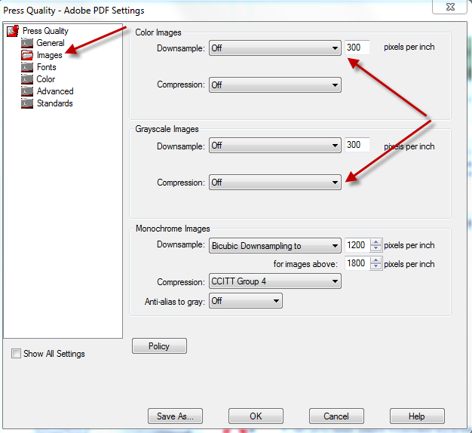

Next, still in the Acrobat tab, choose Create PDF. Enter a location and name for your document.

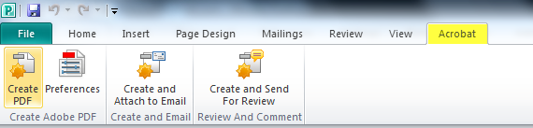

After PDF creation, the PDF will automatically open in Adobe Acrobat. Preview the PDF making sure everything looks good. If some of the linked images do not appear in the PDF, go back to the Publisher document and check the properties of the problematic image, possibly deleting and re-adding the image. Then generate the PDF again.

Give your PDF file to a lab assistant for plotting using a USB flash drive.

Troubleshooting
If you get an error message that the PDF printer is small causing pages to be split, Cancel and follow the directions below.
- In Publisher, choose File-Print
- Set the Printer as Adobe PDF
- Set the Paper Size to PostScript Custom Page Size, then click on the Properties button
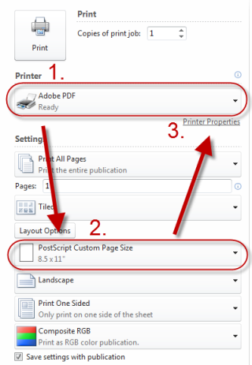

Go to the Layout Tab and click Advanced
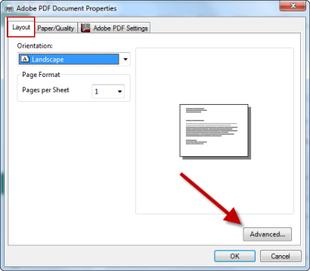

Click on Edit Custom Page Size
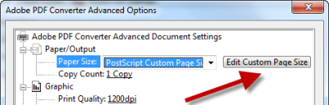

Set the page size to 40x30:

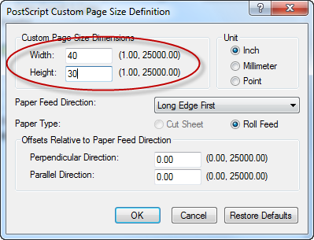

Click OK all the way back to the original print screen.

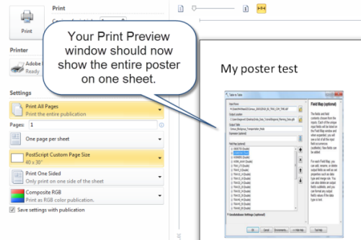

Now, go back to the Acrobat Toolbar, and click Create PDF again. If you still get the error message, change the portrait/landscape setting under the File-Print window and try again.
