Best Practices for Installing Windows and ArcGIS on a Mac Operating System (OS)
February 15, 2017

Introduction
ArcGIS Desktop is configured to run on a Windows Operating System, and does not support ArcGIS software installed directly onto the Mac Operating System (OS). However, it is possible to install Windows as a separate operating system on a Mac through the use of a non-virtualized or virtualized environment, and therefore run ArcGIS Desktop. There are a two primary methods for running Windows on a Mac:
- Boot Camp -Apple’s pre-installed multi boot utility. Users can use this non-virtualized environment on a mac to install Windows OS and ArcGIS Desktop. Boot Camp allows users to boot the Mac into either the Windows or the Mac OS. It does not allow the operating systems to run simultaneously; you much choose one or the other.
- Virtual Machines using Parallels or VMware Fusion. These are third party software’s which allow Windows to run simultaneously with the Mac OS. Both systems are able to be active at the same time, unlike boot camp.

Which option is best for me?
This really depends on the type and amount of analysis that will be performed and how the user would like to interact with the Mac OS.
Parallels or VMware Fusion work better for light analysis and simple data visualization, due to the fact that there is less processing power and memory available to run ArcGIS in conjunction with the Mac OS. This has the benefit of being able to switch between the Mac OS and Windows OS in a single session, but does not allow for robust analysis due to the fact that the memory and processing resources are split between the two systems.
Pros | Cons
Users can switch between the Mac and Windows Operating Systems in a single use. | Memory and CPU resources are split between operating systems, which will result in slower processing speeds than Boot Camp
Files can be easily shared between Mac and Windows applications | Not ideal for large datasets or intensive analytical processes
Utilizes all free HD Space | Purchase Required (Tufts students, see OnTheHub)  Parallels – see website for current prices. Currently $79.99  VMware Fusion - see website for current prices. Currently $49.99
Does not require a permanent HD partition
Allows copy & paste between Windows and Mac OS
Allows users to move files between systems

Bootcamp is a better choice for users who require the full processing power of ArcGIS because the user boots into only one operating system at a time. However, this means that they are not able to flip between the Mac and Windows operating systems in a single use, but they are able to utilize the full memory and processing power for intensive analysis and larger datasets.
Pros | Cons
Free and pre-installed utility on all Macs since 2007 | Requires a dedicated, semi-permanent HD Partition
Windows and ArcGIS will run at “full speed” | You must decide in advance how much HD memory to give Windows and ArcGIS
OS has access to all hardware and memory during one single session | Requires user logs off one OS before booting into the other OS
Access to partition and its files in either mode. You can copy and move files, but will not be able to directly copy and paste content saved on your Mac to your Windows. | Files not easily shared between the two OS
Allows copy & paste between Windows and Mac OS
Allows users to move files between systems

Check System Requirements
Regardless of which method you choose, you must first determine whether your computer meetings the minimum requirements for installing ArcGIS Desktop. Then you must determine whether it meets the requirements for either method of running Windows OS.
To check your Mac system info, click on the Apple icon in the upper left corner of your screen and select “About this mac”. To determine HD Free space, right click on the Storage tab to view available hard drive space.
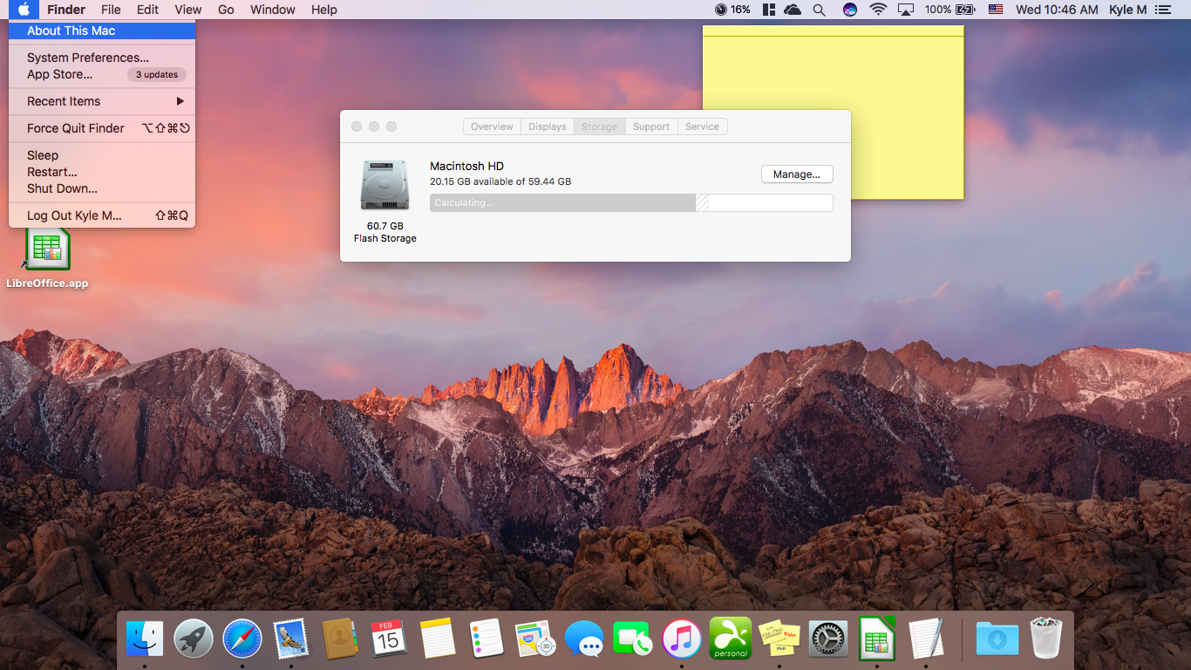
ArcGIS Desktop 10 min requirements:
http://resources.arcgis.com/content/arcgisdesktop/10.0/arcgis-desktop-system-requirements
- CPU Speed 2.2 GHz minimum or higher; Hyper-threading (HHT) or Multi-core recommended
- Processor Intel Pentium 4, Intel Core Duo, or Xeon Processors; SSE2 (or greater)
- Memory/RAM 2 GB or higher
- Display Properties 24 bit color depth
- Screen Resolution 1024 x 768 recommended or higher at Normal size (96dpi)
- Swap Space Determined by the operating system, 500 MB minimum.
- Disk Space 2.4 GB
In addition, up to 50 MB of disk space may be needed in the Windows System directory
(typically C:\Windows\System32). You can view the disk space requirement for each of the 10.0 components in the Setup program.

Windows 7 min requirements in Boot Camp 4.0:
http://support.apple.com/kb/HT1899
- OSX v10.7 Lion or Mac OS X v10.6 Snow Leopard & Boot Camp 3.1 Update
- 55 GB of free disk space on startup drive

Windows 7 min requirements general:
http://windows.microsoft.com/systemrequirements/
- 1 gigahertz (GHz) or faster 32-bit (x86) or 64-bit (x64) processor
- 1 gigabyte (GB) RAM (32-bit) or 2 GB RAM (64-bit)
- 16 GB available hard disk space (32-bit) or 20 GB (64-bit)
- DirectX 9 graphics device with WDDM 1.0 or higher driver

VMware Fusion min requirements:
http://communities.vmware.com/docs/DOC-17096
- Any 64 bit capable Mac
- 2gb of RAM (4GB of RAM for Fusion 8.0 Pro)
- 750mb of HD space for VMware Fusion & 5GB for ea. virtual machine
- Mac OSX 10.6.7 or later; OS Lion recommended

Parallels min requirements:
http://www.parallels.com/products/desktop/system-requirements/
- A Mac computer with an Intel Core 2 Duo, Core i3, Core i5, Core i7, or Xeon processor.
- Minimum 2 GB of memory (4 GB of memory is recommended to run Windows 7 in a virtual
- machine or if your host OS is Lion)
- About 500 MB of disk space on the boot volume (Macintosh HD) for Parallels Desktop installation.
- About 15 GB of disk space for each virtual machine.
- Mac OS X Mountain Lion 10.8
- Mac OS X Lion 10.7
- Mac OS X Snow Leopard 10.6.8 or later
- Mac OS X Leopard v10.5.8 or later
- Note: Mac OS X Tiger v10.4.x is not supported in this version of Parallels Desktop.

Accessing Software (Windows, Parallels & VMware Fusion) for Tufts University Students & Faculty at a Discounted Price
If you are a part of the Tufts community, it is possible to access Windows Operating System (and other softwares including Microsoft Suite, Adobe, SPSS, etc) for a significantly discounted price at Tufts’ On The Hub Webpage.
- Go to Tufts’ On The Hub Webpage and click on Sign In at the upper right hand corner.
- Log in with your Tufts Username (UTLN) and Tufts Password.
- If you are a student, click on the Student tab. If you faculty/staff, click on the Faculty/Staff tab.
- Navigate to the software of your choosing or search by the software.
- Choose the version of Windows which you would like to install. For students, click on Microsoft. There you can “purchase” a copy of the Windows OS for free. Add it to the cart and check out. The website will give you a key.
- Go to Microsoft’s website to download the Windows disc image from the link below: https://www.microsoft.com/en-us/software-download/vlacademicISO
- It will prompt you to enter the product key that On the Hub provides, then you’ll be able to download the ISO.
- If you are using Boot Camp, save the ISO on to a USB.
- If you will be using VMware or Parallels, download one of the softwares as well and follow the directions for installation.

Using Boot Camp on your Mac OS to Install Windows OS

Check System Requirements - Some versions of Windows require a certain processor, and more hard drive space and memory (RAM) than others. Check the documentation that came with your copy of Windows to find out what you need. Then use System Information to see what your Mac currently has.

Get a Windows disk image - When you purchase Windows, it comes as a disk image file (ISO) that you download, or as an installation disc or USB flash drive. If your copy of Windows came on a DVD, you should create a disk image of it to work with Boot Camp. If your version of Windows came on a USB flash drive, you can download an ISO from Microsoft.

If you are a Tufts University Student, you can access a free version of Windows (and other softwares). See the above section on Accessing Software for Tufts University Students and faculty/staff.

Open Boot Camp Assistant - Boot Camp Assistant guides you through installing Windows on your Mac. Open this app from the Utilities folder in the Applications folder and follow the onscreen instructions to automatically repartition your startup disk and download related software drivers for Windows. If you're prompted during installation, connect a blank USB flash drive.

Format your Windows partition - When you complete the assistant, your Mac restarts to the Windows installer. When you're asked where you want to install Windows, select the BOOTCAMP partition, then click Format.

Install Windows - Follow the onscreen prompts to finish your Windows installation.

Restart your computer -After Windows is installed, you can switch between OS X and Windows. Use the Startup Disk preference pane in OS X, or the Boot Camp system tray item in Windows to select your startup disk, then restart your computer. You can also hold down the Option key while restarting to view the Boot Camp selection menu, and select which OS to boot.

Using Parallels on your Mac OS to install Windows OS

Check System Requirements - Some versions of Windows require a certain processor, and more hard drive space and memory (RAM) than others. Check the documentation that came with your copy of Windows to find out what you need. Then use System Information to see what your Mac currently has.

Download Parallels along with Windows -If you are a Tufts University Student, you can access a free version of these softwares. Accessing Software for Tufts University Students and faculty/staff.

Follow the prompts for installing Parallels or VMware.

Once installed, open Parallels Desktop (in the Applications folder).

Choose File > New. If you have a Windows installation disc, insert it into the DVD drive. If you have a USB storage with Windows, connect the storage to the Mac.

Click Install Windows or another OS from a DVD or image file. Parallels Desktop scans for and lists installable operating systems. If you see the version of Windows you want to install, select it, click Continue and go to step 8.

If the Windows installation source didn't show up automatically in Step 6, click Locate manually to browse for it manually. You can browse from the following sources:

DVD: If you have a Windows DVD, insert it into the DVD drive. Once Windows is detected, click Continue. If your Mac doesn't have a DVD drive, you can use an Apple SuperDrive, another Mac's DVD drive via Remote Disc, or make an image from the disc.

Image File: If you have a Windows image file, click Image File and drag the image to the Parallels Wizard window. Once Windows is detected, click Continue.

USB Drive: If you have a bootable USB installer with Windows, click USB Drive and connect the drive to the Mac. Once Windows is detected, click Continue

Note: Parallels Desktop may fail to detect some operating systems (for example, the latest Linux distributions). If this happens but you're sure that the operating system can be installed, click Continue, specify the OS type manually (if it's not listed, choose Other), and follow the onscreen instructions.
- Be sure to leave Express installation selected.
Note: If you deselect Express installation, you'll need to install Parallels Tools after the installation to allow the most seamless operation between Windows and Mac OS X.
- If you are installing a recent version of Windows, select how you want to use Windows:
  - Like a Mac: Windows programs appear on the Mac desktop, just like Mac applications. Documents and media from Mac OS X and Windows are kept together on your Mac.
  - Like a PC: The Windows desktop and programs appear in a single window, separate from Mac applications. You can drag and drop objects between Windows and the Mac.
- If you are installing Windows 8, select how you want it to work:
  - Like Windows 8: Windows 8 boots to the Start screen and Windows 8 applications run in full screen only.
  - Like Windows 7: Windows 8 boots to the desktop, Windows 8 applications run in resizable windows, and the Start menu is available.
- Choose where you want to store Windows from the Location menu.
By default, Parallels Desktop stores Windows in your Documents > Parallels folder. To allow all users of your computer to have access to this installation of Windows, select Share with other users of this Mac.
- If you want to pre-set things like how much memory Windows uses or whether it starts automatically when you open Parallels Desktop, select Customize settings before installation. You can also adjust these settings after the operating system is installed.
- Click Continue. The assistant installs Windows.
- Once Windows is installed, you can start it up by opening a Windows program or by clicking the power button in the Parallels Virtual Machines list.
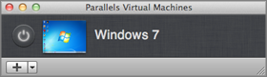
When you install Windows, Parallels Desktop creates an administrator account with a blank password. Once the installation is complete, it is recommended that you change this password.

Using VMware Fusion on your Mac OS to install Windows OS

Check System Requirements - Some versions of Windows require a certain processor, and more hard drive space and memory (RAM) than others. Check the documentation that came with your copy of Windows to find out what you need. Then use System Information to see what your Mac currently has.

Download VMware Fusion, along with Windows -If you are a Tufts University Student, you can access a free version of these softwares. Accessing Software for Tufts University Students and faculty/staff.

Follow the prompts for installing VMware Fusion. Enter your serial number. If you do not have a serial number, click Get Serial Number to go to the VMware Web site, where you can license VMware Fusion and get a serial number.

Once installed, open VMware Fusion by going to Applications and double clicking on VMware Fusion or using Spotlight search.
- From the Virtual Machine Library window, click the New button or choose File > New. The New Virtual Machine Assistant launches.
- In the Introduction panel, click Continue.
- In the Operating System panel, select an operating system and version for the new virtual machine.
- In the Name panel, enter the name for the virtual machine in the Save as field. By default, the virtual machine will be saved in your /Documents/Virtual Machines folder. To browse for a different location, select Other from the Where field.
- In the Virtual Hard Disk panel, set the maximum size for the virtual hard disk. The Advanced Disk Options section provides the following choices:
  - Allocate all disk space now – This option gives somewhat better performance for your virtual machine. However, if you allocate all the disk now, you will not be able to use the VMware Tools shrink disk feature later. Allocating all disk space now is a time-consuming operation that cannot be canceled, and requires as much physical disk space as you specify for the virtual disk
  - Split disk into 2GB files – Select this option if your virtual machine will be used in a hard drive with a file system that does not support files larger than 2GB. 
  - Use an Existing Virtual Disk – Select this option to use an existing virtual disk. Enter the existing virtual disk (.vmdk) file, including the path, or click Choose to browse for the file.
- In the Windows Easy Install panel, select Use Easy Install.
  - Enter your Name, Password (optional) and Windows Product key. The entry in the Name field is displayed in information boxes as the name your Windows software is registered to. It is not the Windows user name. The entry in the Password field is the password for the windows administrator account only. The Product key is not provided by VMware. It is on the sticker attached to the packaging for the Windows operating system CD-ROM.
  - Select Make your home folder accessible to the virtual machine to have Windows Easy Install configure your home folder as a shared folder, so you can share files between the virtual machine and your Mac.
  - Select whether the virtual machine can Read only or Read & Write.
- In the Finish panel:
  - Leave the option Start virtual machine and install operating system now selected.
  - If you are installing Windows from an installation disc, put the disc in your Mac CD/DVD drive and select the option Use operating system installation disc.
  - If you are installing from a disc image file (.iso), select the option Use operating system installation disc image file, and browse to the file. To do this, go to Virtual Machine > CD/DVD (SATA) > Choose Disk or Disk Image.
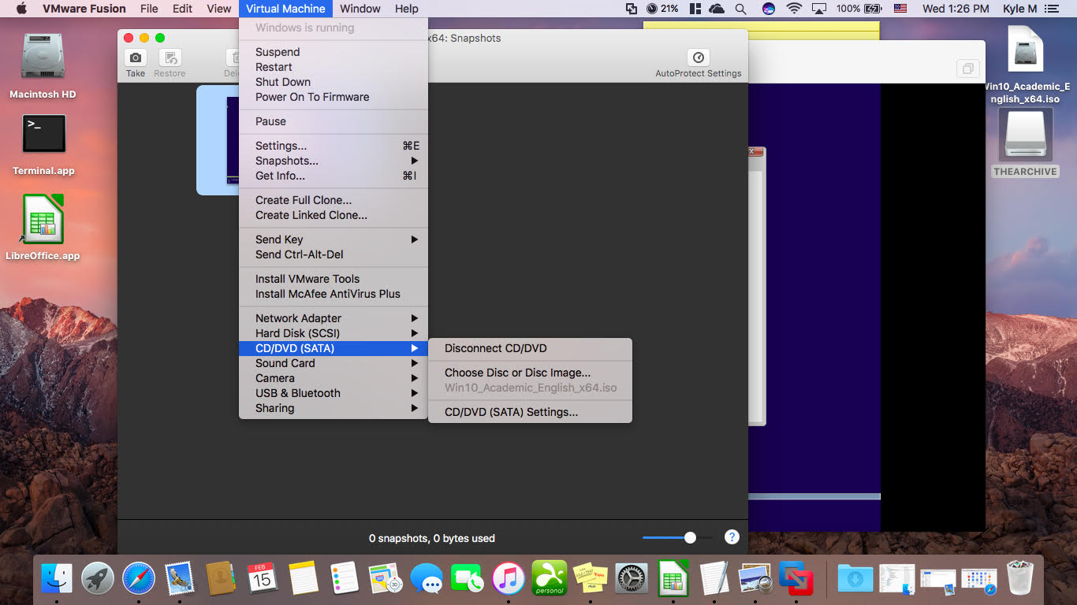
- Click Finish. VMware Fusion installs Windows. This can take up to 45 minutes. After installing Windows, VMware Fusion installs VMware Tools, and powers on the virtual machine.

Installing ArcGIS
Once you have an operating system with Windows installed, you are able to download ArcGIS Desktop.
Follow the directions on the GIS.Tufts.edu website for installing ArcGIS: https://sites.tufts.edu/gis/gis-software/licensing-and-acquisition/

