Uncompressing .exe Files on Data Lab Computers (e.g., from MassGIS)

Note: Tufts has most of the MassGIS data library on it’s M: drive GIS data server under M:\State\MA\MassGIS, so you should not normally need to download MassGIS data unless you need an updated or new data set that is not on our server. But if you do, please follow the instructions below carefully!

- Use Mozilla Firefox for downloading GIS data sets (this process will NOT work with Internet Explorer!)
- When downloading the data set, choose the option to SAVE FILE

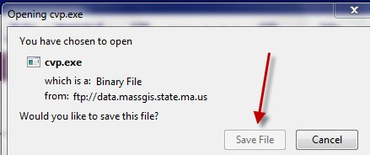
- In the Downloads interface, right-click in the BLUE area and choose Open Containing Folder:

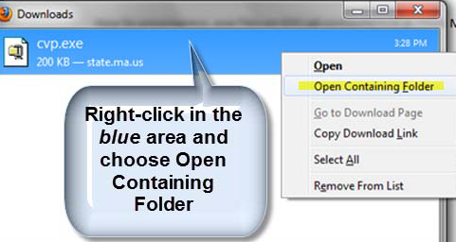
- That will take you to the Downloads folder. Right-click on the EXE file and choose your Extract option (In case you don’t have that option go to step 5).

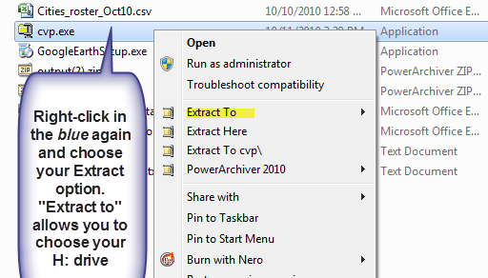
- Some exe files will give you the option Compress to instead of Extract to. In that case click on the
Power Archiver 2011 option.

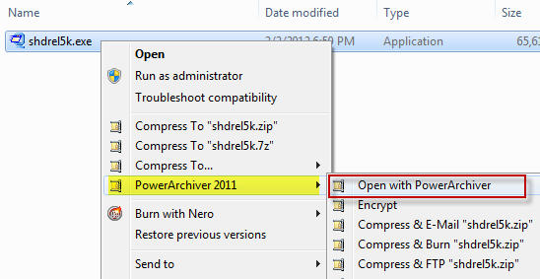

The Power Archiver window is now open, and you can choose your Extract option (don’t just click on one file – make sure all files are selected).

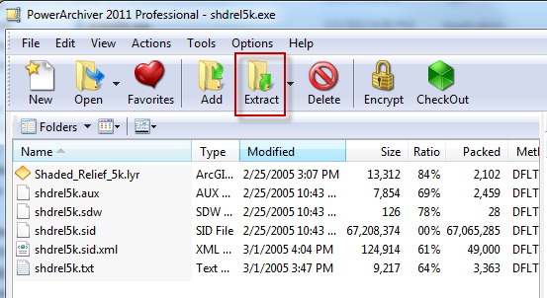

You will be prompted for where you want to extract the data – you can navigate to your personal drive and create a new folder as needed.

