ArcGIS 10.7.1 Student Editions: Digital Download Instructions
Revised August 28, 2019

Installing ArcGIS Desktop 10.7.1 Digital Distribution Student Edition
You will need to have received a student software key code. You may request one by emailing the DataLab-support@elist.tufts.edu. Support for the ArcGIS Desktop Education Edition is available at http://esri.com/evalhelp.

Before Installing ArcGIS for Desktop:
- Check the system requirements to make sure your computer has the hardware and software required.
  - ArcMap requires Microsoft .NET Framework 4.5 and Microsoft Internet Explorer version 9 or newer. Before running the installation program for ArcMap, ensure that your machine meets these prerequisites. The install guide provides an overview of installing and setting up ArcMap and links to detailed resources, including system requirements.
  - ArcGIS Pro requires Microsoft .NET Framework 4.5.1 and Microsoft Internet Explorer version 10 or newer. Before running the installation program for ArcGIS Pro, ensure that your machine meets these prerequisites. The Install Guide for ArcGIS Pro provides an overview of installing and setting up ArcGIS Pro and links to detailed resources, including system requirements.
- If you have ArcGIS version 10.1 or later installed, you do not need to uninstall it before installing a later version of 10.x; the ArcGIS setup package will detect and upgrade your software.
- If you have ArcGIS version 10.0 or earlier installed, please uninstall it using the Uninstall Utility (download below) before installing the newer version.

Set up your ESRI Account
- First, you will need to activate your Enterprise Login for ESRI.Com. Go to www.esri.com
- Press Sign In in the upper right hand corner. At the bottom of the sign in box, click the link for “Sign in with ENTERPRISE LOGIN”.
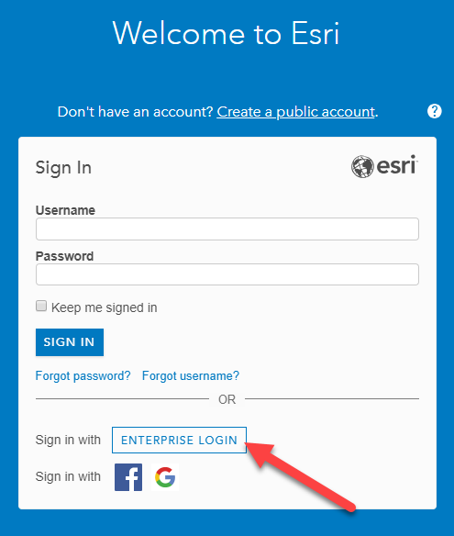
- Enter tuftsgis in the text box so the full domain reads “tuftsgis.maps.arcgis.com” 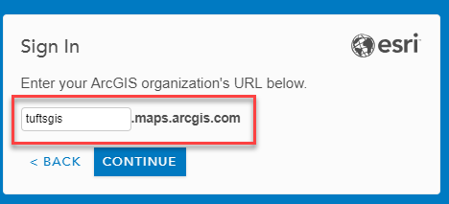
- Click the option that says: Sign in to Tufts University Using: TUFTS UNIVERSITY. Use your Tufts UTLN and current password to login. (UTLN Ex: Asmith01). Press Log in.
- Note: You will receive an error that you do not have ESRI access enabled and that you need to contact your administrator. Wait 5 minutes and then log in again and proceed with the next set of directions. Your permissions will be updated during this 5 minute period. If you still receive the error after 20 minutes, please email DataLab-Support@elist.tufts.edu and mention you need your ESRI Access Enabled to download the software.

Activate your Authorization Code
- Visit http://www.esri.com/EducationEdition
- Click on I have an ESRI Account. You will use an account that is connected to your Tufts UTLN.
- At the bottom of the sign in box, click the button for ““Sign in with ENTERPRISE LOGIN”.
  - Once again, enter “tuftsgis” in the text box so the full domain reads tuftsgis.maps.arcgis.com
  - Click the option that says: Sign in to Tufts University Using: TUFTS UNIVERSITY
  - Use your Tufts UTLN and current password to login. (UTLN Ex: Asmith01). Press Log in.
- Enter the authorization code you have been given by the Data Lab Staff. The format of the code is similar to EVA123456789.
- Click Activate ArcGIS.

Download and Install the Software
- Select the option for ArcGIS Pro 2.4 AND ArcGIS 10.7.1. This is the current version running at Tufts and it is important to install the matching version to avoid compatibility issues. 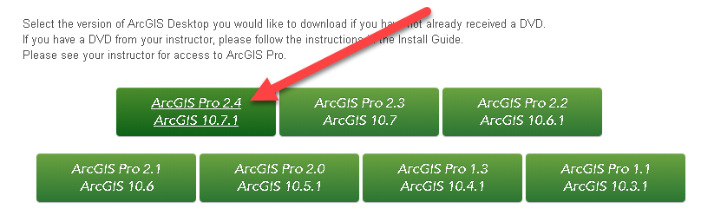
- Scroll down to the File Description table. To download ArcGIS 10.7.1, find ArcGIS Desktop (ArcMap) and click Download.
ArcGIS Pro might additionally be a software program of interest with cool tools, but it is not something we currently use in Tufts GIS classes. If you download ArcGIS Pro, you will need to email the DataLab-Support@elist.tufts.edu to get your license activated.
Note: When downloading with the Esri Download Manager, you can select and download multiple products at once. However, only one product should be launched at a time when the downloads are complete.
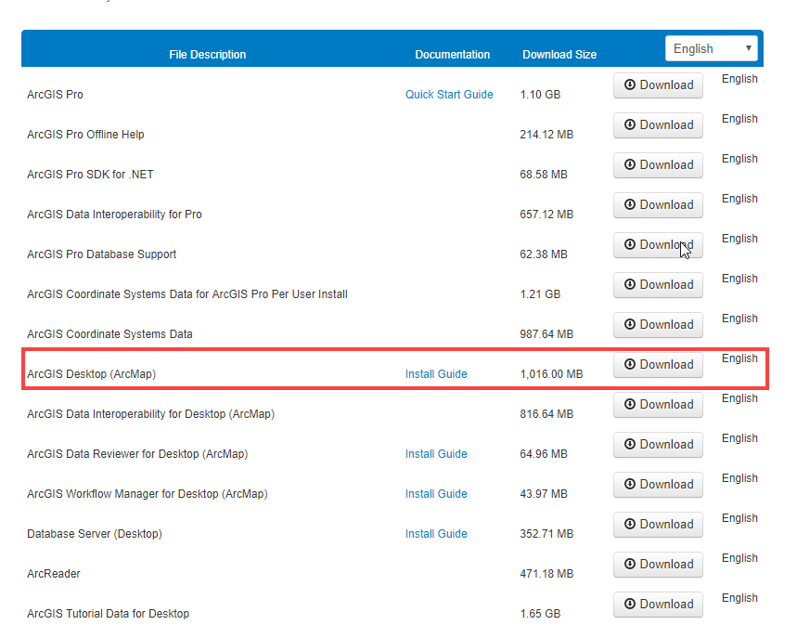
- Download installation media by pressing the Click to download your file now button.
Depending on the internet application you’re using, the installation wizard might open automatically, it might save to the downloads bar at the bottom of chrome, or it might be saved to your downloads file. 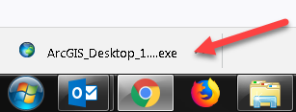
- Once it downloads, Run the installation wizard by opening the ArcGIS_Desktop executable (.exe).
- Select a destination folder to extract the install files to and press Next. If you choose, you can automatically launch the setup after the files have been extracted by clicking the box “launch the setup program”.
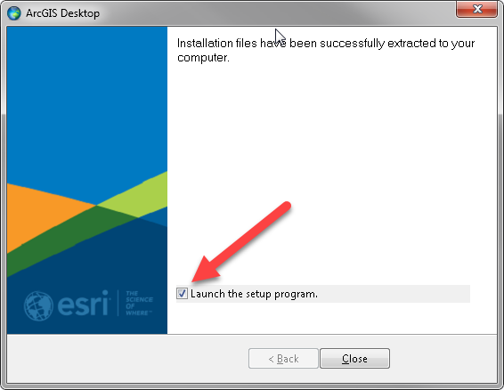
- Press YES when asked if you want to let ArcGIS make changes to your computer.
- Proceed through the setup installer options by clicking Next.
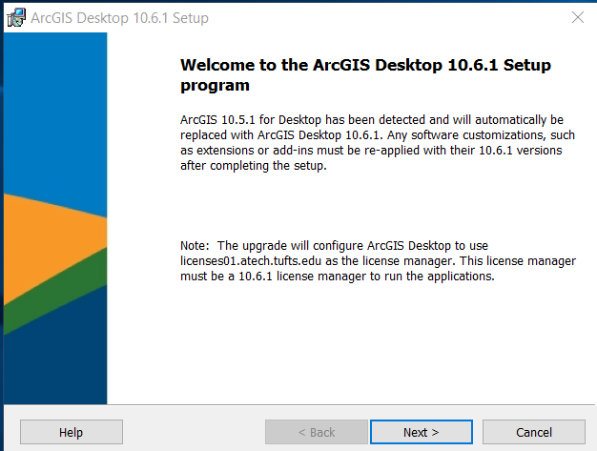
- Select the Complete installation type.
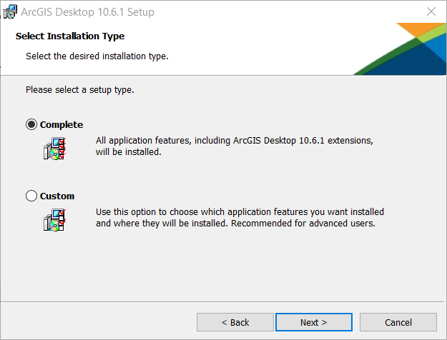
- Click next through all the prompts. You will see the software being installed and the progress bar. This may take several minutes.
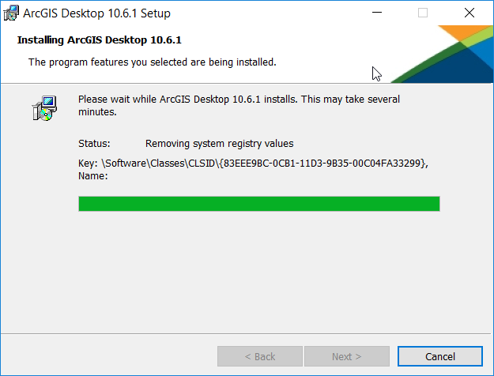
- After the files are installed, the Authorization Wizard will open and prompt you to choose a product to authorize. Select “I have installed my software and need to Authorize it”
Note: If the authorization Wizard does not automatically open, open the program ArcGIS Administrator and select ArcGIS Desktop Advanced (Single Use) (shown below). Then select “I have installed my software and need to authorize it” (as shown in the screen shot above). Press Next.
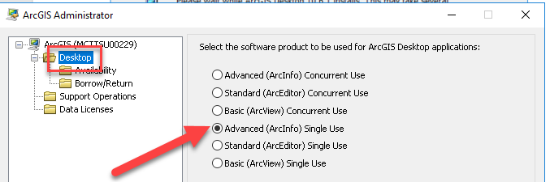
- Fill out your authorization information and press next. Fill out your industry information and press next.
- Enter your activated code into the text box, as shown below. Press Next.
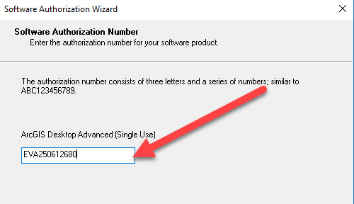
- Select “I do not want to authorize any extensions at this time.” Press Next. P
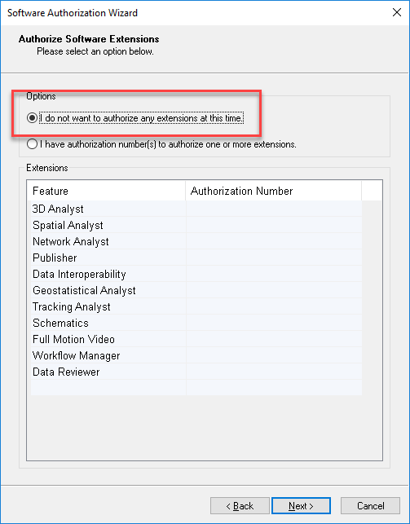
- Press Next again. You do not need to evaulate software extensions. 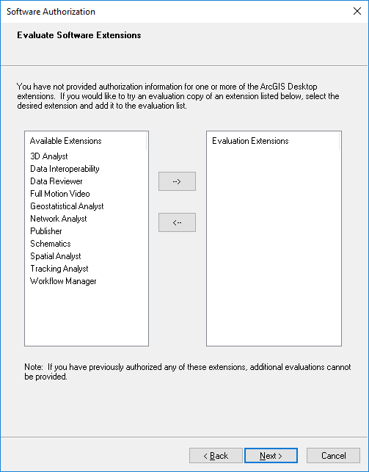
- Press finish once your software authorizes successfully. 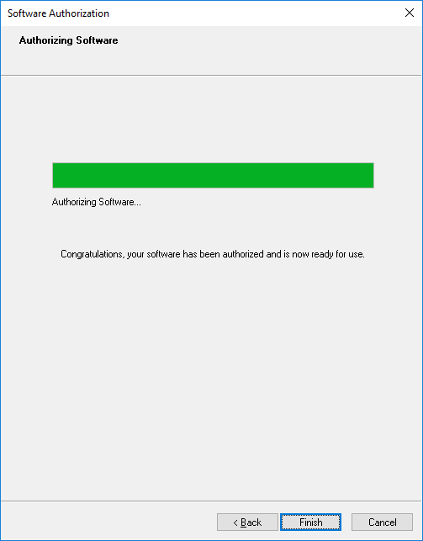
- Open ArcMap 10.7.1 to ensure that everything works.
Support for the ArcGIS Desktop Education Edition is available at esri.com/trialhelp

Mapping Network Drives
If you would like to map the Tufts Network Drives to connect to the H, M or S Drives, please follow the instructions on our Data Lab Website. Note the extra VPN step if you’re connecting from your home.
https://sites.tufts.edu/datalab/accounts-network-drives/

