Guidelines for How to Fix and Prepare Tissue for Histology Submission

# Overview

## Histology involves all processes from the collection of tissue from the animal to cover slipping the final slide product. For the final product to be high quality, all steps in the process must be performed optimally. Please refer to this document for recommendations on steps you can take before submitting fixed tissue to the Animal Histology Core (AHC) to help ensure you get the best results. For frozen sample submissions, please refer to our guidelines on Preparation of Frozen Tissues for Histology.

## Basic Steps in Histology

1. Tissue collection from the animal

2. Fixation

3. Special processes such as decalcification

4. Tissue Trimming

5. Cassetting

6. Processing

7. Embedding

8. Sectioning

9. Deparaffinization and rehydration

10. Staining

11. Cover slipping

These **guidelines will cover recommendations for actions you can take in your laboratory for steps 1-5** that will 1) improve the quality of the final slide; 2) reduce your costs; 3) decrease turnaround time from the histology laboratory and 4) avoid the most common histology mistakes.

### Step 1: Tissue Collection from the Animal

### **General Recommendations**

### • Contact the Comparative Pathology Service for group or one-on-one training on gross anatomy and necropsy technique. Mouse necropsy workshops are held in DLAM every other month. You can also review published necropsy techniques and our Tips for Research Necropsies.

### • Collect tissue immediately after euthanasia to prevent postmortem autolysis and decomposition. Changes occur in tissues within minutes of death.

• **STOP, don’t throw it out!** Whenever possible, collect more organs and tissues than you think you will need, even if your study is limited to just one organ system. You do not have to plan to do histology on the other organs you collect, but you will have them, just in case. Once you discard organs, they are GONE. It is generally better to find that you never needed tissues that you collected than to find that you wish you had collected them. You can submit just one organ for histology and keep the rest in formalin indefinitely, just in case the need arises to look at other tissues. You can submit a jar of tissues to the histology lab and only request that one tissue be trimmed and the others saved, so there is little to no additional cost associated with saving extra tissue. *Pathologist note: sometimes during histopathology assessment of your tissues of interest, changes will be seen that can only be interpreted if other organs can be assessed too.*

Scenario 1:

You are studying the spleen and lymph nodes and notice after all of the tissue analyses that one animal appears to be an outlier. You wonder if the cause of variation can be determined. You have saved a full set of tissues from the animal, so Comparative Pathology Services can go back to your saved tissues and perform histology. Histology of head sections reveals a severe suppurative middle ear infection, which accounts for the changes you observe in this animal. Scenario 2:

You are studying the spleen and lymph nodes and only need those organs for your work. While collecting your samples, you notice that the liver looks enlarged and is pale tan. You also think the stomach looks different. You mention those changes later to the Comparative Pathology Service. Because you collected the liver and stomach, CPS can do histology on these organs and tells you that there is lymphoma of the liver and that the stomach was dilated with food but was otherwise normal histologically. Without saving those organs, there would have been no way to make an assessment.

Scenario 3:

You are studying spleen and lymph nodes, and you collect tissues from over a hundred animals over a two-year period. While preparing your manuscript, you read that the mutation that you have been studying has recently been described to cause effects in the bone marrow and kidney, also. Because you saved the sternum, hind leg, and kidney in formalin as part of a full set of tissues on each animal, you can go back and have slides of bone marrow and kidney prepared of all your study animals to include with your published work.

• Place tissue into fixative immediately after collection.

• Don’t let tissue dry out before it gets placed in fixative. Dry edges can create artifacts in IHC.

• Don’t freeze animal carcasses if you plan to do histology. Freezing results in ice crystal formation in the tissues and poor histologic morphology. Collect tissue into formalin to preserve it rather than freezing the carcass. If an animal dies and you cannot do tissue collection right away, put the carcass in the refrigerator and then do the tissue collection as soon as you are able.

• Most mouse organs can be collected whole without having to cut them into smaller pieces for adequate penetration by fixative.

• In animals larger than a mouse (rats, rabbits, swine, etc.) many or all organs will need to be cut to no thicker than 5 mm in order for the fixative to penetrate the tissue rapidly. In a rat, kidney, liver, and testes are three tissues that would normally need to be cut into smaller pieces before fixation.

• If you are collecting rodent embryos, please request our guidelines for collecting rodent embryos for histology.

• Caution! *Be SURE that you are collecting the tissue you think you are. The most common mistake in tissue collection we find in tissues submitted to our lab is mistaking fat or salivary gland for lymph nodes at collection in mice.* If you are collecting mouse lymph nodes or any other tissues and are not sure that you are identifying the tissue correctly, don’t hesitate to call one of our staff to assist you.

**Containers and Labeling**

• Always label the container itself and not the lid (to avoid confusing container IDs when you remove the lid)

• Use leak-proof containers so fixative does not spill in your lab or in transit to the histology lab. We recommend that you invest in containers made for histology samples, as these are usually study, wide-mouthed, and large enough for an adequate volume of fixative. Our lab will return the empty containers to you, if you request, for you to clean and reuse.

• Select a large enough container to hold a 20:1 ratio of formalin to tissue.

• Fix tissues in flat bottomed jars, not conical tubes. If a tissue sits at the bottom of a small conical tube, it will not have adequate formalin exposure.

• Avoid containers with narrow necks. Tissues may expand in formalin. Tissues that went into a jar easily may be more difficult to remove through a narrow neck after fixation.

• Label containers with:

o PI name

o Animal ID

o Collection Date

o Fixative o Project name (Optional)

Here are some examples for fixing and storing tissues.

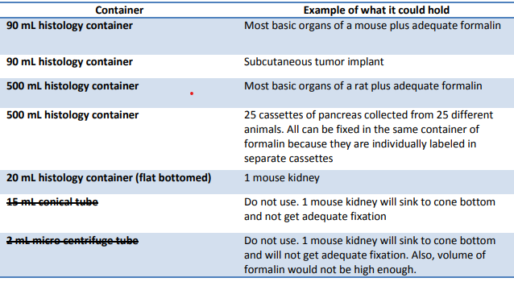

There are many sources for histology containers. Fisher and VWR both carry a good selection.

Step 2: Fixation

**General Recommendations**

• Most tissues can be fixed in 10% neutral buffered formalin (NBF). You can buy histology containers prefilled with formalin or you can buy formalin separately and reuse histology containers. If you will be using a large volume of formalin over a 6-month to year period, we recommend the 20 L poly pak boxes of formalin (Fisher) that come with a spigot for easy and safe dispensing.

• Do not use old or expired NBF. We have seen examples where use of old formalin ruined tissue morphology for a study.

• Use a 20:1 ratio of formalin to tissue. The most common fixation problem we see in tissues submitted to our laboratory is tissue that is fixed in an inadequate volume of fixative. This reduces the quality of the final slide product.

• Occasional swirling of the jar or gentle agitation for the first 24 hours in fixative may increase the quality of fixation

• Other Fixatives

o Davidson’s fixative: Eyes

o Bouin's: Embryos, reproductive tissues, and brain

*Note: Avoid fixing mouse brain in ethanol or transferring mouse brain to alcohols after formalin fixation, to avoid a vacuolar artifact in the white matter.*

Step 3: Decalcification of Bone (as needed)

Bone or mineralized tissue must be decalcified prior to routine sectioning of paraffin embedded blocks. If you are submitting tissue for histology that contains bone or calcified tissue, it needs to be decalcified to remove the mineral before it is trimmed and processed. Mineralized tissue is very hard and may either pop out of the block when it is sectioned, or the sections may be poor quality because the microtome blade will not cut mineralized tissue smoothly. The decalcification process removes calcium mineral from fixed bone, leaving the tissue bendable and easily cut with a sharp blade.

There are several techniques and solutions to decalcify bone. Contact the AHC for a recommendation on the best decalcification solution to use for your project needs. The AHC routinely uses 8.8% formic acid to decalcify specimens. Length of decalcification is dependent on size of tissue, and most mouse tissue will decalcify in 2-3 days. If another decalcification method (EDTA, HCl) is required, please contact the core. If you have never decalcified tissue before, please consult us first for our recommendations to prevent accidental chemical “burn” of the tissue that can ruin tissue morphology.

Step 4: Tissue Trimming

Trimming is cutting a fixed tissue or organ to create a flat surface with correct orientation. You can do this yourself with training and a few basic supplies (cutting board, forceps, single edge razor blade) or our histologists can do this for you. ***Trimming should be done after, not prior to, fixation***. If you trim before tissue fixes, it will continue change shape and usually bulges on the cut surface, requiring trimming again after fixation. The purpose of trimming is to create an even, flat surface in the area of interest in the tissue so that the histologists to not have to face (cut with the microtome) into the paraffin block as deeply when trying to get the first good sections for a slide. There is less tissue loss in the block and a better visualization of the structures of interest.

• Certain tissues must always be trimmed, including but not limited to: skin, heart, kidneys, brain; mouse embryos older than about E12; testes, and any tissue larger than the thickness of the cassette.

• Other tissues or organs are often trimmed for optimal examination. Trimming is recommended but may not be required: e.g. tumors, liver, lungs, intestines

• Some tissues or organs should not or need not be trimmed for routine screening: e.g. rodent eyes, pancreas, ovary, rodent lymph nodes, or mouse uterus. However, there are instances in which even these organs might need to be trimmed.

*Standard trimming* of rodent tissues will be done by our histologists based on the RENI guidelines with some adaptations. See <http://reni.item.fraunhofer.de/reni/trimming/>. These published trimming recommendations are also helpful to follow if you trim the tissues yourself.

*Custom trimming* should be done when 1) trying to locate or demonstrate a very specific area of an organ not generally captured using standard trim guidelines; 2) when an organ has lesions that might not be captured on standard trimming sections; and 3) whenever trimming is requested at custom landmarks by project design.

Trimming and cassetting are usually done at the same time.

Step 5: Cassetting

All tissues for paraffin embedding must be cassetted before processing. Cassetting is taking trimmed or untrimmed tissue and orienting it in a tissue cassette to the area of interest. You can cassette tissues yourself or the AHC histologists can provide that service.

To trim tissues in your laboratory, you will need:

• a cutting board

• single-edged razor blades or a specialty histology trim knife and blades

• a small scissors

• a forceps preferably without teeth

• histology cassettes

• a wide-mouthed histology container of formalin to place the cassettes into after cassetting

• a #2 pencil

• may want a small fine-mesh food strainer (from Bed Bath and Beyond, Target, Walmart, etc.) so that you can pour the fixative out of the container into another jar and catch the tissues

• access to RENI trimming guide for quick reference

• A chemical hood or a hood fitted with an appropriate filter to remove formalin vapors. Consult with Tufts or Tufts Medical Center EH&S if you are unsure of which hood or filters are necessary for your safety and protection.

• Appropriate personal safety protection, to include nitrile gloves, a lab coat, and safety goggles. Consult with EH&S for full information on formalin safety.

**General recommendations for labeling cassettes**

• Caution! **Label cassettes only in #2 pencil**. You also may be able to use certain solvent resistant histology markers, but please have our lab do a trial run with your pen in our processor first to be sure. Never use a Sharpie marker, which is not solvent resistant, to label histology cassettes or all your labels will disappear from your cassettes. The AHC is not responsible for loss of cassette identification from improperly labeled cassettes.

• ***Each cassette must be labeled*.** Our staff will label the slide with the cassette label.

• ***It is not necessary to label cassettes with the names of the organ(s) contained within.*** For example, “kidney, liver” are unnecessary labels on a cassette. Shape and color of organs trimmed by standard methods makes it easy to spot which organs are on a slide easily without viewing the tissue on a microscope. An exception is if you want to label one cassette as “Right cervical lymph node” and the next cassette as “Left cervical lymph node” which you would not be able to tell just by histologic examination.

• Label each cassette on the top (preferably) or side of the cassette with a ***unique number*** for each cassette. When labeling, keep in mind other submissions you may make at a later date and be sure that you will be able to distinguish the slides and blocks later. A **good labeling system** will also likely designate a unique number to each individual animal as well as to each cassette. Multiple cassettes submitted for the same animal may be labeled in sequential order. It will also be brief enough that errors are less likely to be made when transcribing the cassette label to the slide. **Poor labeling or having no planned labeling system** in place can lead to blocks and slides from multiple animals labeled with the same ID over time or can be so long as to be impossible to transcribe to a slide.

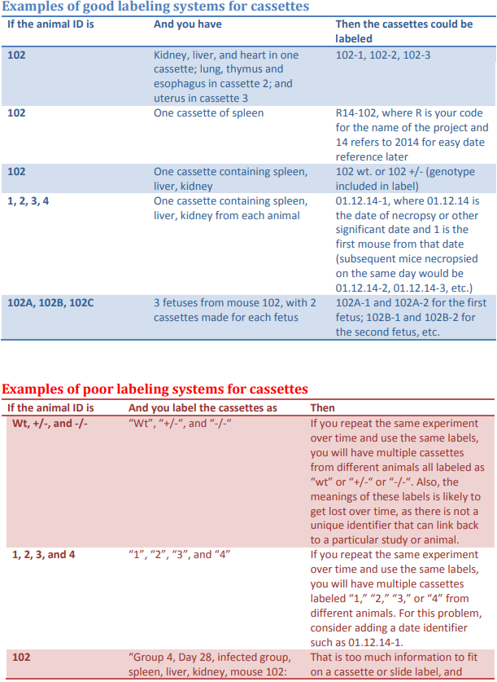

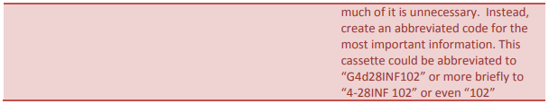

*General Recommendations for Placing Tissue in Cassettes*

• Use of blades. Use a new, sharp, clean single-edged razor blade or specialty blades that are made for trimming histology tissues. At a minimum, change blades between tissues from different animals. Use a new blade if you feel that your blade is beginning to dull or a different end of the blade that may be sharper.

• Cut down (into the cutting board) and away from you. For your safety, always hold tissues with a forceps, not with your fingers when cutting. With a new, sharp blade, you should be able to make one smooth cut by just pressing down. Do not saw at the tissue. If you find that the tissue begins to just press down under the blade and not cut, use a new blade. Do not use a scissors to cut the tissue. Scissor cuts do not leave a flat and smooth enough surface for optimal slide quality.

• The area of most interest to you in your tissue should face down in the cassette. Universally, histologists know that the side facing down in a cassette is the face of the tissue you want sectioned.

• You can put multiple tissues in one cassette. This saves your lab money, decreases turnaround time because there are fewer cassettes for our lab to process, and reduces the number of slides you will have to examine and store.

• The general rule of thumb is that tissues combined in the same cassette should be of the same density (for example heart, liver, spleen, and kidney often cut well in a cassette together, versus decalcified bone and lung, which would not cut well together). Brain should be submitted in its own cassette, but there can be multiple sections of brain in the same cassette. Pathologist note: If you plan to put only one organ or tissue in a cassette because you are concerned you will not be able to tell them apart when you look at them microscopically, we will be pleased to teach you to recognize the different tissues so that we can reduce your histology costs by at least half by combining the tissues in the same cassette.

• Review the list of tissues above that “must be trimmed.” Never submit tissues in a cassette that are listed above in the “must always be trimmed” category without trimming them unless you tell the histologist that they still need to be trimmed.

*Histology labs assume that tissues submitted in cassettes are ready for processing. Once cassettes have been put on the tissue processor and the tissues are infiltrated with paraffin, it is much harder to then go back and trim and orient tissues correctly. The final slide quality may not be as good as tissue that was trimmed correctly before processing.*

• Caution! Note that very small tissues (such as normal mouse lymph nodes, transverse sections of normal mouse spleens, endoscopic biopsies, and cell pellets) can pass through the holes of some histology cassettes during transport and processing and be lost to analysis.

*For small tissues, consider using cassettes with very small holes (ask us for recommendations) or use biopsy sponges, lens paper, or Histogel to ensure that small sections are not lost in processing.* The AHC is not responsible for small tissues that are lost in processing due to improper cassetting if you cassette them yourself. On request, we will provide you with our recommendations for cassetting your small tissues.

• For certain projects, multi-chambered cassettes that contain up to 6 separate compartments may be helpful. For example, by setting an orientation template, 6 different lymph node sites can be processed in just one cassette and sections of these lymph nodes on the final slide can be matched with the template to identify each node by site.

**What to Request from the Animal Histology Core**

Above, we covered steps that may be taken in your own laboratory to prepare tissues for histology. At this point, the remaining steps are usually done by the histology core. Review our [Histo Checklist](https://sites.tufts.edu/histopath/animal-histology-core/histology-submission-checklist/) and then prepare to bring your samples to the AHC. If you are unsure what you need to request, our histologists will talk with you and help you determine that. The remaining steps in the histology process that are generally done in the histology laboratory are briefly described below. Please also refer to the [Fee Schedule](https://sites.tufts.edu/histopath/fee-schedule/) for additional definitions and information on services.

**Processing:** Tissue processing includes dehydration, clearing, and infiltration of the tissue with paraffin wax. This is usually accomplished on a piece of equipment called a tissue processor using programs that the lab has established for a species, tissue, or special need. Tissue processing is done by our histologists unless you have access to a tissue processor in another lab. If you are submitting tissue for routine paraffin embedding and sectioning, then processing will be part of your service.

**Paraffin Embedding:** Embedding immediately follows tissue processing. Tissue embedding involves carefully removing processed tissue from the cassettes, placing them into a mold while maintaining their original orientation, and then filling the mold with paraffin wax. This produces a paraffin block. Embedding is done by our histologists unless you have access to an embedding station in another lab or already have embedded blocks that were previously prepared. Tissues that have been processed and embedded can remain in a block indefinitely. Paraffin blocks can be sectioned immediately or years later. If your protocol calls for a defined period of tissue fixation, you can get the tissue processed and embedded after the defined period of fixation and can then hold the blocks until you determine your final sectioning needs later across your whole study.

**Sectioning:** Sectioning of paraffin blocks is done using a microtome that cuts very thin sections of the paraffin-embedded tissues, which are placed on a slide. Routine thickness for paraffin sections in the AHC is 5 microns. If you require thicker or thinner paraffin sections, please give us special instructions in the submission form. Normally, once a block is embedded, the histologists must cut (or “face”) into the block with the microtome to get their first good section. A small amount of tissue will be lost from the block in the facing process. You must notify our histologists if your area of interest in the tissue is so close to the start of the tissue in the block that facing into the block might be a problem.

**Unstained section:** Slides with a paraffin section of tissue that has not been deparaffinized and has not been stained with any stains.

**Serial Section:** Sections of tissue that are placed sequentially on the slide one right after the next.

**Levels:** Sections of tissue taken at intervals, with the histology technician cutting further into the block. Multiple levels can be placed on one slide or several slides, usually 3-4 depending on the size of the tissue. Also called step-sectioning. For instance, a section is taken, then the block is cut deeper wasting 100-200 microns of tissue which is discarded, then another section is taken and put on the slide. Insert text here that supports the guidelines.

**Stains:**

• The basic histology stain is Hematoxylin and Eosin (H&E). The hematoxylin is a nuclear stain and stains the nucleus blue/black/purple, depending on the hematoxylin used. Eosin is a cytoplasmic counterstain, with at least 3 different shades of pink depending on the cell part or tissue type.

• Special stains: These are specific stains used to determine special tissue types such as collagen, or stains that will identify a particular bacteria or mineral. We have a list of our routine special stains (see Menu) but can accommodate other requests.

• Immunohistochemistry: The core is not offering IHC stains currently.

For additional information on histology and pathology services available through the Tufts Comparative Pathology Services, please see our website <http://sites.tufts.edu/histopath>

**Effective Date:**

**Revision Date:**

**Authorizing Signature:**

CMS Histocore Fix and Prep Guide