Project Title: Development of Bioelectronic Scaffolds for Hybrid Brain Tissue
Team Members: Zainab Olushoga, Diamond Mensah, Enrique Rodriguez
PI / Mentor(s): Dr. Brian Timko, Dr. David Kaplan

New Edits to the Document highlighted in yellow

Project Description:
Bioelectronic devices embedded within the hybrid, engineered tissues could provide stable, long-term readouts of tissue function. We will achieve and optimize flexible, porous scaffolds that provide signals from up to 32 spatially-distinct locations. We will then embed these scaffolds within a 3D brain tissue model to obtain readouts of neural activity. Time permitting, we will apply algorithms to quantify changes in synaptic connectivity over time.

Engineering Design Elements:
- What are the objectives of the project and the criteria for selecting them?
The objective of the project is to embed a bioelectronic device into a 3D brain tissue model. We plan for the neurons(iNSCs) to grow in the scaffold and for the bioelectronic device to be integrated and form a hybrid brain tissue. Once this is accomplished we expect to be able to measure neural activity.
- What system, component, or process is to be designed?
A novel hybrid brain tissue that contains a bioelectronic embedded into the tissue. We are tasked with figuring out the best way to embed and track signals for the neurons in the hybrid tissue.
- What need does it fulfill (clinical, research, etc.)?
Allows for monitoring of electronic signals in live organoids, specifically in brain tissue. The monitoring is essential for understanding tissues that have systemic signalings such as cardiac tissue or brain tissue. Using the bioelectronic chips will allow for the creation of tissues that are more representative of actual tissues.
- What scientific, math, and/or engineering methods will be applied?
Currently, we are still exploring which methods will be applied for the integration of both parts of this project. We will be using soldering to connect the bioelectronic device to the PCP board to measure the voltage of the neurons. We will be analyzing the electrical signals being output from the bioelectronic device and in the future we plan on also performing tensile tests on our scaffolds.
- What realistic constraints (cost, safety, reliability, aesthetics, ethics and social impact, etc.) are to be considered?
Considering that individually both components of our project are well reviewed and established constraints are mainly surrounding the integration of the two components. This will be the first time evaluating so we will have to evaluate the constraints throughout our project. We believe that a realistic concern may be sterility since we are going to have to bring devices from the clean room on 200 boston ave to scitech labs in order to create the integrated system. Another concern was the size of the device and the scafold, specifically we changed our approach from cutting a normal sized scaffold in half to stacking 2 normal sized scaffolds on top of one another using an adhesive. Aesthetically, the device could be smaller and look more like “hybrid” tissue rather than a device seemingly stabbing the organoid model. We aren’t too worried at this because this whole project is very novel and in the future we expect there to be way more advances that will allow for a more aesthetic model. Another realistic constraint is that we are hoping that the integration of the device with the scaffold will not introduce contamination but that is a real concern considering the device wil be travelling from a completely different building. Yet we plan to sterilize the device by soaking it in ethanol for 30 minutes and then washing it and never removing it from the hood before creating the hybrid device.
- What alternative solutions or changes to the plan will be considered?
We have considered embedding the bioelectronic prior to the scaffold being salt leeched, so we won’t have to worry about the adhesive working well or degrading over time. Another problem is we may have to seed more cells than normal since we are now using 2 scaffolds to mke one hybrid scaffold meaning there should be double the surface area.
- What are the planned tests and what are the quantitative milestones that will demonstrate the achievement of the objectives?
Do a comparison of scaffold degradation with and without the device. Immunostaining and images to see neurons. We would also conduct a neural activity assay. To test the adhesive success we are considering performing a tensile stress test on the scaffolds and compare the stress strain curves of the scaffolds with and without adhesive. Where a successful adhesive will have similar properties to a nonadhesive scaffold.

- Competition: what else is going on in the field that would compete with the project plans?
As of right now, there is no competition in this field. The combination of both the bioelectronic device and the tissue model is new to the field. We even attended bioelectronic hybrid tissue talks at BMES and no one is doing work like this in the field currently.

Introduction/Background:
Bioelectronics as stated in the name combines biology with electronics. With recent advancements, there is a promise that bioelectronics can be used to understand tissues that rely on electric signaling to lead their function. Along with an understanding of the tissues a better understanding of diseases that affect these tissues can also be developed. Currently, methods of understanding electrophysiology are invasive and complicated such as patch clamp assays or they lack temporal resolution such as Calcium Fluorescence imaging^{2,3}.
We believe that a hybrid tissue, which is an organoid embedded with a bioelectronic could address this gap in knowledge. We are specifically interested in using this for neurons and brain tissue generally. The Kaplan Lab has already established a brain model using neurons and silk fibroin as a scaffold^{4–6}. The organoids serve as a 3D functional model of the brain that can spontaneously fire, they also can alter the compositions of the scaffold to model a selection of disease states associated with neurons and brain tissues⁵. The scaffold shown in figure 3 has the exact dimensions and components as those used in this method the only difference is that the scaffolds used in the hybrid tissue have an additional hole in the middle making a donut shape to allow for a representation of grey matter to be the silk section and the hole to be the white matter section of the tissue model.
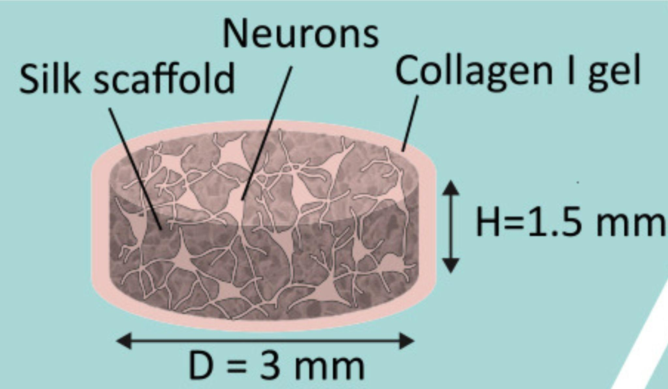
Figure 2 Model of the Brain Tissue. Shows the dimensions and important components of the 3D functional tissue model⁵.
The bioelectronic sensor we plan to use for our projects is a flexible scaffold that is designed to interface with neural cells. The sensors record real-time electrophysiology of electric active tissue. These readings allow us to characterize action potentials and cellular networks. Additionally, we can monitor ion channel states, and evaluate neural pathways. Specifically, the sensor is attached to a multielectrode array that was designed in the Timko Lab¹. The multi-electrode array is rigid so it will not contour to the tissue meanwhile the sensor is flexible to allow for it to integrate with the active tissue, promoting cell-to-cell communications. Our main focus is the integration of the hybrid brain model. To ensure that the device could interface with cells they coated the microelectrode array with SU8 on the top and bottom, shown in a piece breakdown in figure 4. The reason why SU8 was selected as passivation is that it is biocompatible, inert, and compatible with cells^{1,7}. Gold was chosen as the metal for electronics because of its malleability as well as its low toxicity¹.
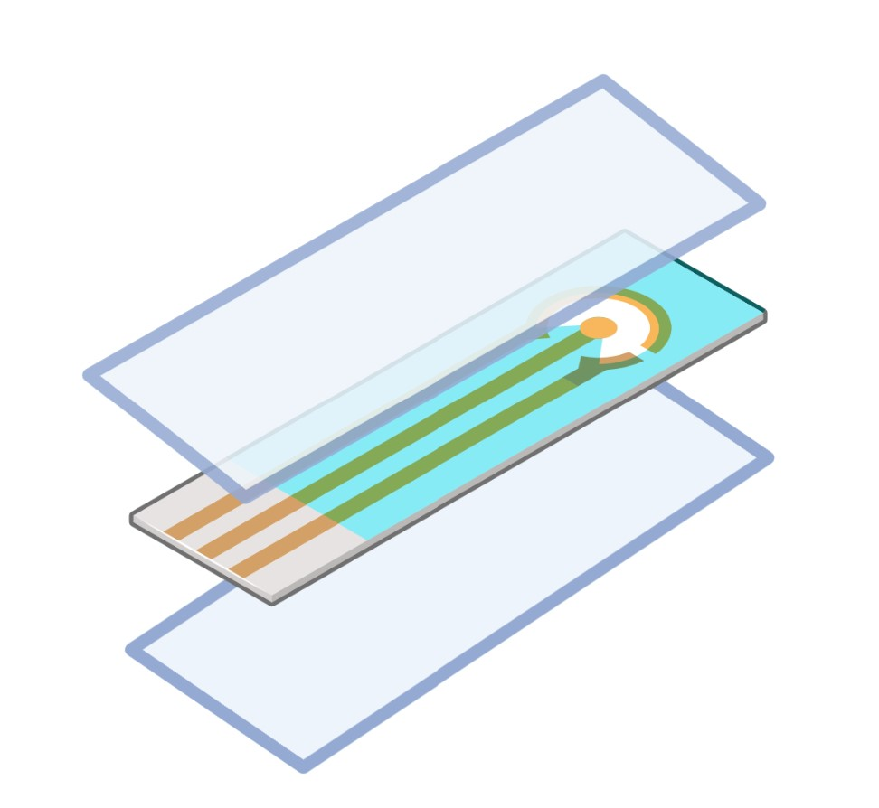
Figure 3 Schematic of Layers of the bioelectronic device. Light blue layers represent SU8+ and the middle layer represents gold electrodes.
Separately the brain model and the flexible electronic innovations are well-known and researched however it's unknown how these would work together jointly. We expect that sandwiching the scaffold around the sensors would allow for the growth of neurons around the sensors, which would allow for integration. To successfully create the model hiNSCs are differentiated and then seeded on the silk scaffold. Once the neurons are in the scaffold their axons grow toward the center to communicate with one another. In Figure 5 we see an example of how the bioelectronic electrodes and the neurons will interface. This will create a circuit that can output electrical impulse readings on the surface and interior of the neurons.
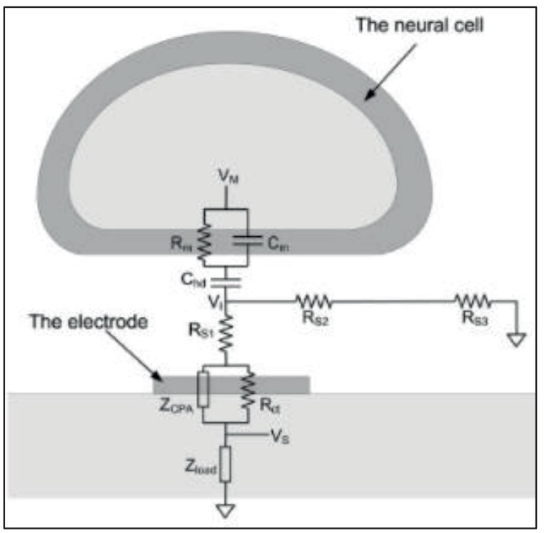
Figure 4 The Interface of the Bioelectronic and the Neurons. Adapted from Joye, Neil, et al⁸.
By taking these reading forms for prolonged periods of time it will hopefully give insight into how diseases function. It will provide information about systemic signaling, and once this platform is well established it can be applied to other tissues which rely heavily on systemic and spontaneous electrical signaling.

Methods:
Exp 0 (Current) Make the scaffolds and implant them into devices without neurons.
- Create silk scaffold donuts.
- Prepare the flexible bioelectronic device.
- Cut silk scaffold in half and input the bioelectronic
- Use a surgical adhesive
- Put in media and observe and compare degradation or lack of degradation of the scaffold.
EXP0 has to be pushed due to the SU8 layer and BioEs device being delayed due to fabrication issues + unforeseen neuronal cell culture contamination

(Future)
Exp 1 Tensile Stress Test and Shear Testing for adhesive compatibility
Exp 2 Culture seed scaffold and make sure it is viable without bioelectronics and then also with bioelectronic.
- After seeding the differentiated neurons into the scaffold we will perform cell viability assays to see how neurons are functions and compare
Exp 3 Conduct Calcium Assays to see if the neurons are spontaneously firing.
Exp 4 Take some images to characterize the neurons' immunofluorescence and imaging etc.

Exp 5 Gather signals from scaffold and neurons and perform more assays
- See how the neurons signal each other
Results (future):
Results have been set back due to unknown contamimnation of seeded scaffolds and non seeded scaffolds. We plan to have to results in the next three week
Discussion (future-work):
N/A
Participation:
We all are working together as much as possible on the project. We all worked together in order to fabricate the silk scaffolds.
Bi weekly Report (10/14/22): This block we all took turns with changing the water when we were doing dialysis and silk scaffold preparation. Diamond submitted the order forms for our cell media. Zainab diluted our silk after we had concentrated it post dialysis, so that it reached the proper concentration. We all worked together to sieve salt and prepare the silk for salt leeching. We observed Marilyn complete seeding her neurons on her own scaffolds, nd coating her scaffolds with collagen as well.
Mid Semester Report (10/21/22): Our contributions to the mid semester report are detailed on the document we submit for the midsemester report.
Bi weekly Report (11/04/22): We worked together with seeding of MEFs, media changes for the MEFs, creating media to seed neurons on MEFs, then seeding the iNSCs on the scaffolds, then creating differentiation media for the iNSCs over the psat few weeks by alternating days in which we went to lab with some occasions having all of us show up to lab together. We also have begun the process of getting trained to fabricate the devices and use the cleanroom for next semester.
Timeline
1. Define Project
2. Learning Essentials of Tissue
Components
2.1 Cell Culture
2.2 Scaffold Formulation
2.3 Neuron differentiation
3.Tissue Engineering Component
3.1 Neuron Culture and Differentiation
3.2 Scaffold and culture integration
4. Electronic Device Integration
4.1 Without cells
4.2 With cells

1 2 3 4 5 6 7 8 9 10 11 12 13 14 15
Weeks (Semester 1)
Green = Completed
Yellow = In progress
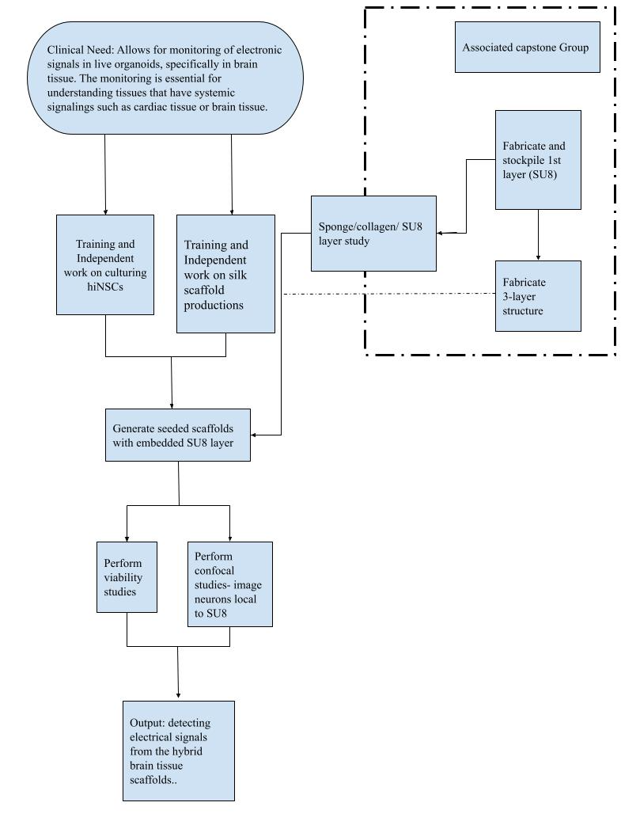
Bibliography:
(1) Cote, M. A. Development and Characterization of a Bioelectronic Scaffold for a Hybrid Brain Model. M.S., Tufts University, United States -- Massachusetts, 2022.
(2) Wood, C.; Williams, C.; Waldron, G. J. Patch Clamping by Numbers. Drug Discov. Today 2004, 9 (10), 434–441. https://doi.org/10.1016/S1359-6446(04)03064-8.
(3) Russell, J. T. Imaging Calcium Signals in Vivo: A Powerful Tool in Physiology and Pharmacology. Br. J. Pharmacol. 2011, 163 (8), 1605–1625. https://doi.org/10.1111/j.1476-5381.2010.00988.x.
(4) Chwalek, K.; Tang-Schomer, M. D.; Omenetto, F. G.; Kaplan, D. L. In Vitro Bioengineered Model of Cortical Brain Tissue. Nat. Protoc. 2015, 10 (9), 1362–1373. https://doi.org/10.1038/nprot.2015.091.
(5) Dingle, Y.-T. L.; Liaudanskaya, V.; Finnegan, L. T.; Berlind, K. C.; Mizzoni, C.; Georgakoudi, I.; Nieland, T. J. F.; Kaplan, D. L. Functional Characterization of Three-Dimensional Cortical Cultures for In Vitro Modeling of Brain Networks. iScience 2020, 23 (8), 101434. https://doi.org/10.1016/j.isci.2020.101434.
(6) Liaudanskaya, V.; Chung, J. Y.; Mizzoni, C.; Rouleau, N.; Berk, A. N.; Wu, L.; Turner, J. A.; Georgakoudi, I.; Whalen, M. J.; Nieland, T. J. F.; Kaplan, D. L. Modeling Controlled Cortical Impact Injury in Three-Dimensional Brain-like Tissue Cultures. Adv. Healthc. Mater. 2020, 9 (12), e2000122. https://doi.org/10.1002/adhm.202000122.
(7) Nemani, K. V.; Moodie, K. L.; Brennick, J. B.; Su, A.; Gimi, B. In Vitro and in Vivo Evaluation of SU-8 Biocompatibility. Mater. Sci. Eng. C 2013, 33 (7), 4453–4459. https://doi.org/10.1016/j.msec.2013.07.001.
(8) Joye, N.; Schmid, A.; Leblebici, Y. Electrical Modeling of the Cell–Electrode Interface for Recording Neural Activity from High-Density Microelectrode Arrays. Neurocomputing 2009, 73 (1), 250–259. https://doi.org/10.1016/j.neucom.2009.09.006.

Plan for Cell Culture as of (10/11/22) EXP0:
Cut scaffold donuts the week of the 17th of October.
Start MEFs on the 17th so they are confluent by the 24th
Coat the Scaffolds with collagen ECM on the 24 & 25 and then be ready for seeding on the 26th.
Seed iNSCs the week of Halloween ( seed iNSCs, tentatively by October 21st )
Change media every day until they are confluent.
Seed onto scaffold at 26 th October, and then hard deadline is the 29 th October .
NF3 for cell viability.
2 MEFs into 2 plates of iNSCs
100 million cells = 50 scaffolds ( if we want to do 2 donuts per sandwich we get 50)
Or if we cut scaffolds in half to sandwich the device in between, we would have 100 samples.

Peel Test
What is the local area around the scaffold look like ?
A thin cross section using paraffin wax to determine how the cells local environment is using freeze drying techniques.

Constraints: neuron density may be really high in order to ensure that the neurons interface witht he devices.

Optimization issue with cell density at seeding.
Neuron density
Sterility
Ensuring the device stays together.
SU8 into the scaffold can very easily get contaminated.
70% ethanol for 30 min in the hood
Neurons need to fire spontaneously.
Calcium fluorescence to check the spontaneous firing of the neurons.
Patch clamp assay

How are we going to measure success, what are the action items, what are the quantifiable and desired results ?
- Calcein AM for live dead staining
- We will then image the hybrid tissue and come to the conclusion that it was successful after seeing that the creation of the device

