**Development of Bioelectronic Scaffolds for Hybrid Brain Tissue**

Enrique Rodriguez, Zainab Olushoga, Diamond Mensah

Dr. Brian Timko & Dr. David Kaplan

April 21, 2023

New Edits Highlighted in Yellow

**ABSTRACT**

Bioelectric sensors are a popular tool for quickly assessing the cellular physiologic status and metabolic changes. They can record real-time electrophysiology of active tissue - which can then be used to characterize action potentials and cellular networks. The Timko Lab has previously proposed and designed a flexible 3D bioelectronic scaffold multielectrode array (BioES) meant to be embedded with neural cells. When embedded within the hybrid engineered tissue scaffolds, these bioelectronic devices could provide stable, long-term readouts of tissue function. Within this two-team project, our research aims to develop and characterize the hybrid tissue scaffold environment and confirm the biocompatibility of the hybrid brain model and the bioelectronic device by embedding the bioelectronic device into the hybrid brain model. This type of integration has not previously been achieved and verifying this possibility could open a new range of possibilities for the field of bioengineering.

*This project is adapted from Megan A. Cote’s thesis submitted for a Master of Science in BME*1

**Key Words:** bioelectronics, brain model, silk scaffolds

**ENGINEERING DESIGN**

The project's overall objective and the end goal is to embed a 3-layer, bioelectronic device into a 3D brain tissue model. We plan for the human-induced neuronal stem cells (hiNSCs) to grow in a porous silk scaffold and to integrate a flexible 3D bioelectric scaffold multielectrode array (BioES) to form a hybrid brain model. Once this is accomplished, we expect to be able to measure electrical impulses from the neuronal cells seeded into the scaffolds. Successful integration means that it may be possible for researchers to monitor the electric signals in live organoids, specifically those modeling brain and cardiac tissue. The use of these bioelectronic chips will allow for the creation and verification of more representative models.

Our first objective is to integrate the top SU-8 layer of the BioES into the empty silk scaffold using an adhesive. SU-8 is a commonly used epoxy-based negative photoresist – meaning that exposure to UV light results in epoxy cross-linking leading to curing/hardening. This property allows for the unexposed portions to remain soluble and thus they can be stripped away using an developer solution. The SU-8 has inert electrical properties and high compatibility with cells which is why it was chosen for this project. The larger two electrodes/layers just serve as ground references for the system which is why initial studies will focus on integrating just the SU8 layer. Next, we will assess structural integrity and compatibility between the empty silk scaffold (no hiNSCs), the SU-8 layer, and the surgical adhesive by looking for deterioration over time. Our next objective would be to generate hiNSC seeded scaffolds with an embedded SU-8 layer and conduct viability assays of the cells to ensure long term survival within the silk scaffolds and device. We also plan on immunostaining our samples to visualize neural cells in the silk environment. We want to conduct metabolic calcium fluorescence assays to ensure spontaneous neural activity. Our final objective for this semester is to perform confocal studies to image neurons and activity on the SU-8 layer. Successful integration will signify a sound basis to move forward with the 3-layer BioES device.

From there we want to move forward with integrating the brain model with the completed 3-layer BioES. We want to perform viability studies - starting with live-dead assays for cell survival within the device. We are still exploring which methods and will optimize as we move forward. As of now, we will be using soldering to connect the bioelectronic device to the PCP board to measure the voltage of the neurons. We will use Kwik-Sil Silicone Elastomer as an adhesive to connect our seeded silk scaffolds to the BioES and the SU-8 layer.

We expect there to be issues, especially regarding the travel between the Clean Rooms where the device is constructed, and the cell culture labs where the brain model will be developed. This could bring up issues with sterility. Current plans are to sterilize all materials with 70% ethanol and to sterilize the device and its layers with *both* 70% ethanol and UV exposure from the tissue culture hood since we could not find another UV source.

There may also be issues regarding the cell density which we seed since we are planning on sandwiching the BioES between 2 pieces of seeded silk scaffolds rather than cutting one scaffold in half. In addition, we want to ensure there are enough cells in contact with the device interface. For this, we plan on having multiple sets of empty scaffolds ready if we find that we need to increase our seeding density. As of now, we are moving forward using the standard seeding protocol used in the Kaplan Lab2,3.

**DESIGN FLOW CHART**

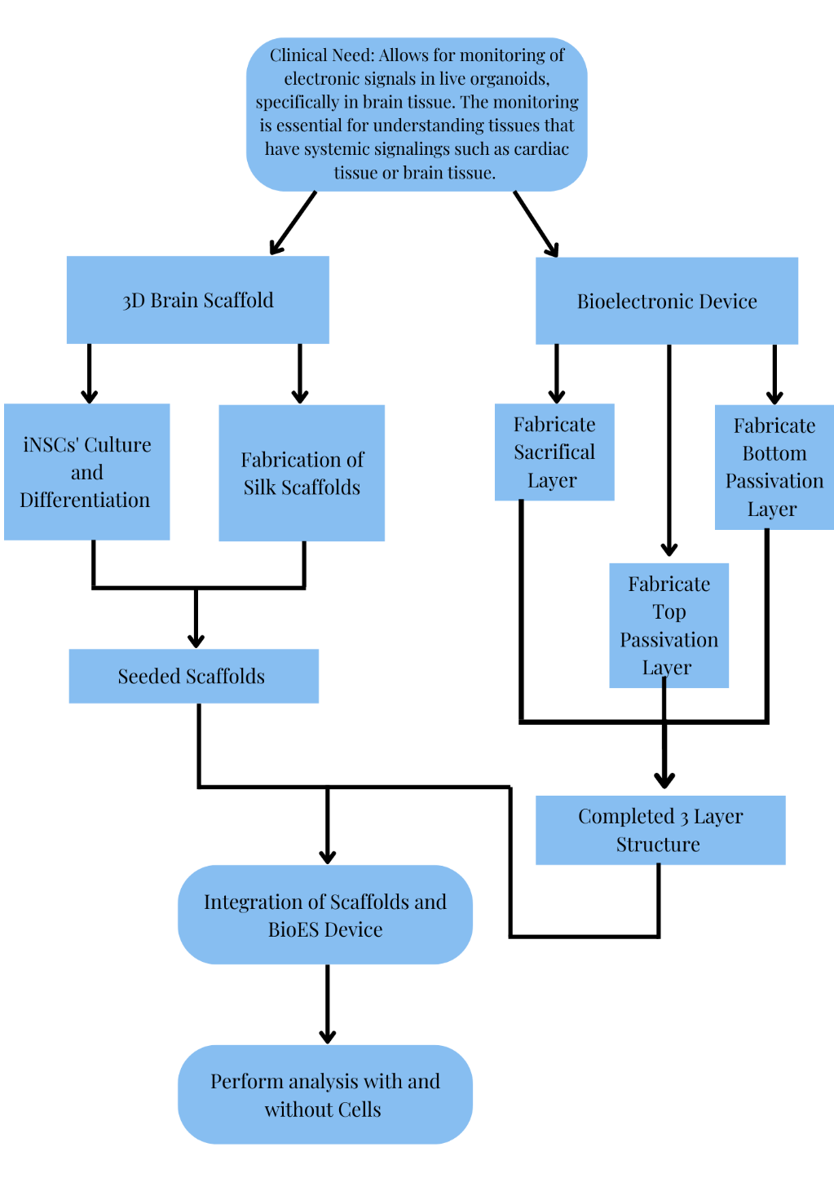

**FIGURE 1.** The design flow chart of our project shows the main objectives and goals of the current project as well as the ultimate endpoint for this semester. Arrows demonstrate intended progress.

**DESIGN TABLE**

|  |  |  |  |  |
| --- | --- | --- | --- | --- |
| **Project Aims** | **Project Goals** | **Assay** | **Threshold of Success** | **Outcome** |
| Aim 1.1 | *Assess structural integrity and compatibility of empty silk scaffold and SU-8 top layer* | *Integration using surgical adhesive – “Kwiksil”*  *Leave model at room temp. for >6 hours and observe degradation*  *Lift model gently and hold in air for ~1 minute and observe if the adhesive fails* | *After 6-hours of the silk scaffold being adhered to the passivation layer, we will observe no degradation and a maintained structural integrity after slight agitation* | *SU8 layer and Silk Scaffold will be compatible with glue and we can move forward to the cell integration* |
| Aim 1.2 | *Characterize in vitro Brain Model* | *Flou-4 AM Calcium* | *>12 events / minute* | *Ability to identify the distinct baseline nature of our brain model to compare to future integrations* |
| *Calcian AM Viability* | *70-80% Viability* |
| *Beta III Tubulin (tuj1)* | *1.2 – 1.3 million cells/mm^3* |
| Aim 1.3 | *Embed the SU-8 layer of the BioES into the in vitro brain model* | *Thermofisher Live Dead* | *>60% Viability* | *Determined compatibility of SU8 layer with our brain model* |
| *Repeat Aim 1.2 Assays* | *Same Thresholds* |
| Aim 2 | *Generate Seeded Scaffolds with an embedded 3-layer BioES* | *Repeat Assays in Aim 1.3* | *Same Thresholds* | *Complete compatibility and seeded neurons throughout the scaffolds and full BioES* |
| *Connect BioES to PCB Board and Computer* | *Any voltage and Electrical Readings (no set values)* |

**INTRODUCTION & BACKGROUND**

Bioelectronics as stated in the name combines biology with electronics. With recent advancements, there is a promise that bioelectronics can be used to understand tissues that rely on electric signaling to lead their function. Along with understanding the tissues, a better understanding of diseases that affect these tissues can also be developed. Currently, methods of understanding electrophysiology are invasive and complicated such as patch clamp assays or they lack temporal resolution such as Calcium Fluorescence imaging4,5.

We believe that a hybrid tissue, which is an organoid embedded with a bioelectronic could address the problems related to invasive and complicated protocols associated with electric signal tracking. We are specifically interested in using this for neurons and brain tissue generally. The Kaplan Lab has already established a brain model using neurons and silk fibroin as a scaffold2,6,7. The organoids serve as a 3D functional model of the brain that can spontaneously fire, they also can alter the compositions of the scaffold to model a selection of disease states associated with neurons and brain tissues6. The scaffold shown in figure 2 has the exact dimensions and components as those used in this method the only difference is that the scaffolds used in the hybrid tissue have an additional hole in the middle making a donut shape to allow for a representation of grey matter to be the silk section and the hole to be the white matter section of the tissue model.

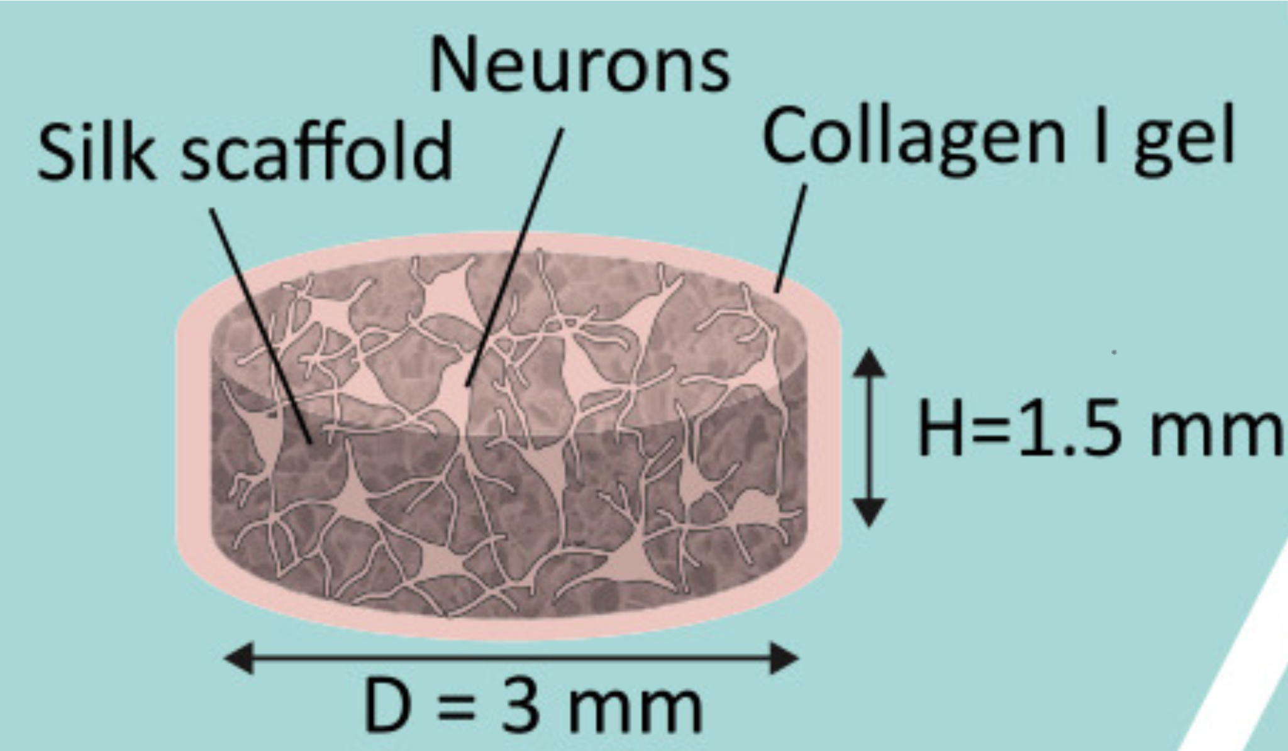

**Figure 2 Model of the Brain Tissue.** Shows the dimensions and important components of the 3D functional tissue model6.

The bioelectronic sensor we plan to use for our projects is a flexible scaffold that is designed to interface with neural cells. The sensors record real-time electrophysiology of electric active tissue. These readings allow us to characterize action potentials and cellular networks. Additionally, we can monitor ion channel states, and evaluate neural pathways. Specifically, the sensor is attached to a multielectrode array that was designed in the Timko Lab1. The multi-electrode array is rigid so it will not contour to the tissue meanwhile the sensor is flexible to allow for it to integrate with the active tissue, promoting cell-to-cell communications. Our main focus is the integration of the hybrid brain model. To ensure that the device could interface with cells they coated the microelectrode array with SU8 on the top and bottom, shown in a piece breakdown in figure 4. SU8 was selected as passivation is that it is known to be biocompatible, inert, and compatible with the neuronal cells1,8. Gold was chosen as the metal for electronics because of its malleability as well as its low toxicity1.

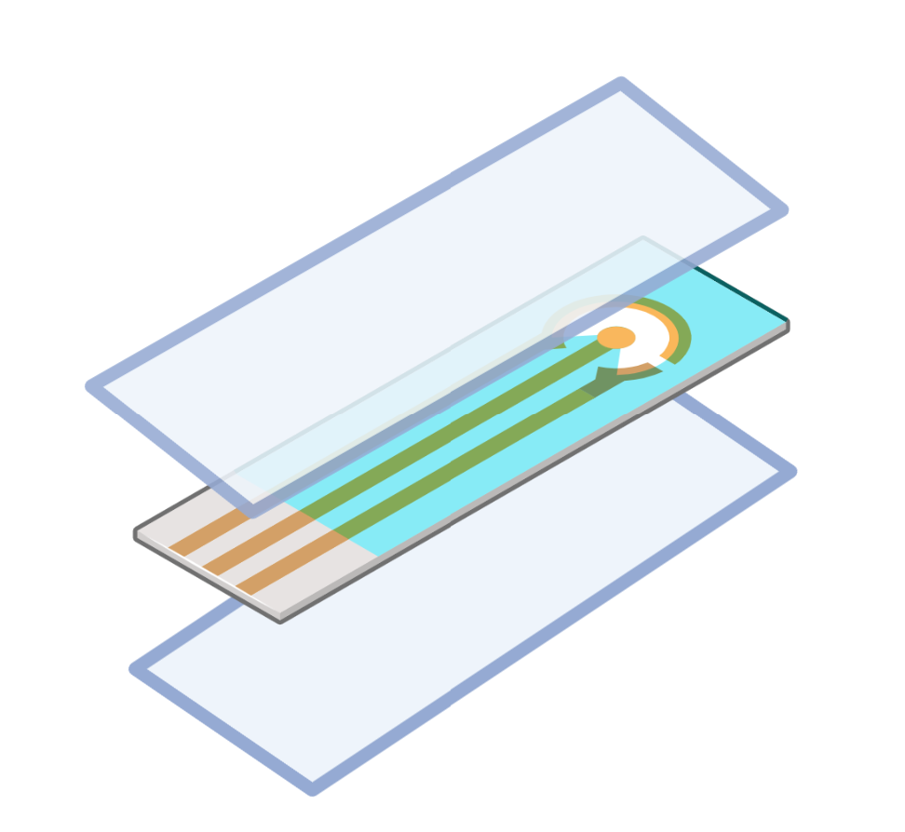

**Figure 3 Schematic of Layers of the bioelectronic device.** Light blue layers represent SU8+ and the middle layer represents gold electrodes.

For this integration, we plan on using Kwik-Sil Silicon Elastomer purchased through World Precision Instruments. Kwik-Sil is a medium-viscosity surgical adhesive specifically developed for chronic peripheral nerve studies – so we know that it is biocompatible. WPI markets it as having good adhesion and high tear strength and elongation which should allow for long term (multiple days – weeks) of study without bond breakage. Maintaining adhesion and structural integrity will allow for us to successfully complete our studies and will allow for our device to be functional when it comes time to use it as an actual brain model in disease studies.

Separately the brain model and the flexible electronic innovations are well-known and researched however it's unknown how these would work together jointly. We expect that sandwiching the scaffold around the sensors would allow for the growth of neurons around the sensors, which would allow for integration. To successfully create the model hiNSCs are differentiated and then seeded on the silk scaffold. Once the neurons are in the scaffold their axons grow toward the center to communicate with one another. In Figure 4 we see an example of how the bioelectronic electrodes, and the neurons will interface. This will create a circuit that can output electrical impulse readings on the surface and interior of the neurons.

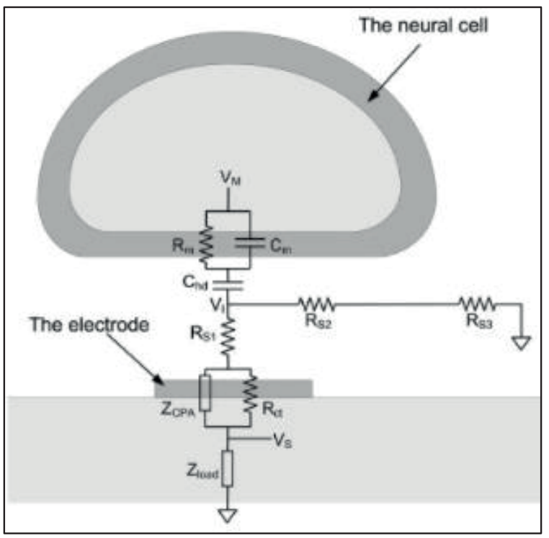

**Figure 4 The Interface of the Bioelectronic and the Neurons.** *Adapted from Joye, Neil, et al*9*Taking*ing these reading forms for prolonged periods of time it will hopefully give insight into how diseases function. It will provide information about systemic signaling, and once this platform is well established it can be applied to other tissues which rely heavily on systemic and spontaneous electrical signaling.

**UNIFYING FIGURE**

**FIGURE 5.** This graphical summary outlines the experimental steps of the project beginning with cell differentiation in conjunction with the BioES device layers. Assembly, compatibility assays, and viability assays will follow then finishing with the end goal of assessing how successful the fully fabricated device is at detecting action potentials and neuron behavior.

**SPECIFIC AIMS**

***Aim 1: Evaluate Biocompatibility between polymer passivation SU8 layers, silk scaffold, and adhesive***

*1.1:* *Goal: Assess structural integrity and compatibility of empty silk scaffold and SU-8 top layer.* The goal of this sub-aim is to verify the ability of our proposed integration model to maintain structure and integrity while in before to adding any hiNSCs. Structural integrity is an important foundational step to ensure our brain model and device are compatible and stable for future experiments. This step is also important for determining if our adhesive can hold the structure together. We will generate silk collagen scaffolds with no seeded hiNSCs and adhere the scaffolds to the electrode end of the SU8 device using Kwik-Sil Silicone Elastomer. We will observe the model’s degradation overnight (>6 hours), and we will observe its ability to maintain structural integrity when it’s touched/moved afterwards. This will aid in verifying our current design model. We will measure success by observing no deterioration in our scaffolds and our ability to gently lift the adhered scaffold for ~1 minute after 24 hours, 48 hours, and 96 hours. Although the body of the adhesive container can be sterilized in 70% ethanol, the liquid within cannot be if exposed. So, we will keep it in the lab, minimize how often it is opened to prevent dried clumps from forming, and attempt to keep it in the fume hood as often as possible. Failure to achieve this adhesion goal will have us looking at other adhesive alternatives including temperature cured collagen gels or Kwik-Cast silicone sealant which is like Kwik-Sil but is a low viscosity silicon sealant specifically developed to embed peripheral nerved with electrodes and adhere live tissue to read-out devices. That’s beyond the scope of our current goals but it may work as a good surgical adhesive.

*1.2: Goal: Characterize in vitro Brain Model.* Prior to full integration with the BioES, we must first be able to identify the distinct nature of the brain model environment within the silk scaffold. This aim will also help us better visualize cell clustering. As we mentioned within the Design Elements section, a problem we expect to encounter involves the seeding density of the hiNSCs. The current protocol has a seeding density of 2million cells per scaffold. We plan on sandwiching 2 scaffolds on each side of our device. There needs to be enough cells near the top layer of the scaffold which will be in contact with the SU-8 and BioES for them to receive signaling information. Within this aim, we will be able to characterize the brain model and the growth behavior of the hiNSCs. Here hiNSCs will be thawed and grown as per Kaplan lab protocol2,3. Once confluent, they will be seeded onto the silk scaffolds with a collagen gel mixture and allowed to grow within the scaffold overnight. We will conduct **Calcein AM viability assay** to assess cell viability within the hybrid scaffold ***(goal: 70-80% viable cells per scaffold group)***, **Beta III Tubulin tuj1 stain** of scaffold sections to visualize and quantify neural cell density within the silk environment ***(goal: 1.2-1.3 million cells/mm^3)***, and possibly a **Flou-4 AM Calcium Imaging** assay to verify spontaneous neural activity as spontaneous activity is essential for obtaining readouts from the complete 3-layer BioES device ***(goal: >12 events/min)***. Successful achievement of these goals will verify our stem cell growth plan and seeding. If we can’t achieve our goal for the calcium assays, we could also stain our samples for common neuralderm markers or conduct quantitative PCR (qRT-PCR) to analyze the expression of genes known to change during neural development. Failure from more than 1 of these objectives would mean we would need to rework our initial seeding amount or colony growth timeline.

*1.3:* *Embed the SU-8 layer of the BioES into the in vitro brain model*. This will work in the same way as Aim 1.1 except the scaffold will no longer be empty. The Brain model part will be kept in a petri dish with cell culture media to keep neurons alive and viable. Cell viability will be assessed within this new complex environment using live-dead assays to ensure longer-term survival within our setup. This will help us finalize the biocompatibility and viability between all the interacting parts of our devices and scaffolds to ensure they will survive when fully integrated in Aim 2. Success will be if we observe 70-80% cell viability, otherwise, we may have to revisit our seeding or device fabrication plans. We will also perform confocal imaging on the hybrid device to image neural cells local to the SU8 device to characterize, visualize and assess their behavior/health. We will also repeat our *Aim 1.2* assays specifically with the same output goals to verify consistent neuronal activity/readouts both with and without the device.

***Aim 2: Generate Seeded Scaffolds with an embedded 3-layer BioES.***

Here we will repeat the plans described in Aim 1.3 but now we will utilize the completed 3-layer BioES device. The exposed end of the BioES device which is not connected to the seeded brain model will then be soldered onto the PCP board to begin measuring neuron voltage output and spontaneous electrical signals.

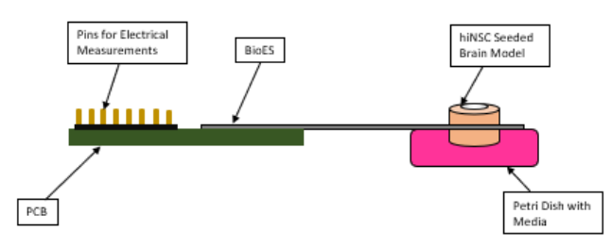

**FIGURE 6.** Completed hybrid brain model assembly plan - *as adapted from Megan A. Cote*1

**METHODS**

**Silk Scaffolds** were developed using a protocol established by the Kaplan lab - no changes were made10. 5 grams worth of silkworm cocoons are cut and boiled in 2 liters of deionized water. They are then rinsed in cold DI water three times before being transferred to a fume hood for overnight drying. Once dry, silk was dissolved in a lithium bromide solution and this mixture was dialyzed over 3 days. After 3 days, the mixture was centrifuged, and the silk concentration was calculated. Water was either added or dried from the solution until the desired 6% concentration was achieved.

**Cell Culturing** was developed using the Kaplan lab protocol with no changes being made (*Appendix B*). This began with thawing and plating mouse embryonic fibroblasts (MEFs) to secrete growth factors and promote pluripotency in our stem cells11. MEFs media was changed every 4 days until they reached 90-95% confluency then hiNSCs were ready to be added. The MEFs were inactivated by adding 500ul of Mitomycin C to the culture plate, leaving it to rest for at least 3 hours, then washing 3x with 1X PBS. HiNSCs complete media was added to the plate. HiNSCs were then thawed, centrifuged, and gently added to the same culture plate to not break up the cell colonies. The plate was left to rest for 20 minutes before being incubated. The media was changed every 1-2 days (preferably 1 day to further delay differentiation and to allow for stronger proliferation of stem cells). All cells were cultured using standard sterile tissue culture technique.

**For BioES Base Passivation Layer Fabrication** *see Appendix A*

**For BioES sterilization**, the device will be gently removed from DI water, thoroughly sterilized in 70% ethanol, then allowed to sterilize under the tissue culture hood’s UV light which remains on for ~2 hours but we will leave it overnight. The next day, in that same culture hood, the device will be placed in a sterile petri dish with silk scaffolds and a sprayed down adhesive bottle. Once the device is adhered to the scaffold, we will place everything in a sterile dish where cells can then be seeded. All work involving the scaffolds will be done in the lab hoods to minimize any contamination.

**Silk Scaffold preparation and integration** began by aspirating deionized water from the silk sponges and transferring them to a 6-well plate, 1 scaffold per well. Coating silk scaffolds in poly-L-orinthine (PLO) solution until scaffolds are submerged and then leaving them in the incubator overnight. The next day, aspirate the PLO solution off the scaffolds and wash them with PBS using the bench rotator for 3 minutes at 15rpm – aspirate off PBS and repeat this 4x. Then coat scaffolds with Mouse Brain Laminin for 4-6 hours. In fume hood, place and adhere 1 scaffold to each side of the SU-8 layer with the Kwik-Sil Elastomer and allow to cure at room temperature for 20 minutes (figure 7).

**Cell seeding onto composite structure** began by preparing roughly 150mL of complete hiNSC media. HiNSCs are lifted from their culture plate and counted. Using sterile tweezers, scaffold+SU8 composite structure are moved to new plates. Carefully dry off scaffolds using an aspirating pipette. Individually seed each sponge with 2 million cells, incubate for 30 minutes, then add 150uL of complete media. Return to incubator overnight. The entire structure will then be backfilled with collagen.

**Beta Tubulin 3 Staining** was conducted by lightly drying and transferring mature, seeded scaffolds into a new 48-well plate. Scaffolds were treated with ~500ul of a 4% PFA fixing solution for 1 – 12 hours in the 4°C fridge. The fixing solution was aspirated out and scaffolds were then treated with ~500ul of blocking buffer for 30 minutes at room temperature then it was aspirated out. A solution of primary antibody (Mouse beta-tubulin – 1:1000 dilution) was created and added to scaffolds and agitated overnight in the 4°C fridge. The following day, primary antibody was aspirated out and the scaffolds were washed with 1X PBS 5 times for 5-10 minutes per wash on a shaker. A secondary antibody solution was created (488 Goat Anti Mouse – 1:500 dilution) and added to the scaffolds. The plate was covered in aluminum foil and left at room temperature for 1 hour. The secondary antibody was washed out with PBS, scaffolds were placed on the shaker in just a PBS solution for 5-10 minutes, re-covered with aluminum, and finally stored in the 4°C fridge until imaging could be done.

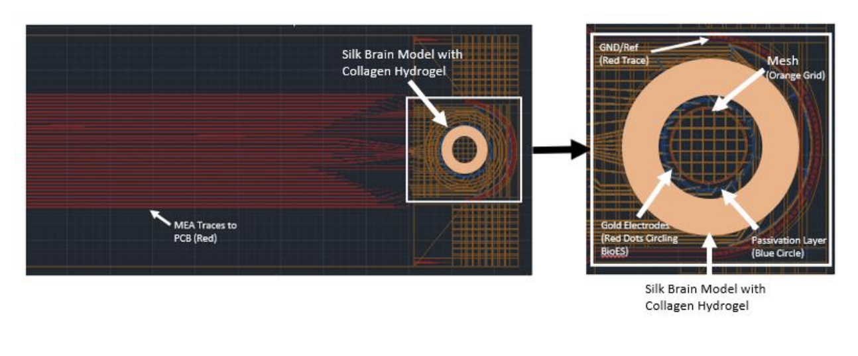

**FIGURE 7.** Bioelectronic Device and Scaffold Set Up (CAD Design) - *as adapted from Megan A. Cote*1

**RESULTS**

**FIGURE 8. Neurons in 3D Silk Scaffold.** This image was attained using a Beta Tubulin-3 Assay stain, where green shows the scaffold and the neurons.

In Figure 8, the Beta Tubulin-3 Assay reveals that there was a network of live neuronal cells, and they were successfully distinguished from the background and the other green silk scaffold.

**A**

**B**

**Figure 9**. A. 10mm Silicon Wafer, untreated (right). 10mm Silicon Wafer coated with 200nm of Nickel to form a sacrificial layer which can be etched away in future steps to remove the device (right). B. Nickel Coated Wafer after having SU8-2002 spun down on it.

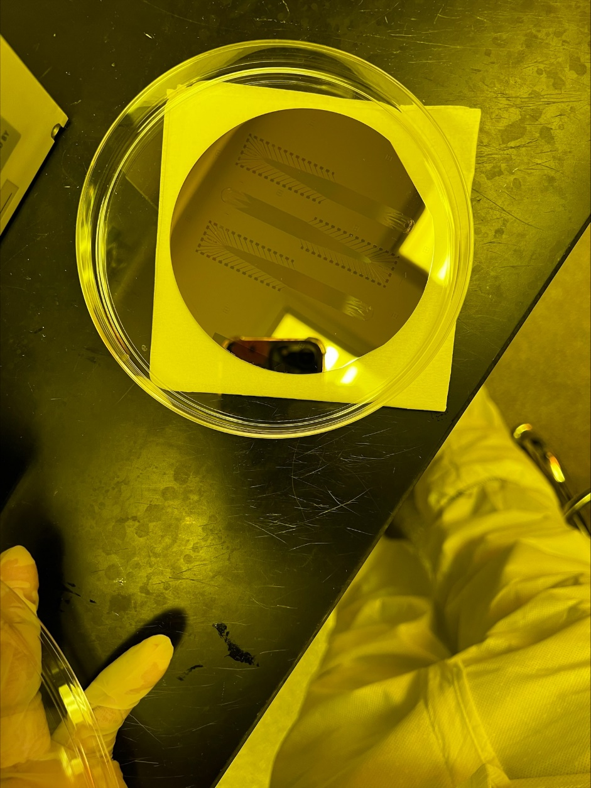

**B**

**A**

Figure 10. Silicon wafer post-UV exposure with design pattern. This Wafer is being developed in an SU8 development solution which strips away any non-crosslinked SU8 from our nickel layer. Leaving just the device pattern made from the SU8. B. Completed SU8 Base Passivation Layer on 200nm Nickel Layer attached to Silicon Wafer.

Figure 11. Potential Contamination in 2 out of 4 Brain Model Plates.

**DISCUSSION**

Fabrication and silk processing was the first objective of the experiments. We successfully processed the silk fibroin and used it to create 3D silk donut scaffolds and then added collagen. Scaffolds that weren’t used for the experiments were stored for use the following semester. After seeding the cells contamination occurred, thus we had setbacks with our methods and had to adjust the goals for this semester. We shifted to seeding the cells on the scaffold and then performed a Beta Tubulin-3 Assay on the scaffold to validate our methods going into the upcoming semester. Our Beta Tubulin-3 staining shows that our scaffold fabrication methods resulted in visible neuronal networks, which was expected.

Sadly, network density couldn’t be evaluated due to time constraints during the day. However, a MATLAB code has been developed to quantify network density from multiple Z-stack images of live cells.

In hopes of getting a higher quality and more even sacrificial layer of Nickel down, we tried using the Thermo Evaporator available in the lab to melt nickel pellets - essentially sublime them from solids to gas, then allow the gas nickel to coat our solid wafer then solidify to create a uniform layer. And with this layer, once we get a coat of SU8, we can then etch the nickel away via chemical dissolution and this will leave us with a free floating solid SU8 that we can experiment with.

Problems: there isn’t a set protocol for using the Thermo evaporator with nickel. We went in the week before spring break but saw no deposit. We suspected that this was due to the physical distance that exists between the area which is subliming the metal and the area that our wafer sits. To combat this, we designed a stage extender meant to decrease that distance.

We then went to try again, but this time the machine sensors read that there was too much deposit too quickly. Normally we build up to a deposition rate of 1-3 Amps per second but this time the rate fluctuated between 0.01-0.13 before shooting up to 999. This caused an emergency shut down of the machine. But opening the machine showed that the metal hadn’t even melted and was barely even warm to the touch meaning that something was off with the actual sensor we use to detect metal deposition.

Thermal evaporation still resulted in failed depositions after a few more attempts; we believe this is due to the physical set up within the evaporation chamber. The thermal evaporator relies on a quartz crystal to accurately measure deposition rate and film thickness. This crystal acts as a deposition monitor and normally lies below the substrate holder. But with the stage extender, our substrate holder is farther down and lies below the crystal. We believe that this is causing a shadow to be cast over the crystal causing it to misread the deposition. In addition, we normally use a tungsten boat with the evaporator but found online that some tungsten boats don’t work well with nickel deposition since the material will just alloy with the nickel pellet. This would explain why on the runs where we didn’t use the stage extender, the deposition rate simply wouldn’t increase, and the nickel would be slightly stuck to the boat but not melted out of its original cylinder shape. So Thermal evaporation is simply not a viable choice for nickel deposition.

For this reason, we moved to the sputter, which works like the thermal evaporator by working under vacuum to produce a thin metal layer, but the sputter is based on ion bombardment on our metal of choice which results in metal vapor to be released on our substrate. This process was significantly faster (~2 hours, with a 1 hour wait). Initial runs resulted in uneven sputtering, and this was found to be caused by a faulty gun shutter which is meant to cover the metal that we were not using. The shutter would accidentally cover the gun depositing nickel leading to uneven deposition. This was fixed by cleaning the laser that the machine used to detect the position of the gun and by recalibrating the shutter’s set position by manually screwing the shutter to where we wanted it to be. With this we were finally able to get down a 200nm sacrificial nickel layer (Figure 9A), spin down SU8 2002 negative photoresist (Figure 9B), expose it under a UV lamp and print a mask onto the wafer (which leaves us with a desired pattern). We were also able to develop the wafer in a SU8 developer which leaves us with our visible first layer on just the nickel sacrificial layer (Figure10). Now we need to figure out the nickel etching protocol for stripping away the nickel layer and leaving us with the free floating SU8 base passivation layer.

Figures 9-10 show that we were able to finally fabricate a base passivation layer and now we need to focus on getting lift off from the silicon wafer via Nickel Etching. Nickel etching utilizes Transene TFB which is a highly (but very selectively) corrosive chemical containing 15-20% Nitric Acid, <1% Proprietary Surfactant, and 80-85% Water. The Clean Room standard operating procedure has that this chemical can etch away nickel at a rate of 50nm/sec when heated to 40˚C.

An initial etchant run resulted in our SU8 degrading along with the nickel layer. We left the wafer to soak at 40˚C for 1 hour while we watched, then 6 hours – per previous protocol recommendation. Previous runs by the other team had them leaving the wafer in for multiple days before seeing lift off. We think this happened since their device were significantly thicker than ours and had multiple layers. We need to meet with the Clean Room coordinator and Professor Timko to decide how to move forward.

Regarding the tissue culture end, we set aside 10, 5week old scaffolds and began staining for Beta Tubulin. We are still waiting for supplies needed for the Flur4 Calcium Assay.

Roughly 2 days afterwards, we noticed potential contamination in 2 out of 4 of our plates (Figure 11). We had to bleach these and keep a close eye on our remaining plates to see if they all developed contamination. Over ~5 days, we noticed no obvious signs of contamination in the remaining 2 plates both from inspecting the media and the scaffold. We believe this contamination might have occurred because a few weeks back, both plates were accidentally opened on the bench rather than in the hood. We marked these plates off to check them but clearly, they didn’t make it. We did take some of the beta tubulin samples from one of the contamination plates, but there was no obvious contamination prior to fixing the cells. We will just keep watch and see if we notice anything suspicious during imaging on May 1st.

**FUTURE WORK**

We plan on finishing our Calcium Protocol, Fabrication Protocol, and Cell Culture Protocol to help streamline the process for whoever takes on this project after us

We are now focused on verifying our Flur4 Calcium assay in the brain models, Beta Tubulin quantification for network density, and Metal Etching on the fabrication side of things. We don’t expect to integrate the two parts this semester.

We plan on using the remaining scaffolds, assuming no further contamination, to run a Calcium AM assay for spontaneous firing. We may not have enough time to quantify the videos generated for a set amount of firing activities.

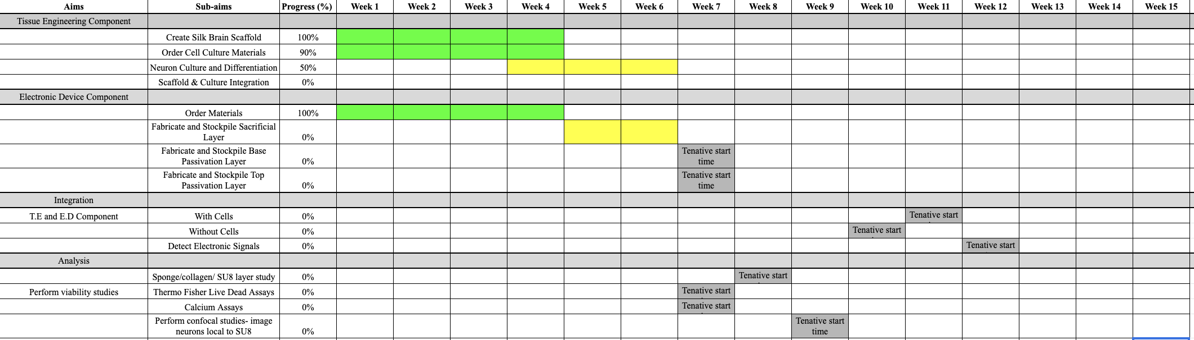

**FIGURE 9. Gantt Chart for Spring 2022.** This Gantt chart shows our current plan for spring semester work. It is a live document that will be updated on a regular basis.

**Individual Contributions**

**Zainab:** Design Flow Chart, Methods, Website Design, Engineering Design, Final Presentation, Blog Posts on Website, Silk Processing, Cell Culture, Gantt Chart

**Enrique:** Introduction, Citations, Formatting, Figure 4, Engineering Design, Final PowerPoint, Figure 8 Image Processing, Imaging, Silk Processing, Cell Culture

**Diamond:** Specific Aims, Unifying Figure, Methods, Abstract, Engineering Design, Final PowerPoint, Imaging, Cell Culture

**Acknowledgments:** We would like to thank Professor Timko and Professor Kaplan for their guidance and mentorship on this project. We would also like to thank Marilyn Kelly for all her assistance and guidance with cell culture and silk scaffold preparation.

**Appendix A**

**Base Passivation Layer Fabrication**

**Nickel Sacrificial Layer**

1. Plasma Clean the Silicon Wafer (plenty available on *Timko Lab* shelf in Clean Room) in March CS-1701F Reactive Ion Etcher
   1. Parameters: 100% Oxygen Clean, 200 W Power, 60s Clean Time, 60-80mT Base Pressure (80mT is best)
   2. **This device requires a formal *Check-Out* with Clean Room Staff. Refer to and study the “March CS-1701F Reactive Ion Etcher” protocol available on the Tufts Micro- and Nanofabrication Website**
   3. Result of this step can be seen in Figure 9A, on the left side
2. Sputter 200nm of Nickel onto the Silicon Wafer
   1. *Nickel thickness is subject to change depending on finial results.*
   2. *You must allow the sputter to pump-down/pressurize for at least an hour to have a high-quality film sputtered onto the silicon wafer. Longer Pump down = Lower Base Pressure = Higher Quality Sputter*
   3. *During this pump down, we recommend taking out the SU8 2002 from the 7˚C fridge and allowing it to warm to room temp.*
   4. **This device requires a formal *Check-Out* with Clean Room Staff. Refer to and study the “Nanomaster NSC-3000 DC Magnetron Sputter Tool” protocol available on the Tufts Micro- and Nanofabrication Website**
   5. Result of this step can be seen in Figure 9A, on the right side

Base Passivation Layer

1. Dehydration bake at 150 ˚C wafer on an uncovered hotplate for 5 minutes.
   1. *Do not place wafer directly back into petri dish – this will melt the plastic. Place a nanofab napkin down as a barrier.*
2. Using the nitrogen gun, blow condensed air onto the wafer to remove any immediately obvious impurities.
   1. *Blow air at an angle by holding the wafer at 45 degrees, moving gun in a sweeping motion.*
3. In a small brown, glass bottle, pour a small amount of SU8. Use this to collect from to prevent contaminating the large stock bottle.
4. Using the “Dirty Spinner,” spin SU8 2002 onto the wafer by pipetting ~2mL onto the surface of our wafer then starting a spin cycle. Cover as much of the surface area as you can but avoid adding so much that the SU8 begins to spill over.
   1. Parameters: 60 second spin at 1000rpm in 3 steps. *A build up, a spreading, and a slowdown. Example: 10 seconds @ 1000rpm, 60s @ 1000rpm, & 10 seconds @ 0rpm*
   2. **This device *does not* require a formal *Check-Out* with Clean Room Staff. Refer to and study the “Laurell WS-400B-6NPP-Lite Manual Spinner” protocol available on the Tufts Micro- and Nanofabrication Website. We highly recommend still observing an experienced user using this machine.**
5. Pre-Bake wafers at 95 degrees Celsius on the hotplate
   1. Results after this step can be seen in Figure 9B
6. Using the Timko Lab Mask and the mask aligner, expose the SU8 layer under the mask to UV.
   1. Parameters: 10.7 second exposure, 30nm alignment separation distance, hard contact.
   2. **This device requires a formal *Check-Out* with Clean Room Staff. Refer to and study the “Karl Suss MA6 Mask Aligner” protocol available on the Tufts Micro- and Nanofabrication Website**
   3. *This device has a UV bleed! You MUST turn away and warn other people in the lab that the UV lamp is about to be exposed!!*
   4. *For the passivation layer, the Alignment step can be skipped from the online protocol.*
7. Post-bake at 95 ˚C on a hotplate for 2 minutes

Chemical Processing for Base Passivation Layer

**Working in the Solvents Fume Hood**

1. If not already available - gather a glass petri dish large enough to hold your wafer. Get another Glass beaker that’s large enough to hold all your wafers – a 1000mL beaker tends to be good enough for one wafer.
   1. *Label the petri dish “SU-8 Developer” and the beaker “SU-8 developer/IPA.”*
2. Get SU-8 Developer from the solvents Cabinet – tends to be on the bottom shelf.
   1. *Half-fill a glass petri dish with the developer – there should already be one with a label on the shelf next to the fume hood. ONLY USE GLASS DISHES*
   2. Develop Exposed wafer in the solution for ~60 seconds.
   3. Refer to “SU-8 Photoresist Processing” protocol for further details.
   4. Results of this step can be seen in figure 10A.
3. In the “SU-8 developer/IPA” beaker, hold the developed wafer over the opening and carefully spray the surfaces with generous amounts of isopropanol alcohol aka IPA. This should be readily available in the fume hood.
4. Blow condensed air onto the wafer surface at an angle in sweeping motions.
5. Hard Bake the wafer on a hot plate at 200˚C for 10 minutes
6. While Baking, clean fume hood
   1. *Dump SU-8 developer and SU-8 developer/IPA solutions into satellite waste found under fume hood. Refer to “SU-8 Photoresist processing” protocol for proper labeling and accumulation vessel for this solution.*
7. After baking, transfer wafer to napkin lined plastic petri dish and plasma clean in RIE
   1. Parameters: 100% Oxygen, 200 W Power, 30s clean time, 80mT base pressure)
   2. Final Results can be seen in figure 10B

Nickel Etching (Currently Developing in Lab)

**Refer to “TFB Nickel Etchant” protocol regardless!! Highly volatile, corrosive, and toxic chemical and requires heavy protection and very special disposal***

**Only work in Special “Acids/Bases Fume Hood” with proper PPE**

**Always work with a partner or have someone know you are currently working with this solution. Just in case something goes wrong, someone is available to call for help***

1. Fill a 1000mL beaker with deionized water for each wafer you are processing.
2. Using TFB Nickel Etchant solution, fill a glass petri dish half full and place onto a hot plate set to 40˚C.
   1. Hold tweezers in DI water for at least 5 minutes.
3. Carefully place wafer into glass petri dish using tweezers and leave to soak until lift off (come and check on the device every 1-2 hours for ~6 hours)
4. Carefully remove the lifted off layer using a swab and gently place in DI water to rinse for at least 5 minutes.
5. Store layer in DI water in a separate Tupperware container then properly clean up following lab protocol.
6. Wash hands afterwards in nearby bathroom

**Appendix B**

**Tissue Culture Methods**

MEF Media:

•500mL DMEM + Glutamax (Gibco #10569)

•50mL heat-inactivated FBS

•5mL Anti-Anti (Gibco #152400)

*MEFS should only be passaged up to P5. Monitor morphology and proliferation rate. MEFs need to be healthy and actively dividing before inactivation process for subsequent use as a feeder layer. Inactivated MEF plates may be used between D1-6 post-plating before plating with hiNSCs. Ideally, inactivate MEFs the day of seeding hiINSCs.*

**Plating MEFs:**

1.Using 0.2% Gelatin, coat two 15cm plates with 19mL diH2O and 1mL 0.2% Gelatin to make a 0.02% coating. Let the gelatin sit for at least 20 minutes.

2.While the plates are coating, thaw one vial of MEFs on ice. Once thawed, add MEFs into 5mL of MEF media in a 15mL conical tube and spin at 1000rpm for 5 min.

3.Aspirate the supernatant and resuspend the pellet into 6/8 mL of media (some quantity that is easily divisible by 2).

4.Once the plates are done coating, aspirate the solution and replace it with 15 mL of MEF media to each plate. Add in half of the MEF containing solution such that the total volume in the plate is close to 20mL.

5.Ensure the plates are well mixed and let them rest at room temperature for 20 min before placing in the 37C incubator.

6.Change the media on the MEFs every 4 days (Mon/Thurs or Tues/Fri). Media should be room temperature before changing.

**Splitting MEFs:**

1.Once MEFs have reached approximately 80-85% confluency, they need to be split. Typically, for a large experiment, a good ratio is 2 plates to 8 plates and then to 16 plates.

2.Aspirate the media off the plate and rinse each plate with 15mL of 1X PBS. Aspirate the 1X PBS off and add 3mL of 0.25% Trypsin-EDTA to coat the plate and place in the incubator for 2-3 minutes.

3.After incubating, quench the trypsin with 6mL of media. Tap the plate on the sides a few times if the cells have not lifted.

4.Collect the cell containing solution into 15mL/50mL tubes and spin at 1000rpm for 5 min. Aspirate off the supernatant and resuspend in MEF media before re-plating onto pre-coated gelatin plates.

5.Change the media on the MEFs every 4 days.

**Inactivating MEFs:**

1. Once the MEFs have reached 90-95% confluency, they are ready to be inactivated to work as a feeder plate for the hINSCs. To inactivate, add 500uL of Mitomycin C solution to the plate, mix, and return to the incubator for 3 hours.

~Mitomycin C (Millipore, #SF008)

2. After 3 hours, aspirate off the media and rinse each plate 3 times with 1X PBS and re-add media to the plate or add INSCs and INSC media.

**Thawing and Culturing hiNSC:**

Complete Media:

• KnockOut DMEM (Thermo Fisher, #10829-018) - 307.2mL

• GlutaMax (Thermo Fisher, #35050-061) - 4mL

• KnockOut Serum (Thermo Fisher, #A1099202) - 80mL

• anti-Anti (Thermo Fisher, #15240-062) - 4mL

• 2-mercaptoethanol (Thermo Fisher, #21985-023) - 728 uL

• FGF Basic (Thermo Fisher, #PHG0024) - 100uL per 50mL aliquot at 10ug/mL

Make 50mL aliquots and spike with 100uL per aliquot. This medium can be used for up to 1 week.

*Do NOT overpipet colonies! Need to maintain some of colony structure in order to allow for future proliferation. *

*ALWAYS add bFGF fresh! *

*Never heat the media in water/bead bath! Leave on Bench for ~20-30 minutes so that it comes to room temp. *

**Thawing:**

1.Thaw a frozen vial in gloved hand

2.Add 1mL hINSC complete medium to the vial, and gently pipet and transfer to a 15mL tube containing 5mL of media .

a. add and bring up the media very slow (one drop at a time) so as to not disturb/shred the colonies.

3. Centrifuge cells at 3000rpm for 2 minutes and resuspend in 10mL of fresh complete medium

4. Remove medium from feeder plate, and add hiNSC suspension

a. In the scope, you should see sphere-like clumps of cells floating above the feeder layer

5. Let sit out for 20min before putting into the incubator

6. Change media every 1-2 days

*\*When pipetting INSCs, pipette media directly onto the cell pellet quickly to dislodge it. Bring the solution up once and back down once before finally collecting it for plating. The pellet should be completely off the bottom and in pieces in the suspension.*

**Passaging hINSCs:**

1.Rinse the plate with 20mL of 1X PBS

2.Add 3mL of TrypLE. Incubate at 37C for approximately 1min (Do not over-trypsinize)

3.Add ~6mL of complete medium to stop the reaction. Use a cell scraper to gently dislodge colonies in a circular motion.

4.Transfer all colonies in suspension into a 15mL tube. Rinse plate once with 1XPBS to make sure all colonies were collected

5.Centrifuge at 3000rpm for 1 min

6.Resuspend in complete medium for appropriate colony density

7.Remove medium from MEF feeder plate and add colony cell suspension. Rock plate gently to evenly distribute colonies.

8.Cultures typically need to be passaged once per week.

*for seeding, use high density cultures and create a single cell suspension by pipetting more thoroughly*

**Appendix C – Likely to be removed**

**Previous Updates and Additional Images**

We worked on taking care of our cells this week, making sure to seed neurons, change media, we have continued to prepare more silk scaffolds for our experiments. We have also met with Marilyn and Prof. Timko on multiple occasions to discuss plans and update them on what we have been doing. I have attached two photos detailing our neuronal colonies which were seeded on top of fibroblasts. In the future we plan to fabricate our device, glue the device and the scaffold together then, seed our neurons onto the device.

Left is a light microscope image of our cells and the right is a zoomed in photo showing our colonies.

1. 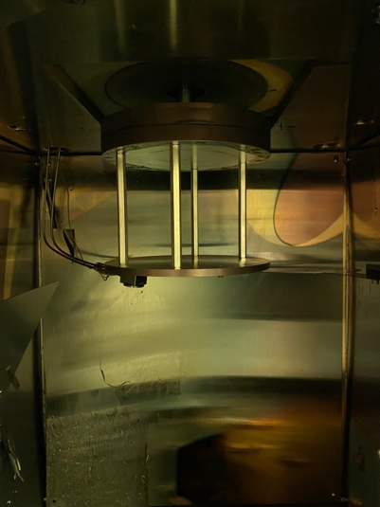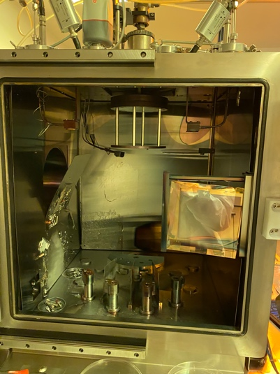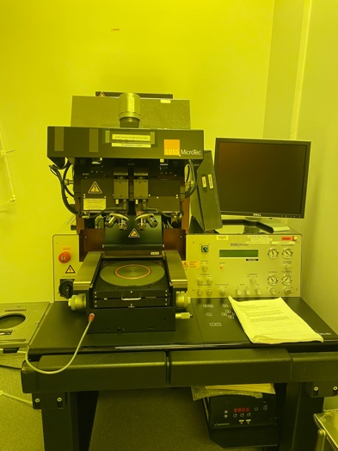**This is the mask aligned which we will use to set the SU8 and print our mask patterns**
2. **The inside of the evaporator, up top is where we have the wafer, and the bottom is where we put the metal pellets**
3. **Up-close of our stage extender which literally brings our wafer closer to metal sources**
4. **Our seeded scaffold @ 2 weeks**

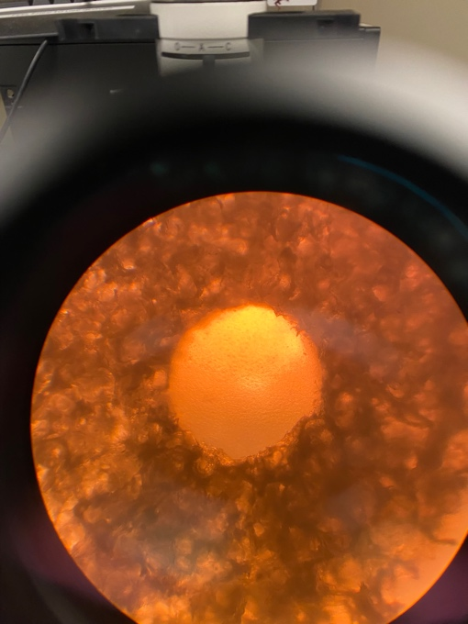

**References:**

(1) Cote, M. A. Development and Characterization of a Bioelectronic Scaffold for a Hybrid Brain Model. M.S., Tufts University, United States -- Massachusetts, 2022. https://www.proquest.com/docview/2669590847/abstract/418D560B55E64CC0PQ/1 (accessed 2022-09-29).

(2) Chwalek, K.; Tang-Schomer, M. D.; Omenetto, F. G.; Kaplan, D. L. In Vitro Bioengineered Model of Cortical Brain Tissue. *Nat. Protoc.* **2015**, *10* (9), 1362–1373. https://doi.org/10.1038/nprot.2015.091.

(3) Tang-Schomer, M. D.; White, J. D.; Tien, L. W.; Schmitt, L. I.; Valentin, T. M.; Graziano, D. J.; Hopkins, A. M.; Omenetto, F. G.; Haydon, P. G.; Kaplan, D. L. Bioengineered Functional Brain-like Cortical Tissue. *Proc. Natl. Acad. Sci.* **2014**, *111* (38), 13811–13816. https://doi.org/10.1073/pnas.1324214111.

(4) Wood, C.; Williams, C.; Waldron, G. J. Patch Clamping by Numbers. *Drug Discov. Today* **2004**, *9* (10), 434–441. https://doi.org/10.1016/S1359-6446(04)03064-8.

(5) Russell, J. T. Imaging Calcium Signals in Vivo: A Powerful Tool in Physiology and Pharmacology. *Br. J. Pharmacol.* **2011**, *163* (8), 1605–1625. https://doi.org/10.1111/j.1476-5381.2010.00988.x.

(6) Dingle, Y.-T. L.; Liaudanskaya, V.; Finnegan, L. T.; Berlind, K. C.; Mizzoni, C.; Georgakoudi, I.; Nieland, T. J. F.; Kaplan, D. L. Functional Characterization of Three-Dimensional Cortical Cultures for In Vitro Modeling of Brain Networks. *iScience* **2020**, *23* (8), 101434. https://doi.org/10.1016/j.isci.2020.101434.

(7) Liaudanskaya, V.; Chung, J. Y.; Mizzoni, C.; Rouleau, N.; Berk, A. N.; Wu, L.; Turner, J. A.; Georgakoudi, I.; Whalen, M. J.; Nieland, T. J. F.; Kaplan, D. L. Modeling Controlled Cortical Impact Injury in Three-Dimensional Brain-like Tissue Cultures. *Adv. Healthc. Mater.* **2020**, *9* (12), e2000122. https://doi.org/10.1002/adhm.202000122.

(8) Nemani, K. V.; Moodie, K. L.; Brennick, J. B.; Su, A.; Gimi, B. In Vitro and in Vivo Evaluation of SU-8 Biocompatibility. *Mater. Sci. Eng. C* **2013**, *33* (7), 4453–4459. https://doi.org/10.1016/j.msec.2013.07.001.

(9) Joye, N.; Schmid, A.; Leblebici, Y. Electrical Modeling of the Cell–Electrode Interface for Recording Neural Activity from High-Density Microelectrode Arrays. *Neurocomputing* **2009**, *73* (1), 250–259. https://doi.org/10.1016/j.neucom.2009.09.006.

(10) Kim, U.-J.; Park, J.; Joo Kim, H.; Wada, M.; Kaplan, D. L. Three-Dimensional Aqueous-Derived Biomaterial Scaffolds from Silk Fibroin. *Biomaterials* **2005**, *26* (15), 2775–2785. https://doi.org/10.1016/j.biomaterials.2004.07.044.

(11) Cairns, D. M.; Chwalek, K.; Moore, Y. E.; Kelley, M. R.; Abbott, R. D.; Moss, S.; Kaplan, D. L. Expandable and Rapidly Differentiating Human Induced Neural Stem Cell Lines for Multiple Tissue Engineering Applications. *Stem Cell Rep.* **2016**, *7* (3), 557–570. https://doi.org/10.1016/j.stemcr.2016.07.017.