Development of Bioelectronic Scaffolds for Hybrid Brain Tissue
Enrique Rodriguez, Zainab Olushoga, Diamond Mensah
Dr. Brian Timko & Dr. David Kaplan
March 3, 2023

New Edits Highlighted in Yellow

ABSTRACT
Bioelectric sensors are a popular tool for quickly assessing the cellular physiologic status and metabolic changes. They have the ability to record real-time electrophysiology of active tissue - which can then be used to characterize action potentials and cellular networks. The Timko Lab has previously proposed and designed a flexible 3D bioelectronic scaffold multielectrode array (BioES) meant to be embedded with neural cells. When embedded within the hybrid engineered tissue scaffolds, these bioelectronic devices could provide stable, long-term readouts of tissue function. Within this two-team project, our research aims to develop and characterize the hybrid tissue scaffold environment and confirm the biocompatibility of the hybrid brain model and the bioelectronic device by embedding the bioelectronic device into the hybrid brain model. This type of integration has not previously been achieved and verifying this possibility could open a new range of possibilities for the field of bioengineering.
This project is adapted from Megan A. Cote’s thesis submitted for a Master of Science in BME¹

Key Words: bioelectronics, brain model, silk scaffolds
ENGINEERING DESIGN
The project's overall objective and the end goal is to embed a 3-layer, bioelectronic device into a 3D brain tissue model. We plan for the human-induced neuronal stem cells (hiNSCs) to grow in a porous silk scaffold and to integrate a flexible 3D bioelectric scaffold multielectrode array (BioES) to form a hybrid brain model. Once this is accomplished, we expect to be able to measure electrical impulses from the neuronal cells seeded into the scaffolds. Successful integration means that it may be possible for researchers to monitor the electric signals in live organoids, specifically those modeling brain and cardiac tissue. The use of these bioelectronic chips will allow for the creation and verification of more representative models.
Our first objective is to integrate the top SU-8 layer of the BioES into the empty silk scaffold using an adhesive. The SU-8 is a polymer with inert electrical properties and high compatibility with cells. The larger two electrodes/layers just serve as ground references for the system which is why initial studies will focus on integrating just the SU8 layer. Next, we will assess structural integrity and compatibility between the empty silk scaffold (no hiNSCs), the SU-8 layer, and the surgical adhesive by looking for deterioration over time. Our next objective would be to generate hiNSC seeded scaffolds with an embedded SU-8 layer and conduct viability assays of the cells to ensure long term survival within the silk scaffolds and device. We also plan on immunostaining our samples to visualize neural cells in the silk environment. We want to conduct metabolic calcium fluorescence assays to ensure spontaneous neural activity. Our final objective for this semester is to perform confocal studies to image neurons and activity on the SU-8 layer. Successful integration will signify a sound basis to move forward with the 3-layer BioES device.
From there we want to move forward with integrating the brain model with the completed 3-layer BioES. We want to perform viability studies - starting with live-dead assays for cell survival within the device. We are still exploring which methods and will optimize as we move forward. As of now, we will be using soldering to connect the bioelectronic device to the PCP board to measure the voltage of the neurons. We will use Kwik-Sil Silicone Elastomer as an adhesive to connect our seeded silk scaffolds to the BioES and the SU-8 layer.
We expect there to be issues, especially regarding the travel between the Clean Rooms where the device is constructed, and the cell culture labs where the brain model will be developed. This could bring up issues with sterility. Current plans are to sterilize all materials with 70% ethanol and to sterilize the device and its layers with both 70% ethanol and UV exposure from the tissue culture hood since we could not find another UV source.
There may also be issues regarding the cell density which we seed since we are planning on sandwiching the BioES between 2 pieces of seeded silk scaffolds rather than cutting one scaffold in half. In addition, we want to ensure there are enough cells in contact with the device interface. For this, we plan on having multiple sets of empty scaffolds ready if we find that we need to increase our seeding density. As of now, we are moving forward using the standard seeding protocol used in the Kaplan Lab^{2,3}.
DESIGN FLOW CHART
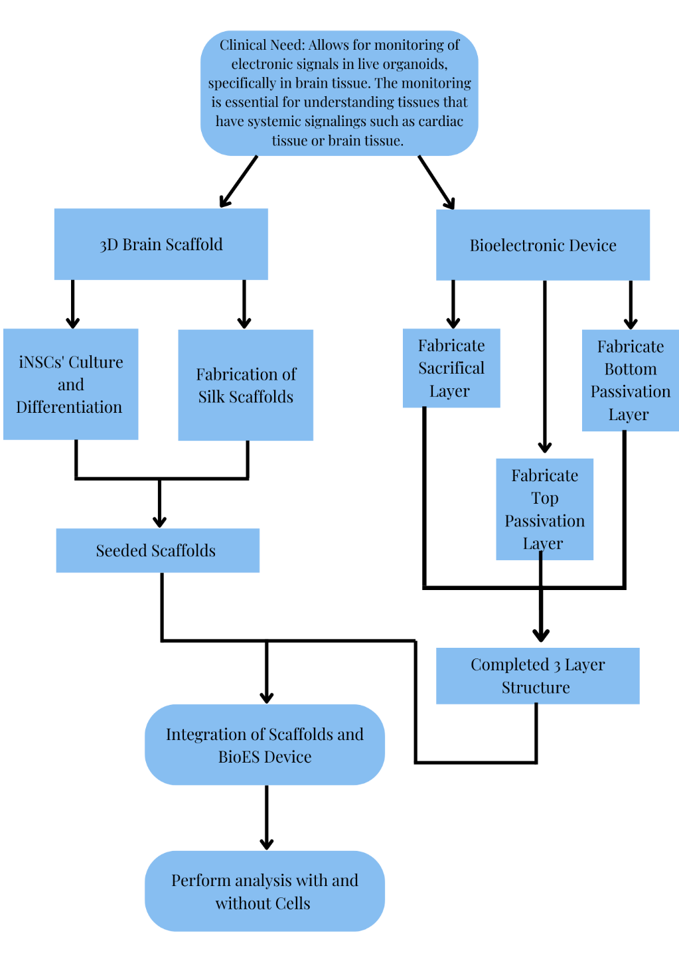
FIGURE 1. The design flow chart of our project shows the main objectives and goals of the current project as well as the ultimate endpoint for this semester. Arrows demonstrate intended progress.
INTRODUCTION & BACKGROUND
Bioelectronics as stated in the name combines biology with electronics. With recent advancements, there is a promise that bioelectronics can be used to understand tissues that rely on electric signaling to lead their function. Along with understanding the tissues, a better understanding of diseases that affect these tissues can also be developed. Currently, methods of understanding electrophysiology are invasive and complicated such as patch clamp assays or they lack temporal resolution such as Calcium Fluorescence imaging^{4,5}.
We believe that a hybrid tissue, which is an organoid embedded with a bioelectronic could address the problems related to invasive and complicated protocols associated with electric signal tracking. We are specifically interested in using this for neurons and brain tissue generally. The Kaplan Lab has already established a brain model using neurons and silk fibroin as a scaffold^{2,6,7}. The organoids serve as a 3D functional model of the brain that can spontaneously fire, they also can alter the compositions of the scaffold to model a selection of disease states associated with neurons and brain tissues⁶. The scaffold shown in figure 2 has the exact dimensions and components as those used in this method the only difference is that the scaffolds used in the hybrid tissue have an additional hole in the middle making a donut shape to allow for a representation of grey matter to be the silk section and the hole to be the white matter section of the tissue model.
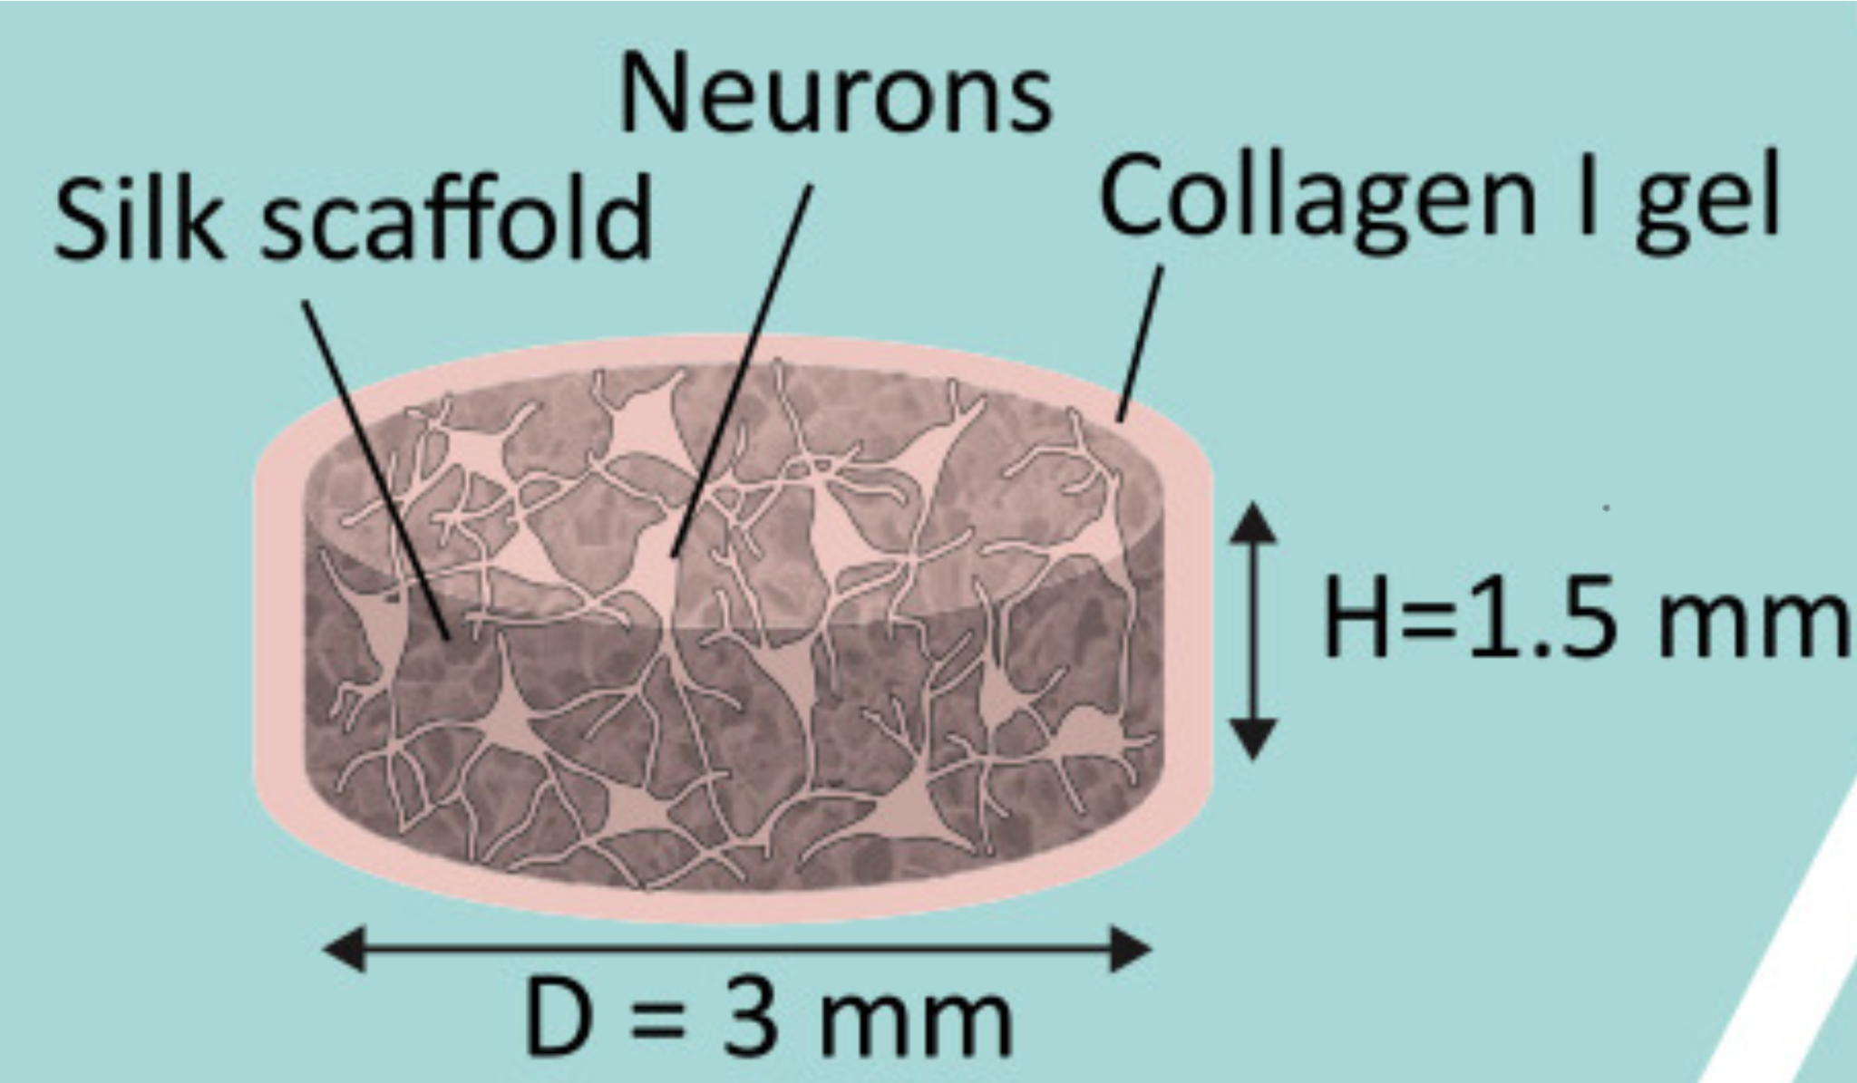
Figure 2 Model of the Brain Tissue. Shows the dimensions and important components of the 3D functional tissue model⁶.
The bioelectronic sensor we plan to use for our projects is a flexible scaffold that is designed to interface with neural cells. The sensors record real-time electrophysiology of electric active tissue. These readings allow us to characterize action potentials and cellular networks. Additionally, we can monitor ion channel states, and evaluate neural pathways. Specifically, the sensor is attached to a multielectrode array that was designed in the Timko Lab¹. The multi-electrode array is rigid so it will not contour to the tissue meanwhile the sensor is flexible to allow for it to integrate with the active tissue, promoting cell-to-cell communications. Our main focus is the integration of the hybrid brain model. To ensure that the device could interface with cells they coated the microelectrode array with SU8 on the top and bottom, shown in a piece breakdown in figure 4. The reason why SU8 was selected as passivation is that it is known to be biocompatible, inert, and compatible with the neuronal cells^{1,8}. Gold was chosen as the metal for electronics because of its malleability as well as its low toxicity¹.
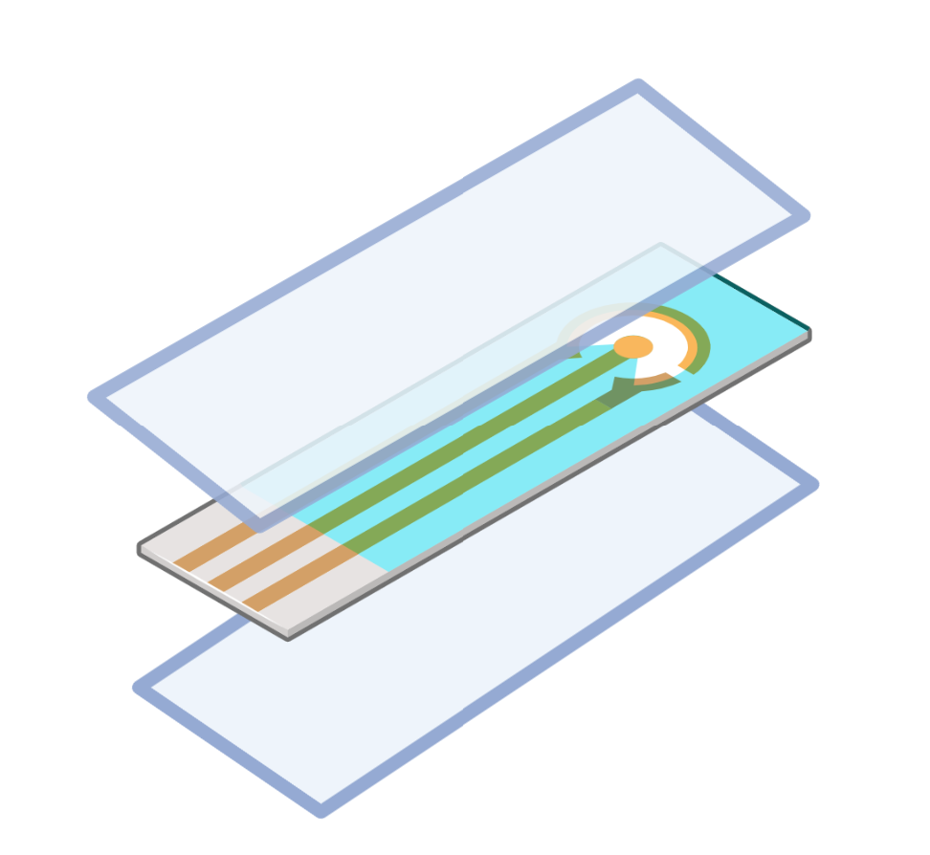
Figure 3 Schematic of Layers of the bioelectronic device. Light blue layers represent SU8+ and the middle layer represents gold electrodes.
For this integration, we plan on using Kwik-Sil Silicon Elastomer purchased through World Precision Instruments. Kwik-Sil is a medium-viscosity surgical adhesive specifically developed for chronic peripheral nerve studies – so we know that it is biocompatible. WPI markets it as having good adhesion and high tear strength and elongation which should allow for long term (multiple days – weeks) of study without bond breakage. Maintaining adhesion and structural integrity will allow for us to successfully complete our studies and will allow for our device to be functional when it comes time to use it as an actual brain model in disease studies.
Separately the brain model and the flexible electronic innovations are well-known and researched however it's unknown how these would work together jointly. We expect that sandwiching the scaffold around the sensors would allow for the growth of neurons around the sensors, which would allow for integration. To successfully create the model hiNSCs are differentiated and then seeded on the silk scaffold. Once the neurons are in the scaffold their axons grow toward the center to communicate with one another. In Figure 4 we see an example of how the bioelectronic electrodes and the neurons will interface. This will create a circuit that can output electrical impulse readings on the surface and interior of the neurons.
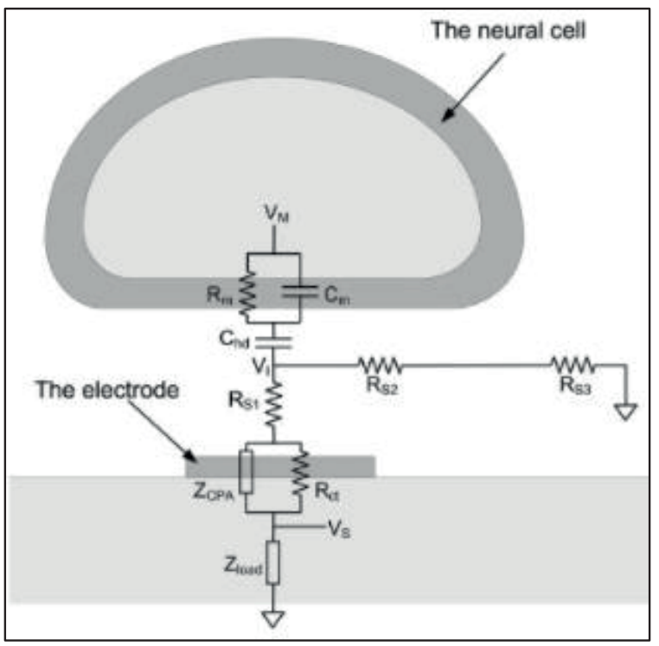
Figure 4 The Interface of the Bioelectronic and the Neurons. Adapted from Joye, Neil, et al⁹Takinging these reading forms for prolonged periods of time it will hopefully give insight into how diseases function. It will provide information about systemic signaling, and once this platform is well established it can be applied to other tissues which rely heavily on systemic and spontaneous electrical signaling.

UNIFYING FIGURE
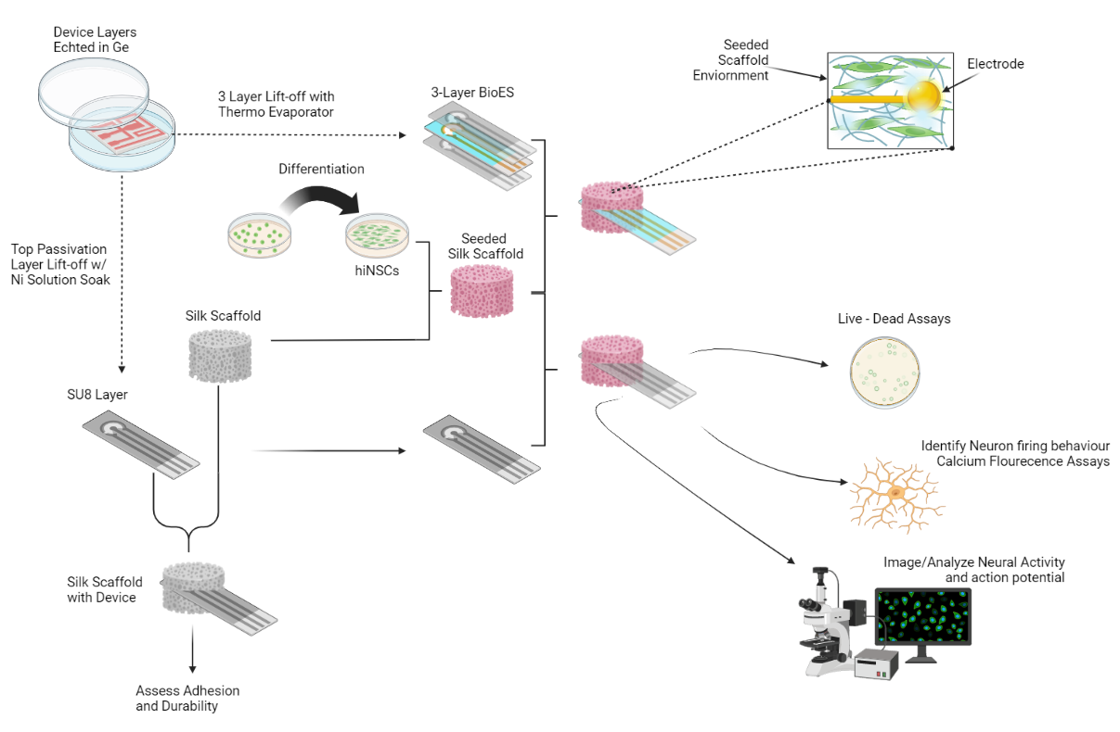
FIGURE 5. This graphical summary outlines the experimental steps of the project beginning with cell differentiation in conjunction with the BioES device layers. Assembly, compatibility assays, and viability assays will follow then finishing with the end goal of assessing how successful the fully fabricated device is at detecting action potentials and neuron behavior.
SPECIFIC AIMS
Aim 1: Evaluate Biocompatibility between polymer passivation SU8 layers, silk scaffold, and adhesive
1.1: Goal: Assess structural integrity and compatibility of empty silk scaffold and SU-8 top layer. The goal of this sub-aim is to verify the ability of our proposed integration model to maintain structure and integrity while in before to adding any hiNSCs. Structural integrity is an important foundational step to ensure our brain model and device are compatible and stable for future experiments. This step is also important for determining if our adhesive can hold the structure together. We will generate silk collagen scaffolds with no seeded hiNSCs and adhere the scaffolds to the electrode end of the SU8 device using Kwik-Sil Silicone Elastomer. We will observe the model’s degradation overnight (>6 hours), and we will observe its ability to maintain structural integrity when it’s touched/moved afterwards. This will aid in verifying our current design model. We will measure success by observing no deterioration in our scaffolds and our ability to gently lift the adhered scaffold for ~1 minute after 24 hours, 48 hours, and 96 hours. Although the body of the adhesive container can be sterilized in 70% ethanol, the liquid within cannot be if exposed. So, we will keep it in the lab, minimize how often it is opened to prevent dried clumps from forming, and attempt to keep it in the fume hood as often as possible. Failure to achieve this adhesion goal will have us looking at other adhesive alternatives including temperature cured collagen gels or Kwik-Cast silicone sealant which is like Kwik-Sil but is a low viscosity silicon sealant specifically developed to embed peripheral nerved with electrodes and adhere live tissue to read-out devices. That’s beyond the scope of our current goals but it may work as a good surgical adhesive.
1.2: Goal: Characterize in vitro Brain Model. Prior to full integration with the BioES, we must first be able to identify the distinct nature of the brain model environment within the silk scaffold. This aim will also help us better visualize cell clustering. As we mentioned within the Design Elements section, a problem we expect to encounter involves the seeding density of the hiNSCs. The current protocol has a seeding density of 2million cells per scaffold. We plan on sandwiching 2 scaffolds on each side of our device. There needs to be enough cells near the top layer of the scaffold which will be in contact with the SU-8 and BioES for them to receive signaling information. Within this aim, we will be able to characterize the brain model and the growth behavior of the hiNCSs. Here hiNSCs will be thawed and grown as per Kaplan lab protocol^{2,3}. Once confluent, they will be seeded onto the silk scaffolds with a collagen gel mixture and allowed to grow within the scaffold overnight. We will conduct Calcein AM viability assay to assess cell viability within the hybrid scaffold (goal: 70-80% viable cells per scaffold group), Beta III Tubulin tuj1 stain of scaffold sections to visualize and quantify neural cell density within the silk environment (goal: 1.2-1.3 million cells/mm^3), and possibly a Flou-4 AM Calcium Imaging assay to verify spontaneous neural activity as spontaneous activity is essential for obtaining readouts from the complete 3-layer BioES device (goal: >12 events/min). Successful achievement of these goals will verify our stem cell growth plan and seeding. If we can’t achieve our goal for the calcium assays, we could also stain our samples for common neuralderm markers or conduct quantitative PCR (qRT-PCR) to analyze the expression of genes known to change during neural development. Failure from more than 1 of these objectives would mean we would need to rework our initial seeding amount or colony growth timeline.
1.3: Embed the SU-8 layer of the BioES into the in vitro brain model. This will work in the same way as Aim 1.1 except the scaffold will no longer be empty. The Brain model part will be kept in a petri dish with cell culture media to keep neurons alive and viable. Cell viability will be assessed within this new complex environment using live-dead assays to ensure longer-term survival within our setup. This will help us finalize the biocompatibility and viability between all the interacting parts of our devices and scaffolds to ensure they will survive when fully integrated in Aim 2. Success will be if we observe 70-80% cell viability, otherwise, we may have to revisit our seeding or device fabrication plans. We will also perform confocal imaging on the hybrid device to image neural cells local to the SU8 device to characterize, visualize and assess their behavior/health. We will also repeat our Aim 1.2 assays specifically with the same output goals to verify consistent neuronal activity/readouts both with and without the device.
Aim 2 (Future): Generate Seeded Scaffolds with an embedded 3-layer BioES
Here we will repeat the plans described in Aim 1.3 but now we will utilize the completed 3-layer BioES device. The exposed end of the BioES device which is not connected to the seeded brain model will then be soldered onto the PCP board to begin measuring neuron voltage output and spontaneous electrical signals.
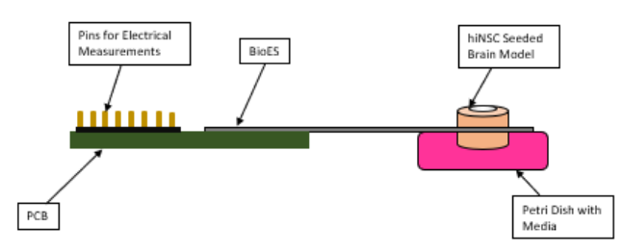
FIGURE 6. Completed hybrid brain model assembly plan - as adapted from Megan A. Cote¹

METHODS
Silk Scaffolds were developed using a protocol established by the Kaplan lab - no changes were made¹⁰. 5 grams worth of silkworm cocoons are cut and boiled in 2 liters of deionized water. They are then rinsed in cold DI water three times before being transferred to a fume hood for overnight drying. Once dry, silk was dissolved in a lithium bromide solution and this mixture was dialyzed over 3 days. After 3 days, the mixture was centrifuged, and the silk concentration was calculated. Water was either added or dried from the solution until the desired 6% concentration was achieved.
Cell Culturing was developed using the Kaplan lab protocol with no changes being made. This began with thawing and plating mouse embryonic fibroblasts (MEFs) to secrete growth factors and promote pluripotency in our stem cells¹¹. MEFs media was changed every 4 days until they reached 90-95% confluency then hiNSCs were ready to be added. The MEFs were inactivated by adding 500ul of Mitomycin C to the culture plate, leaving it to rest for at least 3 hours, then washing 3x with 1X PBS. HiNSC complete media was added to the plate. HiNSCs were then thawed, centrifuged, and gently added to the same culture plate to not break up the cell colonies. The plate was left to rest for 20 minutes before being incubated. The media was changed every 1-2 days (preferably 1 day to further delay differentiation and to allow for stronger proliferation of stem cells). All cells were cultured using standard sterile tissue culture technique.
For BioES sterilization, the device will be gently removed from DI water, thoroughly sterilized in 70% ethanol, then allowed to sterilize under the tissue culture hood’s UV light which remains on for ~2 hours but we will leave it overnight. The next day, in that same culture hood, the device will be placed in a sterile petri dish with silk scaffolds and a sprayed down adhesive bottle. Once the device is adhered to the scaffold, we will place everything in a sterile dish where cells can then be seeded. All work involving the scaffolds will be done in the lab hoods to minimize any contamination.
Silk Scaffold preparation and integration began by aspirating deionized water from the silk sponges and transferring them to a 6-well plate, 1 scaffold per well. Coating silk scaffolds in poly-L-orinthine (PLO) solution until scaffolds are submerged and then leaving them in the incubator overnight. The next day, aspirate the PLO solution off the scaffolds and wash them with PBS using the bench rotator for 3 minutes at 15rpm – aspirate off PBS and repeat this 4x. Then coat scaffolds with Mouse Brain Laminin for 4-6 hours. In fume hood, place and adhere 1 scaffold to each side of the SU-8 layer with the Kwik-Sil Elastomer and allowing to cure at room temperature for 20 minutes (figure 7).
Cell seeding onto composite structure began by preparing roughly 150mL of complete hiNSC media. HiNSCs are lifted from their culture plate and counted. Using sterile tweezers, scaffold+SU8 composite structure are moved to new plates. Carefully dry off scaffolds using an aspirating pipette. Individually seed each sponge with 2 million cells, incubate for 30 minutes, then add 150uL of complete media. Return to incubator overnight. The entire structure will then be backfilled with collagen.
Beta Tubulin 3 Staining was conducted by lightly drying and transferring mature, seeded scaffolds into a new 48-well plate. Scaffolds were treated with ~500ul of a 4% PFA fixing solution for 1 – 12 hours in the 4°C fridge. The fixing solution was aspirated out and scaffolds were then treated with ~500ul of blocking buffer for 30 minutes at room temperature then it was aspirated out. A solution of primary antibody (Mouse beta-tubulin – 1:1000 dilution) was created and added to scaffolds and agitated overnight in the 4°C fridge. The following day, primary antibody was aspirated out and the scaffolds were washed with 1X PBS 5 times for 5-10 minutes per wash on a shaker. A secondary antibody solution was created (488 Goat Anti Mouse – 1:500 dilution) and added to the scaffolds. The plate was covered in aluminum foil and left at room temperature for 1 hour. The secondary antibody was washed out with PBS, scaffolds were placed on the shaker in just a PBS solution for 5-10 minutes, re-covered with aluminum, and finally stored in the 4°C fridge until imaging could be done.
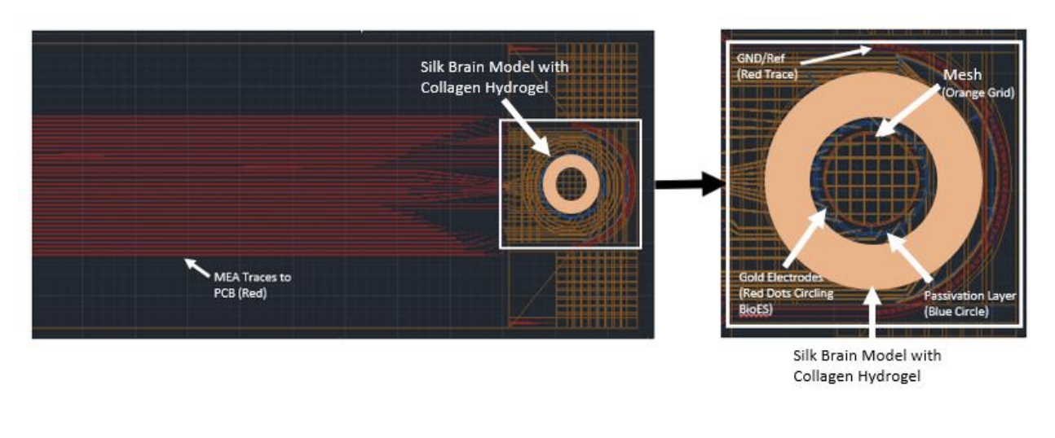
FIGURE 7. Bioelectronic Device and Scaffold Set Up (CAD Design) - as adapted from Megan A. Cote¹

RESULTS
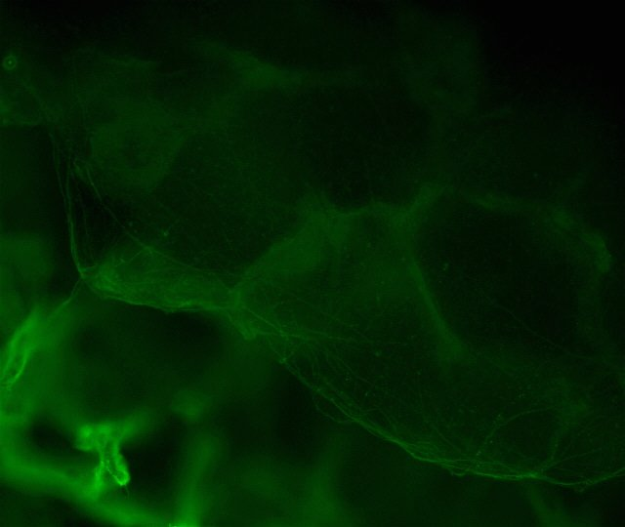
FIGURE 8. Neurons in 3D Silk Scaffold. This image was attained using a Beta Tubulin-3 Assay stain, where green shows the scaffold and the neurons.
In Figure 8, the Beta Tubulin-3 Assay reveals that there was a network of live neuronal cells, and they were successfully distinguished from the background and the other green silk scaffold.
DISCUSSION
Fabrication and silk processing was the first objective of the experiments. We successfully processed the silk fibroin and used it to create 3D silk donut scaffolds and then added collagen. Scaffolds that weren’t used for the experiments were stored for use the following semester. After seeding the cells contamination occurred, thus we had setbacks with our methods and had to adjust the goals for this semester. We shifted to seeding the cells on the scaffold and then performed a Beta Tubulin-3 Assay on the scaffold to validate our methods going into the upcoming semester. Our Beta Tubulin-3 staining shows that our scaffold fabrication methods resulted in visible neuronal networks, which was expected.
Sadly, network density couldn’t be evaluated due to time constraints during the day. However, a MATLAB code has been developed to quantify network density from multiple Z-stack images of live cells.
We plan on expanding our results to include a network density reading to understand if we need to modify our seeding density along with a Calcium AM assay to understand neuronal activity and verify spontaneous action potential readout.
FUTURE WORK
We plan on starting the spring semester by splitting the group to work on the various parts of the project. One or two members will work on the BioES and SU8 development in the cleanroom while others focus on the tissue engineering component as seen in our flowchart (figure 1).
As seen in figure 9, following the completion of the individual components, the focus will shift to integration, viability, and data analysis. Currently we have completed majority of the Tissue Engineering component and plan on seeding the scaffold within the next 2-3 weeks. Simultaneously we have begun working on fabricating the sacrificial layer. Due to some complications with the Tufts cleanroom, we have moved to Harvard and will soon begin fabricating the Base Passivation Layer and the Top Passivation Layer. Fabrication should move fairly quickly once we have access to the lab spaces. After fabrication we can head on to our compatibility tests and combining the two parts.

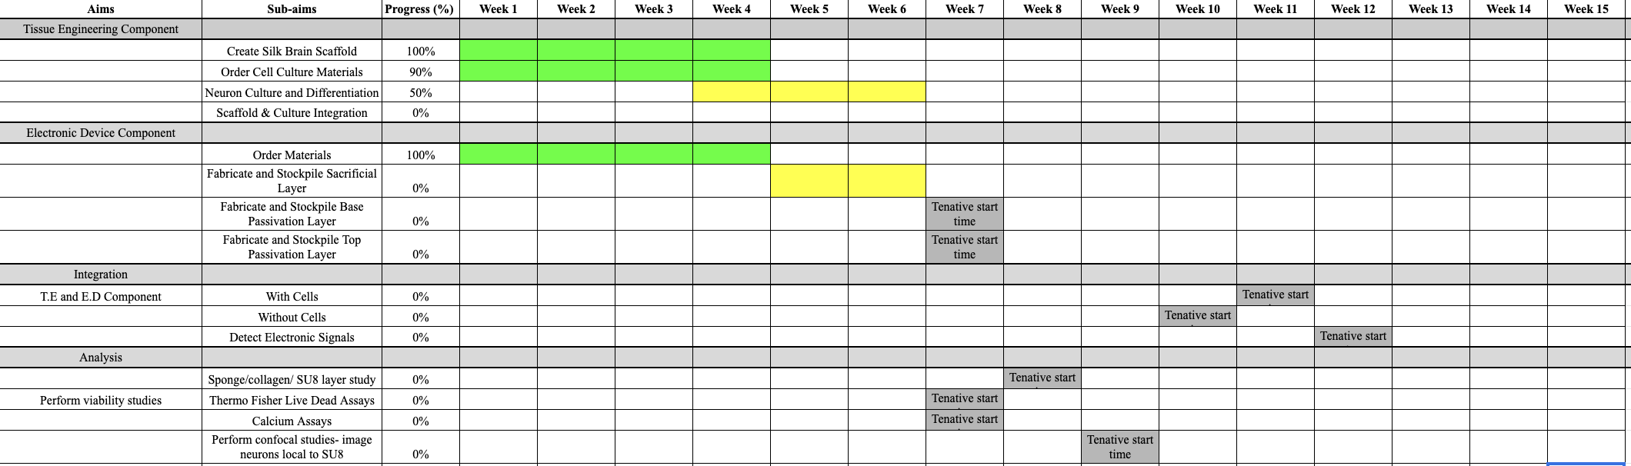
FIGURE 9. Gantt Chart for Spring 2022. This Gantt chart shows our current plan for spring semester work. It is a live document that will be updated on a regular basis.

Individual Contributions
Zainab: Design Flow Chart, Methods, Website Design, Engineering Design, Final Presentation, Blog Posts on Website, Silk Processing, Cell Culture, Gantt Chart
Enrique: Introduction, Citations, Formatting, Figure 4, Engineering Design, Final PowerPoint, Figure 8 Image Processing, Imaging, Silk Processing, Cell Culture
Diamond: Specific Aims, Unifying Figure, Methods, Abstract, Engineering Design, Final PowerPoint, Imaging, Cell Culture
Acknowledgments: We would like to thank Professor Timko and Professor Kaplan for their guidance and mentorship on this project. We would also like to thank Marilyn Kelly for all her assistance and guidance with cell culture and silk scaffold preparation.

BI-WEEKLY UPDATE 3/3/23

We worked on taking care of our cells this week, making sure to seed neurons, change media, we have continued to prepare more silk scaffolds for our experiments. We also have met with Marilyn and Prof. Timko on multiple occasions to discuss plans for the future and update them on what we have been doing. I have attached two photos detailing our neuronal colonies which were seeded on top of fibroblasts. In the future we plan to fabricate out device glue the device and the scaffold together then, seed our neurons onto the device.
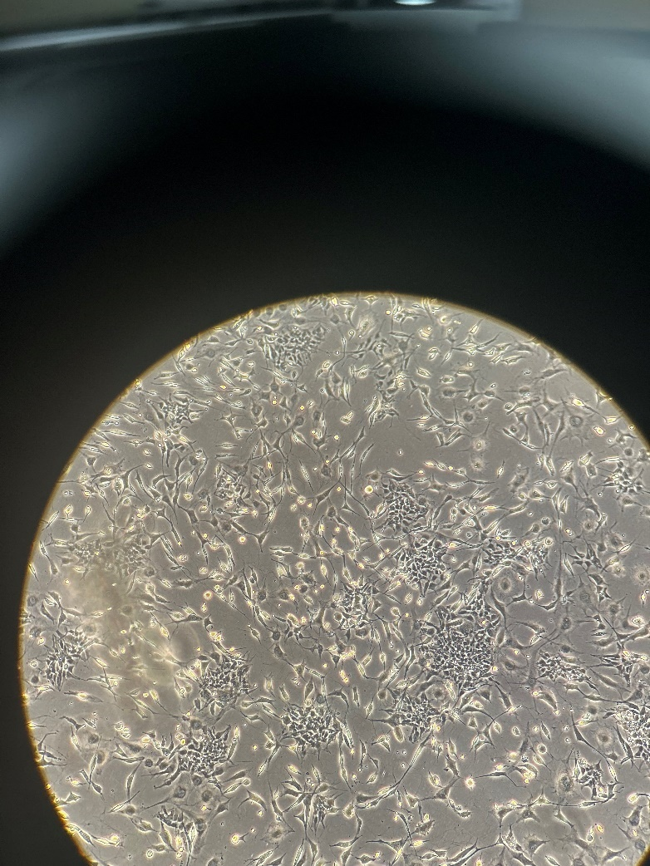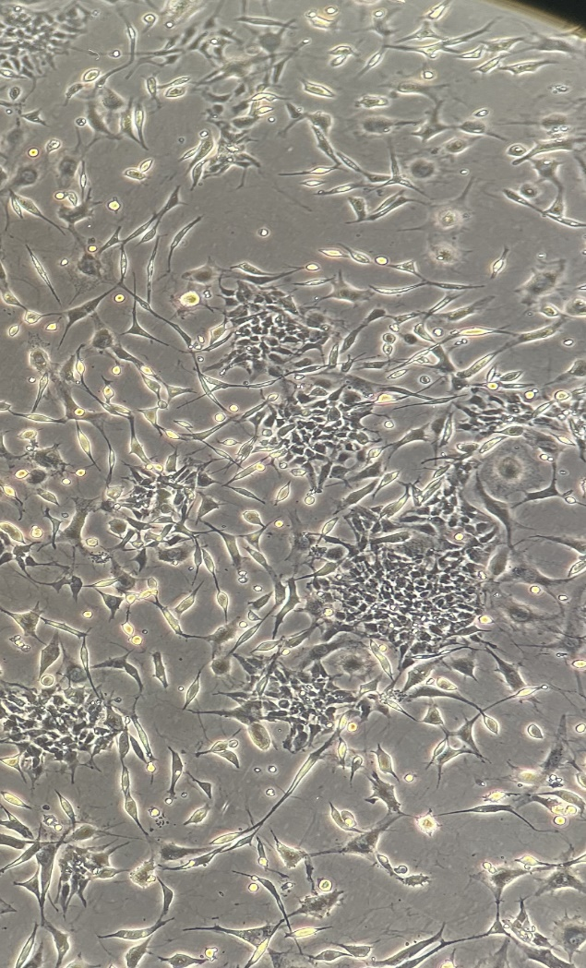

Left is a light microscope image of our cells and the right is a zoomed in photo showing our colonies.

References:
(1) Cote, M. A. Development and Characterization of a Bioelectronic Scaffold for a Hybrid Brain Model. M.S., Tufts University, United States -- Massachusetts, 2022. https://www.proquest.com/docview/2669590847/abstract/418D560B55E64CC0PQ/1 (accessed 2022-09-29).
(2) Chwalek, K.; Tang-Schomer, M. D.; Omenetto, F. G.; Kaplan, D. L. In Vitro Bioengineered Model of Cortical Brain Tissue. Nat. Protoc. 2015, 10 (9), 1362–1373. https://doi.org/10.1038/nprot.2015.091.
(3) Tang-Schomer, M. D.; White, J. D.; Tien, L. W.; Schmitt, L. I.; Valentin, T. M.; Graziano, D. J.; Hopkins, A. M.; Omenetto, F. G.; Haydon, P. G.; Kaplan, D. L. Bioengineered Functional Brain-like Cortical Tissue. Proc. Natl. Acad. Sci. 2014, 111 (38), 13811–13816. https://doi.org/10.1073/pnas.1324214111.
(4) Wood, C.; Williams, C.; Waldron, G. J. Patch Clamping by Numbers. Drug Discov. Today 2004, 9 (10), 434–441. https://doi.org/10.1016/S1359-6446(04)03064-8.
(5) Russell, J. T. Imaging Calcium Signals in Vivo: A Powerful Tool in Physiology and Pharmacology. Br. J. Pharmacol. 2011, 163 (8), 1605–1625. https://doi.org/10.1111/j.1476-5381.2010.00988.x.
(6) Dingle, Y.-T. L.; Liaudanskaya, V.; Finnegan, L. T.; Berlind, K. C.; Mizzoni, C.; Georgakoudi, I.; Nieland, T. J. F.; Kaplan, D. L. Functional Characterization of Three-Dimensional Cortical Cultures for In Vitro Modeling of Brain Networks. iScience 2020, 23 (8), 101434. https://doi.org/10.1016/j.isci.2020.101434.
(7) Liaudanskaya, V.; Chung, J. Y.; Mizzoni, C.; Rouleau, N.; Berk, A. N.; Wu, L.; Turner, J. A.; Georgakoudi, I.; Whalen, M. J.; Nieland, T. J. F.; Kaplan, D. L. Modeling Controlled Cortical Impact Injury in Three-Dimensional Brain-like Tissue Cultures. Adv. Healthc. Mater. 2020, 9 (12), e2000122. https://doi.org/10.1002/adhm.202000122.
(8) Nemani, K. V.; Moodie, K. L.; Brennick, J. B.; Su, A.; Gimi, B. In Vitro and in Vivo Evaluation of SU-8 Biocompatibility. Mater. Sci. Eng. C 2013, 33 (7), 4453–4459. https://doi.org/10.1016/j.msec.2013.07.001.
(9) Joye, N.; Schmid, A.; Leblebici, Y. Electrical Modeling of the Cell–Electrode Interface for Recording Neural Activity from High-Density Microelectrode Arrays. Neurocomputing 2009, 73 (1), 250–259. https://doi.org/10.1016/j.neucom.2009.09.006.
(10) Kim, U.-J.; Park, J.; Joo Kim, H.; Wada, M.; Kaplan, D. L. Three-Dimensional Aqueous-Derived Biomaterial Scaffolds from Silk Fibroin. Biomaterials 2005, 26 (15), 2775–2785. https://doi.org/10.1016/j.biomaterials.2004.07.044.
(11) Cairns, D. M.; Chwalek, K.; Moore, Y. E.; Kelley, M. R.; Abbott, R. D.; Moss, S.; Kaplan, D. L. Expandable and Rapidly Differentiating Human Induced Neural Stem Cell Lines for Multiple Tissue Engineering Applications. Stem Cell Rep. 2016, 7 (3), 557–570. https://doi.org/10.1016/j.stemcr.2016.07.017.

