Project Title: Development of Bioelectronic Scaffolds for Hybrid Brain Tissue
Team Members: Zainab Olushoga, Diamond Mensah, Enrique Rodriguez
PI / Mentor(s): Dr. Brian Timko, Dr. David Kaplan

Clean Room + Device Updates since the start of the semester:
- Clean Room Shut Down indefinitely for repairs as of 01/19
  - We have prepared a back-up with the Harvard Clean Room in Cambride by prepping a proposal to send over if things go south again. We want to avoid this at all cost since another major issue with the device Ye Lim’s group had was transporting it form 200 Boston Ave to Sci Tech without damage. A trip from Cambridge would objectively be worse.
  - Have been communicating with Timko + Ye Lim to better understand the previous device fabrication protocol and make modifications based on the last group’s struggles
    - We are thinking of using a thermal evaporator rather than the Sputter Tool.
      - Ye Lim’s group struggled a lot to get proper lift off of the SU8 base layer from the nickel sacrificial layer when they utilized the Sputter Tool
      - The Sputter Tool is also offline for repairs for an indefinite amount of time…
      - The Sputter is what actually deposits the metallic film needed on the sacrificial layer and what our SU8 lifts off of
      - The thermoevaporator can also deposit metal with higher accuracy and care but, due to its build, that quality comes at the sacrifice of film thickness. We need to achieve a 200nm thickness and we hope to get that with the thermoevaporator if we use a stage extender to basically bring the sample table closer to the source of deposition. In theory, this should allow for greater deposition in the same amount of time since the distance is reduced.
    - We also spoke with members of the Kaplan Neuro Team about trying out different sized containers to transport the completed device from 200 Boston. Ye Lim’s group just used a petri dish filled with DI water which caused a lot of movement for the thin/fragile device. We couldn’t get a concrete answer regarding the SU8 layer or full device’s dimensions but we are thinking of using a more rectangular well plate to carry the device along with extra padding in the transport box to minimize how much free water it’s in and how much movement it experiences.
  - As of 02/17/2023 - Jim (Clean Room manager) told us that repairs are moving along schedule and the clean room (assuming all goes well) might be good by the end of next week so that we can start going inside.
    - They repaired the heat exchanger + ventilation problems but there are control issues that they are still sorting out.
    - Although the Clean Room is still closed, some devices are now available and can be used also the clean room is not really “clean” with the control issues. The thermoevaporator is online and since it works by creating an internal vaccum, we think the cleanness of the general room shouldn’t effect our results but we won’t know until we get the chance to go in and test it out (Timko agrees).
- The surgical adhesive we ordered through Timko lab back in October arrived this week

Tissue Culture / Wet Lab Updates
- We restarted our neuron culture this semester with plans to have 2 sets: 1 set specifically for imaging and characterizing our tissues with no device incorporation then another set of the exact same experiments but with the device (eventually) adhered and seeded. We will decide exactly how many samples go into each set once we are finished cutting all our scaffolds
- We are planning for
  - a Beta Tubilin 3 stain for neuron visualization as well as a network density quantification using a MatLab code a member of the Kaplan Lab designed and verified.
  - A Calcein AM stain for cell viability
  - A Calcium Assay to assess spontaneous firing and neuron activity - this one is still in the planning phase since we don’t have a solid protocol and other members of the Neuron team have never run one or have never successfully run one.
- For device sterilization: The plan is to use a 70% ethanol wash then UV exposure. We need to verify that the Timko Lab or Clean Room have functioning UV lights otherwise we can work with our lab space to see about using the TC hood’s built in UV light overnight (Olivia’s Idea)
- For actually getting signal readouts of the hybrid device when complete: Since the brain model needs to be kept in the incubator as much a spossibel to keep th neurons at in an ideal environment, we plan on using an incubator within the Timko Lab space. We will have the device + brain model scaffold in the incubator with the wires leading out of the door into the computer we will use to see the live readouts. The incubator may need to be turned off for a brief period of time while getting the readouts based on what previous Timko Lab members experienced while trying to run similar experiments where they needed to keep samples incubated. But this we will have to wait until we are working through it to decide the best path forward.

Project Description:
Bioelectronic devices embedded within the hybrid, engineered tissues could provide stable, long-term readouts of tissue function. We will achieve and optimize flexible, porous scaffolds that provide signals from up to 32 spatially-distinct locations. We will then embed these scaffolds within a 3D brain tissue model to obtain readouts of neural activity. Time permitting, we will apply algorithms to quantify changes in synaptic connectivity over time.

Engineering Design Elements:
- What are the objectives of the project and the criteria for selecting them?
The objective of the project is to embed a bioelectronic device into a 3D brain tissue model. We plan for the neurons(iNSCs) to grow in the scaffold and for the bioelectronic device to be integrated and form a hybrid brain tissue. Once this is accomplished we expect to be able to measure neural activity.
- What system, component, or process is to be designed?
A novel hybrid brain tissue that contains a bioelectronic embedded into the tissue. We are tasked with figuring out the best way to embed and track signals for the neurons in the hybrid tissue. We have decided that it would be best to adhere unseeded scaffolds to the device and then seed the cells onto the scaffolds and the device to ensure even growth throughout the scaffolds and the device.
- What need does it fulfill (clinical, research, etc.)?
Allows for monitoring of electronic signals in live organoids, specifically in brain tissue. The monitoring is essential for understanding tissues that have systemic signalings such as cardiac tissue or brain tissue. Using the bioelectronic chips will allow for the creation of tissues that are more representative of actual tissues.
- What scientific, math, and/or engineering methods will be applied?
Currently, we are still exploring which methods will be applied for the integration of both parts of this project. We will be using soldering to connect the bioelectronic device to the PCP board to measure the voltage of the neurons. We will be analyzing the electrical signals being output from the bioelectronic device and in the future, we plan on also performing tensile tests on our scaffolds.
- What realistic constraints (cost, safety, reliability, aesthetics, ethics and social impact, etc.) are to be considered?
Considering that individually both components of our project are well reviewed and established constraints are mainly surrounding the integration of the two components. This will be the first time evaluating so we will have to evaluate the constraints throughout our project. We believe that a real concern may be sterility since we are going to have to bring devices from the clean room on 200 Boston Ave to SciTech labs in order to create the integrated system. Another concern was the size of the device and the scaffold, specifically, we changed our approach from cutting a normal-sized scaffold in half to stacking 2 normal-sized scaffolds on top of one another using an adhesive. Aesthetically, the device could be smaller and look more like “hybrid” tissue rather than a device seemingly stabbing the organoid model. We aren’t too worried about this because this whole project is very novel and in the future, we expect there to be way more advances that will allow for a more aesthetic model. Another realistic constraint is that we are hoping that the integration of the device with the scaffold will not introduce contamination but that is a real concern considering the device will be traveling from a completely different building. Yet we plan to sterilize the device by soaking it in ethanol for 30 minutes and then washing it and never removing it from the hood before creating the hybrid device.
- What alternative solutions or changes to the plan will be considered?
We have considered embedding the bioelectronic prior to the scaffold being salt leeched, so we won’t have to worry about the adhesive working well or degrading over time. Another problem is we may have to seed more cells than normal since we are now using 2 scaffolds to make one hybrid scaffold meaning there should be double the surface area. To ensure that the neurons grow around the device, we plan to seed the scaffolds once they are attached to the device.
- What are the planned tests and what are the quantitative milestones that will demonstrate the achievement of the objectives?
Do a comparison of scaffold degradation with and without the device. Immunostaining and images to see neurons. We would also conduct a neural activity assay. To test the adhesive success we are considering performing a tensile stress test on the scaffolds and comparing the stress-strain curves of the scaffolds with and without adhesive. Where a successful adhesive will have similar properties to a nonadhesive scaffold.

- Competition: what else is going on in the field that would compete with the project plans?
As of right now, there is no competition in this field. The combination of both the bioelectronic device and the tissue model is new to the field. We attended bioelectronic hybrid tissue talks at BMES; no one is currently doing work like this in the field.

Introduction/Background:
Bioelectronics as stated in the name combines biology with electronics. With recent advancements, there is a promise that bioelectronics can be used to understand tissues that rely on electric signaling to lead their function. Along with an understanding of the tissues a better understanding of diseases that affect these tissues can also be developed. Currently, methods of understanding electrophysiology are invasive and complicated such as patch clamp assays or they lack temporal resolution such as Calcium Fluorescence imaging^{2,3}.
We believe that a hybrid tissue, which is an organoid embedded with a bioelectronic could address this gap in knowledge. We are specifically interested in using this for neurons and brain tissue generally. The Kaplan Lab has already established a brain model using neurons and silk fibroin as a scaffold^{4–6}. The organoids serve as a 3D functional model of the brain that can spontaneously fire, they also can alter the compositions of the scaffold to model a selection of disease states associated with neurons and brain tissues⁵. The scaffold shown in figure 3 has the exact dimensions and components as those used in this method the only difference is that the scaffolds used in the hybrid tissue have an additional hole in the middle making a donut shape to allow for a representation of grey matter to be the silk section and the hole to be the white matter section of the tissue model.
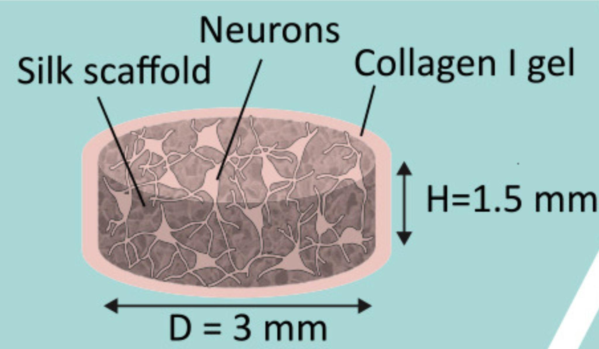
Figure 2 Model of the Brain Tissue. Shows the dimensions and important components of the 3D functional tissue model⁵.
The bioelectronic sensor we plan to use for our projects is a flexible scaffold that is designed to interface with neural cells. The sensors record real-time electrophysiology of electric active tissue. These readings allow us to characterize action potentials and cellular networks. Additionally, we can monitor ion channel states, and evaluate neural pathways. Specifically, the sensor is attached to a multielectrode array that was designed in the Timko Lab¹. The multi-electrode array is rigid so it will not contour to the tissue meanwhile the sensor is flexible to allow for it to integrate with the active tissue, promoting cell-to-cell communications. Our main focus is the integration of the hybrid brain model. To ensure that the device could interface with cells they coated the microelectrode array with SU8 on the top and bottom, shown in a piece breakdown in figure 4. The reason why SU8 was selected as passivation is that it is biocompatible, inert, and compatible with cells^{1,7}. Gold was chosen as the metal for electronics because of its malleability as well as its low toxicity¹.
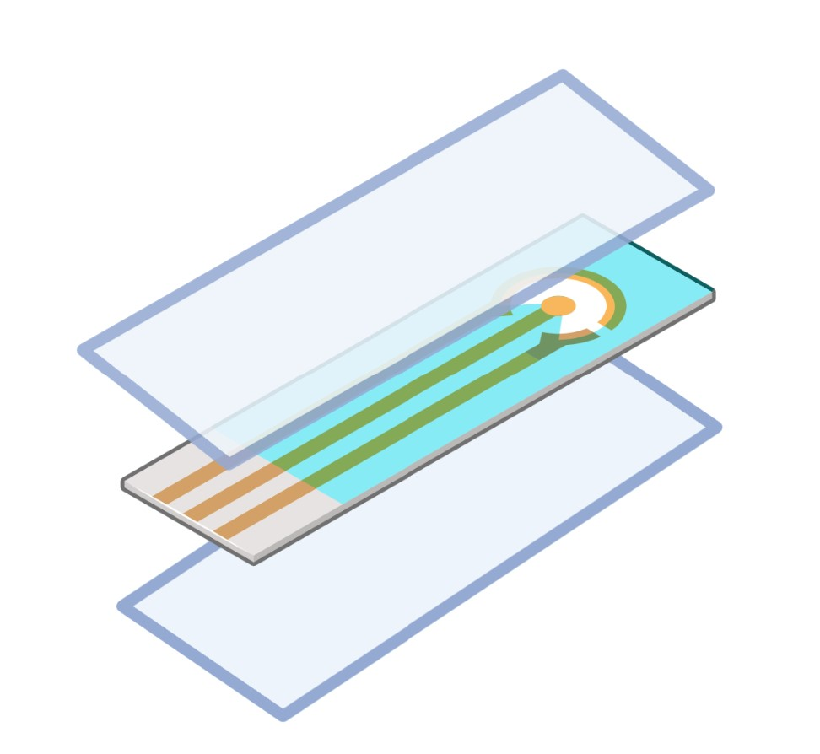
Figure 3 Schematic of Layers of the bioelectronic device. Light blue layers represent SU8+ and the middle layer represents gold electrodes.
Separately the brain model and the flexible electronic innovations are well-known and researched however it's unknown how these would work together jointly. We expect that sandwiching the scaffold around the sensors would allow for the growth of neurons around the sensors, which would allow for integration. To successfully create the model hiNSCs are differentiated and then seeded on the silk scaffold. Once the neurons are in the scaffold their axons grow toward the center to communicate with one another. In Figure 5 we see an example of how the bioelectronic electrodes and the neurons will interface. This will create a circuit that can output electrical impulse readings on the surface and interior of the neurons.
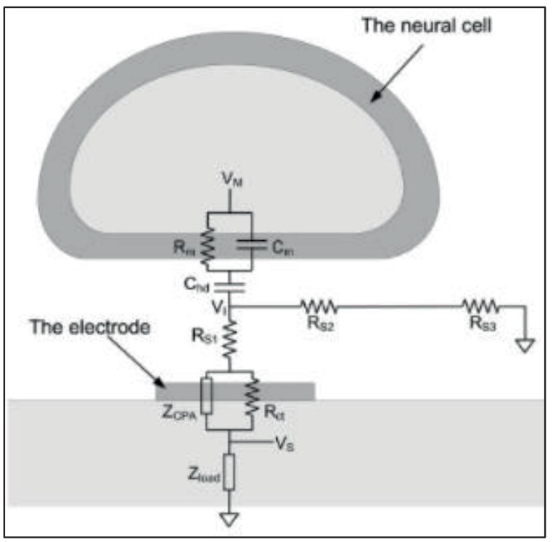
Figure 4 The Interface of the Bioelectronic and the Neurons. Adapted from Joye, Neil, et al⁸.
By taking these reading forms for prolonged periods of time it will hopefully give insight into how diseases function. It will provide information about systemic signaling, and once this platform is well established it can be applied to other tissues which rely heavily on systemic and spontaneous electrical signaling.

Methods:
Exp 0 (Current) Make the scaffolds and implant them into devices without neurons.
- Create silk scaffold donuts.
- Prepare the flexible bioelectronic device.
- Cut silk scaffold in half and input the bioelectronic
- Use a surgical adhesive
- Put in media and observe and compare degradation or lack of degradation of the scaffold.
EXP0 has to be pushed due to the SU8 layer and BioEs device being delayed due to fabrication issues + unforeseen neuronal cell culture contamination

(Future)
Exp 1 Tensile Stress Test and Shear Testing for adhesive compatibility
Exp 2 Culture seed scaffold and make sure it is viable without bioelectronics and then also with bioelectronics.
- After seeding the differentiated neurons into the scaffold we will perform cell viability assays to see how neurons are functions and compare
Exp 3 Conduct Calcium Assays to see if the neurons are spontaneously firing.
Exp 4 Take some images to characterize the neurons' immunofluorescence and imaging etc.

Exp 5 Gather signals from scaffold and neurons and perform more assays
- See how the neurons signal each other
Results (future):
Results have been set back due to unknown contamination of seeded scaffolds and nonseeded scaffolds. We plan to have to results in the next three week
Discussion (future work):
N/A
Participation:
We all are working together as much as possible on the project. We all worked together in order to fabricate the silk scaffolds.
Biweekly Report (10/14/22): In this block, we all took turns changing the water when we were doing dialysis and silk scaffold preparation. Diamond submitted the order forms for our cell media. Zainab diluted our silk after we had concentrated it post-dialysis so that it reached the proper concentration. We all worked together to sieve salt and prepare the silk for salt leaching. We observed Marilyn completely seeding her neurons on her own scaffolds, and coating her scaffolds with collagen as well.
Mid-Semester Report (10/21/22): Our contributions to the mid-semester report are detailed in the document we submitted for the mid-semester report.
Bi-weekly Report (11/04/22): We worked together with the seeding of MEFs, media changes for the MEFs, creating media to seed neurons on MEFs, then seeding the iNSCs on the scaffolds, then creating differentiation media for the iNSCs over the past few weeks by alternating days in which we went to the lab with some occasions having all of us show up to lab together. We also have begun the process of getting trained to fabricate the devices and use the cleanroom for next semester.
Bi-weekly Report(2/17/23): Diamond and Zainab plated MEFs at the beginning of the semester. After plating the MEFS, we all took turns with checking in on the MEFs and changing the media until they were 80% confluent. After they reached confluency the MEFs were split form 2 plates to 8plates by Diamond. Diamond and Enrique alternated media changes until the MEFs were ready to be inactivated. The MEFs were inactivated by Zainab. At this point Diamond washed and seeded the INSCs after we witch we also atenrated on changing the media. Enrique and Diamond took on the task of cutting new scaffolds. Due to some confusion, the neurons differentiated into single cells. Enrique took on the task of restarting our culture. Zainab was able to spilt the MEFS into 8 plates by the weeks end. We anticipate inactivation by the end of next week.
Timeline

Aims | Sub-aims | Progress (%) | Week 1 | Week 2 | Week 3 | Week 4 | Week 5 | Week 6 | Week 7 | Week 8 | Week 9 | Week 10 | Week 11 | Week 12 | Week 13 | Week 14 | Week 15
Tissue Engineering Component
 | Create Silk Brain Scaffold | 100%
 | Order Cell Culture Materials | 90%
 | Neuron Culture and Differentiation | 50%
 | Scaffold & Culture Integration | 0%
Electronic Device Component
 | Order Materials | 100%
 | Fabricate and Stockpile Sacrificial Layer | 0%
 | Fabricate and Stockpile Base Passivation Layer | 0%
 | Fabricate and Stockpile Top Passivation Layer | 0%
Integration
T.E and E.D Component | With Cells | 0%
 | Without Cells | 0%
 | Detect Electronic Signals | 0%
Analysis
 | Sponge/collagen/ SU8 layer study | 0%
Perform viability studies | Thermo Fisher Live Dead Assays | 0%
 | Calcium Assays | 0%
 | Perform confocal studies- image neurons local to SU8 | 0%

Green = Completed
Yellow = In progress
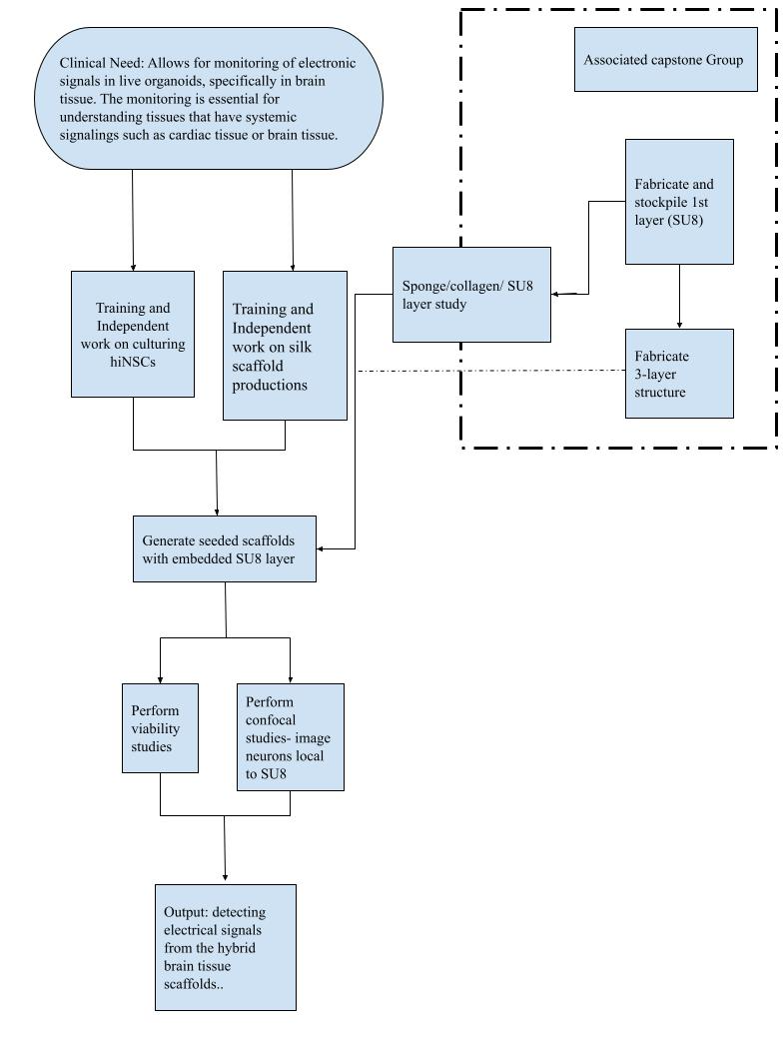
Bibliography:
(1) Cote, M. A. Development and Characterization of a Bioelectronic Scaffold for a Hybrid Brain Model. M.S., Tufts University, United States -- Massachusetts, 2022.
(2) Wood, C.; Williams, C.; Waldron, G. J. Patch Clamping by Numbers. Drug Discov. Today 2004, 9 (10), 434–441. https://doi.org/10.1016/S1359-6446(04)03064-8.
(3) Russell, J. T. Imaging Calcium Signals in Vivo: A Powerful Tool in Physiology and Pharmacology. Br. J. Pharmacol. 2011, 163 (8), 1605–1625. https://doi.org/10.1111/j.1476-5381.2010.00988.x.
(4) Chwalek, K.; Tang-Schomer, M. D.; Omenetto, F. G.; Kaplan, D. L. In Vitro Bioengineered Model of Cortical Brain Tissue. Nat. Protoc. 2015, 10 (9), 1362–1373. https://doi.org/10.1038/nprot.2015.091.
(5) Dingle, Y.-T. L.; Liaudanskaya, V.; Finnegan, L. T.; Berlind, K. C.; Mizzoni, C.; Georgakoudi, I.; Nieland, T. J. F.; Kaplan, D. L. Functional Characterization of Three-Dimensional Cortical Cultures for In Vitro Modeling of Brain Networks. iScience 2020, 23 (8), 101434. https://doi.org/10.1016/j.isci.2020.101434.
(6) Liaudanskaya, V.; Chung, J. Y.; Mizzoni, C.; Rouleau, N.; Berk, A. N.; Wu, L.; Turner, J. A.; Georgakoudi, I.; Whalen, M. J.; Nieland, T. J. F.; Kaplan, D. L. Modeling Controlled Cortical Impact Injury in Three-Dimensional Brain-like Tissue Cultures. Adv. Healthc. Mater. 2020, 9 (12), e2000122. https://doi.org/10.1002/adhm.202000122.
(7) Nemani, K. V.; Moodie, K. L.; Brennick, J. B.; Su, A.; Gimi, B. In Vitro and in Vivo Evaluation of SU-8 Biocompatibility. Mater. Sci. Eng. C 2013, 33 (7), 4453–4459. https://doi.org/10.1016/j.msec.2013.07.001.
(8) Joye, N.; Schmid, A.; Leblebici, Y. Electrical Modeling of the Cell–Electrode Interface for Recording Neural Activity from High-Density Microelectrode Arrays. Neurocomputing 2009, 73 (1), 250–259. https://doi.org/10.1016/j.neucom.2009.09.006.

Plan for Cell Culture as of (10/11/22) EXP0:
Cut scaffold donuts the week of the 17th of October.
Start MEFs on the 17th so they are confluent by the 24th
Coat the Scaffolds with collagen ECM on the 24 & 25 and then be ready for seeding on the 26th.
Seed iNSCs the week of Halloween ( seed iNSCs, tentatively by October 21st )
Change media every day until they are confluent.
Seed onto scaffold at 26 th October, and then hard deadline is the 29 th October .
NF3 for cell viability.
2 MEFs into 2 plates of iNSCs
100 million cells = 50 scaffolds ( if we want to do 2 donuts per sandwich we get 50)
Or if we cut scaffolds in half to sandwich the device in between, we would have 100 samples.

Peel Test
What is the local area around the scaffold look like?
A thin cross section using paraffin wax to determine how the cells' local environment is using freeze-drying techniques.

Constraints: neuron density may be really high in order to ensure that the neurons interface with the devices.

Optimization issue with cell density at seeding.
Neuron density
Sterility
Ensuring the device stays together.
SU8 into the scaffold can very easily get contaminated.
70% ethanol for 30 min in the hood
Neurons need to fire spontaneously.
Calcium fluorescence to check the spontaneous firing of the neurons.
Patch clamp assay

How are we going to measure success, what are the action items, and what are the quantifiable and desired results?
- Calcein AM for live dead staining
- We will then image the hybrid tissue and come to the conclusion that it was successful after seeing that the creation of the device

