Learning through thinking made visible!
The role of feedback and interactions within hybrid learning environments

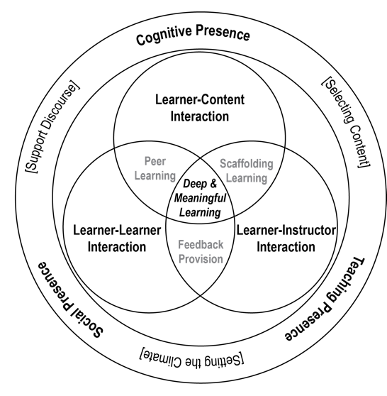
Abstract
Engaging students in the process of independent and active learning in the context of hybrid learning environments requires the careful integration of multiple instructional scaffolding strategies, particularly involving formative feedback. In 2020, the pivot into online teaching amplified the need for more constructive, interactive and flexible environments – emerging evidenced effective practices are likely to become the ‘new normal’.

Chemistry as a discipline is grounded in the use of multiple representations to support students in their development of their mental models of phenomena which we cannot directly observe. Diversity in prior knowledge is known to impact on students’ ability to recognize, transform, connect and construct understanding through combinations of multimodal representations. Translation of learning into online environments introduces more complexity and widens the transactional distance between the student and the teacher. Digital environments inherently introduce greater risk for inequitable access and lower participation in online learning activities and assessment. In practice, the overarching question becomes ‘Do you see what I see?’

Our research is situated within the design-based research paradigm, I will discuss recent outcomes for how we have introduced scaffolding to support learning using multimodal representations in hybrid environments. Examples of student engagement in generating their own representations and explanations online will also be shared to illustrate strategies for the development of representational competencies and embedding formative feedback online.

Zoom Info
Meeting ID: 991 8951 0081
Passcode: 2021

Bio
Gwen Lawrie is a Teaching-Focused Professor in the School of Chemistry and Molecular Biosciences (SCMB) at the University of Queensland (UQ). She is also a Principal Practitioner (Professional Learning) with the Institute for Teaching and Learning Innovation at UQ. Her work, at the nexus between chemistry education and higher education research, has enabled her to embed research outcomes into empirical, evidence-based teaching practices. Gwen is a Fellow of the Royal Australian Chemical Institute, Senior Fellow of the Higher Education Academy and is recent past Chair of the RACI Chemistry Education Division. She has received recognition for her teaching and research through multiple institutional and national awards. Gwen is the current Editor in Chief of Chemistry Education & Research Practice (RSC Journal).

