

**Business Innovation Facility**

**Impact Evaluation**

Tufts University

Medford, MA 02155 USA

30 June 2018

The research was conducted under Tufts SBER IRB protocol 1505056 and was funded by the Department for International Development.

Laura Babbitt

Drusilla Brown

Nimah Mazaheri

Elyse Voegeli

# Introduction and Methodology

The Myanmar Business Innovation Facility (BIF) is a program that provides production system and human resource management technical assistance to apparel factories in Myanmar.

Factories are provided with and trained to use Excel spreadsheets that track key performance indicators (KPI) including: Length of Service, Absenteeism (Planned and Unplanned), Workforce Turnover, Order-to-Ship Ratio, Cut-to-Ship Ratio, Cut-to-Ship Loss, Efficiency Rate, Total Quantity Ordered, Total Quantity Cut, Total Quantity Shipped, Monthly Work Hours (High and Average), Take-home Pay, Line Production and Garments per Worker per 8-Hour Day.

The program also provided training for managers in the factory. The production manager was trained in production line management to improve production efficiency. A pilot line is selected for training purposes and the supervisors on the pilot line are trained in the new system. The HR manager was trained in the human resource management procedures that emphasize re-humanization of workers, management of excess overtime, pay practices, communication, problem solving, etc.

To examine the effectiveness of the BIF program, a randomized controlled trial was conducted in 14 factories in Myanmar. Two factories left the study after the baseline and two factories left after the midline. KPI data was collected for 15 factories. Two production lines in each study factory were selected for the study. One line was randomly assigned to be the pilot, or treatment, line and the other was assigned to be the shadow line.

The study spanned 36 months, starting in January 2015. It began by teaching a representative from each factory to complete a simplified version of the trackers. Tracking of production and HR data proceeded for five months prior to treatment of the first batch of factories.

At month 5, just prior to the treatment of batch 1, a baseline survey was taken of workers on both lines, supervisors of both lines and management, including the GM, HR, IE and FM. After the baseline, batch 1 was trained. Training of batch 1 occurred during months 5 to 14. Following batch 1, workers, supervisors and managers were resurveyed for a midline. Following the midline, batch 2 was trained. Batch 2 training occurred during months 15 to 27.Following batch 2, workers, supervisors and managers were resurveyed for an endline. The study concluded with a second endline survey of workers, supervisors and managers at month 36.

96 supervisors completed the baseline survey, 79 completed the midline survey, 57 completed the first endline survey and 43 completed the second endline survey. 340 workers completed the baseline survey, 276 completed the midline survey, 195 completed the first endline survey and 112 completed the second endline survey.

**Key Findings**

**Pay Transparency.** The BIF program was especially successful in increasing workers’ perception of pay transparency. Training was immediately effective in improving workers’ perceptions of pay transparency and the effect strengthened over time, many months after training had ended. Generally, treatment greatly decreased workers’ belief that pay was confusing or unfair. Treatment had the equivalent effect of making workers change their response from always thinking that the pay is unfair to never thinking the pay is unfair. Accompanying the finding, treatment also made workers trust that the factories would pay them their earned wage.

            Even though the minimum wage may have adversely affected the plan of the program to use pay incentives, improving the clarity of communication around pay practices linked the relationship between work and pay in the minds of the workers. Following training, workers stated that they had a better understanding on how pay was calculated and that it was linked to their amount of effort.

**Pay Practices and Job Satisfaction**. Treatment affected both the use of pay incentives and pay transparency, and the relationship between pay incentives and transparency on worker job satisfaction. In terms of pay incentives, quality and productivity bonuses increased worker job satisfaction, but attendance and skill bonuses showed no effect. Given that treatment improved, at least temporarily, the use and value of quality bonuses, which had the largest effect on job satisfaction, it may be beneficial for future programs to apply more emphasis on the use of quality bonuses.

            Not only did treatment have a strong effect on improving workers’ perception of pay transparency, these perceptions were shown to be important both for their overall job satisfaction and the frequency with which they thought about quitting. When workers understood how their pay is calculated and they felt comfortable asking questions about their pay, they had greater job satisfaction and thought less about quitting. Complimentarily, the fewer workers that believed their pay is confusing or unfair, the more satisfied they were with their jobs and the less often they thought about quitting.

Future programs should continue to encourage workers’ understanding of pay and transparency as it is both effective and important for overall worker views on work.

**Improvements in Grievance Procedures, Conflict Resolution, and Workplace Communication**. Throughout the program, managers responded to treatment by establishing grievance procedures and worker and safety committees, and by implementing changes to pre-existing grievance committees. Both batches of factories were planning such an innovation at the baseline and some factories had begun implementing new procedures.  By the second endline, the average factory in Batch 2 was implementing a new grievance procedure and the single factory that responded in Batch 1 had fully established a new procedure. Throughout the program managers in both batches expressed that they had been working on establishing worker and safety committees.

            With the changes in managers’ actions towards grievance procedures and committees, there were a number of positive outcomes associated with improved conflict resolution and workers’ perspective of workplace dynamics. Training had a temporary, but strong effect on workers’ satisfaction with the resolution with their last conflict with coworkers. The effect weakened in the months following treatment. Treatment also, however, had a large and lasting effect on workers’ confidence in resolving conflicts at work.

            A byproduct of the treatment’s effects on communication between workers and supervisors was the improvement of worker-to-worker and worker-to-manager relations, and an increased sense of interdependence within the factories.  The positive effects on interdependence among workers lingered in the months following training, but their statistical significance declined in the long-term.  Additionally, workers experienced increased feelings of self-worth and contribution to the factory, indicating these perceptions of increased effectiveness in their managers as well. These beliefs lasted beyond the conclusion of the training.

            Training that promotes healthy and accessible means of conflict resolution within the workplace yields equally beneficial effects on the inter- and intrapersonal relationships between workers and managers, and should be encouraged in future programs.

**Re-humanization of Workers**. There is some evidence that workers were re-humanized in the minds of supervisors. Supervisors increased communication with workers throughout the training, which in turn resulted in a lasting improvement in supervisors’ understanding of workers’ needs and motivations. Supervisors were ultimately less likely to objectify workers, by thinking about their needs, and showed a more in-depth understanding of pay as an effective (but not exclusive) means of incentive.  When supervisors thought more about what they could do for their workers as opposed to the reverse, they were able to gain a better understanding of what motivates their workers.

**Working Conditions and Job Satisfaction**. Worker reports regarding health issues and safety conditions within the factory were associated negatively with overall level of job satisfaction.  In fact, worker complaints about excessive noise and heat appeared to have the largest impact on job satisfaction.  Regular access to clean toilets and personal protective equipment improved job satisfaction, further confirming the relationship between working conditions and job satisfaction.

**Worker Health**. Workers consistently reported relatively few instances of poor health throughout the program.  Both mental and physical health were considered, with workers being asked how often they felt sad or depressed and how frequently they were sick, and responses for both mental and physical health remained low as training progressed.

Despite the rarity of these instances, the training still resulted in even fewer reported incidents of feeling sad, depressed, or physically ill.  Results suggested that workers following treatment reported never feeling sad or depressed in the long run.  These results appeared on both the pilot and shadow line, and were strongly significant for both.  Following treatment, workers also reported fewer instances of feeling sick.  This result was only significant in the months following treatment and decayed in the long-term, but showed on the shadow line as well and persisted.

            Treatment significantly mitigated the negative association between depression or sickness and job dissatisfaction, life dissatisfaction, and frequent lateness. That is, depression affected the job satisfaction of non-treatment workers by almost double the amount that it affected treatment workers.  This effect was even greater on depression and life satisfaction, and depression and lateness (workers on the treatment line displayed a negative association between depression and lateness by the end of treatment).  These results were similar when tested with regard to physical illness.

**Worker Family Outcomes**. Family wellbeing, in this study, was measured by savings behavior and acquisition of household capital.  Household savings and acquisition of capital increased with treatment while borrowing decreased, all indicators of improved family wellbeing.

Treatment resulted in an increase of worker savings on both the pilot and shadow lines, despite its negative effect on wages.  This effect was only significant on the shadow line, however, where nearly 40% more workers reported that their family had saved money than workers with no treatment. Workers also reported increased acquisition of household assets such as electricity, indoor toilets, mobile phones, and refrigerators, (though worker turnover in the long run resulted in a negative effect on worker households’ acquisition of running water).  Treatment yielded a net positive on household wellbeing nonetheless.

Household financial security benefited significantly from treatment, indicated by a reduction in reports of household borrowing that grew by nearly 10% over time.

Despite the treatment’s negative effect on wages, its positive effects on intra-factory communication and worker understanding of pay translated into more family confidence in their wages.  Thus, treatment enabled families to save more, borrow less, and acquire more assets.

### Pay Transparency

As a consequence of treatment, firms improved considerably in their transparency of pay practices. There was a very large treatment effect on the perception that pay seems confusing or unfair. Workers were asked how often the amount they receive seems confusing or unfair. Shown in Figure 4.13, the treatment effect was negative (reducing the perception of unfairness), statistically significant and cured over time. The treatedlonglongago coefficient is -3.89 (see column 1 of Table 4.9) and highly significant, the equivalent of workers changing their response from always thinking that the pay is unfair to never thinking the pay is unfair. Factories improved their pay procedures in a manner appreciated by workers and the practices persisted after the end of training.

Similarly, workers were asked whether they trusted the factory to pay them the money they had earned. There was a very strong positive effect that intensified over time. Examining Figure 4.14, in the months after treatment, workers’ responses improved by 1.33 on the treatment line and 1.09 on the shadow line, and both effects were significant at the 1% level. A treatment effect greater than 1 represents an average shift in response from “Neither agree nor disagree” to “agree” with the statement, “I trust the factory to pay me what I have earned.” Effects on the shadow line suggest a strong spillover effect from the treatment.

There was also a positive, strongly statistically significant treatment effect on worker reports that showed a clear link between how much they work and how much they are paid. Thus, even though the minimum wage may have adversely affected the plan of the program to use pay incentives, improving the clarity of communication around pay practices linked the relationship between work and pay in the minds of the workers. In fact, there was a strong treatment effect on worker understanding of how their pay is calculated. These effects are depicted in Figure 4.16 and Figure 4.15 and columns 3 and 4 of Table 4.9. For both outcomes, there were not statistically significant effects during training, but there was improvement through the program. The long term treatment effects were greater than 1 and statistically significant at the 5% level.

Throughout the program, general managers also demonstrated interest in worker pay and how it could be altered. Managers were asked if they were considering altering both the worker payment plan and pay package. Table 4.8 and Figures 4.18 and 4.17 show that manager perspective does not change a lot throughout the program, but on average managers in both data collection batches were considering making changes. By endline II, managers in Batch 2 factories did shift their responses towards actually implementing changes in their factories. This finding is not inherently positive or negative. Managers can consider making changes that are adverse to workers, such as reducing the use of pay incentives like bonuses. However, it does suggest that managers were thinking about changes, which was accompanied by greater worker trust and understanding of factory pay strategies.

Table 4.7: Worker Response Summary Statistics, Payment Transparency

|  |  |  |  |  |  |  |  |  |  |  |  |  |  |  |  |  |  |  |  |  |
| --- | --- | --- | --- | --- | --- | --- | --- | --- | --- | --- | --- | --- | --- | --- | --- | --- | --- | --- | --- | --- |
| Batch 1 Factories | | | | | | | | | | | | | | | | | | | | |
|  | Baseline | | | | | Midline | | | | | Endline I | | | | | Endline II | | | | |
| VARIABLES | N | mean | | sd | | N | mean | | sd | | N | mean | | sd | | N | mean | | sd | |
|  |  |  | |  | |  |  | |  | |  |  | |  | |  |  | |  | |
| Pay_Confusing_Unfair | 84 | 2.702 | | 1.519 | | 60 | 1.783 | | 1.121 | | 56 | 1.357 | | 0.749 | | 35 | 1.543 | | 1.010 | |
| trustfactorypay | 90 | 3.444 | | 1.181 | | 77 | 3.792 | | 0.656 | | 59 | 4.034 | | 0.524 | | 42 | 3.833 | | 0.730 | |
| linkworkpay | 79 | 3.392 | | 1.148 | | 71 | 3.690 | | 0.872 | | 58 | 3.879 | | 0.796 | | 40 | 3.825 | | 0.675 | |
| understandpay | 83 | 3.434 | | 1.139 | | 76 | 3.276 | | 1.103 | | 59 | 3.898 | | 0.759 | | 42 | 3.690 | | 0.643 | |
|  |  |  | |  | |  |  | |  | |  |  | |  | |  |  | |  | |
| Batch 2 Factories | | | | | | | | | | | | | | | | | | | | |
|  | Baseline | | | | Midline | | | | | Endline I | | | | | | Endline II | | | | |
| VARIABLES | N | mean | sd | | N | | | mean | sd | N | | | mean | | sd | N | | mean | | sd |
|  |  |  |  | |  | | |  |  |  | | |  | |  |  | |  | |  |
| Pay_Confusing_Unfair | 175 | 1.651 | 1.082 | | 163 | | | 1.491 | 0.812 | 116 | | | 1.543 | | 1.042 | 60 | | 1.700 | | 1.154 |
| trustfactorypay | 192 | 3.922 | 0.892 | | 181 | | | 3.890 | 0.745 | 130 | | | 3.923 | | 0.689 | 61 | | 3.787 | | 0.755 |
| linkworkpay | 183 | 3.896 | 0.829 | | 177 | | | 3.842 | 0.838 | 126 | | | 3.889 | | 0.761 | 60 | | 3.850 | | 0.709 |
| understandpay | 182 | 3.791 | 0.841 | | 186 | | | 3.634 | 0.916 | 128 | | | 3.680 | | 0.904 | 61 | | 3.787 | | 0.819 |
|  |  |  |  | |  | | |  |  |  | | |  | |  |  | |  | |  |

Table 4.8: Manager Response Summary Statistics, Changes to Worker Pay

|  |  |  |  |  |  |  |  |  |  |  |  |  |  |  |  |  |  |  |  |  |
| --- | --- | --- | --- | --- | --- | --- | --- | --- | --- | --- | --- | --- | --- | --- | --- | --- | --- | --- | --- | --- |
| Batch 1 Factories | | | | | | | | | | | | | | | | | | | | |
|  | Baseline | | | | | Midline | | | | | Endline I | | | | | Endline II | | | | |
| VARIABLES | N | mean | | sd | | N | mean | | sd | | N | mean | | sd | | N | mean | | sd | |
|  |  |  | |  | |  |  | |  | |  |  | |  | |  |  | |  | |
| Alter_paymentplan | 6 | 1.833 | | 0.408 | | 5 | 1.600 | | 0.894 | | 5 | 1.600 | | 0.894 | | 1 | 2 | |  | |
| Alter_paypackage | 6 | 1.667 | | 0.516 | | 5 | 1.600 | | 0.894 | | 5 | 1.800 | | 0.837 | | 1 | 2 | |  | |
|  |  |  | |  | |  |  | |  | |  |  | |  | |  |  | |  | |
| Batch 2 Factories | | | | | | | | | | | | | | | | | | | | |
|  | Baseline | | | | Midline | | | | | Endline I | | | | | | Endline II | | | | |
| VARIABLES | N | mean | sd | | N | | | mean | sd | N | | | mean | | sd | N | | mean | | sd |
|  |  |  |  | |  | | |  |  |  | | |  | |  |  | |  | |  |
| Alter_paymentplan | 6 | 1.833 | 0.408 | | 5 | | | 1.400 | 0.548 | 5 | | | 2.200 | | 0.837 | 5 | | 2.800 | | 1.095 |
| Alter_paypackage | 6 | 1.833 | 0.408 | | 4 | | | 1.500 | 0.577 | 5 | | | 2.400 | | 1.140 | 5 | | 2.800 | | 1.095 |
|  |  |  |  | |  | | |  |  |  | | |  | |  |  | |  | |  |

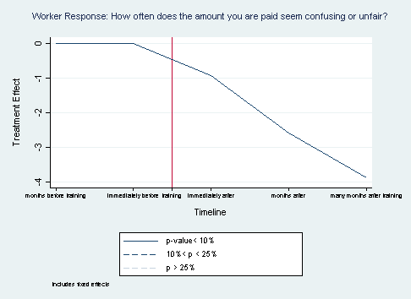

Figure .: Workers’ Payment Amount is Confusing or Unfair Treatment

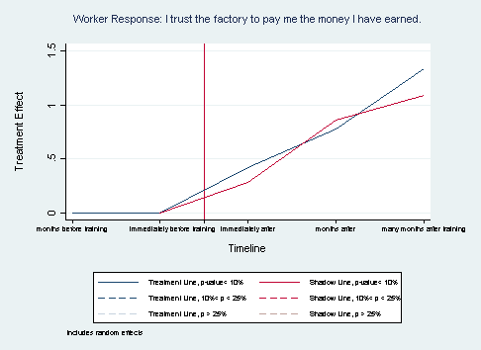

Figure .: Worker's Trust Factory Pay Treatment

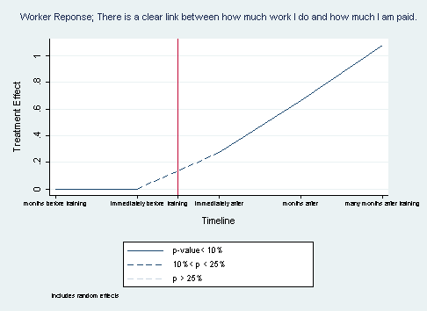

Figure .: Worker Sees Link between Work Amount and Pay Amount Treatment

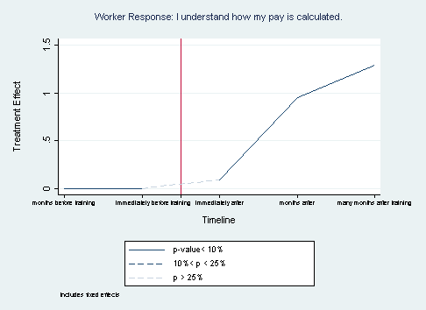

Figure .: Workers Understanding their Pay Calculation Treatment

Table 4.9: Worker Regression Results, Pay Transparency

|  |  |  |  |  |
| --- | --- | --- | --- | --- |
|  | (1) | (2) | (3) | (4) |
| VARIABLES | Pay_Confusing_Unfair | trustfactorypay | linkworkpay | understandpay |
| justtreated | -0.920** |  | 0.271 | 0.0901 |
|  | (0.382) |  | (0.209) | (0.221) |
| treatedlongago | -2.584*** |  | 0.660** | 0.950** |
|  | (0.601) |  | (0.295) | (0.323) |
| treatedlonglongago | -3.891*** |  | 1.077** | 1.291** |
|  | (1.065) |  | (0.444) | (0.515) |
| TLjusttreated |  | 0.418** |  |  |
|  |  | (0.165) |  |  |
| TLtreatedlongago |  | 0.777*** |  |  |
|  |  | (0.231) |  |  |
| TLtreatedlnglongago |  | 1.334*** |  |  |
|  |  | (0.381) |  |  |
| SLjusttreated |  | 0.283** |  |  |
|  |  | (0.125) |  |  |
| SLtreatedlongago |  | 0.854*** |  |  |
|  |  | (0.218) |  |  |
| SLtreatedlnglngago |  | 1.091*** |  |  |
|  |  | (0.341) |  |  |
| midline | 0.0862 | -0.0260 | -0.00822 | -0.0187 |
|  | (0.157) | (0.0961) | (0.152) | (0.194) |
| endline | 1.201** | -0.320* | -0.196 | -0.298 |
|  | (0.468) | (0.166) | (0.255) | (0.335) |
| endlineII | 2.849*** | -0.869*** | -0.596 | -0.946* |
|  | (0.733) | (0.331) | (0.413) | (0.503) |
| Treatmentfactory |  | -0.489*** | -0.460*** |  |
|  |  | (0.166) | (0.162) |  |
| Treatmentline |  | -0.0897 | -0.0850 |  |
|  |  | (0.113) | (0.0796) |  |
| female |  | 0.526*** | 0.459*** |  |
|  |  | (0.165) | (0.0794) |  |
| age | -0.0316 | 0.0307 | 0.0329 | 0.208** |
|  | (0.145) | (0.0213) | (0.0308) | (0.0942) |
| education | -0.0627 | 0.0583** | 0.0366 | -0.184 |
|  | (0.122) | (0.0288) | (0.0258) | (0.142) |
| Never_Married | -0.228 | -0.204* | -0.0884 | -0.497 |
|  | (0.376) | (0.112) | (0.183) | (0.656) |
| Married | -0.128 | -0.197 | 0.0299 | -0.00581 |
|  | (0.283) | (0.170) | (0.177) | (0.722) |
| W1_Time_Employ | -0.0309 | -0.00280 | -0.0186 | -0.0338 |
|  | (0.0372) | (0.0144) | (0.0135) | (0.0332) |
| W2_Previous_Work | 0.0415 | -0.0103 | -0.0263 | 0.0482 |
|  | (0.0380) | (0.0224) | (0.0236) | (0.0468) |
| Constant | 2.520** | 3.314*** | 3.449*** | 4.205*** |
|  | (0.839) | (0.237) | (0.175) | (0.766) |
|  |  |  |  |  |
| Observations | 707 | 782 | 744 | 767 |
| R-squared | 0.123 |  |  | 0.100 |
| Number of uniqueID | 420 | 443 | 425 | 436 |

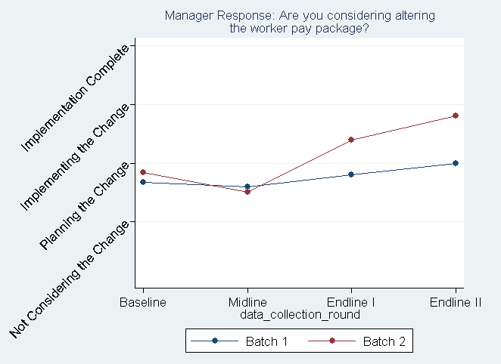

Figure .: Managers Considering Altering the Worker Pay Package

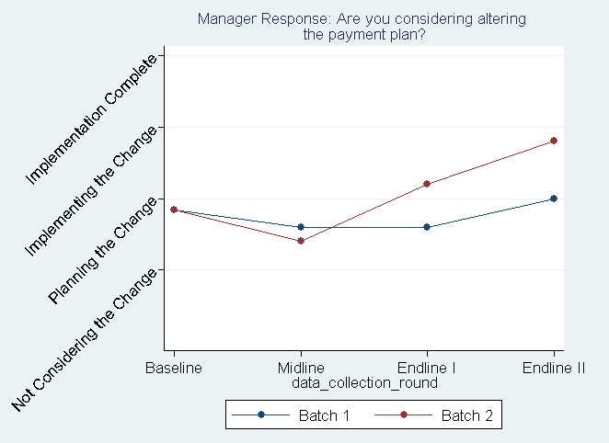

Figure .: Managers considering Altering the Payment Plan

### Pay Practices and Job Satisfaction

In addition to the use of pay incentives and pay transparency, the treatment also affected the relationship between pay incentives and transparency on worker job satisfaction.

Some employee incentives, like bonuses, are linked to workers’ overall level of job satisfaction. These relationships can be seen in Table 4.10. Among workers who have received a quality or productivity bonus, the value of the bonus is positively associated with a worker’s level of job satisfaction. This may hold for annual bonuses as well, although the results are less strong. Quality bonuses appear to have a slightly larger impact on job satisfaction than productivity bonuses. Receiving a skills bonus or attendance bonus is not associated with a worker’s level of job satisfaction.

While treatment largely did not encourage the use of pay incentives, these findings suggest that incentives, like bonuses, are still important and can be used to improve worker wellbeing. Given that treatment improved, at least temporarily, the use and value of quality bonuses, which, in turn, had the greatest effect on worker job satisfaction, it may be beneficial for future programs to apply more emphasis to the use of quality bonuses.

Many aspects about how factories pay their workers (and their payment practices) are also linked to workers’ overall level of job satisfaction. Table 4.11 indicates that, for workers, all measures of pay transparency used in the survey have a beneficial and strongly statistically significant effect on level of job satisfaction. For example, having the frequent perception that one’s pay is confusing or unfair is negatively associated with a worker’s level of job satisfaction, meaning that as pay is less often seen as confusing or unfair, workers are more satisfied with their job. Being comfortable about asking for help in understanding how one’s pay is calculated, having greater trust that the factory will pay a worker the money they earned, perceiving a clear link between how much work they do and how much they are paid, and having a better understanding of how their pay is calculated are all positively associated with a worker’s level of job satisfaction.

Complimentary to impacting workers’ job satisfaction, good pay practices have a practical use as they also impact the frequency with which workers think about quitting. Table 4.12 shows the link between several workers’ opinions on factory pay practices and their opinions on quitting. The belief that factors other than effort (such as race, gender, religion, etc.) determine pay, or that pay is in general confusing or unfair, has a positive relationship with workers considering quitting. The more workers believe payments are unfair, the more frequently they think about quitting. Conversely, receiving pay calculation training, being comfortable asking questions about pay, and understanding how pay is calculated decreases the frequency with which workers think about quitting.

Training had a robust effect on workers’ perception of pay transparency and, following treatment, workers believed that pay was fairer. Workers’ perceptions of pay then has a strong effect on their job satisfaction and the frequency with which they think about quitting. Treatment, then, was not only effective in altering workers’ perceptions of pay, but also targeted perceptions that are important for overall worker wellbeing and retention.

Table 4.10: Link between Bonuses and Job Satisfaction

|  |  |  |  |  |  |
| --- | --- | --- | --- | --- | --- |
|  | (1) | (2) | (3) | (4) | (5) |
| **Female** | -0.562*** | -0.378 | -0.058 | -0.075 | -0.086 |
|  | (0.187) | (0.346) | (0.265) | (0.267) | (0.268) |
| **Age** | -0.07 | -0.001 | -0.015 | -0.02 | -0.019 |
|  | (0.047) | (0.05) | (0.032) | (0.032) | (0.033) |
| **Education** | -0.119*** | -0.081** | -0.085*** | -0.0878*** | -0.091*** |
|  | (0.042) | (0.038) | (0.029) | (0.03) | (0.031) |
| **Never Married** | -0.134 | -0.252* | 0.067 | 0.05 | 0.052 |
|  | (0.31) | (0.15) | (0.195) | (0.202) | (0.18) |
| **Married** | 0.069 | -0.02 | 0.236 | 0.227 | 0.229 |
|  | (0.302) | (0.178) | (0.341) | (0.343) | (0.323) |
| **Time Employed** | 0.021 | 0.003 | -0.015 | -0.013 | -0.012 |
|  | (0.035) | (0.021) | (0.017) | (0.017) | (0.017) |
| **Prev. Work Exp.** | -0.05 | -0.03 | -0.046** | -0.043** | -0.045* |
|  | (0.037) | (0.043) | (0.022) | (0.021) | (0.023) |
| **Quality Bonus** | 0.122*** |  |  |  |  |
|  | (0.027) |  |  |  |  |
| **Productivity Bonus Amount** |  | 0.086** |  |  |  |
|  |  | (0.044) |  |  |  |
| **Annual Bonus** |  |  | 0.119* |  |  |
|  |  |  | (0.071) |  |  |
| **Skill Bonus** |  |  |  | -0.086 |  |
|  |  |  |  | (0.092) |  |
| **Attendance Bonus** |  |  |  |  | 0.082 |
|  |  |  |  |  | (0.09) |
|  |  |  |  |  |  |
| Observations | 271 | 252 | 634 | 634 | 634 |
|  |  |  |  |  |  |
| Notes: Robust standard errors in parentheses *** p<0.01, ** p<0.05, * p<0.1. For ease of display, all treatment/control group variables (*treatmentfactory*, *treatmentline*, *TLjusttreated, SLjusttreated*), time control variables (*midline*, *endline*, *endlineII*), and the constant term were omitted from the table. Dependent variable:“How satisfied are you with your job overall?” (1 = completely dissatisfied; 5 = completely satisfied). Model: linear panel estimator with random effects and clustered by factory | | | | | |

Table 4.11: Link between Pay Transparency and Job Satisfaction

|  |  |  |  |  |  |
| --- | --- | --- | --- | --- | --- |
|  | (1) | (2) | (3) | (4) | (5) |
| **Female** | -0.1 | 0.147 | 0.008 | 0.139 | 0.131 |
|  | (0.207) | (0.231) | (0.195) | (0.241) | (0.209) |
| **Age** | -0.009 | -0.037 | -0.029 | -0.016 | -0.024 |
|  | (0.029) | (0.038) | (0.038) | (0.033) | (0.034) |
| **Education** | -0.083*** | -0.102*** | -0.11*** | -0.111*** | -0.1*** |
|  | (0.026) | (0.037) | (0.026) | (0.029) | (0.027) |
| **Never Married** | 0.205 | 0.062 | 0.156 | 0.132 | 0.093 |
|  | (0.209) | (0.198) | (0.219) | (0.205) | (0.215) |
| **Married** | 0.414 | 0.266 | 0.332 | 0.327 | 0.24 |
|  | (0.28) | (0.293) | (0.287) | (0.297) | (0.322) |
| **Time Employed** | -0.015 | -0.009 | -0.011 | -0.006 | -0.006 |
|  | (0.022) | (0.02) | (0.017) | (0.017) | (0.018) |
| **Previous Work Experience** | -0.019 | -0.019 | -0.016 | -0.027 | -0.022 |
|  | (0.022) | (0.02) | (0.02) | (0.021) | (0.018) |
|  |  |  |  |  |  |
| **Pay Confusing Unfair** | -0.129** |  |  |  |  |
|  | (0.053) |  |  |  |  |
| **Comfortable asking Pay Ques.** |  | 0.144*** |  |  |  |
|  |  | (0.038) |  |  |  |
| **Trust Factory Pay** |  |  | 0.32*** |  |  |
|  |  |  | (0.06) |  |  |
| **Link Work Pay** |  |  |  | 0.199*** |  |
|  |  |  |  | (0.0446) |  |
| **Understand How Pay Calculated** |  |  |  |  | 0.258*** |
|  |  |  |  |  | (0.041) |
|  |  |  |  |  |  |
| Observations | 668 | 663 | 745 | 709 | 727 |
|  |  |  |  |  |  |
| Notes: Robust standard errors in parentheses *** p<0.01, ** p<0.05, * p<0.1. For ease of display, all treatment/control group variables (*treatmentfactory*, *treatmentline*, *TLjusttreated, SLjusttreated*), time control variables (*midline*, *endline*, *endlineII*), and the constant term were omitted from the table. Dependent variable:“How satisfied are you with your job overall?” (1 = completely dissatisfied; 5 = completely satisfied). Model: linear panel estimator with random effects and clustered by factory. | | | | | |
|  | | | | | |

Table 4.12: Link between Factory Pay Practices and Thinking about Quitting

|  |  |  |  |  |  |
| --- | --- | --- | --- | --- | --- |
|  | (1) | (2) | (3) | (4) | (5) |
|  |  |  |  |  |  |
| **Female** | 0.253 | -0.0509 | 0.143 | 0.0131 | -0.0747 |
|  | (0.330) | (0.379) | (0.285) | (0.368) | (0.326) |
| **Age** | -0.0383 | -0.0361 | -0.0507 | -0.0434 | -0.0228 |
|  | (0.0396) | (0.0456) | (0.0342) | (0.0385) | (0.0372) |
| **Education** | 0.0433* | 0.0556* | 0.0514* | 0.0846 | 0.0712** |
|  | (0.0256) | (0.0320) | (0.0278) | (0.0540) | (0.0348) |
| **Never Married** | 0.0304 | 0.0620 | -0.00111 | -0.0511 | 0.0686 |
|  | (0.240) | (0.236) | (0.229) | (0.227) | (0.233) |
| **Married** | -0.0867 | -0.0430 | -0.116 | -0.178 | -0.0458 |
|  | (0.144) | (0.156) | (0.230) | (0.195) | (0.174) |
| **Time Employed** | 0.0609*** | 0.0719*** | 0.0673*** | 0.0742*** | 0.0608*** |
|  | (0.0180) | (0.0186) | (0.0165) | (0.0225) | (0.0202) |
| **Prev. Work Exp.** | 0.0364 | 0.0351 | 0.0363 | 0.0343 | 0.0377 |
|  | (0.0248) | (0.0220) | (0.0253) | (0.0328) | (0.0254) |
|  |  |  |  |  |  |
| **Other Factors Determine Pay** | 0.0991***  (0.0380) |  |  |  |  |
|  |  |  |  |  |
| **Received Pay Calc. Training** |  | -0.534*  (0.279) |  |  |  |
|  |  |  |  |  |
| **Pay is Confusing or Unfair** |  |  | 0.222***  (0.0394) |  |  |
|  |  |  |  |  |
| **Comfortable asking Pay Ques.** |  |  |  | -0.229***  (0.0525) |  |
|  |  |  |  |  |
| **Understand How Pay Calculated** |  |  |  |  | -0.104**  (0.0521) |
|  |  |  |  |  |
|  |  |  |  |  |  |
| Observations | 676 | 705 | 676 | 670 | 737 |
|  |  |  |  |  |  |
| Notes: Robust standard errors in parentheses *** p<0.01, ** p<0.05, * p<0.1. For ease of display, all treatment/control group variables (*treatmentfactory*, *treatmentline*, *TLjusttreated, SLjusttreated*), time control variables (*midline*, *endline*, *endlineII*), and the constant term were omitted from the table. Dependent variable:“I often think about quitting” (1 = strongly disagree; 5 = strongly agree). Model: linear panel estimator with random effects and clustered by factory. | | | | | |

### Improvements in Grievance Procedures, Conflict Resolution, and Workplace Communication

While many of the managers’ perceptions and plans regarding the BIF program and changes to the factory remained relatively stagnant throughout the study, managers did seem to pay attention to establishing and altering grievance procedures and establishing worker and safety committees. Average manager responses to questions regarding grievance procedures and committees are shown in Table 5.1 and Figures 5.1 through 5.4.

Batch 2 factories were more likely to report an increase in implementing a grievance procedure. Both batches of factories were planning such an innovation at the baseline and some factories had begun implementing new procedures. By the second endline, the average factory in Batch 2 was implementing a new grievance procedure. Throughout the program, Batch 2 factories were working on implementing worker and safety committees.

In comparison, Batch 1 factories likely already had a grievance procedure in place at the baseline. By the first endline, nearly all factories in Batch 1 were establishing or planning to establish their grievance procedure. At the second endline, the single Batch 1 factory that responded had altered its existing grievance procedure and established both a worker and safety committee.

Treatment likely brought on changes to grievance procedures that in turn improved workers’ beliefs toward conflict resolution in the factory (see Figure 5.5 and column 1 of Table 5.3). During training, there was a positive effect, 0.663, on workers’ satisfaction with how conflicts between their coworkers were resolved. The effect remained positive, but decayed over time, with statistical significance dropping to 10%-25% in the months following training and disappearing all together in the following months.

Worker confidence in terms of conflict resolution (and in general) was also improved by training. While the effect on satisfaction with how conflicts were resolved dissipated, there was a strong effect in workers’ personal confidence in their ability to resolve conflict. Figure 5.6 shows that training had an immediate and lasting effect on workers’ confidence in resolving conflicts at work. In the many months following, treatment improved workers’ responses by 0.968, about one level, moving responses from “Agree” to “Strongly Agree” and suggesting that workers were very confident following training. These results are statistically robust at the 1% and 5% level of statistical significance.

Figure 5.7 displays the treatment effect on workers’ confidence in voicing their opinions at work. There was also a temporary effect on workers’ overall confidence at work. Similar to the trend with worker’s satisfaction with last resolved conflict, there was an immediate boost in worker confidence during training, 0.543 at the 10% significance level, but the effect decayed and ultimately disappeared overtime. This is somewhat disheartening, but could potentially be explained by the rise in sexual harassment and risk in reporting caused by training. As it became more risky for women to report instances of sexual harassment, they became overall less confident in voicing their opinions in the workplace. This is discussed in more detail in section 8.5 of the report.

Modern workplaces emphasize the interdependence of work effort. An effective workplace requires that workers perceive themselves as part of a team and that a worker’s own effort increases the effectiveness of their co-workers. Introductions of better avenues for workers to communicate with supervisors and each other through procedures and committees likely improved relations in the factory. Workers were asked whether they believe that others depend on them to produce high quality work. Figure 5.8 shows there was a positive treatment effect, indicating an increase in interdependence, especially in the months immediately following training. There was some decay in statistical significance several months after training, suggesting that communication lessened over time.

We also observed a treatment effect on worker confidence in their ability to produce high quality work. In all measures, the treatment effects in the fifth column of Table 5.3 were statistically significant and strengthened over time, even several months after the treatment was complete. Such an outcome indicates that the lessons of training became embedded in the organizational culture.

Improved communication also impacted manager-worker relations. Workers not only saw their work as more important to the factory following training, but also perceived managers to be more effective at their jobs. Figure 5.10 shows that in the months after training, workers believed the effectiveness of managers increased. Using values from Table 5.3, column 6, workers shifted their responses from generally neutral or slightly disagreeing (constant value 2.768) to agreeing that managers were effective at their jobs (treatment effect 1.279 at 5% level of significance).

Table 5.1: Manager Response Summary Statistics, Grievance Procedures and Worker Committees

|  |  |  |  |  |  |  |  |  |  |  |  |  |  |  |  |  |  |  |  |  |
| --- | --- | --- | --- | --- | --- | --- | --- | --- | --- | --- | --- | --- | --- | --- | --- | --- | --- | --- | --- | --- |
| Batch 1 Factories | | | | | | | | | | | | | | | | | | | | |
|  | Baseline | | | | | Midline | | | | | Endline I | | | | | Endline II | | | | |
| VARIABLES | N | mean | | sd | | N | mean | | sd | | N | mean | | sd | | N | mean | | sd | |
|  |  |  | |  | |  |  | |  | |  |  | |  | |  |  | |  | |
| Est_grievance | 6 | 2.167 | | 0.408 | | 5 | 2.200 | | 0.837 | | 5 | 2.800 | | 0.837 | | 1 | 2 | |  | |
| Alter_grieveance | 6 | 2.167 | | 0.983 | | 5 | 2 | | 1 | | 5 | 2.200 | | 0.447 | | 1 | 4 | |  | |
| est_workercomm | 6 | 2.667 | | 0.816 | | 5 | 2.600 | | 1.517 | | 5 | 2.600 | | 0.548 | | 1 | 4 | |  | |
| est_safetycomm | 7 | 2 | | 0.577 | | 5 | 2.400 | | 1.342 | | 5 | 3 | | 0.707 | | 1 | 4 | |  | |
|  |  |  | |  | |  |  | |  | |  |  | |  | |  |  | |  | |
| Batch 2 Factories | | | | | | | | | | | | | | | | | | | | |
|  | Baseline | | | | Midline | | | | | Endline I | | | | | | Endline II | | | | |
| VARIABLES | N | mean | sd | | N | | | mean | sd | N | | | mean | | sd | N | | mean | | sd |
|  |  |  |  | |  | | |  |  |  | | |  | |  |  | |  | |  |
| Est_grievance | 6 | 2.500 | 0.837 | | 6 | | | 2.833 | 0.983 | 4 | | | 3.250 | | 0.957 | 6 | | 3 | | 0.894 |
| Alter_grieveance | 6 | 2.167 | 0.408 | | 4 | | | 2.250 | 0.500 | 5 | | | 2.800 | | 0.837 | 5 | | 3.400 | | 0.894 |
| est_workercomm | 7 | 2.857 | 0.900 | | 6 | | | 3 | 1.095 | 5 | | | 2.800 | | 0.837 | 6 | | 2.667 | | 1.211 |
| est_safetycomm | 6 | 3.333 | 0.816 | | 6 | | | 3.167 | 0.983 | 5 | | | 3.200 | | 0.837 | 6 | | 3.333 | | 1.033 |
|  |  |  |  | |  | | |  |  |  | | |  | |  |  | |  | |  |

Table 5.2: Worker Response Summary Statistics, Conflict Resolution and Confidence

|  |  |  |  |  |  |  |  |  |  |  |  |  |  |  |  |  |  |  |  |  |
| --- | --- | --- | --- | --- | --- | --- | --- | --- | --- | --- | --- | --- | --- | --- | --- | --- | --- | --- | --- | --- |
| Batch 1 Factories | | | | | | | | | | | | | | | | | | | | |
|  | Baseline | | | | | Midline | | | | | Endline I | | | | | Endline II | | | | |
| VARIABLES | N | mean | | sd | | N | mean | | sd | | N | mean | | sd | | N | mean | | sd | |
|  |  |  | |  | |  |  | |  | |  |  | |  | |  |  | |  | |
| Coworker_conflict | 34 | 4.382 | | 1.457 | | 39 | 4.821 | | 1.121 | | 23 | 4.783 | | 1.085 | | 16 | 4.313 | | 1.537 | |
| Confident_resolveconflict | 75 | 3.400 | | 0.930 | | 66 | 3.621 | | 0.739 | | 58 | 3.759 | | 0.630 | | 37 | 3.541 | | 0.836 | |
| Confident_voiceopinion | 71 | 3.380 | | 0.976 | | 59 | 3.492 | | 0.878 | | 57 | 3.667 | | 0.831 | | 37 | 3.622 | | 0.721 | |
| Confident_highquality | 86 | 3.686 | | 0.936 | | 77 | 3.831 | | 0.677 | | 60 | 4.050 | | 0.565 | | 42 | 3.976 | | 0.604 | |
| Othersdepend_highquality | 71 | 3.380 | | 1.163 | | 72 | 3.486 | | 0.822 | | 60 | 3.517 | | 0.770 | | 41 | 3.537 | | 0.977 | |
| Managers_effective | 83 | 3.735 | | 0.938 | | 76 | 3.658 | | 0.946 | | 57 | 4.088 | | 0.474 | | 42 | 3.929 | | 0.463 | |
|  |  |  | |  | |  |  | |  | |  |  | |  | |  |  | |  | |
| Batch 2 Factories | | | | | | | | | | | | | | | | | | | | |
|  | Baseline | | | | Midline | | | | | Endline I | | | | | | Endline II | | | | |
| VARIABLES | N | mean | sd | | N | | | mean | sd | N | | | mean | | sd | N | | mean | | sd |
|  |  |  |  | |  | | |  |  |  | | |  | |  |  | |  | |  |
| Coworker_conflict | 57 | 4.509 | 1.390 | | 66 | | | 4.379 | 1.356 | 42 | | | 4.833 | | 1.034 | 20 | | 4.750 | | 1.118 |
| Confident_resolveconflict | 161 | 3.553 | 0.993 | | 160 | | | 3.212 | 1.018 | 112 | | | 3.554 | | 0.889 | 59 | | 3.576 | | 0.835 |
| Confident_voiceopinion | 165 | 3.467 | 1.021 | | 144 | | | 3.222 | 1.034 | 111 | | | 3.712 | | 0.779 | 59 | | 3.576 | | 0.894 |
| Confident_highquality | 181 | 3.895 | 0.785 | | 178 | | | 3.803 | 0.729 | 128 | | | 3.938 | | 0.599 | 61 | | 4.049 | | 0.530 |
| Othersdepend_highquality | 162 | 3.481 | 1.053 | | 151 | | | 3.430 | 1.049 | 119 | | | 3.462 | | 0.881 | 58 | | 3.517 | | 0.960 |
| Managers_effective | 176 | 3.920 | 0.759 | | 161 | | | 3.901 | 0.654 | 129 | | | 3.938 | | 0.429 | 57 | | 3.895 | | 0.618 |
|  |  |  |  | |  | | |  |  |  | | |  | |  |  | |  | |  |

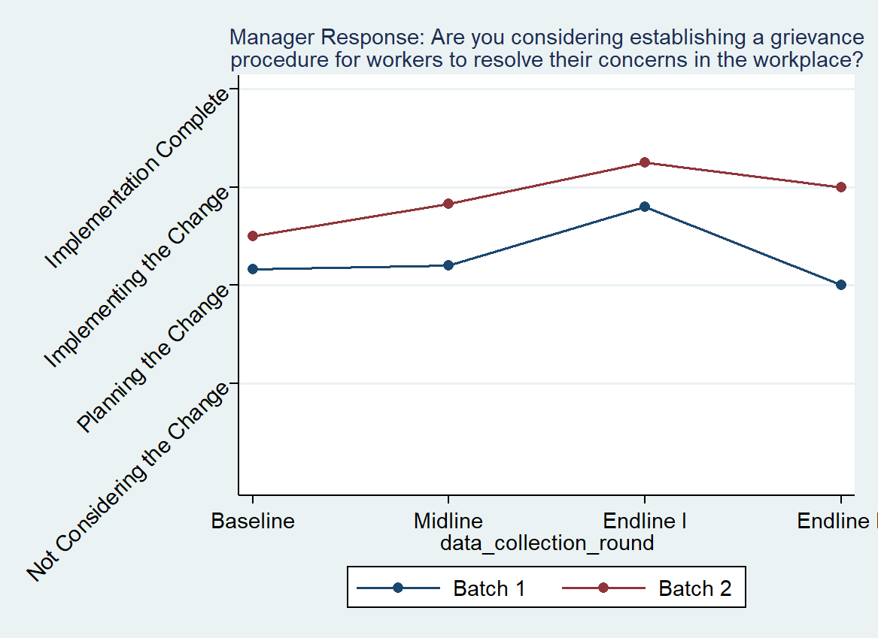

Figure .: Managers Considering Establishing Grievance Procedure

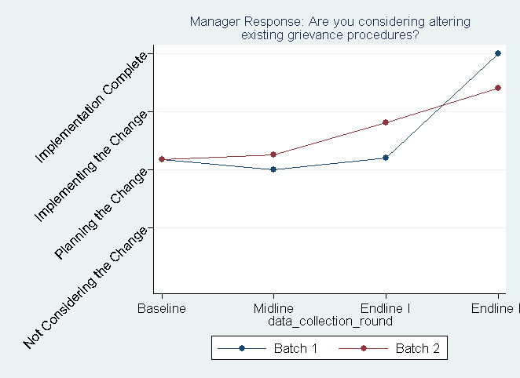

Figure .: Managers Considering Altering Existing Grievance Procedures

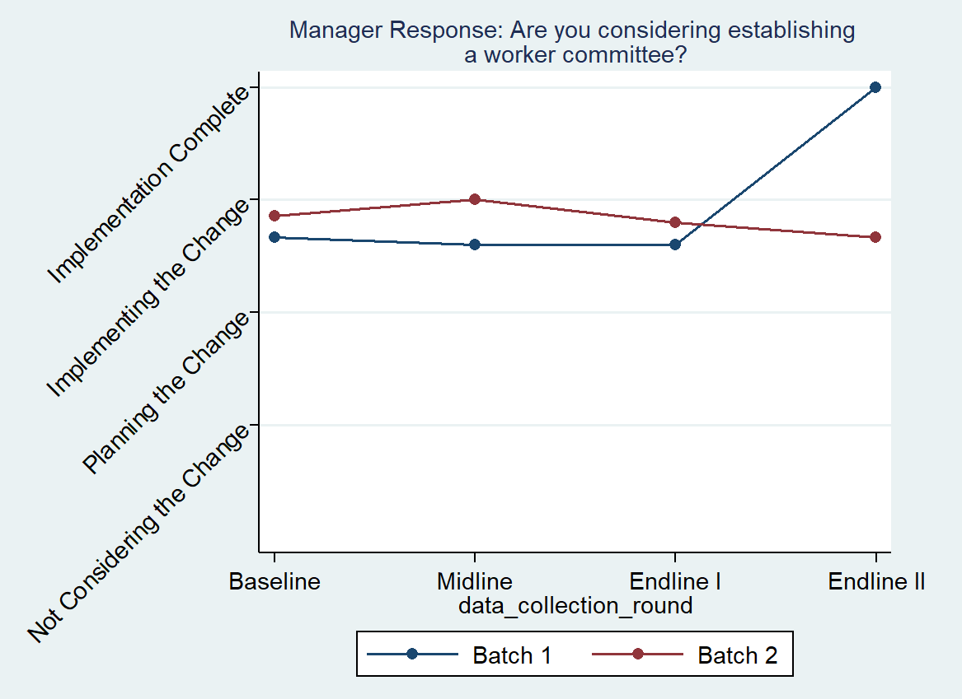

Figure .: Managers Considering Establishing Worker Committee

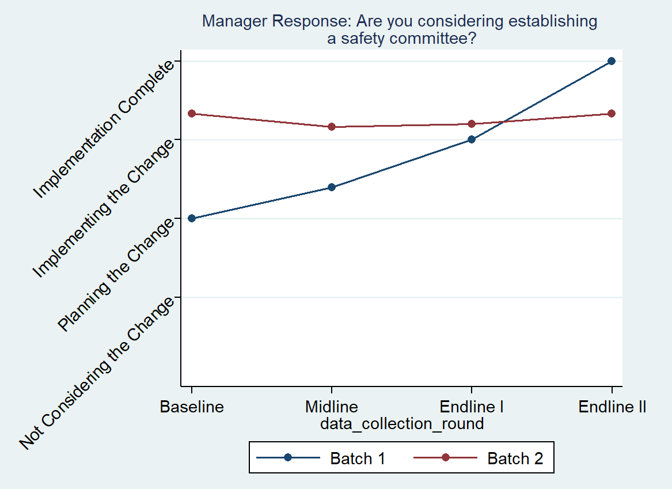

Figure .: Managers Considering Establishing Safety Committee

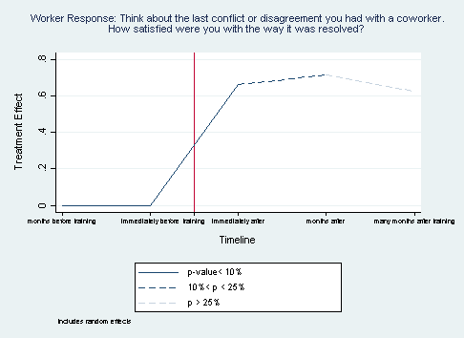

Figure .: Worker Satisfaction with Coworker-Conflict Resolution Treatment

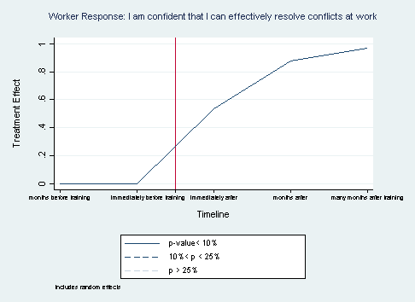

Figure .: Worker Confidence in their Conflict-Resolution Ability at Work Treatment

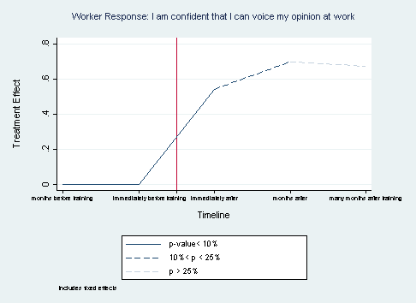

Figure .: Worker Confidence in Voicing Opinion at Work Treatment

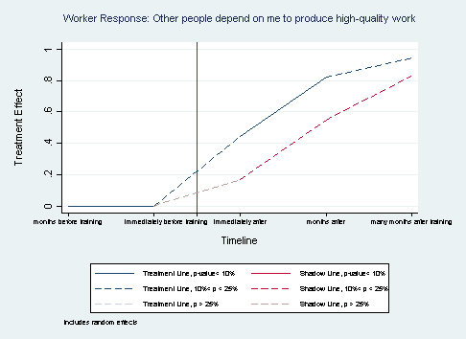

Figure .: Workers Believe Others Depend on Them to Produce High-Quality Work Treatment

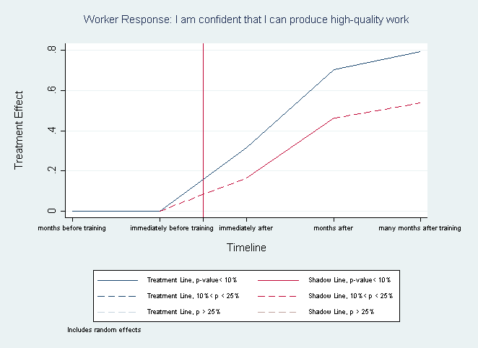

Figure .: Worker Confidence for High-Quality Work Treatment

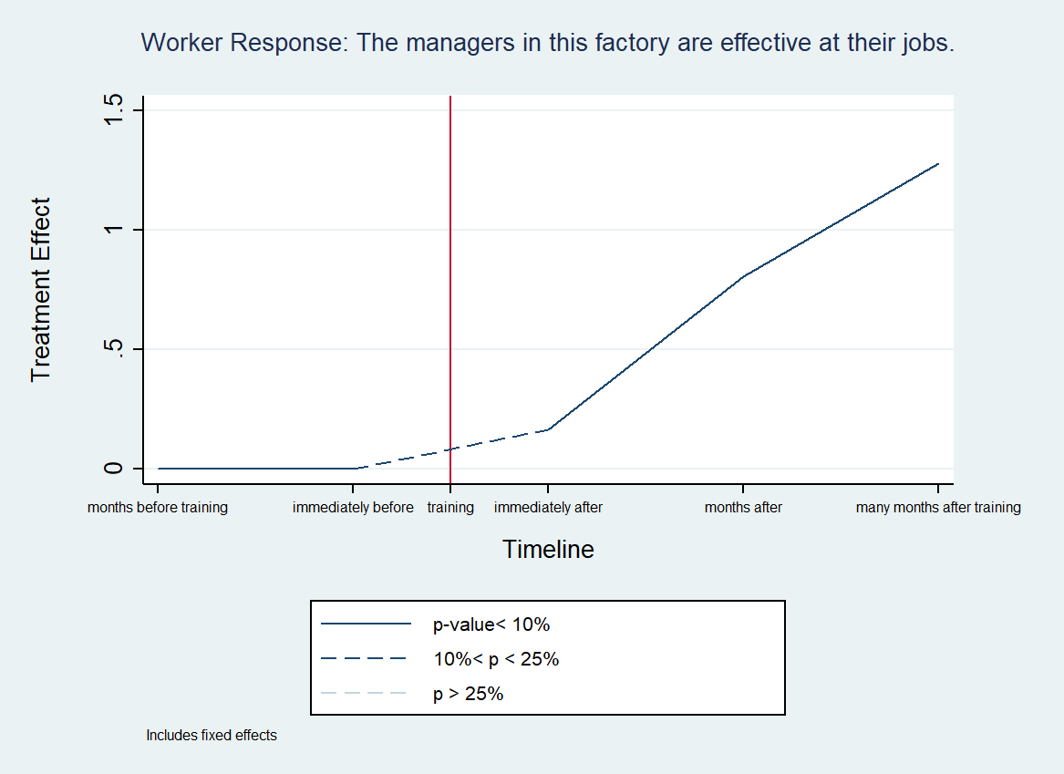

Figure .: Workers Believe Managers are Effective at Job Treatment

Table 5.3: Worker Regression Results, Conflict Resolution and Confidence

|  |  |  |  |  |  |  |
| --- | --- | --- | --- | --- | --- | --- |
|  | (1) | (2) | (3) | (4) | (5) | (6) |
| VARIABLES | Coworker_conflict | Confident_resolveconflict | Confident_voiceopinion | Othersdepend_highquality | Confident_highquality | Managers_effective |
| justtreated | 0.663* | 0.534*** | 0.543* |  |  | 0.165 |
|  | (0.356) | (0.168) | (0.269) |  |  | (0.0952) |
| treatedlongago | 0.717 | 0.882*** | 0.700 |  |  | 0.805** |
|  | (0.482) | (0.279) | (0.502) |  |  | (0.272) |
| treatedlonglongago | 0.627 | 0.968** | 0.673 |  |  | 1.279** |
|  | (0.759) | (0.389) | (0.633) |  |  | (0.561) |
| TLjusttreated |  |  |  | 0.445 | 0.316* |  |
|  |  |  |  | (0.330) | (0.186) |  |
| TLtreatedlongago |  |  |  | 0.822* | 0.704** |  |
|  |  |  |  | (0.489) | (0.282) |  |
| TLtreatedlnglongago |  |  |  | 0.946 | 0.793** |  |
|  |  |  |  | (0.731) | (0.372) |  |
| SLjusttreated |  |  |  | 0.168 | 0.165 |  |
|  |  |  |  | (0.280) | (0.120) |  |
| SLtreatedlongago |  |  |  | 0.550 | 0.462** |  |
|  |  |  |  | (0.427) | (0.200) |  |
| SLtreatedlnglngago |  |  |  | 0.830 | 0.539 |  |
|  |  |  |  | (0.718) | (0.358) |  |
| midline | -0.280 | -0.292** | -0.229 | -0.111 | -0.0490 | -0.0217 |
|  | (0.182) | (0.123) | (0.203) | (0.184) | (0.113) | (0.0915) |
| endline | -0.538 | -0.483** | -0.504 | -0.370 | -0.152 | -0.273 |
|  | (0.345) | (0.224) | (0.444) | (0.322) | (0.208) | (0.195) |
| endlineII | -0.842* | -0.835** | -0.555 | -0.657 | -0.373 | -0.943* |
|  | (0.498) | (0.346) | (0.631) | (0.519) | (0.301) | (0.465) |
| Treatmentfactory | -0.190 | -0.136 |  | -0.286 | -0.224** |  |
|  | (0.175) | (0.147) |  | (0.205) | (0.102) |  |
| Treatmentline | 0.0973 | 0.000272 |  | -0.309*** | -0.150 |  |
|  | (0.182) | (0.0875) |  | (0.119) | (0.104) |  |
| female | 0.0510 | -0.0278 |  | 0.321** | 0.163** |  |
|  | (0.170) | (0.0920) |  | (0.126) | (0.0702) |  |
| age | 0.0320 | 0.0646* | 0.209* | 0.112*** | -0.00464 | -0.0139 |
|  | (0.0674) | (0.0337) | (0.113) | (0.0178) | (0.0257) | (0.0400) |
| education | 0.0309 | -0.0358 | -0.0827 | -0.0165 | 0.0379** | 0.0816 |
|  | (0.0821) | (0.0267) | (0.139) | (0.0229) | (0.0187) | (0.0917) |
| Never_Married | -0.0795 | 0.101 | -0.842* | 0.544** | -0.128 | 0.619* |
|  | (0.183) | (0.184) | (0.457) | (0.244) | (0.125) | (0.312) |
| Married | -0.425** | 0.151 | -0.788** | 0.384 | -0.127 | 0.355 |
|  | (0.180) | (0.189) | (0.285) | (0.282) | (0.108) | (0.236) |
| W1_Time_Employ | 0.0703* | -0.0213 | 0.0178 | -0.00126 | -0.00459 | 0.0143 |
|  | (0.0388) | (0.0190) | (0.0423) | (0.0136) | (0.00869) | (0.0169) |
| W2_Previous_Work | -0.0128 | -0.00669 | 0.0468 | -0.0255 | -0.000301 | 0.0182 |
|  | (0.0518) | (0.0187) | (0.0488) | (0.0257) | (0.0198) | (0.0288) |
| Constant | 4.000*** | 3.568*** | 3.660*** | 2.704*** | 3.784*** | 2.768*** |
|  | (0.433) | (0.415) | (0.633) | (0.273) | (0.280) | (0.880) |
|  |  |  |  |  |  |  |
| Observations | 279 | 686 | 669 | 696 | 766 | 734 |
| Number of uniqueID | 204 | 410 | 397 | 414 | 438 | 420 |

### Re-humanization of Workers

While workers generally felt more confident at work and more integral to the workings of the factory, managers and supervisors had different outcomes with respect to the program’s attempt to re-humanize the workers. There was little evidence of increased humanization of workers in the minds of managers. However, there was some evidence that workers were re-humanized in the minds of supervisors. Table 5.5 and Table 5.6 show the summary statistics for manager and supervisor responses to various statements regarding their perceptions of workers.

The number of manager response observations were too low to conduct statistical analysis, but their average responses by data collection round and batch are presented in Figure 5.11 through Figure 5.17. Managers’ views on worker agency were neutral to slightly positive and improved slightly over time for both batches. Managers were asked to what extent they agreed with the statement, “The workers in this factory do not think for themselves and must be told what to do.” In Batch 2 factories, mangers’ responses improved steadily from the baseline, where the average response was neutral, to the second endline, where managers generally disagreed with the statement. Managers in Batch 1 factories started by disagreeing with the claim that workers could not think for themselves. During the midline and first endline, these beliefs slightly worsened towards being neutral, but by the second endline average responses had returned to disagreeing with the statement. Managers’ perceptions of worker agency improved slightly overtime, and they were consistently neutral regarding workers’ level of intelligence, shown in Figure 5.12.

Manager perceptions remained generally neutral on worker motivations and the effectiveness of force. Figure 5.13 shows average manager responses regarding using force against worker. It suggests that throughout the program, managers in Batch 1 factories on average shifted their opinions between being neutral to slightly disagreeing with the claim that force was the only way to encourage work. By the end of the program, average responses had returned to neutral. Batch 2 managers had an initial improvement at the midline, trending towards disagreeing that force was needed to motivate workers. Overtime the response decayed and Batch 2 managers also returned towards neutral. Managers’ perceptions of worker motivations, especially regarding money, did not change over the timeline.

While there is little evidence that manager perceptions of workers changed over time, some of the managers’ beliefs about workers were positive. Throughout the program, managers on average agreed or strongly agreed that having workers feel comfortable and safe made them more productive, as shown in Figure 5.16. Managers also agreed that listening to worker feedback was important. Figure 5.17 suggests that for managers in both batches, this belief did not change over time. Overall, managers were neutral about the abilities of workers, the use of force against them, and their motivations, but recognized that treating workers well and listening to them could be good for business.

There is some evidence that workers were re-humanized in the minds of supervisors. Statistical analysis was performed on supervisor data, the results of which are presented in Table 5.5 and Figure 5.18 through Figure 5.21.

Supervisors were less likely to objectify workers, increasing their willingness to think about help they could provide workers. In both supervisor considering workers’ needs and increasing communication with workers, treatment was immediately responsible for about a 0.5 improvement in response, meaning supervisors on average changed their responses by half a response level (“neutral” to “disagree”). Immediately after treatment and the several months following, treatment caused supervisors to disagree more with the statement, “I think more about what my workers can do for me than what I can do for them.” The treatment effect was significant initially at the 1% level and became larger in value (-.552 to -.734) in the months after treatment, but was less statistically significant. The effect dropped to the 10-25% significance level in the many months after treatment (see Figure 5.18). In addition to thinking about workers’ needs, Figure 5.19 suggests that supervisors increased general communication with workers, though the effect was significant only at the 10-25% level.

Supervisors came to realize that workers are motivated by pay incentives. In Figure 5.20, it is seen that treatment had a positive effect of .396 immediately following training and.745 in the months following on the supervisors’ belief that workers are motivated by money more than anything else, statistically significant at the 10% level or below. Given that workers find large amounts of job satisfaction related to factory pay practices (See Section 4.4), changes in supervisor responses may suggest better communication between workers and supervisors that lead to supervisors gaining a better understanding of what motivates workers.

However, supervisors also realized that workers have concerns other than money. While compensation may be the most important motivator, supervisors were less likely to believe that workers would leave the factory for a very small amount of money. Figure 5.21 shows that the treatment effect on supervisor’s belief of workers’ willingness to leave the factory based on money strengthened over time and remained statistically significant. In the long run, treatment has an effect of -1.516, significant at the 10% level.

Table 5.4: Manager Response Summary Statistics, Worker Re-humanization

|  |  |  |  |  |  |  |  |  |  |  |  |  |  |  |  |  |  |  |  |  |
| --- | --- | --- | --- | --- | --- | --- | --- | --- | --- | --- | --- | --- | --- | --- | --- | --- | --- | --- | --- | --- |
| Batch 1 Factories | | | | | | | | | | | | | | | | | | | | |
|  | Baseline | | | | | Midline | | | | | Endline I | | | | | Endline II | | | | |
| VARIABLES | N | mean | | sd | | N | mean | | sd | | N | mean | | sd | | N | mean | | sd | |
|  |  |  | |  | |  |  | |  | |  |  | |  | |  |  | |  | |
| workers_agency | 7 | 1.857 | | 0.378 | | 5 | 2.600 | | 0.894 | | 5 | 2.600 | | 0.894 | | 2 | 2 | | 1.414 | |
| workers_intelligent | 7 | 3 | | 0.816 | | 5 | 3 | | 0.707 | | 5 | 3 | | 1.225 | | 2 | 2.500 | | 0.707 | |
| workers_workifforced | 7 | 2.143 | | 0.378 | | 5 | 2.600 | | 0.894 | | 5 | 2 | | 0.707 | | 2 | 3 | | 1.414 | |
| workers_moneymotive | 6 | 2.667 | | 0.816 | | 5 | 2.600 | | 0.548 | | 5 | 2.600 | | 0.894 | | 2 | 3.500 | | 0.707 | |
| workers_leavefactory | 6 | 3 | | 0.894 | | 5 | 3 | | 0.707 | | 5 | 2.800 | | 1.304 | | 2 | 3.500 | | 0.707 | |
| workers_workifsafe | 7 | 4.286 | | 0.488 | | 5 | 4.400 | | 0.548 | | 5 | 4.200 | | 0.447 | | 2 | 4.500 | | 0.707 | |
| workerfeedback | 7 | 4 | | 0 | | 5 | 4 | | 0 | | 5 | 4 | | 0 | | 2 | 4 | | 0 | |
|  |  |  | |  | |  |  | |  | |  |  | |  | |  |  | |  | |
| Batch 2 Factories | | | | | | | | | | | | | | | | | | | | |
|  | Baseline | | | | Midline | | | | | Endline I | | | | | | Endline II | | | | |
| VARIABLES | N | mean | sd | | N | | | mean | sd | N | | | mean | | sd | N | | mean | | sd |
|  |  |  |  | |  | | |  |  |  | | |  | |  |  | |  | |  |
| workers_agency | 7 | 2.571 | | 0.535 | | 6 | 2.333 | | 0.516 | | 5 | 2.200 | | 0.447 | | 6 | 2 | | 0.632 | |
| workers_intelligent | 7 | 3.143 | | 0.690 | | 6 | 3.333 | | 0.516 | | 5 | 3.400 | | 0.548 | | 6 | 3.333 | | 0.516 | |
| workers_workifforced | 7 | 3.143 | | 1.069 | | 6 | 2.500 | | 1.049 | | 4 | 2.500 | | 0.577 | | 6 | 2.667 | | 0.516 | |
| workers_moneymotive | 7 | 3.286 | | 0.756 | | 6 | 3 | | 0.632 | | 5 | 3 | | 0.707 | | 6 | 2.833 | | 0.753 | |
| workers_leavefactory | 7 | 3.286 | | 1.113 | | 6 | 2.833 | | 0.408 | | 5 | 3.200 | | 0.837 | | 6 | 3.333 | | 0.816 | |
| workers_workifsafe | 7 | 4.286 | | 0.488 | | 6 | 4.167 | | 0.408 | | 5 | 4 | | 0 | | 6 | 3.833 | | 0.983 | |
| workerfeedback | 7 | 4 | | 0.577 | | 6 | 3.833 | | 0.408 | | 5 | 4 | | 0 | | 6 | 4 | | 0.632 | |
|  |  |  |  | |  | | |  |  |  | | |  | |  |  | |  | |  |

Table 5.5: Supervisor Response Summary Statistics, Worker Re-humanization

|  |  |  |  |  |  |  |  |  |  |  |  |  |  |  |  |  |  |  |  |  |
| --- | --- | --- | --- | --- | --- | --- | --- | --- | --- | --- | --- | --- | --- | --- | --- | --- | --- | --- | --- | --- |
| Batch 1 Factories | | | | | | | | | | | | | | | | | | | | |
|  | Baseline | | | | | Midline | | | | | Endline I | | | | | Endline II | | | | |
| VARIABLES | N | mean | | sd | | N | mean | | sd | | N | mean | | sd | | N | mean | | sd | |
|  |  |  | |  | |  |  | |  | |  |  | |  | |  |  | |  | |
| Concern_forworkers | 32 | 3.594 | | 0.798 | | 20 | 3.250 | | 0.786 | | 18 | 3.500 | | 0.618 | | 13 | 3.385 | | 0.768 | |
| Communication_workers | 32 | 2.156 | | 1.221 | | 20 | 1.850 | | 1.137 | | 18 | 1.944 | | 0.938 | | 13 | 2.231 | | 0.927 | |
| workers_moneymotive | 35 | 3.600 | | 0.914 | | 20 | 3.500 | | 0.946 | | 18 | 3.278 | | 0.958 | | 13 | 2.769 | | 1.013 | |
| workers_leavefactory | 32 | 3.750 | | 0.803 | | 20 | 3.350 | | 0.745 | | 18 | 3.278 | | 0.669 | | 13 | 3.385 | | 0.768 | |
|  |  |  | |  | |  |  | |  | |  |  | |  | |  |  | |  | |
| Batch 2 Factories | | | | | | | | | | | | | | | | | | | | |
|  | Baseline | | | | Midline | | | | | Endline I | | | | | | Endline II | | | | |
| VARIABLES | N | mean | sd | | N | | | mean | sd | N | | | mean | | sd | N | | mean | | sd |
|  |  |  |  | |  | | |  |  |  | | |  | |  |  | |  | |  |
| Concern_forworkers | 62 | 3.226 | | 0.838 | | 57 | 3.281 | | 0.796 | | 38 | 3.053 | | 0.928 | | 28 | 3 | | 0.903 | |
| Communication_workers | 63 | 2.016 | | 1.157 | | 58 | 2.069 | | 1.137 | | 38 | 1.789 | | 0.991 | | 28 | 1.714 | | 0.810 | |
| workers_moneymotive | 65 | 3.677 | | 0.850 | | 58 | 3.362 | | 0.986 | | 39 | 3.308 | | 1.004 | | 29 | 3.207 | | 0.940 | |
| workers_leavefactory | 62 | 3.565 | | 0.781 | | 55 | 3.600 | | 0.735 | | 39 | 3.436 | | 0.852 | | 29 | 3.517 | | 0.634 | |
|  |  |  |  | |  | | |  |  |  | | |  | |  |  | |  | |  |

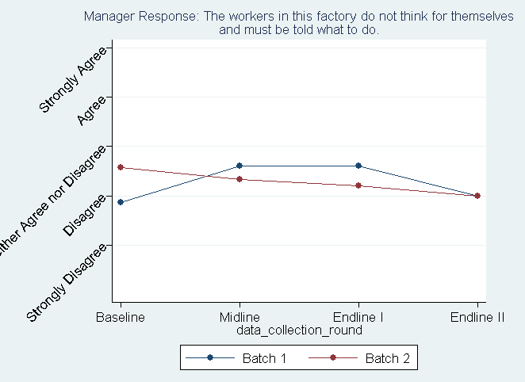

Figure .: Managers' Belief on Worker Agency

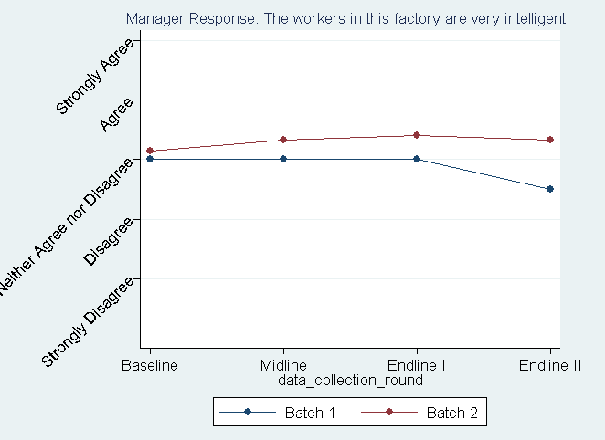

Figure .: Managers’ Belief on Worker Intelligence

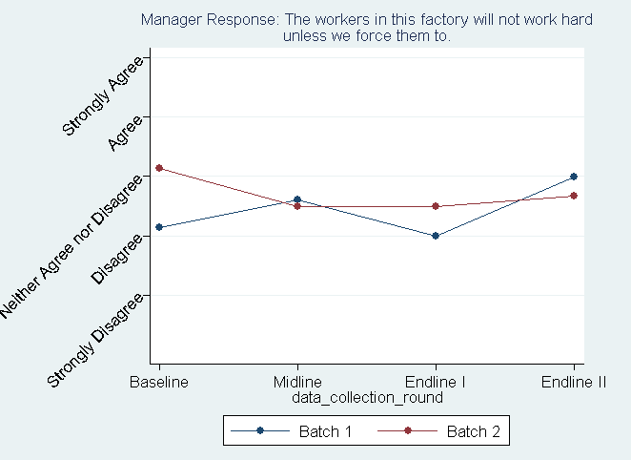

Figure .: Managers’ Belief on Workers' Response to Force

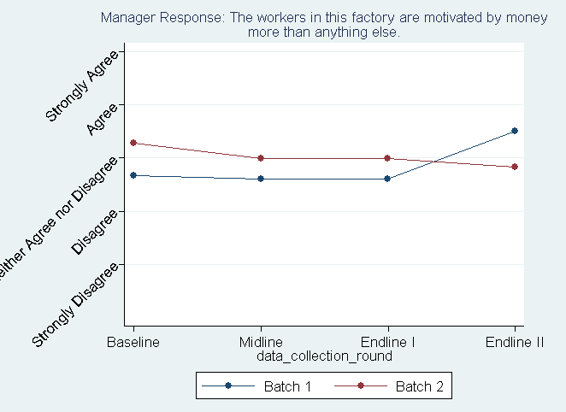

Figure .: Managers’ Belief on Workers Motivated by Money

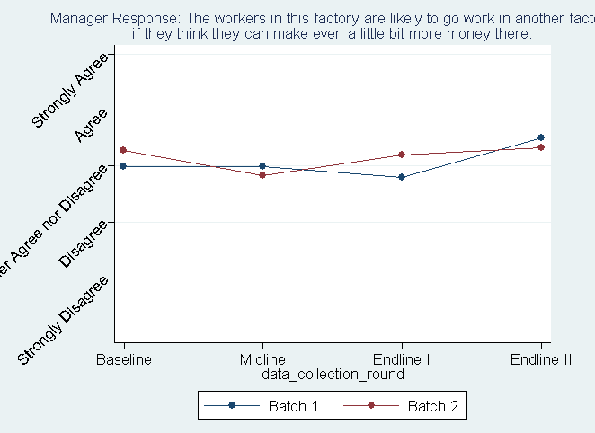

Figure .: Managers’ Belief that Workers Will Leave Factory for More Money

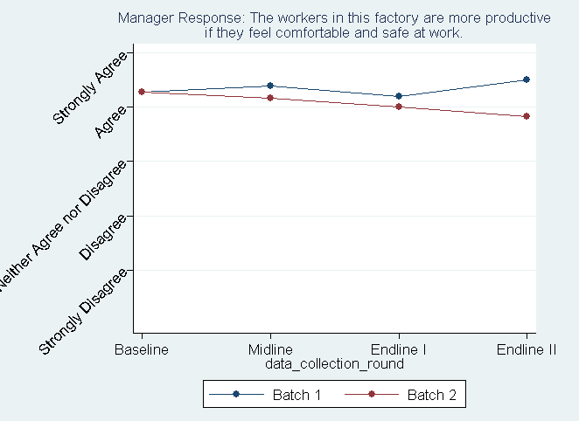

Figure .: Managers’ Belief that Worker Comfort and Safety is Important for Productivity

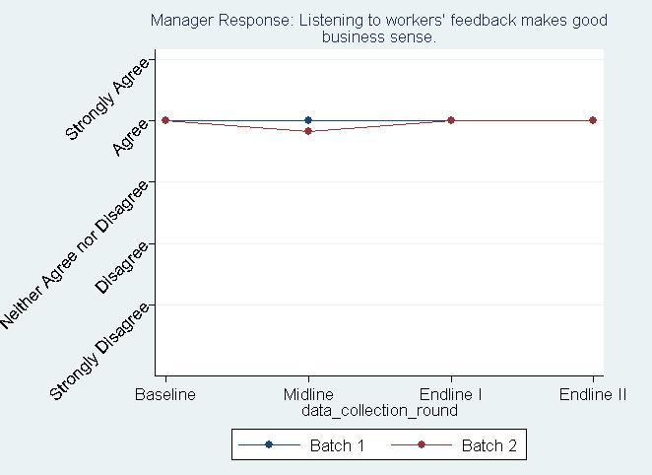

Figure .: Managers' Belief on Worker Feedback

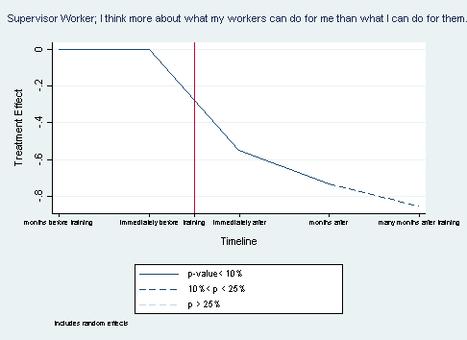

Figure .: Supervisors’ Concern for Workers Treatment

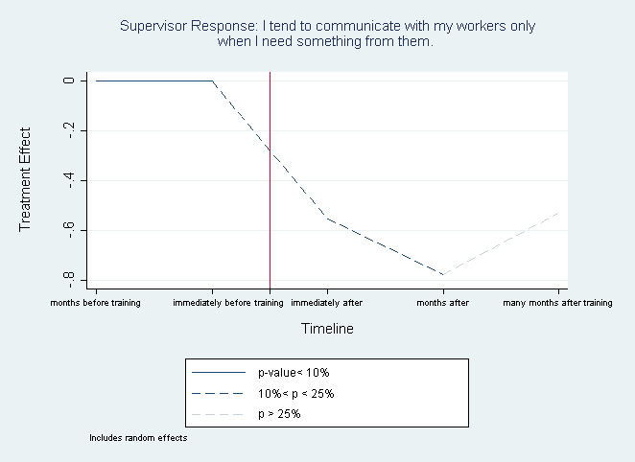

Figure .: Supervisors’ Communication with Workers Treatment

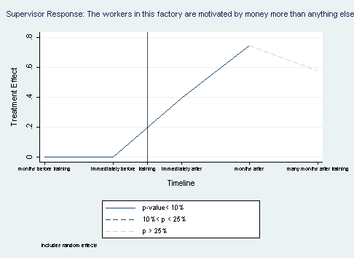

Figure .: Supervisors’ Belief on Workers Motivated by Money Treatment

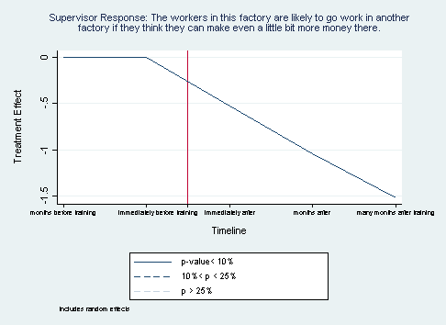

Figure .: Supervisors’ Belief that Workers Will Leave Factory for More Money Treatment

Table 5.6: Supervisor Regression Results, Worker Rehumanization

|  |  |  |  |  |
| --- | --- | --- | --- | --- |
|  | (1) | (2) | (3) | (4) |
| VARIABLES | Concern_forworkers | Communication_workers | workers_moneymotive | workers_leavefactory |
|  |  |  |  |  |
| justtreated | -0.552** | -0.553 | 0.396** | -0.523* |
|  | (0.270) | (0.395) | (0.170) | (0.299) |
| treatedlongago | -0.734* | -0.776 | 0.745* | -1.043* |
|  | (0.402) | (0.670) | (0.383) | (0.559) |
| treatedlonglongago | -0.857 | -0.529 | 0.577 | -1.516* |
|  | (0.666) | (1.045) | (0.592) | (0.836) |
| midline | -0.0532 | -0.00943 | -0.335*** | 0.0267 |
|  | (0.174) | (0.156) | (0.127) | (0.112) |
| endline | 0.328 | 0.355 | -0.808*** | 0.364 |
|  | (0.400) | (0.494) | (0.288) | (0.323) |
| endlineII | 0.446 | 0.478 | -1.148** | 1.013* |
|  | (0.503) | (0.737) | (0.462) | (0.572) |
| Treatmentfactory | 0.557*** | 0.306 | -0.255 | 0.256 |
|  | (0.137) | (0.255) | (0.200) | (0.271) |
| female_Sup | 0.169 | -0.206 | 0.0875 | 0.0724 |
|  | (0.212) | (0.295) | (0.261) | (0.188) |
| S1_Time_Supervisor | -0.0101 | -0.0189 | 0.00437 | -0.0105 |
|  | (0.0170) | (0.0143) | (0.0111) | (0.0153) |
| S2_Previous_Worker_Other | 0.114 | -0.148 | 0.202* | 0.0593 |
|  | (0.152) | (0.204) | (0.113) | (0.111) |
| Constant | 3.183*** | 2.492*** | 3.455*** | 3.560*** |
|  | (0.312) | (0.271) | (0.204) | (0.157) |
|  |  |  |  |  |
| Observations | 244 | 246 | 253 | 244 |
| Number of uniqueID | 109 | 109 | 112 | 111 |

### Working Conditions and Job Satisfaction

Similar to the analysis conducted on the relationship between pay practices and job satisfaction, and in addition to looking at treatment’s effect on occupational health and safety, we also examined the importance of working conditions on workers’ job satisfaction and desire to quit.

In Table 6.3, as expected, workplace conditions are strongly linked to workers’ level of job satisfaction. Reporting frequent headaches, neckaches or backaches was negatively associated with a worker’s overall level of job satisfaction. Similarly, reporting concerns about factory noise, dusty or polluted air, excessive heat, bad chemical smells were also all negatively associated with a worker’s overall level of job satisfaction. This means that the less frequently workers experienced pains or were concerned with various conditions of their workplace, the more satisfied they were with their jobs. Further supporting the result that improving working conditions improves workers’ views of their jobs, giving workers access to clean toilets and personal protective equipment on a regular basis was positively associated with the level of job satisfaction. Worker concerns about excessive heat and noise have the largest coefficients, -.223 and -.222 at the 1% significance level respectively, suggesting that these concerns have the largest impact on job satisfaction and may be beneficial for future programs.

Working conditions also impact workers’ frequency of considering quitting, shown in Table 6.4. Frequency of aches, dusty air, excessive heat, chemical smells, and excessive noise all have positive coefficient values that are significant at the 1% level. In this case, a positive result means that the more workers reported poor working conditions, the more frequently they thought about quitting. Again, excessive noise had the largest coefficient value at .223 followed by worker concerns over air quality at .222. Training had a positive effect on both noise and air quality. Future programs should continue to work on improving these conditions.

Table 6.3: Link between Workplace Conditions and Job Satisfaction

|  |  |  |  |  |  |  |  |  |  |
| --- | --- | --- | --- | --- | --- | --- | --- | --- | --- |
|  | |  |  |  |  |  |  |  |  |
| **Female** | |  | 0.191 | 0.173 | 0.134 | 0.129 | 0.2 | 0.095 | 0.155 |
|  | |  | (0.217) | (0.213) | (0.17) | (0.192) | (0.22) | (0.206) | (0.247) |
| **Age** | |  | -0.027 | -0.019 | -0.016 | -0.018 | 0.016 | -0.022 | -0.005 |
|  | |  | (0.03) | (0.028) | (0.028) | (0.03) | (0.029) | (0.035) | (0.034) |
| **Education** | |  | -0.098*** | -0.077*** | -0.069*** | -0.064** | -0.101*** | -0.077*** | -0.108*** |
|  | |  | (0.026) | (0.026) | (0.028) | (0.031) | (0.03) | (0.024) | (0.03) |
| **Never Married** | |  | 0.098 | 0.027 | 0.056 | 0.028 | 0.126 | 0.145 | 0.097 |
|  | |  | (0.175) | (0.241) | (0.215) | (0.222) | (0.223) | (0.212) | (0.213) |
| **Married** | |  | 0.272 | 0.192 | 0.195 | 0.2 | 0.28 | 0.273 | 0.274 |
|  | |  | (0.281) | (0.33) | (0.307) | (0.323) | (0.305) | (0.297) | (0.316) |
| **Time Employed** | |  | -0.002 | -0.003 | 0.002 | -0.007 | -0.012 | -0.003 | -0.018 |
|  | |  | (0.015) | (0.017) | (0.022) | (0.02) | (0.018) | (0.022) | (0.017) |
| **Prev. Work Exp.** | |  | -0.011 | -0.014 | -0.019 | -0.014 | -0.013 | -0.019 | -0.023 |
|  | |  | (0.02) | (0.021) | (0.02) | (0.02) | (0.021) | (0.024) | (0.022) |
|  | |  |  |  |  |  |  |  |  |
| **Aches** | |  | -0.198*** |  |  |  |  |  |  |
|  | |  | (0.041) |  |  |  |  |  |  |
| **Dusty Air** | |  |  | -0.177*** |  |  |  |  |  |
|  | |  |  | (0.054) |  |  |  |  |  |
| **Excessive Heat** | | |  |  | -0.223*** |  |  |  |  |
|  | |  |  |  | (0.063) |  |  |  |  |
| **Chemical Smells** | |  |  |  |  | -0.178*** |  |  |  |
|  | |  |  |  |  | (0.054) |  |  |  |
| **Clean Toilets** | |  |  |  |  |  | 0.141*** |  |  |
|  | |  |  |  |  |  | (0.023) |  |  |
| **Excessive Noise** | | |  |  |  |  |  | -0.222*** |  |
|  | |  |  |  |  |  |  | (0.029) |  |
| **PPE** | |  |  |  |  |  |  |  | 0.063*** |
|  | |  |  |  |  |  |  |  | (0.022) |
|  | |  |  |  |  |  |  |  |  |
| Observations | |  | 759 | 736 | 745 | 732 | 742 | 747 | 741 |
|  | Notes: Robust standard errors in parentheses *** p<0.01, ** p<0.05, * p<0.1. For ease of display, all treatment/control group variables (*treatmentfactory*, *treatmentline*, *TLjusttreated, SLjusttreated*), time control variables (*midline*, *endline*, *endlineII*), and the constant term were omitted from the table. Dependent variable:“How satisfied are you with your job overall?” (1 = completely dissatisfied; 5 = completely satisfied). Model: linear panel estimator with random effects and clustered by factory. | | | | | | | | |

Table 6.4: Link between Factory Conditions and Thinking about Quitting

|  |  |  |  |  |  |
| --- | --- | --- | --- | --- | --- |
|  |  |  |  |  |  |
| **Female** | -0.165 | -0.168 | -0.154 | -0.222 | -0.186 |
|  | (0.275) | (0.269) | (0.238) | (0.272) | (0.288) |
| **Age** | -0.0247 | -0.0375 | -0.0335 | -0.0262 | -0.0119 |
|  | (0.0368) | (0.0383) | (0.0350) | (0.0368) | (0.0350) |
| **Education** | 0.0589 | 0.0319 | 0.0270 | 0.0201 | 0.0264 |
|  | (0.0411) | (0.0399) | (0.0388) | (0.0374) | (0.0326) |
| **Never Married** | 0.0482 | 0.111 | 0.0406 | 0.0882 | 0.0101 |
|  | (0.184) | (0.264) | (0.208) | (0.224) | (0.257) |
| **Married** | -0.0490 | 0.0260 | -0.0130 | 0.0124 | -0.0463 |
|  | (0.122) | (0.195) | (0.155) | (0.163) | (0.211) |
| **Time Employed** | 0.0621*** | 0.0577*** | 0.0591*** | 0.0666*** | 0.0548*** |
|  | (0.0181) | (0.0200) | (0.0194) | (0.0198) | (0.0157) |
| **Prev. Work Exp.** | 0.0144 | 0.0210 | 0.0178 | 0.0122 | 0.0226 |
|  | (0.0276) | (0.0253) | (0.0251) | (0.0258) | (0.0199) |
|  |  |  |  |  |  |
| **Aches** | 0.203*** |  |  |  |  |
|  | (0.0506) |  |  |  |  |
| **Dusty Air** |  | 0.222*** |  |  |  |
|  |  | (0.0539) |  |  |  |
| **Excessive Heat** |  |  | 0.207*** |  |  |
|  |  |  | (0.0568) |  |  |
| **Chemical Smells** |  |  |  | 0.204*** |  |
|  |  |  |  | (0.0426) |  |
| **Excessive Noise** |  |  |  |  | 0.223*** |
|  |  |  |  |  | (0.0453) |
|  |  |  |  |  |  |
| Observations | 763 | 737 | 747 | 730 | 749 |
| Notes: Robust standard errors in parentheses *** p<0.01, ** p<0.05, * p<0.1. For ease of display, all treatment/control group variables (*treatmentfactory*, *treatmentline*, *TLjusttreated, SLjusttreated*), time control variables (*midline*, *endline*, *endlineII*), and the constant term were omitted from the table. Dependent variable:“I often think about quitting” (1 = strongly disagree; 5 = strongly agree). Model: linear panel estimator with random effects and clustered by factory. | | | | | |

### 7.1 Worker Health

There was a positive treatment effect for workers’ both mental and physical health. Table 7.1 reports the summary statistics for worker reports on how frequently they feel sad or depressed and how frequently they are sick, both on a 1 to 5 scale. Throughout the program, average worker responses for both mental and physical health were between 2 and 3, suggesting that workers generally experienced poor health “rarely” or sometimes.”

Even with existing low reports of poor mental health, with training, workers reported fewer incidences of feeling sad or depressed. The reduction in incidence of poor mental health emerged first on the pilot line and then appeared on the shadow line. By the second endline, the treatment affected both lines by an absolute value greater than 1.5 and was strongly significant at the 1% level. This suggests that in the long run, workers following treatment reported never feeling sad or depressed. Exact regression results are reported in the first column of Table 7.2.

Workers also reported fewer episodes of feeling sick following treatment. Shown in Figure 7.2, on the pilot line, the effect was only statistically significant in the few months following treatment but decayed over a longer period of time. There was a stronger effect on the shadow line that arose in the months after training and persisted. As with depression, the value of the treatment effect was large at -1.454. The statistical relationship was significant at the 10% level both several months after training and many months after training.

Table 7.1: Worker Response Summary Statistics, Worker Health

|  |  |  |  |  |  |  |  |  |  |  |  |  |  |  |  |  |  |  |  |
| --- | --- | --- | --- | --- | --- | --- | --- | --- | --- | --- | --- | --- | --- | --- | --- | --- | --- | --- | --- |
| Batch 1 Factories | | | | | | | | | | | | | | | | | | | |
|  | Baseline | | | | | Midline | | | | Endline I | | | | | Endline II | | | | |
| VARIABLES | N | mean | | sd | | N | mean | sd | | N | mean | | sd | | N | mean | | sd | |
|  |  |  | |  | |  |  |  | |  |  | |  | |  |  | |  | |
| Depression | 93 | 2.667 | | 1.036 | | 79 | 2.544 | 1.119 | | 60 | 2.017 | | 1.049 | | 43 | 2.023 | | 0.963 | |
| Sick | 91 | 2.077 | | 1.057 | | 77 | 2.247 | 1.114 | | 61 | 1.656 | | 0.981 | | 43 | 1.907 | | 0.996 | |
|  |  |  | |  | |  |  |  | |  |  | |  | |  |  | |  | |
| Batch 2 Factories | | | | | | | | | | | | | | | | | | | |
|  | Baseline | | | | Midline | | | | Endline I | | | | | | Endline II | | | | |
| VARIABLES | N | mean | sd | | N | | mean | sd | N | | | mean | | sd | N | | mean | | sd |
|  |  |  |  | |  | |  |  |  | | |  | |  |  | |  | |  |
| Depression | 182 | 2.368 | 1.148 | | 178 | | 2.489 | 1.131 | 132 | | | 2.136 | | 1.032 | 62 | | 2.194 | | 1.084 |
| Sick | 183 | 1.863 | 1.058 | | 181 | | 2.122 | 1.063 | 132 | | | 1.788 | | 0.941 | 60 | | 1.833 | | 1.028 |
|  |  |  |  | |  | |  |  |  | | |  | |  |  | |  | |  |

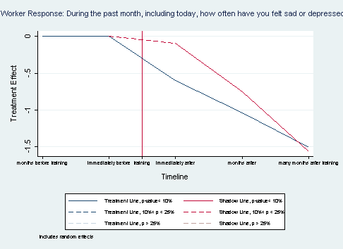

Figure .: Worker’s Frequency of Feeling Sadness or Depression Treatment

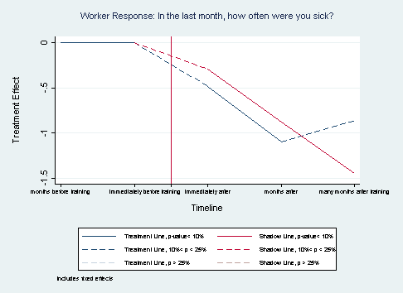

Figure .: Workers’ Frequency of Feeling Sick Treatment

Table 7.2: Worker Regression Results, Worker Health

|  |  |  |
| --- | --- | --- |
|  | (1) | (2) |
| VARIABLES | Depression | Sick |
| TLjusttreated | -0.603*** | -0.484 |
|  | (0.200) | (0.356) |
| TLtreatedlongago | -1.037*** | -1.100* |
|  | (0.385) | (0.536) |
| TLtreatedlnglongago | -1.508** | -0.865 |
|  | (0.610) | (0.701) |
| SLjusttreated | -0.0934 | -0.292 |
|  | (0.0800) | (0.252) |
| SLtreatedlongago | -0.756*** | -0.878* |
|  | (0.281) | (0.475) |
| SLtreatedlnglngago | -1.558*** | -1.454* |
|  | (0.502) | (0.691) |
| midline | 0.111 | 0.514*** |
|  | (0.0727) | (0.159) |
| endline | 0.145 | 0.780* |
|  | (0.267) | (0.391) |
| endlineII | 0.716 | 1.263* |
|  | (0.446) | (0.634) |
| Treatmentfactory | 0.308 |  |
|  | (0.232) |  |
| Treatmentline | 0.148 |  |
|  | (0.177) |  |
| female | -0.0328 |  |
|  | (0.288) |  |
| age | -0.0835* | 0.0458 |
|  | (0.0482) | (0.146) |
| education | 0.0761* | 0.150 |
|  | (0.0400) | (0.140) |
| Never_Married | -0.300 | 1.143** |
|  | (0.245) | (0.490) |
| Married | -0.314 | 1.002** |
|  | (0.265) | (0.414) |
| W1_Time_Employ | 0.0478*** | -0.0629* |
|  | (0.0148) | (0.0342) |
| W2_Previous_Work | 0.0210 | -0.0167 |
|  | (0.0296) | (0.0271) |
| Constant | 2.154*** | 0.267 |
|  | (0.381) | (0.773) |
|  |  |  |
| Observations | 776 | 777 |
| Number of uniqueID | 438 | 439 |

Depression and sickness have major effects in the workplace. Higher prevalence of depression and sickness among a factory’s workforce leads to chronic absenteeism and burnout, which negatively affect a factory’s productivity and performance.

As Table 7.3 indicates, the Myanmar worker survey predictably revealed that workers who reported feeling depressed or more frequently sick were also more likely to report lower job satisfaction, lower life satisfaction, and more frequent episodes of lateness. All effects were strongly significant at the 1% level.

However, we found that treatment substantially mitigated these associations. Treatment reduced the negative association between depression and job satisfaction by about half. The first column of Table 7.3 suggests that for workers who were not on the treatment line, depression had a -.305 effect on job satisfaction while, for treatment line workers, the effect value was only -.152. Treatment’s mitigating effect on life satisfaction was even greater, with the effect actually becoming positive for workers on the treatment line who had just finished training. Similarly, treatment mitigated the association between depression and lateness. Although experiencing depression itself is positively associated with lateness, for workers on the treatment line depression was negatively associated with lateness.

The relationships between sickness, job/life satisfaction, and lateness were similar to that of depression. Treatment reduced the negative association between sickness and job satisfaction by more than half, with a greater mitigating effect on life satisfaction. Treatment also mitigated the association between sickness and lateness. Although sickness itself is positively associated with lateness, for workers on the treatment line sickness was negatively associated with lateness.

Table 7.3: Effect of Treatment and Depression/Sickness on Job/Life Satisfaction, Lateness

|  |  |  |  |  |  |  |
| --- | --- | --- | --- | --- | --- | --- |
| Dependent Variables | **Job Satisf.** | **Job Satisf.** | **Life Satisf.** | **Life Satisf.** | **Late to Work** | **Late to Work** |
| **Female** | 0.188 | 0.0858 | -0.0331 | -0.0420 | -0.341** | -0.271 |
|  | (0.142) | (0.214) | (0.171) | (0.224) | (0.147) | (0.186) |
| **Age** | -0.0271 | -0.00855 | -0.00766 | 0.00536 | 0.0425 | 0.0352 |
|  | (0.0316) | (0.0339) | (0.0552) | (0.0521) | (0.0508) | (0.0533) |
| **Education** | -0.0801*** | -0.0943*** | -0.0426 | -0.0641 | -0.0772** | -0.0690* |
|  | (0.0251) | (0.0234) | (0.0411) | (0.0443) | (0.0361) | (0.0365) |
| **Married** | 0.179 | 0.315 | 0.718** | 0.842*** | 0.479* | 0.389 |
|  | (0.312) | (0.325) | (0.317) | (0.311) | (0.251) | (0.241) |
| **Treatment Factory** | -0.115 | -0.102 | -0.101 | -0.0921 | 0.399*** | 0.401*** |
|  | (0.146) | (0.154) | (0.167) | (0.166) | (0.127) | (0.134) |
| **Treatment Line** | -0.286** | -0.242 | -0.0569 | -0.0565 | 0.0935 | 0.106 |
|  | (0.145) | (0.149) | (0.115) | (0.130) | (0.0748) | (0.0749) |
| **TLjusttreated** | -0.107 | -0.0619 | -0.643** | -0.396 | 0.455 | 0.465 |
|  | (0.127) | (0.104) | (0.325) | (0.338) | (0.324) | (0.285) |
| **CLjusttreated** | 0.0636 | 0.0547 | -0.177 | -0.228 | -0.0530 | -0.00906 |
|  | (0.138) | (0.135) | (0.172) | (0.181) | (0.108) | (0.0909) |
|  |  |  |  |  |  |  |
| **Depression** | -0.305*** |  | -0.213*** |  | 0.106** |  |
|  | (0.0695) |  | (0.0518) |  | (0.0445) |  |
| **Depression* Treatment Line** | 0.153**  (0.0622) |  |  |  |  |  |
|  |  |  |  |  |  |  |
| **Depression* TLjusttreated** |  |  | 0.315***  (0.111) |  | -0.194**  (0.0932) |  |
|  |  |  |  |  |
|  |  |  |  |  |  |  |
| **Sick** |  | -0.246***  (0.0485) |  | -0.119***  (0.0365) |  | 0.111***  (0.0382) |
|  |  |  |  |
| **Sick* Treatment Line** |  | 0.153***  (0.0560) |  |  |  |  |
|  |  |  |  |  |  |
| **Sick* TLjusttreated** |  |  |  | 0.219* |  | -0.220*** |
|  |  |  |  | (0.127) |  | (0.0746) |
|  |  |  |  |  |  |  |
| Observations | 753 | 751 | 757 | 752 | 765 | 762 |
| Notes: Robust standard errors in parentheses *** p<0.01, ** p<0.05, * p<0.1. For ease of display, the following variables were deleted from the table: *midline*, *endline*, *endlineII*, *Never Married, Time Employed, Previous Work Experience,* and the constant term. Model: linear panel estimator with random effects and clustered by factory. Dependent variables: Columns 1, 2 – “How satisfied are you with your job overall?” (1 = completely dissatisfied;…5 = completely satisfied). Columns 3, 4 – “How satisfied are you with your life overall?” (1 = completely dissatisfied;…5 = completely satisfied). Columns 5, 6 – “In the last month, how many times were you late to work for any reason?” (1 = one day; …6 = five or more).Independent variables of interest: *Depression* – “During the past month, including today, how often have you felt sad or depressed?” (1=Never; …5=Always). *Sick –* “In the last month, how often were you sick?”(1=Never; …5=Always). | | | | | | |

### Worker Family Outcomes

The impact evaluation specifically considered the impact on savings behavior and the acquisition of household capital. Table 7.4 reports the summary statistics on workers’ families’ spending behavior and possession of various household items. All variables are binary, meaning that workers responded 0 or 1, “no” or “yes.” The mean values in Table 7.4 are the percentage of workers that responded “yes” to each question by batch and collection round. Additionally, coefficient values for treatment variables in Table 7.5 are the percentage differences of workers responding “yes” between those who experienced varying levels of treatment or no treatment.

In the survey, workers were asked whether their family had saved money and/or borrowed money in the past month. Treatment’s effect on family savings is shown in Figure 7.3. Despite treatment’s negative effect on wages (Section 4.1), workers on both the pilot and shadow lines reported an increase in savings. However, the effect was significant only for workers on the shadow line. On the shadow line, 17.5% more workers immediately reported that their family had saved money in the preceding month. In the long-run, nearly 40% more workers on the shadow line reported that their family had saved money than workers with no treatment.

A reduction in borrowing was more pronounced, as shown in Figure 7.4. The treatment effect on the decline in borrowing was significant at the 1% level and strengthened over time, indicating a significant beneficial effect on household financial security. Immediately after training, slightly less than 10% of workers reported that their families had not borrowed money. In the many months after training, the percentage amplified to 20.8% fewer workers reporting having borrowed money compared to workers with no treatment.

Treatment was also positively associated with the acquisition of household assets. In the summary statistics, the percentage of workers stating that their households have certain assets fluctuated, and sometimes decreased, between data collection rounds. For example, in Batch 1, 13% of workers at the baseline reported that their family had a refrigerator, but at the midline only 10.3% of workers said that they have a refrigerator. For purchases like refrigerators, this decline in responses is likely caused by worker turnover, with new workers reporting that they do not have certain assets, rather than remaining workers reporting that they have lost their assets.

Generally, there was a positive treatment effect on the percentage of workers reporting acquisition of household assets such as electricity (immediate 10% increase, but decays over time), indoor toilets (long term increase of 35% for both treatment and shadow line), mobile phones (long term increase of 30%), and refrigerators (long term effect of 35%). Somewhat surprisingly, despite the increase in workers reporting having indoor toilets, treatment in the long run had a negative effect on worker households reporting having running water. Many months following treatment, 30.7% fewer workers reported having running water in their home.

Regardless, treatment led to a net positive result for workers and household wellbeing. These findings add richness to the results from Chapter 4 that state that, despite not experiencing a wage increase due to treatment, workers achieved improved understanding of pay and trusted the factory more to pay what the workers were due. Given the improved understanding of and trust in their wages, workers and their families thus felt secure enough to save more, borrow less, and acquire various household assets.

Table 7.4: Worker Response Summary Statistics, Family Outcomes

|  |  |  |  |  |  |  |  |  |  |  |  |  |  |  |  |  |  |  |
| --- | --- | --- | --- | --- | --- | --- | --- | --- | --- | --- | --- | --- | --- | --- | --- | --- | --- | --- |
| Batch 1 Factories | | | | | | | | | | | | | | | | | | |
|  | Baseline | | | | | Midline | | | | Endline I | | | | Endline II | | | | |
| VARIABLES | N | mean | | sd | | N | mean | sd | | N | mean | | sd | N | mean | | sd | |
|  |  |  | |  | |  |  |  | |  |  | |  |  |  | |  | |
| W61_family_save | 83 | 0.205 | | 0.406 | | 79 | 0.253 | 0.438 | | 60 | 0.467 | | 0.503 | 42 | 0.333 | | 0.477 | |
| W61_family_borrow | 83 | 0.0964 | | 0.297 | | 79 | 0.0633 | 0.245 | | 60 | 0.0500 | | 0.220 | 42 | 0.0476 | | 0.216 | |
| W62_Electricity | 92 | 0.565 | | 0.498 | | 78 | 0.628 | 0.486 | | 59 | 0.898 | | 0.305 | 43 | 0.744 | | 0.441 | |
| W62_Running_Water | 92 | 0.446 | | 0.500 | | 78 | 0.359 | 0.483 | | 59 | 0.695 | | 0.464 | 43 | 0.279 | | 0.454 | |
| W62_Indoor_Toilet | 92 | 0.500 | | 0.503 | | 78 | 0.372 | 0.486 | | 59 | 0.593 | | 0.495 | 43 | 0.558 | | 0.502 | |
| W62_Mobile_Phone | 92 | 0.630 | | 0.485 | | 78 | 0.718 | 0.453 | | 59 | 0.949 | | 0.222 | 43 | 0.837 | | 0.374 | |
| W62_Refrigerator | 92 | 0.130 | | 0.339 | | 78 | 0.103 | 0.305 | | 59 | 0.305 | | 0.464 | 43 | 0.302 | | 0.465 | |
|  |  |  | |  | |  |  |  | |  |  | |  |  |  | |  | |
| Batch 2 Factories | | | | | | | | | | | | | | | | | | |
|  | Baseline | | | | Midline | | | | Endline I | | | | | Endline II | | | | |
| VARIABLES | N | mean | sd | | N | | mean | sd | N | | | mean | sd | N | | mean | | sd |
|  |  |  |  | |  | |  |  |  | | |  |  |  | |  | |  |
| W61_family_save | 177 | 0.305 | 0.462 | | 165 | | 0.309 | 0.464 | 127 | | | 0.449 | 0.499 | 57 | | 0.386 | | 0.491 |
| W61_family_borrow | 177 | 0.0565 | 0.232 | | 165 | | 0.121 | 0.327 | 127 | | | 0.0787 | 0.270 | 57 | | 0.0702 | | 0.258 |
| W62_Electricity | 185 | 0.714 | 0.453 | | 171 | | 0.673 | 0.471 | 131 | | | 0.771 | 0.422 | 61 | | 0.852 | | 0.358 |
| W62_Running_Water | 185 | 0.476 | 0.501 | | 171 | | 0.398 | 0.491 | 131 | | | 0.618 | 0.488 | 61 | | 0.508 | | 0.504 |
| W62_Indoor_Toilet | 185 | 0.751 | 0.433 | | 171 | | 0.585 | 0.494 | 131 | | | 0.656 | 0.477 | 61 | | 0.656 | | 0.479 |
| W62_Mobile_Phone | 185 | 0.778 | 0.416 | | 171 | | 0.737 | 0.442 | 131 | | | 0.916 | 0.278 | 61 | | 0.885 | | 0.321 |
| W62_Refrigerator | 185 | 0.119 | 0.325 | | 171 | | 0.129 | 0.336 | 131 | | | 0.214 | 0.412 | 61 | | 0.246 | | 0.434 |
|  |  |  |  | |  | |  |  |  | | |  |  |  | |  | |  |

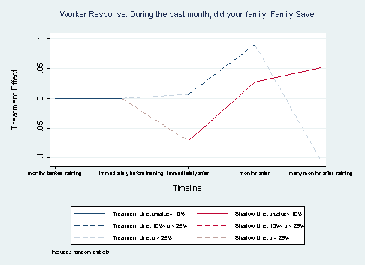

Figure .: Workers’ Family Saving Treatment

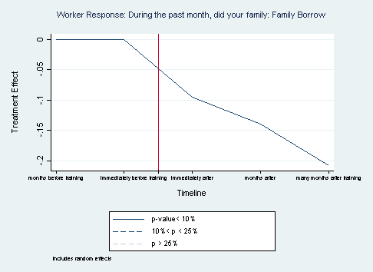

Figure .: Workers’ Family Borrowing Treatment

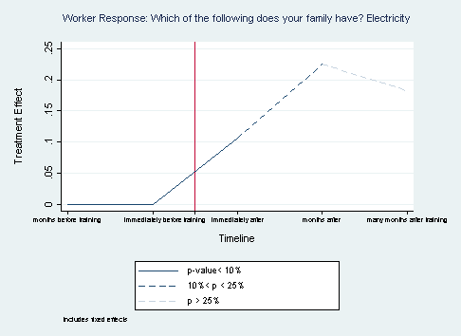

Figure .: Workers’ Family with Electricity Treatment

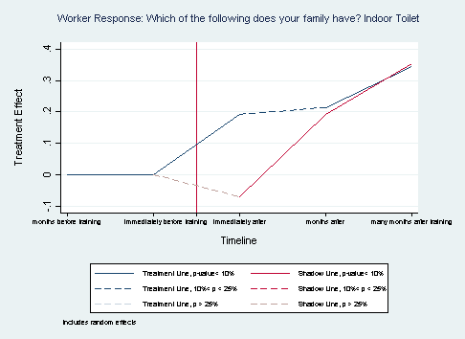

Figure .: Workers’ Family with Indoor Toilet Treatment

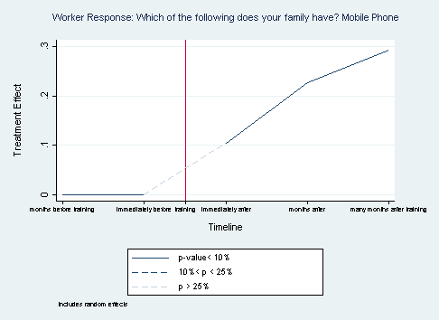

Figure .: Workers’ Family with Mobile Phone Treatment

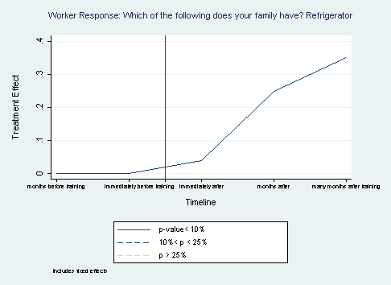

Figure .: Workers’ Family with Refrigerator Treatment

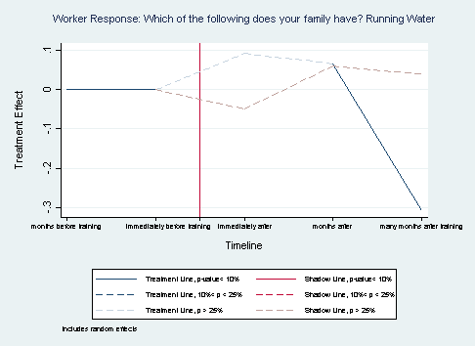

Figure .: Workers’ Family with Running Water Treatment

Table 7.5: Worker Regression Results, Family Outcomes

|  |  |  |  |  |  |  |  |
| --- | --- | --- | --- | --- | --- | --- | --- |
|  | (1) | (2) | (3) | (4) | (5) | (6) | (7) |
| VARIABLES | W61_family_save | W61_family_borrow | W62_Electricity | W62_Indoor_Toilet | W62_Mobile_Phone | W62_Refrigerator | W62_Running_Water |
| justtreated |  | -0.0955*** | 0.106* |  | 0.104 | 0.0372** |  |
|  |  | (0.0276) | (0.0522) |  | (0.105) | (0.0167) |  |
| treatedlongago |  | -0.140** | 0.225 |  | 0.227* | 0.248*** |  |
|  |  | (0.0576) | (0.155) |  | (0.120) | (0.0708) |  |
| treatedlonglongago |  | -0.208*** | 0.183 |  | 0.293** | 0.350** |  |
|  |  | (0.0694) | (0.265) |  | (0.148) | (0.153) |  |
| TLjusttreated | 0.0959 |  |  | 0.192* |  |  | 0.0919 |
|  | (0.103) |  |  | (0.0984) |  |  | (0.0950) |
| TLtreatedlongago | 0.0297 |  |  | 0.215 |  |  | 0.0665 |
|  | (0.0722) |  |  | (0.178) |  |  | (0.132) |
| TLtreatedlnglongago | 0.188 |  |  | 0.346*** |  |  | -0.307* |
|  | (0.137) |  |  | (0.126) |  |  | (0.182) |
| SLjusttreated | 0.175* |  |  | -0.0709 |  |  | -0.0494 |
|  | (0.0924) |  |  | (0.111) |  |  | (0.0617) |
| SLtreatedlongago | 0.0710 |  |  | 0.192 |  |  | 0.0596 |
|  | (0.195) |  |  | (0.117) |  |  | (0.0970) |
| SLtreatedlnglngago | 0.386* |  |  | 0.355* |  |  | 0.0399 |
|  | (0.205) |  |  | (0.188) |  |  | (0.183) |
| midline | 0.00655 | 0.0395** | -0.133*** | -0.167*** | -0.0374 | -0.0290 | -0.0717 |
|  | (0.0394) | (0.0180) | (0.0422) | (0.0462) | (0.0413) | (0.0228) | (0.0523) |
| endline | 0.0904 | 0.0975* | -0.122 | -0.141 | 0.0495 | -0.0745 | 0.149* |
|  | (0.0690) | (0.0523) | (0.110) | (0.0997) | (0.115) | (0.0529) | (0.0856) |
| endlineII | -0.105 | 0.143** | -0.168 | -0.298* | -0.0929 | -0.208 | -0.0238 |
|  | (0.158) | (0.0578) | (0.214) | (0.170) | (0.128) | (0.126) | (0.120) |
| Treatmentfactory | -0.0717 | 0.0259 |  | -0.246*** | -0.140* |  | -0.0335 |
|  | (0.0770) | (0.0318) |  | (0.0621) | (0.0720) |  | (0.0815) |
| Treatmentline | 0.0274 | -0.0131 |  | -0.0659 | 0.0327 |  | -0.0279 |
|  | (0.0474) | (0.0226) |  | (0.0656) | (0.0335) |  | (0.0426) |
| female | 0.0510 | -0.0743** |  | 0.0716 | 0.233** |  | 0.0322 |
|  | (0.0498) | (0.0335) |  | (0.0521) | (0.0967) |  | (0.0989) |
| age | -0.00550 | 0.0218** | -0.0358 | -0.0292** | -0.0247 | -0.0220 | 0.00864 |
|  | (0.0152) | (0.0109) | (0.0395) | (0.0137) | (0.0262) | (0.0387) | (0.0215) |
| education | 0.0127 | -0.0167*** | 0.0663* | 0.0138 | 0.0360*** | 0.0240 | 0.00738 |
|  | (0.0166) | (0.00498) | (0.0334) | (0.0132) | (0.0131) | (0.0496) | (0.0170) |
| Never_Married | 0.0893 | -0.0169 | 0.217 | -0.0181 | 0.0918 | -0.267* | -0.270*** |
|  | (0.180) | (0.115) | (0.226) | (0.0961) | (0.184) | (0.143) | (0.0714) |
| Married | 0.159 | 0.00747 | 0.127 | 0.0541 | 0.130 | -0.304** | -0.229*** |
|  | (0.162) | (0.125) | (0.204) | (0.0801) | (0.183) | (0.113) | (0.0821) |
| W1_Time_Employ | -0.0113* | 0.00371 | 0.0254** | 0.00505 | -0.000322 | 0.0355** | -0.00826 |
|  | (0.00650) | (0.00607) | (0.0102) | (0.00717) | (0.00819) | (0.0117) | (0.00560) |
| W2_Previous_Work | -0.0181 | -0.0131* | 0.0432** | 0.0188 | 0.0210** | 0.0117 | 0.0174*** |
|  | (0.0123) | (0.00758) | (0.0155) | (0.0125) | (0.00838) | (0.0106) | (0.00641) |
| Constant | 0.222 | 0.195 | -0.00650 | 0.639*** | 0.267 | 0.0952 | 0.632*** |
|  | (0.221) | (0.138) | (0.258) | (0.137) | (0.245) | (0.275) | (0.126) |
|  |  |  |  |  |  |  |  |
| Observations | 743 | 743 | 772 | 769 | 769 | 772 | 769 |
| Number of uniqueID | 423 | 423 | 438 | 436 | 436 | 438 | 436 |