**Medically Complex Patient (MCP) Care Clinic Protocol**

***Director, MCP Clinic, Division of Medicine, Department of Comprehensive Care***

In MCP Clinic, we prepare dental students for the dental management of the most common medical conditions that they will face in their daily practice. Under the clinic supervision of Division of Medicine Faculty, TUSDM Pre-doctoral Third, and Fourth Year Students treat MCP patients, and learn about the chair-side dental management of medically complex adult and young adult patients (18+). The clinic process includes: introduction to medically complex dental clinic, patient triage, application of clinical protocols based on evidence-based literature, treatment plans, follow ups, medical consults, dental clearance protocol before major surgeries and interventions. In addition, the students learn to apply risk assessment and dental management in to day to day practice management.

**The patient profile:**

MCP Clinic serves  patients with: Bleeding Problems (including those on anticoagulants), Cardiac Problems (heart murmurs, cardiac defects), Cardiovascular Problems (high blood pressure, arrhythmias), Central Nervous System Problems (seizures, stroke), uncontrolled Diabetes (those with HbA1C levels above 9%), Immune-suppression (cancer), Infectious Diseases (tuberculosis, hepatitis, HIV, herpes, flu), Kidney Problems, Liver Problems, Pregnancy, Prosthetic Joints, Pulmonary Problems: Asthma, Allergies, as well as dental clearance patients who need dental exam and treatment before any invasive medical procedure.

**Schedule:** MCP Clinic treats patients 5 days a week, 9 am and 1 pm sessions.  Due to the complexity of the medical conditions of the patients treated here, there are no evening sessions scheduled.  When students need to schedule their Patients in MCP Clinic:

1. Check the availability in axiUm (under MCP clinic) and
2. Notify your group practice DPAs to book the patient in to MCP clinic.
3. Always notify the MCP faculty through axiUm / by stopping by before coming to MCP.
4. The MCP Faculty will provide specific dental chair management guidelines customized for your patient when they meet with you.

**MCP Clinic Triage and Referral**

**MCP Clinic Protoco**l needs to be followed whenever a student sees their medically complex patient in MCP Clinic.

* Patients are referred to MCP by TMC (Specifically by (but not limited with) Renal Clinic & Infectious Disease Clinic; Outside Private Clinics or Hospitals.
* After a new patient Exam by PC/ faculty
* Already on the record, but Transferred to a new student provider by PC/ faculty
* When MCP tab is checked by Div. of Medicine faculty on the Medical consult form.

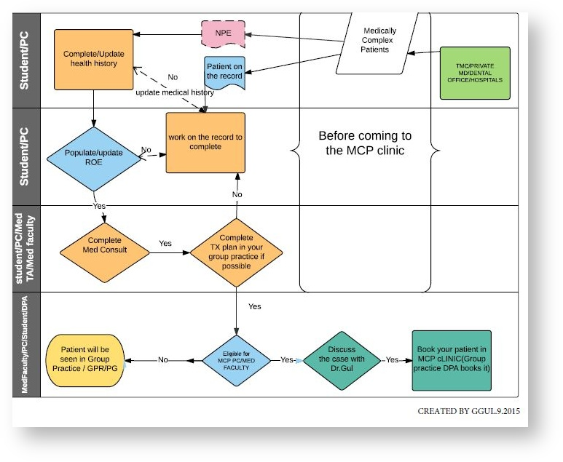

**MCP PROTOCOL**

1. **Admission to MCP:**Please refer to **MCP Triage flow** to book your patient in MCP.
   * Medical consult tab and health history need to be updated and med consult should be swiped (if it was not before) before the patient sits in the chair for their visit, unless it is a Comprehensive Exam (D150).
   * If it is a Comprehensive Exam (D150), Student should proceed as in their group practice and sits for med consult after completion of Health history form, populated ROE and Medicine consult forms. Comprehensive Exam is completed with MCP Faculty.

**2. Dental Procedures:**

* + Student works with MCP faculty & the floor faculty as in her/his group practices.
  + Student needs to do at least 2 of the same procedures or 2 assists before s(he)proceeds with the procedure on the MCP patient. Student is not allowed to work on the MCP patient if s(he) never has done the procedure before.
  + Prosthodontics oriented treatment appointments are suggested to be done in student’s own group practices per Dr. Nui’s request, due to the fact that daily Prosthodontics– faculty limits do not acknowledge the MCP as a group practice location.

**3. Patient’s Consent:**

* + **Student makes sure the patient**has no comprehension or mental issues that will prevent her/him from understanding and signing any consent forms
  + In case of concern, please ask the patient if s(he) ever needed to have a health proxy or assigned any medical guardian.  If the answer is yes, these assigned people has to be with the patient signing consent forms and treatment plans.

**4. Case notes:**

* + Please use ***MCP CASE NOTE*** every time you see your patient in this clinic, in addition to your day notes.  For MCP CASE NOTES: Axium>TX notes >under general notes> under code **300.10>*EXAM OR 300.11>TREATMENT NOTE*.** Only one case notes per session depending on it is a treatment or an exam note.
  + Please transfer all the necessary information from your updated med consult form to this MCP case note so that WHENEVER a Faculty comes to check the patient,  s(he) can see and read all medical related information in one place and it is a good reminder for you as well when you are presenting the case to MCP faculty at the beginning of the session.

**5. Dental anxiety assessment**:

* + Please have your patient fill out the hard copy “Corah’s Dental Anxiety & Concern scale” form and record it on MCP treatment case note under behavior.

**6. Session start:**

* + MCP Clinic Faculty will start the student at the beginning of the session after the patient’s vitals are taken, the medication and health history were updated, and chair set up and the patient are ready to proceed unless it is a procedure that floor faculty wants to start.
  + Student can start the patient with periodontology or operative faculty as well if s(he) has a specific procedure for the session and if the vitals are within normal limits.
  + Student informs MCP faculty before the procedure.

**7. Presentation & Dismissal**:

* + Student provider will present the case briefly to the MCP faculty before he starts working on the patient.
  + And at the end of the session again the MCP faculty will be notified before the patient’s dismissal.

**8. Dental Management of MCP:**

* + Student follows the ABCs of dental management of Medically Complex Patients (Antibiotics, Analgesics, Anesthesia, Allergy, Anxiety, Bleeding, Breathing, Blood Pressure, Drugs, Devices, Equipment, Emergencies, and Follow up).
  + Students are provided with the recent evidence-based literature in regard to their specific patient.

**9. Bio-labs:**

* + Please take patient’s vitals and record on the case note before and after each dental treatment.
  + Please make sure to be aware of the patient’s existing lab values on the day of the treatment.

**10. Medications**:

* + Please ask the patient if s(he) is taking any medications (name, dosage, frequency), and s(he) has a medication list.
  + Please confirm if s(he) took his/her medications before the appointment, and if there are any changes in his/her medications.

**11. Other:**

* + Please confirm if the patient had breakfast/meal before s(he) comes to dental appointments.
  + Please always ask Fasting Blood Sugar value of the day if that is a diabetic patient.
  + Please confirm the position of the dental chair necessary for patient comfort.
  + Please make sure the patient is accompanied when necessary before the appointment and at dismissal.
  + Please keep the appointments short due to the medically compromised condition.
  + Please address dexterity issues as appropriate.
  + To take x-rays in MCP chairs:
    1. Please put the lead apron on the patient.
    2. Please get the sensor from dispensary and plug it under the computer table (under counter).
    3. Turn on the machine and adjust the dosage on the wall. The x-ray machines are allocated with letters.
  + Please note **THERE IS NO GAS LINE in the MCP clinic** so see your patients in your own clinic if you need gas line.

**Finance:**

* Please be aware of the patient's insurance, payment type, and how s (he) will be able to pay for the procedure and clear the process with them on a timely manner.
* Confirm financial arrangements with the patient before their first appointment with you.

**Grant Coverage:**

* If the patient was a grant patient before, it does not qualify her/him as a grant patient at all times.
* Grants are distributed for a specific approved treatment procedure that needs to be completed within a certain time period. They do not provide blanket coverage for other procedures in the clinic.

Any concerns or questions regarding to MCP Clinic, please contact by email Dr. Shaikhi ([khaled.shaikhi@tutfs.edu](mailto:khaled.shaikhi@tutfs.edu)), or Dr. Parad ([samantha.parad@tutfs.edu](mailto:samantha.parad@tutfs.edu)).