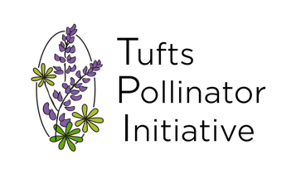
Pollinator Safari Report

Location: 574 Boston Avenue Gardens, Medford, MA
Date: 7/09/2022
Time: 10:30a-12pm
Temperature: 75-80F
Leaders: Nick Dorian, Atticus Murphy, Isaac Weinberg, Jessie Thuma
*Hosted in collaboration with Massachusetts Pollinator Network.

Bees
European honey bee (Apis mellifera)
Common eastern bumble bee (Bombus impatiens)
Two-spotted bumble bee (Bombus bimaculatus)
Brown-belted bumble bee (Bombus griseocollis)
Two-spotted longhorn bee (Melissodes bimaculatus)
- All black bee with white hind legs, likes drinking nectar from Monarda
Sunflower longhorn bee (Melissodes trinodis)
- A specialist of sunflowers and other summer-blooming asters
- Males have super long antennae, green eyes
Ligated furrow bee (Halictus ligatus)
- Really likes asters like black-eyed susans and yarrow
Metallic sweat bee (Lasioglossum sp.)
Masked bee (Hylaeus sp.)
- Tiny and “wasp-like”, carries pollen internally
Large carpenter bee (Xylocopa virginica)
- Distinguish from bumble bees by polished black abdomen and dark-mustard thorax with a perfectly round black spot in the middle

Butterflies/Moths
Monarch (Danaus plexippus)
- Eggs laid on underside of milkweed leaves
Eastern tiger swallowtail (Papilio glaucus)
Cabbage white (Pieris rapae)

Wasps
Grass-carrying wasp (Isodontia exicana)
- Solitary and harmless, hunts crickets, thin waist
Mason wasp (Eumenini)
Great black digger wasp (Sphex pensylvanicus)
- Big, black, and iridescent. Flies fast like a flashy sportscar. They hunt katydids and drink nectar. Totally harmless to people.

Hover Flies
Thick-legged fly (Syritta pipiens)

Other Flies
none
Beetles
Red milkweed beetle (Tetraopes tetrophthalmus)
- A milkweed specialist, look for damaged tips of leaves for their presence

