PROJECT TITLE: Investigating the Role of Neuronal Genes in Breast Cancer Metastasis and Chemotherapy Sensitivity
TEAM MEMBERS: Ariana Barreiro, Kevin Lyons, Maia Buckwald
PI / MENTOR: Madeleine Oudin
PROJECT DESCRIPTION:
The goal of this project is to design a platform to study the role of two neuronal genes on triple negative breast cancer metastasis and chemotherapy sensitivity. Specifically, we are investigating TUBB3 and MAPT, which are two neuronal genes that play a role in microtubule activity. Preliminary data from the Oudin Lab showed that these genes were involved with cell migration/adhesion and were highly upregulated in triple negative breast cancer cells; TUBB3 had also been known to be correlated with a higher metastatic potential in SCLC. Further research in the Oudin Lab indicated that knockdown of these genes led to an increase in proliferation and overall metastatic potential. This project will design a way to further investigate the mechanism of how these genes play a role in microtubule activity which impacts the cell behavior and thus sensitivity to microtubule-based drugs like paclitaxel.
ENGINEERING DESIGN ELEMENTS:
The objective of the project is to define the influence that neuronal gene expression has on the metastasis and proliferation of breast cancer cells. In addition, we plan to investigate the effect on microtubule expression and sensitivity to chemotherapy agents. The focus of this project's design work is on the genetic modification of cells to provide a platform to study how neuronal gene expression increases the malignancy of breast cancer. The project fulfills a research need. The development of targeted cancer therapies relies principally on an advanced knowledge of the dysregulation of gene expression in cancer. Expanding this knowledge will provide avenues for new and more effective treatments. We hypothesize the differences in cell behavior before and after gene knockdown. This will be evaluated with biochemical assays and experimental lab methods such as immunostaining, imaging, and Western Blots, to measure cell migration, cell adhesion, and cell proliferation. Furthermore, to analyze our results, we will mathematically determine the differences in cell proliferation, movement, and viability across various cell lines using advanced statistical analysis. Our most notable constraint is time. We are testing three different cell lines. Within each cell line, we will have three biological replicates: Scr, MAPT knockdown, and TUBB3 knockdown. Each of these will be tested in duplicate. In addition, there will be comparative analysis on the sum of data that is collected. With such a large volume of data to collect and analyze, we are limited principally by the time and maintenance constraints. It is expected that these experiments can be completed in six months and the comparative analysis will be done in the subsequent months.
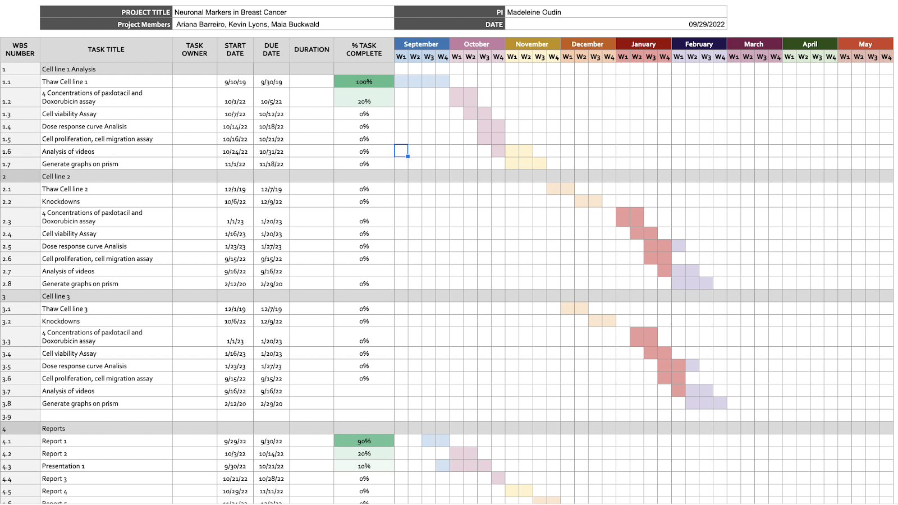
Down the line, we may have alternative plans based on what we observe. We will evaluate our progress as we finish the experiments of the first cell line and decide whether to do the second and third cell lines knockdowns with CRISPR or siRNA. The first quantitative milestone will be the extent of gene knockdown. In every case, it is necessary that a 75% knockdown of the gene is achieved. If the gene is not sufficiently knocked down, it introduces confounding variables to the study. The knockdown cells are also anticipated to have at least a 2 fold increase in both saltatory movement and proliferation compared to controls. These metrics are based on preliminary, yet incomplete, data from the Oudin Lab that investigated these cell lines. Our goal is that the control and knockdown groups will demonstrate a differential dose dependent response to paclotaxel and doxorubicin. These cells should have a 3 fold decrease in viability when exposed to chemotherapy. Similar research in the field of lung cancer is currently being done. Research has focused on small cell lung cancer (SCLC) exploring the neuroendocrine and neuronal gene characteristics of SCLC cells. Recent findings have shown that cancer cells become more neuronal and lose some neuroendocrine characteristics as they gain the ability to metastasize. The research in this field could advance and further explore the effect of silencing genes in chemotherapy treatment. Given that some neuronal characteristics are similar this could decrease the novelty of our experimental findings.

