**PROJECT TITLE:** Investigating the Role of Neuronal Genes in Breast Cancer Metastasis and Chemotherapy Sensitivity

**TEAM MEMBERS:** Ariana Barreiro, Kevin Lyons, Maia Buckwald

**PI / MENTOR:** Madeleine Oudin

**PROJECT DESCRIPTION:**

The goal of this project is to design a platform to study the role of two neuronal genes on triple negative breast cancer (TNBC) metastasis and chemotherapy sensitivity. Specifically, we are investigating TUBB3 and MAPT, which are two neuronal genes that play a role in microtubule activity. Preliminary data from the Oudin Lab showed that these genes were involved with cell migration/adhesion and were highly upregulated in TNBC cells; TUBB3 had also been known to be correlated with a higher metastatic potential in SCLC. Further research in the Oudin Lab indicated that knockdown of these genes led to an increase in proliferation and overall metastatic potential. This project will design a way to further investigate the mechanism of how these genes play a role in microtubule activity which impacts the cell behavior and thus sensitivity to microtubule-based drugs like paclitaxel.

**ENGINEERING DESIGN ELEMENTS:**

The objective of the project is to define the influence that neuronal gene expression has on the metastasis and proliferation of breast cancer cells. In addition, we plan to investigate the effect on microtubule expression and sensitivity to chemotherapy agents. The focus of this project's design work is on the genetic modification of cells to provide a platform to study how neuronal gene expression increases the malignancy of breast cancer. The project fulfills a research need. The development of targeted cancer therapies relies principally on an advanced knowledge of the dysregulation of gene expression in cancer. Expanding this knowledge will provide avenues for new and more effective treatments. We hypothesize the differences in cell behavior before and after gene knockdown. This will be evaluated with biochemical assays and experimental lab methods such as immunostaining, imaging, and Western Blots, to measure cell migration, cell adhesion, and cell proliferation. Furthermore, to analyze our results, we will mathematically determine the differences in cell proliferation, movement, and viability across various cell lines using advanced statistical analysis. Our most notable constraint is time. We are testing three different cell lines. Within each cell line, we will have three biological replicates: Scr, MAPT knockdown, and TUBB3 knockdown. Each of these will be tested in duplicate. In addition, there will be comparative analysis on the sum of data that is collected. With such a large volume of data to collect and analyze, we are limited principally by the time and maintenance constraints. It is expected that these experiments can be completed in six months and the comparative analysis will be done in the subsequent months.

Down the line, we may have alternative plans based on what we observe. We will evaluate our progress as we finish the experiments of the first cell line and decide whether to do the second and third cell lines knockdowns with CRISPR or siRNA. The first quantitative milestone will be the extent of gene knockdown. In every case, it is necessary that a 75% knockdown of the gene is achieved. If the gene is not sufficiently knocked down, it introduces confounding variables to the study. The knockdown cells are also anticipated to have at least a 2 fold increase in both saltatory movement and proliferation compared to controls. These metrics are based on preliminary, yet incomplete, data from the Oudin Lab that investigated these cell lines. Our goal is that the control and knockdown groups will demonstrate a differential dose dependent response to paclotaxel and doxorubicin. These cells should have a 3 fold decrease in viability when exposed to chemotherapy. Similar research in the field of lung cancer is currently being done. Research has focused on small cell lung cancer (SCLC) exploring the neuroendocrine and neuronal gene characteristics of SCLC cells. Recent findings have shown that cancer cells become more neuronal and lose some neuroendocrine characteristics as they gain the ability to metastasize. The research in this field could advance and further explore the effect of silencing genes in chemotherapy treatment. Given that some neuronal characteristics are similar this could decrease the novelty of our experimental findings.

**INTRODUCTION** – Updated 10/14/22

*Breast Cancer*

Breast cancer is the most frequently diagnosed type of cancer and the leading cause of cancer-related deaths among women. Three out of every twenty five women in the United States will be diagnosed with breast cancer (Waks & Winer, 2019). The disease is caused by genetic mutations in epithelial cells of the breast. These mutations dysregulate the proliferative or apoptotic signaling pathways which create aggregates of harmful nonfunctional cells called tumors. The tumors disrupt normal cell function and can be fatal if left untreated.

Classification of breast cancers is based on the surface receptors that the cell line expresses. Surface receptors tend to make the cancer more aggressive, but they can also serve as therapeutic targets. There are four molecular subtypes of breast cancer: luminal A, luminal B, HER2+, and triple-negative. This study specifically uses triple negative breast cancer cells, which does not express any surface receptors.

*Breast Cancer Metastasis*

Metastasis describes the process by which cancer cells leave the original tumor site, disseminate to a foreign tissue, and colonize in a new site to form a new tumor. The 5 year survival rate for metastatic breast cancer is 23.4% (McAllister, 2013). Cancer cells spread throughout the body via the lymphatic system, the bloodstream, or through perineural invasion. The mechanism behind perineural invasion is not well understood, but it does occur in 3-38% of all breast cancer cases. In addition, it is much more prevalent among aggressive forms of breast cancer. (Liebig, Ayala, Wilks, Berger, & Albo, 2009).

*Current Treatment of Triple Negative Breast Cancer*

Due to the absence of surface receptors, there is no therapeutic target for treating TNBC. The disease has a poor prognosis, and those with metastatic TNBC have a shorter median life expectancy than patients with other forms of breast cancer, (Waks & Winer, 2019). The disease has a 5 year survival rate of 40%.

Chemotherapy remains the only FDA-approved treatment for TNBC; however, it has significant negative side effects including hair loss, appetite loss, and anemia. This treatment does not prevent metastasis, as roughly 30% of early-stage breast cancers become metastatic regardless of chemotherapy (Marisa Weiss, 2021). Therefore, chemotherapy is mainly utilized as a palliative measure and to slow the course of the disease.

Research is currently being performed to seek out potential targets for new therapies for TNBC. Examples of these targets include rapamycin (regulator of an impaired pathway), EGFR (plays a role in inducing metastatic behavior like cell proliferation), and VEGF (a factor that is associated with more aggressive cancer) (Rakha & Chan, 2011).

*Neuronal Signatures in Cancer*

A recent article by Yang et al demonstrated an upregulation of neuronal genes, including TUBB3 and Tau, in SCLC. This upregulation is correlated with the presence of axon-like protrusions. These protrusions allow for saltatory movements, similar to neurons, and increase metastatic potential.

Publicly available transcriptome data of breast cancer cells has shown that these cells are also marked by an upregulation in neuronal genes. More specifically, neuronal genes are associated with the most aggressive subtype of breast cancer: TNBC. Two identified neuronal genes that have been identified to be highly expressed in breast cancer and are markers for poor prognosis are β3-tubulin (TUBB3) and microtubule-associated protein Tau (MAPT). The mechanism through which these genes play a role in TNBC is not well characterized. Further research into these gene’s roles may elucidate potential targets in breast cancer therapy.

TUBB3 and MAPT are two genes with slightly different purposes. TUBB3 plays a role in promoting microtubule dynamics, while MAPT plays a role in stabilizing microtubules (Le, 2022). Microtubule dynamics influence metastatic potential of cancer cells through an unknown mechanism. Paclitaxel is an example of a taxane-based chemotherapy that induces cell death through stabilizing microtubules during metaphase. Therefore, paclitaxel loses its effectiveness when TUBB3 is overexpressed (Le, 2022).

Previous research in the Oudin Lab revealed that knockdown of TUBB3 in MDA-MB-231 breast cancer cell line led to the formation of long processes (Le, 2022). In addition, knockdown led to increase in cell speed, saltatory movements, and cell migration. MAPT was then investigated, and those cells exhibited consistent behavior with that of TUBB3 knockdown cells (Le, 2022).

**METHODS** – Experimental Tools, what they are, how they work, how they fit your goals

*Cell Culture*

*Knockdown of Neural Genes*

*Proliferation Assay*

*Migration Assay*

*Exposure to Chemotherapy Agents*

**RESULTS** – Data, Figures, Tables, what they tell you relative to your project goals; iterations based on the findings, etc.

**DISCUSSION** – what have you learned, place this in the context of the field, the literature, patents, etc.

**FUTURE WORK** – what should students do next year to pick up on your project from this year, were it to continue. Or let us know it should not continue and why, etc.

**PARTICIPATION** – list individual contributions of each group member to the project

**REFERENCES:**

Liebig, C., Ayala, G., Wilks, J. A., Berger, D. H., & Albo, D. (2009). Perineural invasion in cancer: a

review of the literature. *Cancer, 115*(15), 3379-3391. doi:10.1002/cncr.24396 PMID: 19484787

Marisa Weiss, M. D., Brian Wojciechowski, M.D., Sameer Gupta, M.D., MPH,. (2021). Metastatic

Breast Cancer. Retrieved from <https://www.breastcancer.org/symptoms/types/recur_metast#:~:text=Nearly%2030%25%20of%20women%20diagnosed,cancer%20will%20develop%20metastatic%20disease>.

McAllister, A. J. R. S. S. (2013). Breast cancer as a systemic disease: a view of metastasis. *Wiley*

*Online Library*. Retrieved from <https://onlinelibrary.wiley.com/doi/full/10.1111/joim.12084> PMCID: PMC3711134

Rakha, E. A., & Chan, S. (2011). Metastatic triple-negative breast cancer. *Clin Oncol (R Coll Radiol),*

*23*(9), 587-600. doi:10.1016/j.clon.2011.03.013 PMID: 21524569

Waks, A. G., & Winer, E. P. (2019). Breast Cancer Treatment: A Review. *JAMA, 321*(3), 288-300.

doi:10.1001/jama.2018.19323 PMID: 30667505

Le, Thanh T. (2022). The neural identity of triple negative breast cancer. A thesis in partial fulfillment

of the requirements for the degree of PhD in Biomedical Engineering. *Tufts University.*

**GANTT CHART: TRACKING PROJECT PROGRESS(UPDATED AS OF 10/12/22)** [Capstone Gantt chart](https://docs.google.com/spreadsheets/d/1Z9VKEtE3O5IKDmT--ln3TSJSga9YQ2dw_hKlbJXKOek/edit?usp=sharing)

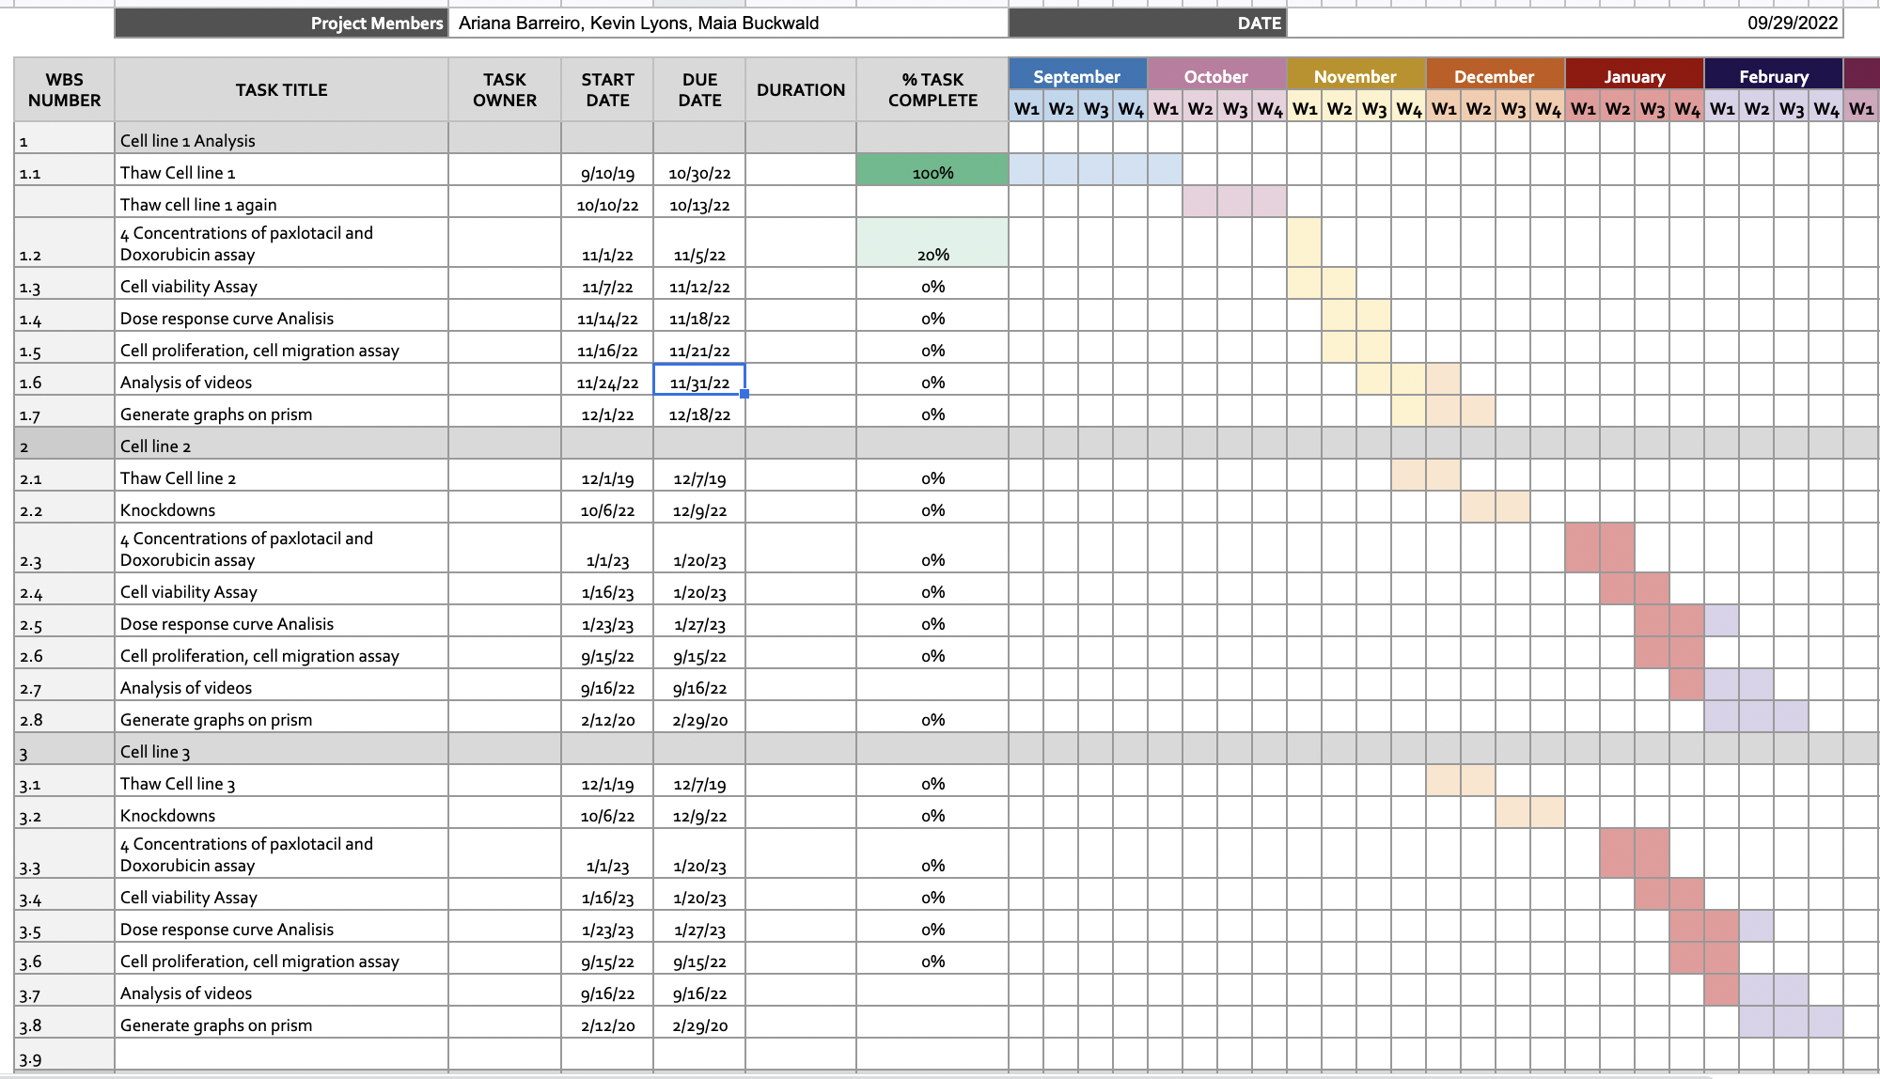

The feedback from the first report suggested we reduce the scope of the project and focus on the completion of only one cell line. We adjusted the gantt chart to take into account potential setbacks; however, we decided to keep all three cell lines. Performing experiments on one cell line this semester and two cell lines in parallel next semester is an entirely realistic timetable, especially given that one of our team members has extensive experience performing similar experiments.

The two additional cell lines are not available to us yet, so we are dedicating this semester to the MDA-MB-231 breast cancer cell line, which was cryopreserved in the Oudin Lab. After the experiments are completed with this cell line, replicating them with the other two cell lines will be much more efficient. To further address our anticipated time constraints, we are considering siRNA instead of CRISPR for future gene knockdowns since this method is less time consuming. With these measures, the time constraint should not pose issues for obtaining significant results. Nevertheless, focusing on just one cell line can still serve as a contingency plan. Despite the limited scope, the results of this study would still be very relevant to understanding the role of two neuronal genes in TNBC cells.

With regards to the focus of our project, we are more interested in the effect of the gene knockdown in the behavior of TNBC cells. The purpose of using multiple cell lines is to confirm that the results are generalizable to all TNBC cells, not just the ones that were investigated in our experiment.

Our Gantt chart had to be slightly modified due to some unforeseen issues with our cells. We had started thawing cells at the beginning of September, and last week we were supposed to test the cell’s response to chemotherapy agents. However, when we looked at our cells prior to the experiment, they did not have the morphology of normal healthy cells. The knockdown cells are supposed to be elongated with axonal protrusions similar to neurons. Our cells did not have this structure. In addition, when the cells were counted, there was an inordinately high number of dead cells. It is likely the cells did not react well to being thawed. Because of the low number of cells, we were concerned that we would not have enough for our experiments. Moreover, using unhealthy cells may negatively impact our results.

We decided to not risk the validity of our experiments and thawed new cells this week. We additionally performed mycoplasma testing on our older and newer plates and are still waiting for results of this test. Consequently, we adjusted the timeline to accommodate the aforementioned delays. The experiments should be completed this upcoming week. It appears that these new plates of cells seem to be growing at a better rate, and their morphology is consistent with typical knockdown cells.

As for the metrics defined to prove success/failure, we feel confident that a difference by at least 2-fold, as stated before, will be significant as this is the standard criteria used in the Oudin Lab. Professor Oudin has discussed these metrics with us and agreed that it should be used.