BME Senior Capstone Project:
Investigating the Role of Neuronal Genes in Breast Cancer Metastasis and Chemotherapy Sensitivity
Ariana Barriero, Maia Buckwald, and Kevin Lyons
Madeleine Oudin
November 4, 2022
All new edits in yellow

Keywords: Triple-negative breast cancer (TNBC), metastasis, Neuronal Markers

Abstract: Maia Buckwald
The goal of this project is to investigate the role of neuronal genes in triple-negative breast cancer metastasis and chemotherapy sensitivity. Currently, three out of every twenty five women in the U.S. will be diagnosed with breast cancer.¹ TNBC is prevalent in 20% of all breast cancer diagnoses; it is known to be an aggressive, metastatic subtype with high mortality rates.² TNBC in particular does not have a therapeutic target for treatment, making chemotherapy only a palliative measure and a way to slow the course of the disease.³ Understanding the mechanisms driving metastasis is crucial for the development of more effective therapies for TNBC. Previous research in the Oudin Lab revealed that knockdown of upregulated neuronal genes TUBB3 and MAPT in MDA-MB-231 human TNBC cells led to an increase in metastatic properties: increase in cell speed, increase in saltatory movements, increase in cell migration, and the formation of elongated cell morphology. Our goal in this project is to further investigate how these neuronal genes play a role in chemotherapy sensitivity. A second goal of this project will be to investigate whether these trends are consistently seen in two other human TNBC cell lines to account for heterogeneity differences in cancer.

Elements of Engineering Design: Ariana, Maia and Kevin
The objective of the project is to define the influence that neuronal gene expression has on the metastatic potential of breast cancer cells. In addition, we plan to investigate the sensitivity to chemotherapy agents. The focus of this project's design work is on optimizing a platform to study how neuronal gene expression plays a role in the malignancy of breast cancer. The project fulfills a research need on better understanding the mechanism behind metastasis. Expanding this knowledge will provide avenues for new and more effective treatments. We hypothesize the differences in cell behavior after gene knockdown will have an increase in metastatic potential.
To optimize our platform, we will first test two different gene knockdown methods: siRNA and CRISPR. It is necessary to perform both of these methods since their efficacies are dependent on factors such as cell line and the target gene. These neuronal genes, TUBB3 and MAPT, have yet to be knockdown in triple-negative breast cancer cells, which is why both methods need to be evaluated to determine which is more efficacious in gene knockdown.
To investigate this we will first optimize two knockdown methods: siRNA and CRISPR. We will then evaluate the effect of each type of knockdown. This will be evaluated with biochemical assays and experimental lab methods such as imaging and immunostaining to measure cell migration, cell adhesion, and cell proliferation. Furthermore, to analyze our results, we will mathematically determine the differences in cell proliferation, movement, and viability across various cell lines using advanced statistical analysis. Our most notable constraint is time.
After optimizing knockdown methods and evaluating its effect in cell behavior and chemotherapy sensitivity, we will assess the applicability of our findings to two other TNBC cell lines (that will later be determined). We expect that these other cell lines will behave similarly. The same gene knockdowns are being performed; therefore, the experiments should yield the same result. The purpose of using these other cell lines is to control for the heterogeneity of cancer cells. At this point, an optimal platform of using either siRNA or CRISPR knockdown will have been determined. The preferred knockdown method will be used in these other cell lines. Within each cell line, we will have three biological replicates: Scr, MAPT knockdown, and TUBB3 knockdown. Each of these will be tested in duplicate. We will perform a comparative analysis on the sum of data that is collected. With such a large volume of data to collect and analyze, we are limited principally by the time and maintenance constraints. It is expected that these experiments can be completed in six months and the comparative analysis will be done in the subsequent months.
Down the line, we may have alternative plans based on what we observe. We will evaluate our progress as we finish the experiments of the first cell line and decide whether to do the second and third cell lines knockdowns with CRISPR or siRNA. The first quantitative milestone will be the extent of gene knockdown. In every case, it is necessary that a 75% knockdown of the gene is achieved. If the gene is not sufficiently knocked down, it introduces confounding variables to the study. We will use a one-way ANOVA t-test between two groups to assess the significance of the effect of knockdown on saltatory movement and proliferation. Each group (MAPT and TUBB3 knockdown) will be compared to control cells (Scramble). It would be optimal if the cells have at least a 2-fold difference in both saltatory movement and proliferation compared to controls. These metrics are based on preliminary, yet incomplete, data from the Oudin Lab that investigated these cell lines. Additionally, our goal is that the control and knockdown groups will demonstrate a differential dose-dependent response to paclitaxel and doxorubicin. We will use a one-way ANOVA t-test between two groups to assess the significance of viability when exposed to chemotherapy. Each group (MAPT and TUBB3 knockdown) will be compared to control cells (Scramble). Previous members in the Oudin lab expected a 3 fold decrease in viability. when exposed to chemotherapy. One-way ANOVA t-test was chosen as a statistical test to determine the significance in these experiments because it is used in cancer literature to determine significant differences in response to chemotherapy between groups. Each knockdown will be compared to the control (Scramble) in this test.
Similar research in the field of lung cancer is currently being done. Research has focused on small cell lung cancer (SCLC) exploring the neuroendocrine and neuronal gene characteristics of SCLC cells. Recent findings have shown that cancer cells become more neuronal and lose some neuroendocrine characteristics as they gain the ability to metastasize. The research in this field could advance and further explore the effect of silencing genes in chemotherapy treatment. Given that some neuronal characteristics are similar this could decrease the novelty of our experimental findings.
Introduction: Kevin and Maia
Breast cancer is the most frequently diagnosed type of cancer and the leading cause of cancer-related deaths among women.¹ About 20% of breast cancers are classified as triple negative, meaning they test negative for the expression of estrogen receptor (ER), progesterone receptor (PR) and human epidermal growth factor receptor 2 (HER2).⁴ The lack of molecular markers in TNBC makes it particularly difficult to treat, as these typically serve as therapeutic targets. The disease has a poor prognosis, and those with TNBC have a shorter median life expectancy than patients with other forms of breast cancer.¹ The disease has a 5 year survival rate of 40%.⁵
Metastasis is the process by which cancer cells leave the original tumor site, disseminate to a foreign tissue, and colonize in a new site to form a new tumor. Metastasis drastically decreases the overall survival rate and results in greater systemic effects of the disease.⁶ One way to reduce metastasis is through the use of targeted therapies. These were first introduced with the approval of the breast cancer drug tamoxifen in 1998.⁷ Targeted therapies work by silencing or inhibiting malignant signaling pathways that are associated with the expression of the cancer phenotype. The uncovering of more and more targeted therapies allows for a wider range of cancer mutations to be mitigated. This provides incremental progress towards a definitive cure for the disease. However, this progress is inherently reliant on the detailed understanding of the effects of gene expression on cell behavior. These systems must be investigated thoroughly in order to elucidate an avenue for effective therapeutic intervention.
Our project is specifically investigating the role of neuronal gene expression in TNBC cells. Preliminary data has shown that the genes β3-tubulin (TUBB3) and microtubule-associated protein Tau (MAPT) are associated with increased metastatic potential of TNBC.
This correlation suggests that these genes play a significant role in the progression of TNBC. Likewise, they could serve as therapeutic targets. To investigate these genes, we plan to first create a knockdown protocol. CRISPR and siRNA are the two most common ways to silence a gene in-vitro. Each of these requires its own set of optimization and quality assurance procedures. Additionally, they are better suited for different scenarios, which is best determined experimentally. The knockdown method will allow us to genetically engineer a platform that will allow us to study the gene’s effect on the malignancy of breast cancer. We plan to investigate how the genes affect cancer cells’ ability to metastasize, proliferate, and respond to chemotherapy. In addition, we plan to validate and generalize these findings by repeating the experiments in multiple cell lines.

Background: Kevin and Maia
Breast cancer is caused by genetic mutations in epithelial cells of the breast. These mutations dysregulate the proliferative or apoptotic signaling pathways which create aggregates of harmful nonfunctional cells called tumors. The tumors disrupt normal cell function and can be fatal if left untreated. Classification of breast cancers is based on the surface receptors that the cell line expresses. Surface receptors tend to make the cancer more aggressive, but they can also serve as therapeutic targets. There are four molecular subtypes of breast cancer: luminal A, luminal B, HER2+, and triple negative. This study specifically uses triple negative breast cancer cells, which do not express any surface receptors.
Metastasis takes place when cancer cells form new tumors distant from the original cancer site, typically in the brain or soft organs of the body.⁸ Cancer cells spread throughout the body via the lymphatic system, the bloodstream, or through perineural invasion. Metastatic triple negative breast cancer is fatal.⁹
Chemotherapy remains the only FDA-approved treatment for TNBC; however, it has significant negative side effects including hair loss, appetite loss, and anemia. This treatment does not prevent metastasis, as roughly 30% of early-stage breast cancers become metastatic regardless of chemotherapy.³ Therefore, chemotherapy is mainly utilized as a palliative measure and to slow the course of the disease.
Research is currently being performed to seek out potential targets for new therapies for TNBC. Examples of these targets include rapamycin (regulator of an impaired pathway), EGFR (plays a role in inducing metastatic behavior like cell proliferation), and VEGF (a factor that is associated with more aggressive cancer).¹⁰
A recent article by Yang et al demonstrated an upregulation of neuronal genes, including TUBB3 and Tau, in SCLC.¹¹ This upregulation is correlated with the presence of axon-like protrusions. These protrusions allow for saltatory movements, similar to neurons, and increase metastatic potential.
Publicly available transcriptome data of breast cancer cells has shown that these cells are also marked by an upregulation in neuronal genes. More specifically, neuronal genes are associated with the most aggressive subtype of breast cancer: TNBC. Two identified neuronal genes that have been identified to be highly expressed in breast cancer and are markers for poor prognosis are β3-tubulin (TUBB3) and microtubule-associated protein Tau (MAPT). The mechanism through which these genes play a role in TNBC is not well characterized. Further research into these gene’s roles may elucidate potential targets in breast cancer therapy.
TUBB3 and MAPT are two genes with slightly different purposes. TUBB3 plays a role in promoting microtubule dynamics, while MAPT plays a role in stabilizing microtubules. Microtubule dynamics influence metastatic potential of cancer cells through an unknown mechanism. Paclitaxel is an example of a taxane-based chemotherapy that induces cell death through stabilizing microtubules during metaphase. Therefore, paclitaxel loses its effectiveness when TUBB3 is overexpressed.¹²
Previous research in the Oudin Lab revealed that knockdown of TUBB3 in MDA-MB-231 breast cancer cell line led to the formation of long processes. In addition, knockdown led to increase in cell speed, saltatory movements, and cell migration. MAPT was then investigated, and those cells exhibited consistent behavior with that of TUBB3 knockdown cells.¹²

Unifying Figure: Ariana
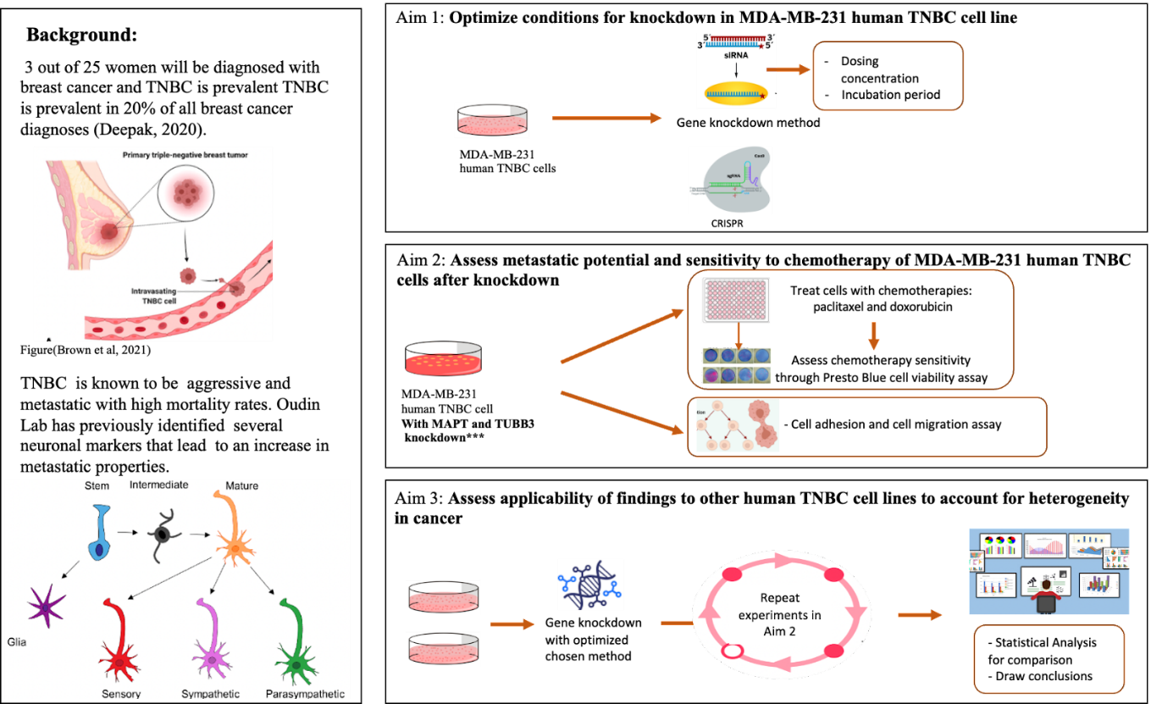
The figure illustrates the background and individual aims for our project. We provide a graphical outline of the experimental methods and deliverables. Our final project is broken into 3 main aims: 1) Optimize conditions for knockdown in MDA-MB-231 human TNBC cell line 2) Assess metastatic potential and sensitivity to chemotherapy of MDA-MB-231 human TNBC cells after knockdown and 3) Assess applicability of findings to other human TNBC cell lines (to be determined) to account for heterogeneity in cancer

Design Flow Chart: Ariana
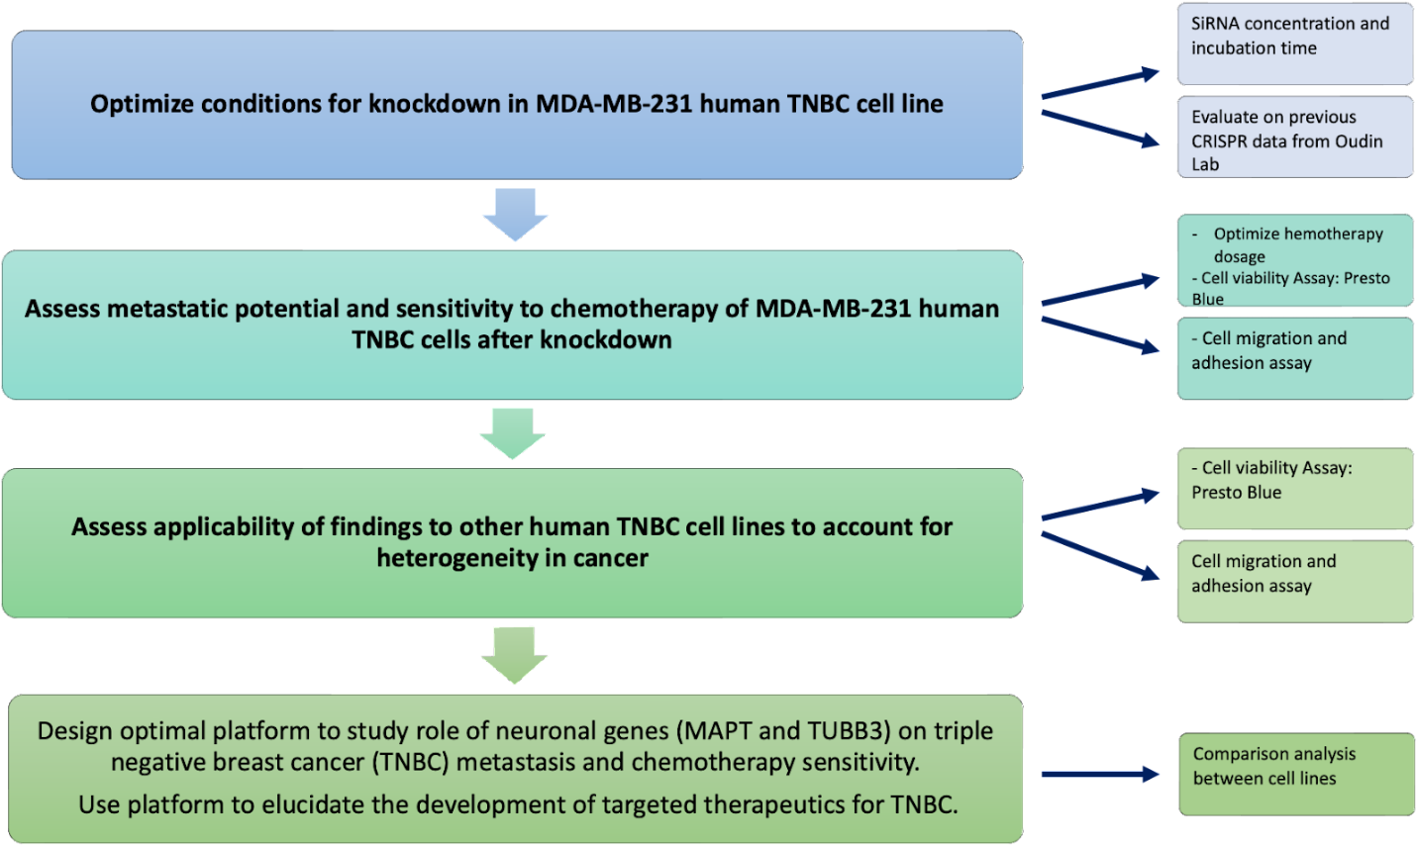
The design flow chart of our project illustrates our three main objectives and our ultimate goal. On the right hand side, we have arrows pointing towards the methods and parameters to accomplish each corresponding goal.

Specific Aims: Maia

Specific Aim 1: Optimize conditions for knockdown in MDA-MB-231 human TNBC cell line
The goal of this aim is to compare the efficacies of knockdown of TUBB3 and MAPT using two different strategies: using siRNA and using CRISPRi. These knockdowns will be performed in MDA-MB-231 human TNBC cell line. It is not feasible to perform this Aim in more than one cell line due to time constraints of the project. It is already known that both methods offer different advantages. Knockdown using siRNA is more time efficient as it can significantly alter the gene expression in just 24 hours. However, it is only able to temporarily reduce gene function. On the other hand, CRISPRi is able to edit the genetic code and completely knockout a gene of interest. The efficacy of the two methods depends on many factors such as the target gene and the cell type used. Since the experiment only involves TNBC cells with identical gene knockdowns, the optimal knockdown method should be the same across all three cell lines. Besides assessment of method of knockdown, optimization of dosing and timing parameters while using siRNA is also required. From these experiments, we will understand the conditions and efficacy of knockdown using each method. From there, we will be better equipped to assess the best method of knockdown in other TNBC cell lines to be evaluated in Specific Aim 3.

Specific Aim 2: Assess metastatic potential and sensitivity to chemotherapy of MDA-MB-231 human TNBC cells after knockdown
The goal of this aim was to take the cells from Aim 1 and assess the effects of knockdown of TUBB3 and MAPT. The mechanism through which these genes play a role in TNBC is not well understood. Metastatic potential will be assessed through migration and adhesion assays. Migration assays involve seeding cells on Collagen I, then imaging them in a migration chamber overnight to track their movements. Cell speed, cell proliferation, and persistence are parameters that will be analyzed after. Adhesion assays are performed to assess cell morphology, which is indicative of invasive capacity. Cells will be seeded onto Collagen I, fixed, stained, then imaged. CellProfiler will be used to perform morphological analysis to assess aspect ratios and cell area. Previous work in the Oudin Lab has assessed metastatic potential of knockdown using CRISPR. This work will be continued by further assessing its effects on chemotherapy sensitivity through cell viability assays. This involves seeding the cells and staining them with Presto Blue to get initial reading in a plate reader. Chemotherapies will then be added to cells except for control cells. Four concentrations of paclitaxel using a two-fold dilution series: 10nM-1.25nM. Four concentrations of doxorubicin will also be assessed using a two-fold dilution series: 500nM-62.5nM. These concentration ranges were previously optimized in the Oudin Lab. In addition, characterizing metastatic potential and chemotherapy sensitivity after knockdown via siRNA will be assessed to look at consistency across knockdown methods. After carrying out this Aim, we will have an understanding of the effects of TUBB3 and MAPT knockdown in TNBC cells. We also will investigate consistencies/differences seen across knockdown methods to further characterize the best method for knockdown.

Specific Aim 3: Assess applicability of findings to other human TNBC cell lines (to be determined) to account for heterogeneity in cancer
The purpose of this Aim is to account for heterogeneity differences that can be seen across cancer lines. It has become standard for cancer research to assess findings in more than one cell line to validate the results. Knockdown will be performed via the optimized method determined in Aims 1 and 2. This aim does not involve any further comparison of the two knockdown methods. It will simply use the protocol that was found to be most effective in earlier experiments. After, the same assays will be performed to investigate effects of knockdown on cell migration, cell morphology, and chemotherapy sensitivity. If results are consistent in other human TNBC cell lines, the data found will be further supported and validated. If results are not consistent, then TUBB3 and MAPT must play different roles in each cell line, which opens the door for new avenues of investigation. Overall, these aims will further the understanding behind the mechanisms through which these neuronal genes play a role in triple-negative breast cancer and is a step closer to developing better therapies.

Methods: Ariana and Maia
Preparation of Media
Preparation of media was needed in order to be able to grow our TNBC cells and perform the corresponding experiments.
DMEM/F12 hiNSCs complete media was the type of media primary used for this experiment. This media is made by adding 2 main components: 50mL aliquot of FBS, and 10mL of PSG. For preparing the media, both components need to be thawed. Once both components are thawed the serum is filtered in a 0.2um filter with a 50mL syringe and put into a media bottle together with the PSG. The bottle is then labeled with name, data and supplements added and stored in the refrigerator.

Thawing and Seeding Protocol

The cells used for this experiment were: MDA-MB-231 TNBC cell lines. The cells were previously frozen by members of the Oudin lab with CRISPR knockdowns of TUBB3 and MAPT. These were the first cells thawed in order to analyze the effect of CRISPR on cell behavior. We thaw MDA-MB-231 TNBC cells without CRISPR gene knockdown to be able to analyze siRNA as a method of knockdown in the following weeks. Media was first thawed for approximately 20 minutes in the water bath. The frozen vials of cells were removed from the -80 freezer and put in the 37C water bath to quickly thaw it. The vials were then sprayed with 70% ethanol and the solution was then pipetted and transferred to a 15 ml tube along with 10 mL of pre-warmed media.,. The tube was then centrifuged at 1000 rpm for 3 minutes to pellet the cells so the toxic DMSO solution could be aspirated. After centrifugation, cells were gently reconstituted in 10 ml of complete growth medium. Cells were then transferred to a labelled flask at high density and incubated overnight at 37C/5% CO2. Cell density was checked the next day to either change media or passage the cells accordingly.

Subculturing Procedure

Every week, cell density was evaluated, and cells were passaged accordingly. To passage cells, the culture medium was first removed by aspiration. The flask was then rinsed with 5mL of DPBS for 1 minute by transferring it to the bottom of the flask and then aspirating again. 1mL of 0.25% trypsin-EDTA, was added to detach the cells and the flask was then incubated at 37°C for approximately 1 min. After the incubation, 9 ml of media was added to stop the reaction. A serological pipet is used to rinse the dish 4 times. Cells were then seeded at desired ratio in new flask containing free media.

CRISPR Protocol

Cells used for the analysis of the first cell line (MDA-MB-231 human TNBC cells) were thawed from a previous graduate student at the Oudin lab who, along with one of us (Maia), had performed the CRISPR gene knockdown. The protocol they previously followed for gene knockdown was described in the cited paper.¹³ It consists of the following:
Gene expression knockdown with CRISPR in 231 cells using CRISPR-Cas9: HEK293T cells were used to create lentivirus carrying FUCas9Cherry plasmid, a gift from Marco Herold (Addgene plasmid #70182; http://n2t.net/addgene:70182; RRID:Addgene 70182). MDA-MB-231-Cas9 cells were created by transducing wild type MDA-MB-231 cells with this virus in DMEM and 10 μg/ml polybrene, and centrifuge for 1h at 800g. Cells were FAC sorted for mCherry positivity at Tufts GSBS.
For knocking down neural genes in cancer cells, the following guide RNAs were used:
TUBB3 sgRNA#1: 5’-ACATCAGCCGATGCGAAGGG-3’
TUBB3 sgRNA#2: 5’-GCTATAAGAGCGCGCGGCCG-3’
MAPT sgRNA#1: 5’-CAGGAACGCGCCCTCTTCGC-3’
MAPT sgRNA#2: 5’-TCACGCTGGGACGTACGGGT-3’
MAPT sgRNA#3: 5’-CACGCTGGGACGTACGGGTT-3’
(MAPT knockdown cells were generated using a pool of all these 3 guides)
Guide RNAs were inserted into plasmid containing puromycin resistance gene and cloned using Stbl3 Competent E.Coli (C737303, Thermo Fisher Scientific, Waltham, MA). Plasmids were sequenced to confirm insertion, and virus production with HEK293T cells and transduction of MDA-MB-231-Cas9 were conducted as described above. Successfully transduced cells were selected by the addition of 0.5 μg/ml puromycin into the media.
Knock-down of MAPT was confirmed using qPCR with primer for gene:
MAPT: 5’-CCTCTCCCGTCCTCGCCTCTG-3’
TUBB3 knockdown was confirmed using Western blot with 1/1000 rabbit anti-β3-tubulin antibody (ab18207, Abcam, Cambridge, MA).

Drug resistance experiment and analysis (Cell Viability Assay)

In order to test the effect of gene knockdowns of MAPT and TUBB3 in chemotherapy sensitivity, drug resistance experiments and analyses were performed accordingly:
5000 cancer cells per well were seeded in 96 well plate and left incubating for 24 hours. Then, media was replaced with media with chemotherapy drugs at varying concentration. Cell viability is measured on day 1 and day 4 with Presto Blue reagent (P50200) according to manufacturer recommendations. Readouts were normalized with blank, then with day 1 control to calculate the cell viability fold change, and finally with day 4 control to display viability as fractions of no drug control.

siRNA Infection

For the initial viability evaluation of MAPT and TUBB3 knockouts, siRNA-TUBB3 and siRNA-MAPT Silencer will be used from provider ThermoFisher with code 4392420 and Assay ID: s21740. The protocol for infection will be followed as instructed by the provider. SiRNA will be diluted in 11.33 uL of water. 3 experimental groups will be tested infection to evaluate the best siRNA concentration for knockouts 1.33 µl of siRNA was pipetted into each 150mM condition. Then, 1.00 µl of siRNA was added for every 100nM condition. Finally, 1.33uL of H2O was added to each control. siRNA was delivered in the media before pipetting it to the cells.
Drug resistance experiment and analysis (Cell Viability Assay)
5000 cancer cells per well were seeded in 96 well plate and left incubating for 24 hours. Then, media was replaced with media with chemotherapy drugs at varying concentration. Cell viability is measured on day 1 and day 4 with Presto Blue reagent (P50200) according to manufacturer recommendations. Readouts were normalized with blank, then with day 1 control to calculate the cell viability fold change, and finally with day 4 control to display viability as fractions of no drug control.

Migration Assay

A glass-bottom 24 well plate will be used. One the first day, the plate will be coated with 0.1mg/mL Collagen I for 1 hour at 37C. After, 300 uL cells will be seeded at 12k/well in media. The plate is then incubated for 2 hours at 37C. The migration chamber will be set up using image acquisition setting, and the cells will be placed inside after their incubation. Brightfield and TXRed will be used when imaging the cells. Multipoint setting will be used to pick 4-5 POVs for each well. Other settings that will be set on the migration chamber will be 10 minutes between image acquisitions for a total of 97 times. There will be an initial delay of 30 minutes before the first image to allow time for the cells to settle.

Morphological analysis via cell adhesion assay

24h after co-culture was established, cells were fixed and stained with DAPI. Images were taken at 20x with approximately 30 field of views per condition. CellProfiler v3.1.8164 was used to identify cell shape: DAPI was used to identify individual cell then mCherry was used to determine cell shape parameters.
Statistical analysis
GraphPad Prism v8.4.3 was used for generation of graphs and statistical analysis. To compare between two groups, unpaired two-tailed Student’s t-test was used and a p-value of ≤ 0.05 is considered significant. To compare between multiple groups, one-way ANOVA with Tukey’s multiple testing correction was used with a corrected p-value of ≤ 0.05 is considered significant. For RNA-seq, adequately expressed genes passing a fold change threshold of 1.2 and with p value ≤ 0.05 in edgeR analysis were considered differentially expressed. Pathways with p value ≤ 0.05 and FDR ≤ 0.01 were considered differentially regulated.

Latest Update of Progress:

Redefining our Aims
Before submitting our first technical report we re-evaluated our aims in order to improve the design elements of our project. We realized that there was a need to first optimize and evaluate both CRISPR and siRNA as gene knockdown methods. Taking into account the time constraints of this project, we decided to evaluate both knockdown methods only on the MDA-MB-231 breast cancer cell line. CRISPR knockdowns of this cell line are already available for us to use(the experiment was done by Maia), but we will optimize the siRNA procedure(including dose concentration and incubation period). We will then assess the effect of both knockdown methods on cell behavior and chemotherapy sensitivity. Optimizing and evaluating the knockdown methods in this cell line will then allow us to make an educated decision on what method to use to assess the applicability of our results in other TNBC cell lines. Taking all those considerations we defined our new aims as 1) Optimize conditions for a knockdown in MDA-MB-231 human TNBC cell line. 2)Assess metastatic potential and sensitivity to chemotherapy of MDA-MB-231 human TNBC cells after knockdown 3) Assess applicability of findings to other human TNBC cell lines (to be determined) to account for heterogeneity in cancer
Contingency Plan
The feedback from the first report suggested we reduce the scope of the project and focus on the completion of only one cell line. Performing experiments on one cell line this semester and two cell lines in parallel next semester is an entirely realistic timetable, especially given that one of our team members has extensive experience performing similar experiments. After the experiments are completed with this cell line, replicating them with the other two cell lines will be much more efficient. Additionally, the knockdown procedure will also be optimized. To further address our anticipated time constraints, we are considering siRNA instead of CRISPR for future gene knockdowns since this method is less time-consuming. With these measures, the time constraint should not pose issues for obtaining significant results. Nevertheless, focusing on just one cell line can still serve as a contingency plan. Despite the limited scope, the results of this study would still be very relevant to understanding the role of two neuronal genes in TNBC cells.
Success Failure Criteria→ maybe statistical significance criteria?
We are designing a platform to study the role of neuronal genes in triple-negative breast cancer metastasis. To successfully study this, we must successfully knock down the expression of these genes in the cell lines to be investigated. We have successfully met these criteria for our design, as we quantified knockdown using Western Blot and qPCR. There was a 0.75 fold change of MAPT mRNA expression from the control cells, and TUBB3 protein expression level was decreased to about 20% of the control cells after performing CRISPR. So, using Western Blot/qPCR to quantify for successful knockdown will be our marker for success. Primary literature indicates >70% knockdown is optimal to produce significant enough changes in the cell. The other assays to be performed on these cells will be exploratory to characterize the effects after knockdown, so there will be no “marker for success” that we can expect to find.
There will be several things that we will look for during testing. First, we are going to be looking for differences in the metastatic potential of our knockdown cells compared to our Scramble control cells. More specifically, we will look at changes in cell speed, cell persistence, cell morphology (cell area, percent elongation, etc.), and cell proliferation. All of these behaviors of cells have previously been identified in the literature to be correlated with metastatic potential. One other thing we are looking for in testing is differences in chemotherapy sensitivity among knockdown and control cells. We hypothesize that knockdown of MAPT and TUBB3 will lead to changes in the efficiency of taxane-based chemotherapy treatment since these genes regulate microtubule dynamics; taxane-based chemotherapy uses a mechanism that leverages microtubule dynamics to kill the cells.

Update on Methods

This past Thursday (10/20), we were able to start the Presto Blue cell viability assay using our MDA-MB-231 TNBC cells. We performed this assay on our Scramble control cells, TUBB3 knockdown cells, and our MAPT knockdown cells. We tested the following chemotherapies and dosing concentrations: Paclitaxel (10nM, 5nM, 2.5nM, and 1.25nM) and Doxorubicin (500nM, 250nM, 125nM, and 62.5nM). The concentration values were determined from preliminary assays; these values appeared to induce a spectrum of differing cell viabilities that would be ideal for generating a dose-response curve. There were blank wells with only media (no cells or chemotherapy treatment), and control wells with media and cells but no chemotherapy treatment. Cell seeding occurred on Thursday. We took an initial Presto Blue reading of our cells before chemotherapy treatment on Friday, then added the chemo to the cells after. After a 72 hour incubation, we then took a second Presto Blue reading on Monday. So far, we have subtracted our blanks and normalized our values to our controls. We are currently in the process of performing the proper statistical tests to determine whether we are seeing significant differences among chemotherapy sensitivities our knockdown cells and our Scramble control cells. Along with these statistical tests, we are also in the process of visualizing our data on dose-response curves on GraphPad Prism.

Gene Knockdown Design Table
Metric/Design Requirement | Method | Success Criteria | Constraints/Risk Assessment
Knockdown of neuronal genes via CRISPR | Immunostaining for TUBB3,  qPCR for MAPT | Primary literature indicates >70% knockdown is optimal. The cited article¹⁴ found 70% knockdown was sufficient to produce significant changes in the cells. | - Cells we are utilizing already have CRISPR knockdown. There was a 0.75 fold change of MAPT mRNA expression from the control cells, and TUBB3 protein expression level was decreased to about 20% of the control cells
Knockdown of neuronal genes via siRNA | Immunostaining for TUBB3,  qPCR for MAPT | Primary literature indicates >70% knockdown is optimal. The cited article¹⁴ found 70% knockdown was sufficient to produce significant changes in the cells. | 1) siRNA is time sensitive for which we need to optimize the timeline of the experiments in relation to the silencing of the gene.  2) Anything less than a 70% knockdown will introduce confounding variables to our experiment.
Cell viability after exposure to chemotherapy | Presto Blue Viability Assay | Would be optimal to observe that cells with knockdown should have a significant difference in viability when exposed to chemotherapy. We will use a one-way ANOVA t-test between two groups to assess for significance. Each group (MAPT and TUBB3 knockdown) will be compared to control cells (Scramble).  This has been the criteria previously used in the Oudin Lab⁶ | Important to consider this is an expected outcome, but cannot be modified to achieve this metric given that the analysis is experimental.
Cell migration and proliferation | Keyence imaging followed by MATLAB analysis:  Cells will be incubated in the Keyence BZ-X710 where images will be taken every ten minutes for sixteen hours. The cell’s displacement will be measured semi-automatically and analyzed in MATLAB scipt | Gene knockdown will be considered significant in playing a role in migration/proliferation if knockdown cells have at least a 2-fold difference in both saltatory movement and proliferation compared to controls.  This has been the criteria previously used in the Oudin Lab⁶ | Important to consider this is an expected outcome, but cannot be modified to achieve this metric given that the analysis is experimental.

Preliminary Results:

The statistical test chosen to analyze the data is a one-way ANOVA t-test between groups to assess significance. An individual t-test will be done for each group (MAPT and TUBB3 knockdown) comparing it to control cells (Scramble). These graphs are made with data from only one replicate of the presto blue viability assay. The statistical difference between the control (Scr) and the gene knockdowns is not significant. One replicate is not enough to draw final conclusions so we are currently working on the second and third replicates of the experiments and will do an overall analysis of the three.

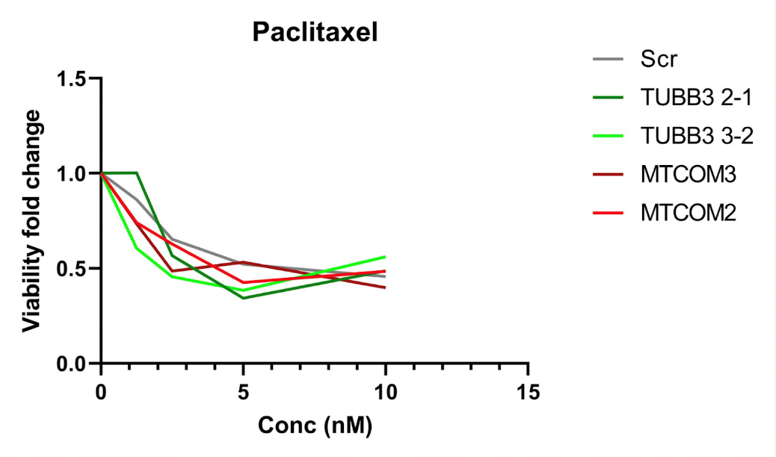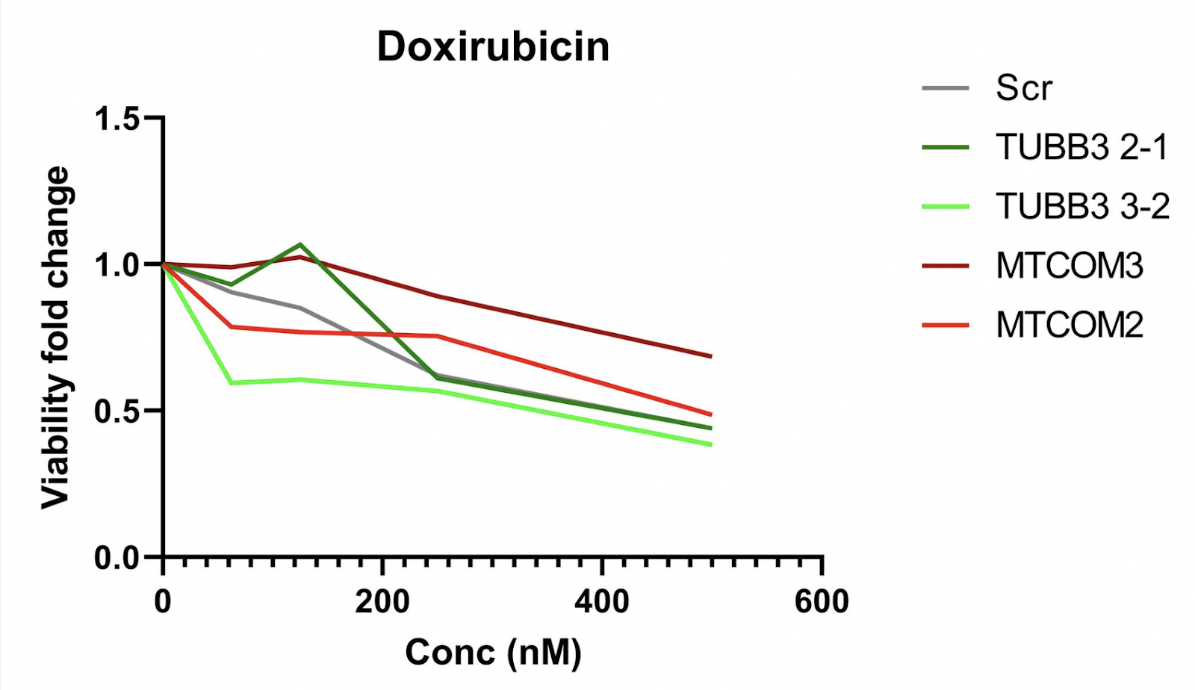

GANTT CHART: TRACKING PROJECT PROGRESS(UPDATED AS OF 10/26/22) Capstone Gantt chart
We made changes to the Gantt chart in order to be able to visualize our progress more easily. We had previously color-coded the chart by month. Now the colors represent the level of completion of the activity. Green stands for completion, yellow for “in progress”, grey for upcoming (not started), and red for delayed or canceled activity. We kept the column that indicates the percentage of the activity completed (the closer the percentage gets to 100, the darker the green becomes).
We have also updated the Gantt chart in order to account for the new aims and timeline. We will optimize the siRNA knockdown protocol and analysis this semester.

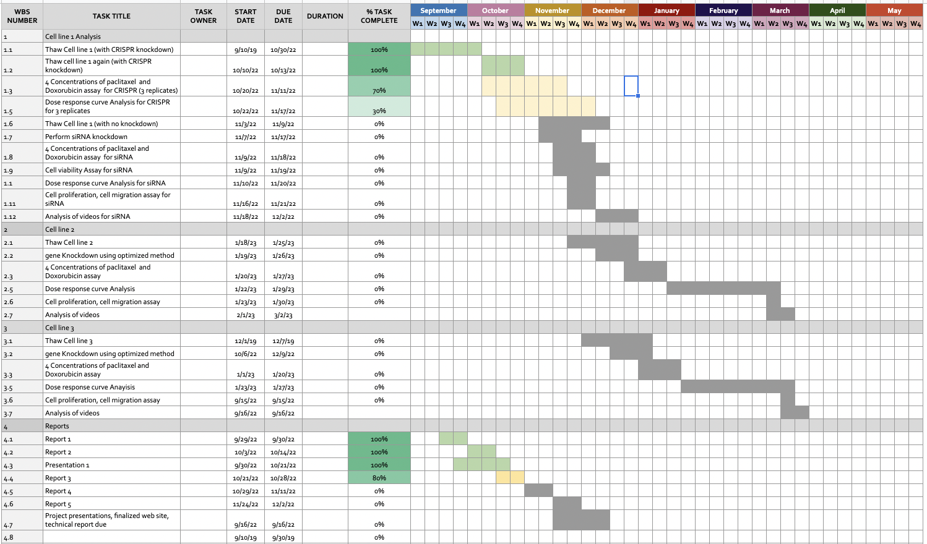
Zoom in for relevant dates:
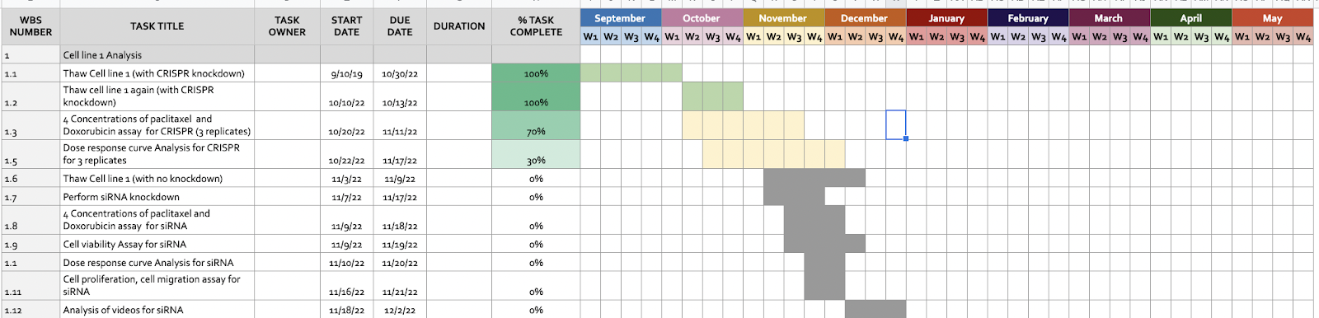

Results: to be completed in future

Discussion: to be completed in future

Future Work: to be completed in future

Conclusion: to be completed in future

References:
1 Waks, A. G. & Winer, E. P. Breast Cancer Treatment: A Review. JAMA 321, 288-300, doi:10.1001/jama.2018.19323 (2019)
2 Deepak, K. G. K. et al. Tumor microenvironment: Challenges and opportunities in targeting metastasis of triple negative breast cancer. Pharmacol Res 153, 104683, doi:10.1016/j.phrs.2020.104683 (2020)
3 Weiss, M. C. et al. A Coala-T-Cannabis Survey Study of breast cancer patients' use of cannabis before, during, and after treatment. Cancer 128, 160-168, doi:10.1002/cncr.33906 (2022).PMC9413357
4 Hudis, C. A. & Gianni, L. Triple-negative breast cancer: an unmet medical need. Oncologist 16 Suppl 1, 1-11, doi:10.1634/theoncologist.2011-S1-01 (2011)
5 Cortes, J. et al. Pembrolizumab plus Chemotherapy in Advanced Triple-Negative Breast Cancer. N Engl J Med 387, 217-226, doi:10.1056/NEJMoa2202809 (2022)
6 Yao, Y., Chu, Y., Xu, B., Hu, Q. & Song, Q. Risk factors for distant metastasis of patients with primary triple-negative breast cancer. Biosci Rep 39, doi:10.1042/BSR20190288 (2019).PMC6549086
7 Lippman, S. M. & Brown, P. H. Tamoxifen prevention of breast cancer: an instance of the fingerpost. J Natl Cancer Inst 91, 1809-1819, doi:10.1093/jnci/91.21.1809 (1999)
8 O'Reilly, D., Sendi, M. A. & Kelly, C. M. Overview of recent advances in metastatic triple negative breast cancer. World J Clin Oncol 12, 164-182, doi:10.5306/wjco.v12.i3.164 (2021).PMC7968109
9 Harbeck, N. & Gnant, M. Breast cancer. Lancet 389, 1134-1150, doi:10.1016/S0140-6736(16)31891-8 (2017)
10 Rakha, E. A. & Chan, S. Metastatic triple-negative breast cancer. Clin Oncol (R Coll Radiol) 23, 587-600, doi:10.1016/j.clon.2011.03.013 (2011)
11 Yang, D. et al. Axon-like protrusions promote small cell lung cancer migration and metastasis. Elife 8, doi:10.7554/eLife.50616 (2019).PMC6940020
12 al., T. T. L. e. Sensory nerves enhance triple-negative breast cancer migration and metastasis via the axon guidance molecule PlexinB3. bioRxiv (2022)
13 Le, T. T. The neural identity of triple negative breast cancer. (2022)
14 Fan, Y. & Guo, Y. Knockdown of eIF3D inhibits breast cancer cell proliferation and invasion through suppressing the Wnt/beta-catenin signaling pathway. Int J Clin Exp Pathol 8, 10420-10427 (2015).PMC4637565

