BME Senior Capstone Project:
Investigating the Role of Neuronal Genes in Breast Cancer Metastasis and Chemotherapy Sensitivity
Ariana Barriero, Maia Buckwald, and Kevin Lyons
Madeleine Oudin
December 9, 2022
All new edits in yellow

Keywords: Triple-negative breast cancer (TNBC), metastasis, Neuronal Markers

Abstract: Maia Buckwald
The goal of this project is to investigate the role of neuronal genes in triple-negative breast cancer metastasis and chemotherapy sensitivity. Currently, three out of every twenty five women in the U.S. will be diagnosed with breast cancer.¹ TNBC is prevalent in 20% of all breast cancer diagnoses; it is known to be an aggressive, metastatic subtype with high mortality rates.² TNBC in particular does not have a therapeutic target for treatment, making chemotherapy only a palliative measure and a way to slow the course of the disease.³ Understanding the mechanisms driving metastasis is crucial for the development of more effective therapies for TNBC. Previous research in the Oudin Lab revealed that knockdown of upregulated neuronal genes TUBB3 and MAPT in MDA-MB-231 human TNBC cells led to an increase in metastatic properties: increase in cell speed, increase in saltatory movements, increase in cell migration, and the formation of elongated cell morphology. Our goal in this project is to further investigate how these neuronal genes play a role in chemotherapy sensitivity. A second goal of this project will be to investigate whether these trends are consistently seen in two other human TNBC cell lines to account for heterogeneity differences in cancer.

Elements of Engineering Design: Ariana, Maia and Kevin
The objective of the project is to define the influence that neuronal gene expression has on the metastatic potential of breast cancer cells. In addition, we plan to investigate the sensitivity to chemotherapy agents. The focus of this project's design work is on optimizing a platform to study how neuronal gene expression plays a role in the malignancy of breast cancer. The project fulfills a research need on better understanding the mechanism behind metastasis. Expanding this knowledge will provide avenues for new and more effective treatments. We hypothesize the differences in cell behavior after gene knockdown will have an increase in metastatic potential.
To optimize our platform, we will first test two different gene knockdown methods: siRNA and CRISPR. It is necessary to perform both of these methods since their efficacies are dependent on factors such as cell line and the target gene. These neuronal genes, TUBB3 and MAPT, have yet to be knockdown in triple-negative breast cancer cells, which is why both methods need to be evaluated to determine which is more efficacious in gene knockdown.
To investigate this we will first optimize two knockdown methods: siRNA and CRISPR. We will then evaluate the effect of each type of knockdown. This will be evaluated with biochemical assays and experimental lab methods such as imaging and immunostaining to measure cell migration, cell adhesion, and cell proliferation. Furthermore, to analyze our results, we will mathematically determine the differences in cell proliferation, movement, and viability across various cell lines using advanced statistical analysis. Our most notable constraint is time.
After optimizing knockdown methods and evaluating its effect in cell behavior and chemotherapy sensitivity, we will assess the applicability of our findings to two other TNBC cell lines (that will later be determined). We expect that these other cell lines will behave similarly. The same gene knockdowns are being performed; therefore, the experiments should yield the same result. The purpose of using these other cell lines is to control for the heterogeneity of cancer cells. At this point, an optimal platform of using either siRNA or CRISPR knockdown will have been determined. The preferred knockdown method will be used in these other cell lines. Within each cell line, we will have three biological replicates: Scr, MAPT knockdown, and TUBB3 knockdown. Each of these will be tested in duplicate. We will perform a comparative analysis on the sum of data that is collected. With such a large volume of data to collect and analyze, we are limited principally by the time and maintenance constraints. It is expected that these experiments can be completed in six months and the comparative analysis will be done in the subsequent months.
Down the line, we may have alternative plans based on what we observe. We will evaluate our progress as we finish the experiments of the first cell line and decide whether to do the second and third cell lines knockdowns with CRISPR or siRNA. The first quantitative milestone will be the extent of gene knockdown. In every case, it is necessary that a 75% knockdown of the gene is achieved. If the gene is not sufficiently knocked down, it introduces confounding variables to the study. We will use a one-way ANOVA t-test between two groups to assess the significance of the effect of knockdown on saltatory movement and proliferation. Each group (MAPT and TUBB3 knockdown) will be compared to control cells (Scramble). It would be optimal if the cells have at least a 2-fold difference in both saltatory movement and proliferation compared to controls. These metrics are based on preliminary, yet incomplete, data from the Oudin Lab that investigated these cell lines. Additionally, our goal is that the control and knockdown groups will demonstrate a differential dose-dependent response to paclitaxel and doxorubicin. We will use a one-way ANOVA t-test between two groups to assess the significance of viability when exposed to chemotherapy. Each group (MAPT and TUBB3 knockdown) will be compared to control cells (Scramble). Previous members in the Oudin lab expected a 3 fold decrease in viability. when exposed to chemotherapy. One-way ANOVA t-test was chosen as a statistical test to determine the significance in these experiments because it is used in cancer literature to determine significant differences in response to chemotherapy between groups. Each knockdown will be compared to the control (Scramble) in this test.
Similar research in the field of lung cancer is currently being done. Research has focused on small cell lung cancer (SCLC) exploring the neuroendocrine and neuronal gene characteristics of SCLC cells. Recent findings have shown that cancer cells become more neuronal and lose some neuroendocrine characteristics as they gain the ability to metastasize. The research in this field could advance and further explore the effect of silencing genes in chemotherapy treatment. Given that some neuronal characteristics are similar this could decrease the novelty of our experimental findings.
Introduction: Kevin and Maia
Breast cancer is the most frequently diagnosed type of cancer and the leading cause of cancer-related deaths among women.¹ About 20% of breast cancers are classified as triple negative, meaning they test negative for the expression of estrogen receptor (ER), progesterone receptor (PR) and human epidermal growth factor receptor 2 (HER2).⁴ The lack of molecular markers in TNBC makes it particularly difficult to treat, as these typically serve as therapeutic targets. The disease has a poor prognosis, and those with TNBC have a shorter median life expectancy than patients with other forms of breast cancer.¹ The disease has a 5 year survival rate of 40%.⁵
Metastasis is the process by which cancer cells leave the original tumor site, disseminate to a foreign tissue, and colonize in a new site to form a new tumor. Metastasis drastically decreases the overall survival rate and results in greater systemic effects of the disease.⁶ One way to reduce metastasis is through the use of targeted therapies. These were first introduced with the approval of the breast cancer drug tamoxifen in 1998.⁷ Targeted therapies work by silencing or inhibiting malignant signaling pathways that are associated with the expression of the cancer phenotype. The uncovering of more and more targeted therapies allows for a wider range of cancer mutations to be mitigated. This provides incremental progress towards a definitive cure for the disease. However, this progress is inherently reliant on the detailed understanding of the effects of gene expression on cell behavior. These systems must be investigated thoroughly in order to elucidate an avenue for effective therapeutic intervention.
Our project is specifically investigating the role of neuronal gene expression in TNBC cells. Preliminary data has shown that the genes β3-tubulin (TUBB3) and microtubule-associated protein Tau (MAPT) are associated with increased metastatic potential of TNBC.
This correlation suggests that these genes play a significant role in the progression of TNBC. Likewise, they could serve as therapeutic targets. To investigate these genes, we plan to first create a knockdown protocol. CRISPR and siRNA are the two most common ways to silence a gene in-vitro. Each of these requires its own set of optimization and quality assurance procedures. Additionally, they are better suited for different scenarios, which is best determined experimentally. The knockdown method will allow us to genetically engineer a platform that will allow us to study the gene’s effect on the malignancy of breast cancer. We plan to investigate how the genes affect cancer cells’ ability to metastasize, proliferate, and respond to chemotherapy. In addition, we plan to validate and generalize these findings by repeating the experiments in multiple cell lines.

Background: Kevin and Maia
Breast cancer is caused by genetic mutations in epithelial cells of the breast. These mutations dysregulate the proliferative or apoptotic signaling pathways which create aggregates of harmful nonfunctional cells called tumors. The tumors disrupt normal cell function and can be fatal if left untreated. Classification of breast cancers is based on the surface receptors that the cell line expresses. Surface receptors tend to make the cancer more aggressive, but they can also serve as therapeutic targets. There are four molecular subtypes of breast cancer: luminal A, luminal B, HER2+, and triple negative. This study specifically uses triple negative breast cancer cells, which do not express any surface receptors.
Metastasis takes place when cancer cells form new tumors distant from the original cancer site, typically in the brain or soft organs of the body.⁸ Cancer cells spread throughout the body via the lymphatic system, the bloodstream, or through perineural invasion. Metastatic triple negative breast cancer is fatal.⁹
Chemotherapy remains the only FDA-approved treatment for TNBC; however, it has significant negative side effects including hair loss, appetite loss, and anemia. This treatment does not prevent metastasis, as roughly 30% of early-stage breast cancers become metastatic regardless of chemotherapy.³ Therefore, chemotherapy is mainly utilized as a palliative measure and to slow the course of the disease.
Research is currently being performed to seek out potential targets for new therapies for TNBC. Examples of these targets include rapamycin (regulator of an impaired pathway), EGFR (plays a role in inducing metastatic behavior like cell proliferation), and VEGF (a factor that is associated with more aggressive cancer).¹⁰
A recent article by Yang et al demonstrated an upregulation of neuronal genes, including TUBB3 and Tau, in SCLC.¹¹ This upregulation is correlated with the presence of axon-like protrusions. These protrusions allow for saltatory movements, similar to neurons, and increase metastatic potential.
Publicly available transcriptome data of breast cancer cells has shown that these cells are also marked by an upregulation in neuronal genes. More specifically, neuronal genes are associated with the most aggressive subtype of breast cancer: TNBC. Two identified neuronal genes that have been identified to be highly expressed in breast cancer and are markers for poor prognosis are β3-tubulin (TUBB3) and microtubule-associated protein Tau (MAPT). The mechanism through which these genes play a role in TNBC is not well characterized. Further research into these gene’s roles may elucidate potential targets in breast cancer therapy.
TUBB3 and MAPT are two genes with slightly different purposes. TUBB3 plays a role in promoting microtubule dynamics, while MAPT plays a role in stabilizing microtubules. Microtubule dynamics influence metastatic potential of cancer cells through an unknown mechanism. Paclitaxel is an example of a taxane-based chemotherapy that induces cell death through stabilizing microtubules during metaphase. Therefore, paclitaxel loses its effectiveness when TUBB3 is overexpressed.¹²
Previous research in the Oudin Lab revealed that knockdown of TUBB3 in MDA-MB-231 breast cancer cell line led to the formation of long processes. In addition, knockdown led to increase in cell speed, saltatory movements, and cell migration. MAPT was then investigated, and those cells exhibited consistent behavior with that of TUBB3 knockdown cells.¹²

Unifying Figure: Ariana
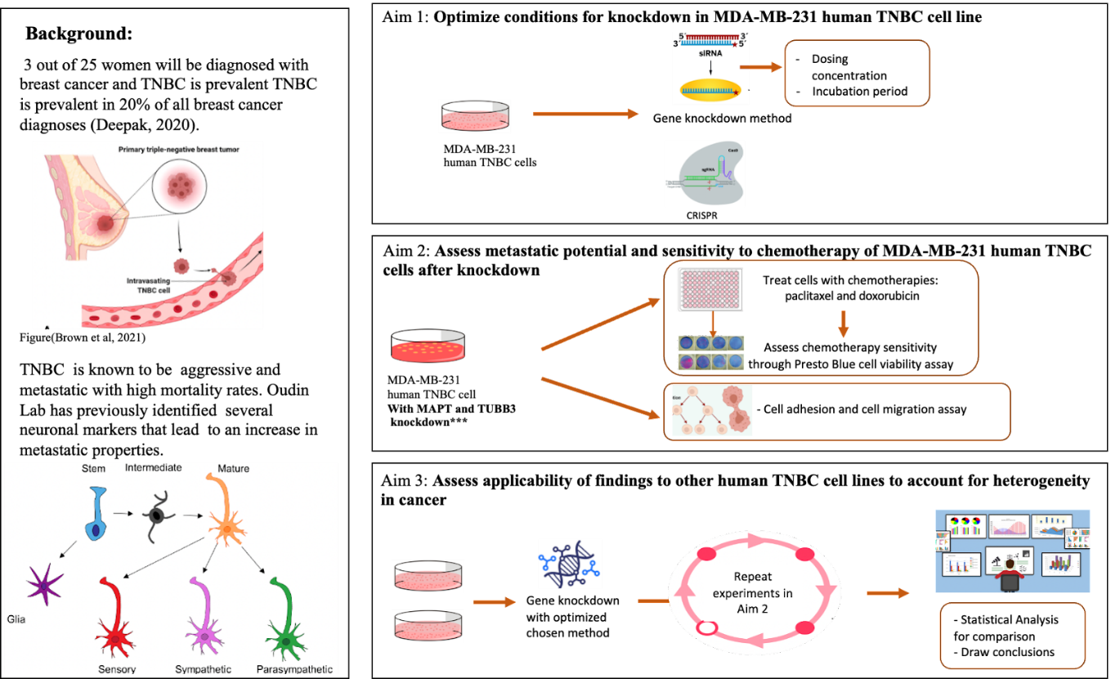
The figure illustrates the background and individual aims for our project. We provide a graphical outline of the experimental methods and deliverables. Our final project is broken into 3 main aims: 1) Optimize conditions for knockdown in MDA-MB-231 human TNBC cell line 2) Assess metastatic potential and sensitivity to chemotherapy of MDA-MB-231 human TNBC cells after knockdown and 3) Assess applicability of findings to other human TNBC cell lines (to be determined) to account for heterogeneity in cancer

Design Flow Chart: Ariana
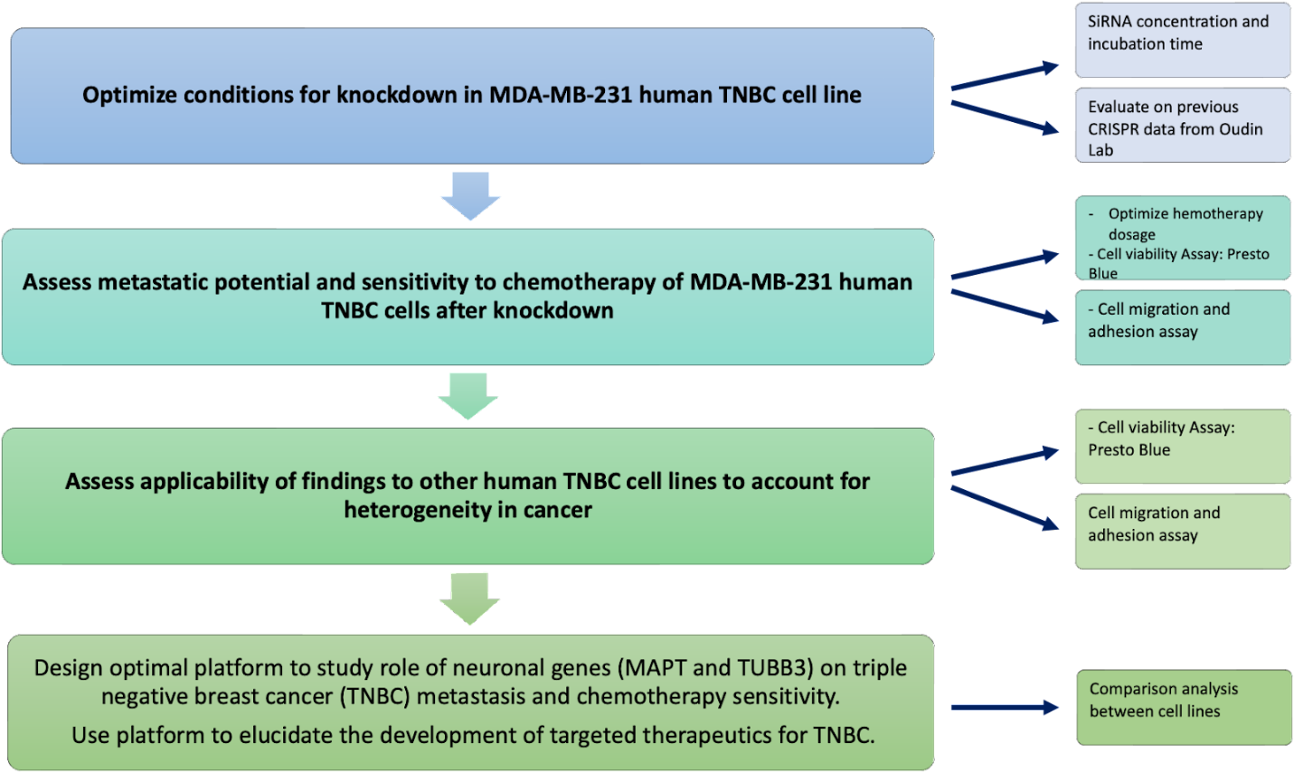
The design flow chart of our project illustrates our three main objectives and our ultimate goal. On the right hand side, we have arrows pointing towards the methods and parameters to accomplish each corresponding goal.

Specific Aims: Maia

Specific Aim 1: Optimize conditions for knockdown in MDA-MB-231 human TNBC cell line
The goal of this aim is to compare the efficacies of knockdown of TUBB3 and MAPT using two different strategies: using siRNA and using CRISPRi. These knockdowns will be performed in MDA-MB-231 human TNBC cell line. It is not feasible to perform this Aim in more than one cell line due to time constraints of the project. It is already known that both methods offer different advantages. Knockdown using siRNA is more time efficient as it can significantly alter the gene expression in just 24 hours. However, it is only able to temporarily reduce gene function. On the other hand, CRISPRi is able to edit the genetic code and completely knockout a gene of interest. The efficacy of the two methods depends on many factors such as the target gene and the cell type used. Since the experiment only involves TNBC cells with identical gene knockdowns, the optimal knockdown method should be the same across all three cell lines. Besides assessment of method of knockdown, optimization of dosing and timing parameters while using siRNA is also required. From these experiments, we will understand the conditions and efficacy of knockdown using each method. From there, we will be better equipped to assess the best method of knockdown in other TNBC cell lines to be evaluated in Specific Aim 3.

Specific Aim 2: Assess metastatic potential and sensitivity to chemotherapy of MDA-MB-231 human TNBC cells after knockdown
The goal of this aim was to take the cells from Aim 1 and assess the effects of knockdown of TUBB3 and MAPT. The mechanism through which these genes play a role in TNBC is not well understood. Metastatic potential will be assessed through migration and adhesion assays. Migration assays involve seeding cells on Collagen I, then imaging them in a migration chamber overnight to track their movements. Cell speed, cell proliferation, and persistence are parameters that will be analyzed after. Adhesion assays are performed to assess cell morphology, which is indicative of invasive capacity. Cells will be seeded onto Collagen I, fixed, stained, then imaged. CellProfiler will be used to perform morphological analysis to assess aspect ratios and cell area. Previous work in the Oudin Lab has assessed metastatic potential of knockdown using CRISPR. This work will be continued by further assessing its effects on chemotherapy sensitivity through cell viability assays. This involves seeding the cells and staining them with Presto Blue to get initial reading in a plate reader. Chemotherapies will then be added to cells except for control cells. Four concentrations of paclitaxel using a two-fold dilution series: 10nM-1.25nM. Four concentrations of doxorubicin will also be assessed using a two-fold dilution series: 500nM-62.5nM. These concentration ranges were previously optimized in the Oudin Lab. In addition, characterizing metastatic potential and chemotherapy sensitivity after knockdown via siRNA will be assessed to look at consistency across knockdown methods. After carrying out this Aim, we will have an understanding of the effects of TUBB3 and MAPT knockdown in TNBC cells. We also will investigate consistencies/differences seen across knockdown methods to further characterize the best method for knockdown.

Specific Aim 3: Assess applicability of findings to other human TNBC cell lines (to be determined) to account for heterogeneity in cancer
The purpose of this Aim is to account for heterogeneity differences that can be seen across cancer lines. It has become standard for cancer research to assess findings in more than one cell line to validate the results. Knockdown will be performed via the optimized method determined in Aims 1 and 2. This aim does not involve any further comparison of the two knockdown methods. It will simply use the protocol that was found to be most effective in earlier experiments. After, the same assays will be performed to investigate effects of knockdown on cell migration, cell morphology, and chemotherapy sensitivity. If results are consistent in other human TNBC cell lines, the data found will be further supported and validated. If results are not consistent, then TUBB3 and MAPT must play different roles in each cell line, which opens the door for new avenues of investigation. Overall, these aims will further the understanding behind the mechanisms through which these neuronal genes play a role in triple-negative breast cancer and is a step closer to developing better therapies.

Methods: Ariana and Maia
Cell Culture
Preparation of Media
Preparation of media was needed in order to be able to grow our TNBC cells and perform the corresponding experiments.
DMEM/F12 hiNSCs complete media was the type of media primary used for this experiment. This media is made by adding 2 main components: 50mL aliquot of FBS, and 10mL of PSG. For preparing the media, both components need to be thawed. Once both components are thawed the serum is filtered in a 0.2um filter with a 50mL syringe and put into a media bottle together with the PSG. The bottle is then labeled with name, data and supplements added and stored in the refrigerator.

Thawing and Seeding Protocol
The cells used for this experiment were: MDA-MB-231 TNBC cell lines. The cells were previously frozen by members of the Oudin lab with CRISPR knockdowns of TUBB3 and MAPT. These were the first cells thawed in order to analyze the effect of CRISPR on cell behavior. We thaw MDA-MB-231 TNBC cells without CRISPR gene knockdown to be able to analyze siRNA as a method of knockdown in the following weeks. Media was first thawed for approximately 20 minutes in the water bath. The frozen vials of cells were removed from the -80 freezer and put in the 37C water bath to quickly thaw it. The vials were then sprayed with 70% ethanol and the solution was then pipetted and transferred to a 15 ml tube along with 10 mL of pre-warmed media. The tube was then centrifuged at 1000 rpm for 3 minutes to pellet the cells so the toxic DMSO solution could be aspirated. After centrifugation, cells were gently reconstituted in 10 ml of complete growth medium. Cells were then transferred to a labelled flask at high density and incubated overnight at 37C/5% CO2. Cell density was checked the next day to either change media or passage the cells accordingly.

Subculturing Procedure
Every week, cell density was evaluated, and cells were passaged accordingly. To passage cells, the culture medium was first removed by aspiration. The flask was then rinsed with 5mL of DPBS for 1 minute by transferring it to the bottom of the flask and then aspirating again. 1mL of 0.25% trypsin-EDTA, was added to detach the cells and the flask was then incubated at 37°C for approximately 1 min. After the incubation, 9 ml of media was added to stop the reaction. A serological pipet is used to rinse the dish 4 times. Cells were then seeded at desired ratio in new flask containing free media.

Knockdown of Neuronal Genes
CRISPR Protocol:
Cells used for the analysis of the first cell line (MDA-MB-231 human TNBC cells) were thawed from a previous graduate student at the Oudin lab who, along with one of us (Maia), had performed the CRISPR gene knockdown.

Drug resistance experiment and analysis (Cell Viability Assay)
In order to test the effect of gene knockdowns of MAPT and TUBB3 in chemotherapy sensitivity, drug resistance experiments and analyses were performed accordingly:
5000 cancer cells per well were seeded in 96 well plate and left incubating for 24 hours. Then, media was replaced with media with chemotherapy drugs at varying concentration. Cell viability is measured on day 1 and day 4 with Presto Blue reagent (P50200) according to manufacturer recommendations. Readouts were normalized with blank, then with day 1 control to calculate the cell viability fold change, and finally with day 4 control to display viability as fractions of no drug control.
siRNA Infection
For the initial viability evaluation of MAPT and TUBB3 knockouts, siRNA-TUBB3 and siRNA-MAPT Silencer will be used from provider ThermoFisher with code 4392420 and Assay ID: s21740. The protocol for infection will be followed as instructed by the provider. SiRNA will be diluted in 11.33 uL of water. 3 experimental groups will be tested infection to evaluate the best siRNA concentration for knockouts 1.33 µl of siRNA was pipetted into each 150mM condition. Then, 1.00 µl of siRNA was added for every 100nM condition. Finally, 1.33uL of H2O was added to each control. siRNA was delivered in the media before pipetting it to the cells.

Migration Assay
A glass-bottom 24 well plate will be used. One the first day, the plate will be coated with 0.1mg/mL Collagen I for 1 hour at 37C. After, 300 uL cells will be seeded at 12k/well in media. The plate is then incubated for 2 hours at 37C. The migration chamber will be set up using image acquisition setting, and the cells will be placed inside after their incubation. Brightfield and TXRed will be used when imaging the cells. Multipoint setting will be used to pick 4-5 POVs for each well. Other settings that will be set on the migration chamber will be 10 minutes between image acquisitions for a total of 97 times. There will be an initial delay of 30 minutes before the first image to allow time for the cells to settle.

Morphological analysis via cell adhesion assay
24h after co-culture was established, cells were fixed and stained with DAPI. Images were taken at 20x with approximately 30 field of views per condition. CellProfiler v3.1.8164 was used to identify cell shape: DAPI was used to identify individual cell then mCherry was used to determine cell shape parameters.
Statistical analysis
GraphPad Prism v8.4.3 was used for generation of graphs and statistical analysis. To compare between two groups, unpaired two-tailed Student’s t-test was used and a p-value of ≤ 0.05 is considered significant. To compare between multiple groups, one-way ANOVA with Tukey’s multiple testing correction was used with a corrected p-value of ≤ 0.05 is considered significant. For RNA-seq, adequately expressed genes passing a fold change threshold of 1.2 and with p value ≤ 0.05 in edgeR analysis were considered differentially expressed. Pathways with p value ≤ 0.05 and FDR ≤ 0.01 were considered differentially regulated.
RESULTS: Kevin, Ariana, and Maia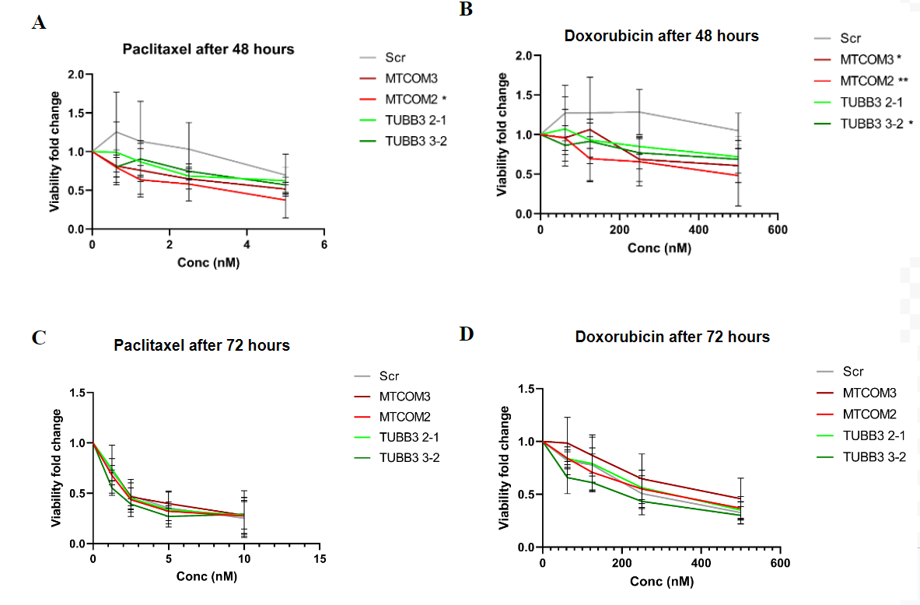
Figure 1: Dose dependent response of cell viability to chemotherapy agents A+C) 48 and 72 hours after exposure to Paclitaxel. Lower dosages were used in the 48 hour condition because the 10 nM condition was determined to be well below the IC50 point in the 72 hour trial. B+D) 48 and 72 hours after exposure to Doxorubicin. One-way ANOVA t-test between two groups was used to assess significance. Each group (MAPT and TUBB3 knockdown) was compared to control cells (Scramble-Scr).

Previously in the Oudin Lab, knockdown of MAPT and TUBB3 was performed on MBA-MD-231 cells. The knockdown was determined to be successful with >70% knockdown assessed by qPCR (MAPT) and Western Blot (TUBB3). These same cells were used to perform a viability assay with paclitaxel and doxorubicin; the results are shown in Figure 1. Upon exposure to paclitaxel, only MTCOM2 demonstrated a statistically significant decrease in viability compared to the control after 48 hours. Upon exposure to doxorubicin, MTCOM2, MTCOM3, and TUBB3 3-2 demonstrated a statistically significant decrease in viability compared to the control after 48 hours. No statistical significance was found at the 72 hour time point.

DISCUSSION: Kevin, Ariana, and Maia
TUBB3 has been previously considered to promote microtubule dynamics. A study in A549 lung cancer cells showed that knocking down TUBB3 resulted in more stable microtubules when quantifying growth/shrink rate.¹⁵ Other studies have shown that expressing mutant TUBB3 in mouse models resulted in a higher level of de-tyrosinated α-tubulin, which is correlated with stabilized microtubules.¹⁶ On the other hand, MAPT has been considered to have stabilizing effect in microtubules as Tau protein attach to tubulin subunits and suppresses the microtubule shrink rate.¹⁵ MAPT and TUBB3 therefore have opposite roles on microtubule dynamics but at the same time induce similar effects in cell morphology and migration.
Figures 1A and 1C show the cell viability in response to paclitaxel, a chemotherapy agent that targets mitotic microtubules in rapidly dividing cancer cells. Clinical data indicate a correlation between resistance to paclitaxel and an overexpression of MAPT and TUBB3. If this resistance is caused by overexpression of these genes, then knockdown cells should be more sensitive to paclitaxel. The TUBB3 knockdowns were not more sensitive to paclitaxel after 48 or 72 hours. One MAPT knockdown, however, did have a statistically significant decrease in viability after 48 hours. Since only one of the replicate showed this pattern, more experimentation is needed.
Figures 1B and 1D show the cell viability in response to doxorubicin, which targets cancer by disrupting nucleotide formation, thereby inhibiting proliferation. So, doxorubicin induces DNA damage, however, does not affect microtubule dynamics. One replicate of TUBB3 and both replicates of MAPT had a statistically significant decrease in viability as a result of exposure to this drug.
Reasoning why we saw different data at 48 hours and 72 hours was likely due to the confounding variable of cell death due to high confluency. 72 hours may have been too long of an incubation period to keep the cells in a 96-well plate. Too long of an incubation period will cause cells to die from confluency, not solely due to chemotherapy exposure.
These preliminary results suggest that there might be a correlation between neuronal genes MAPT and TUBB3 and the effectiveness of chemotherapy. Nevertheless, more trials are needed in order to draw significant conclusions. If the differences seen in the above figures are true, these genes may serve as potential therapeutic targets for TNBC. Overall, this data may also motivate the progression of further research in the neuronal identity of TNBC.

FUTURE WORK – what should students do next year to pick up on your project from this year, were it to continue. Or let us know it should not continue and why, etc.

PARTICIPATION – list individual contributions of each group member to the project

Lab work has been distributed evenly between Ariana, Kevin, and Maia.

GANTT CHART: TRACKING PROJECT PROGRESS (UPDATED AS OF 12/09/22) - Ariana Capstone Gantt chart
The colors in our Gantt chart represent the level of completion of the activity. Green stands for completion, yellow for “in progress”, grey for upcoming (not started), and red for delayed or canceled activity. We kept the column that indicates the percentage of the activity completed (the closer the percentage gets to 100, the darker the green becomes).
As mentioned before, after performing our viability assay 3 times we did not see a significant difference between our control and knockdown cells after 72 hours. To ensure this was true, we troubleshooted to identify if there was an issue with the methods (such as incubation time in the 96 well plate), or if there is really no significant difference in cell viability after exposure to chemotherapy between controls and cells with CRISPR knockdown of TUBB3 and MAPT. We saw some significance so decided to repeat the viability assay with a new standpoint (48hr) 5 times.
To account for the extra time this experiment will take us to do, we have decided to reassess the experiments that test the effect of siRNA knockdown in cell viability and proliferation/migration. We will optimize the dosage and incubation period for successful knockdown and perform the analysis of the effect of the knockdown in cell migration proliferation and viability at the beginning of next semester.
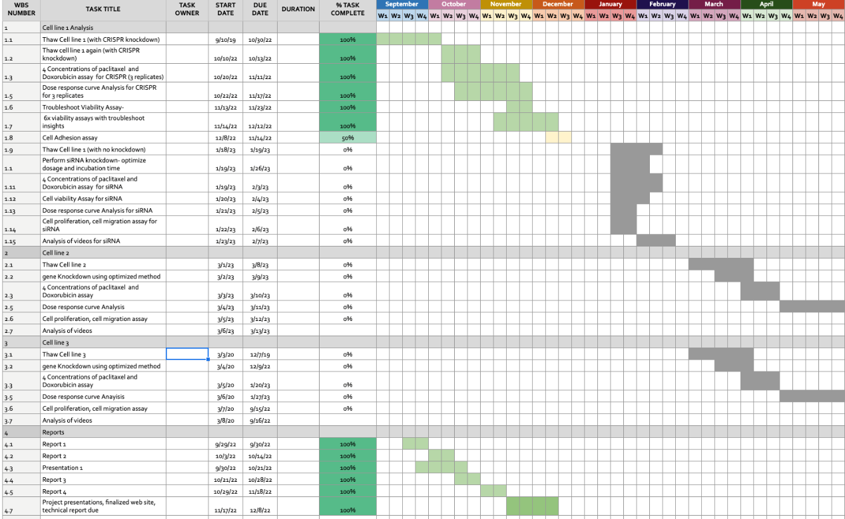
Zoom in for relevant dates:
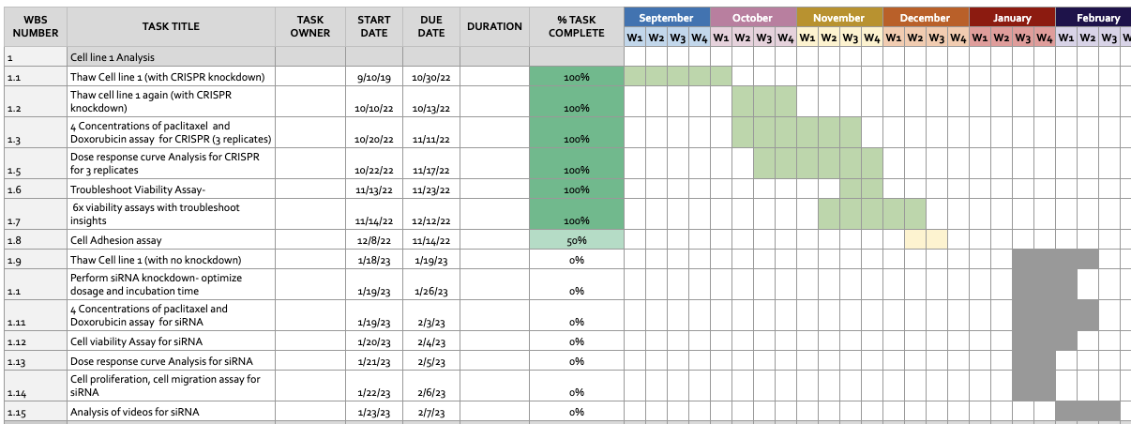
References:
1 Waks, A. G. & Winer, E. P. Breast Cancer Treatment: A Review. JAMA 321, 288-300, doi:10.1001/jama.2018.19323 (2019)
2 Deepak, K. G. K. et al. Tumor microenvironment: Challenges and opportunities in targeting metastasis of triple negative breast cancer. Pharmacol Res 153, 104683, doi:10.1016/j.phrs.2020.104683 (2020)
3 Weiss, M. C. et al. A Coala-T-Cannabis Survey Study of breast cancer patients' use of cannabis before, during, and after treatment. Cancer 128, 160-168, doi:10.1002/cncr.33906 (2022).PMC9413357
4 Hudis, C. A. & Gianni, L. Triple-negative breast cancer: an unmet medical need. Oncologist 16 Suppl 1, 1-11, doi:10.1634/theoncologist.2011-S1-01 (2011)
5 Cortes, J. et al. Pembrolizumab plus Chemotherapy in Advanced Triple-Negative Breast Cancer. N Engl J Med 387, 217-226, doi:10.1056/NEJMoa2202809 (2022)
6 Yao, Y., Chu, Y., Xu, B., Hu, Q. & Song, Q. Risk factors for distant metastasis of patients with primary triple-negative breast cancer. Biosci Rep 39, doi:10.1042/BSR20190288 (2019).PMC6549086
7 Lippman, S. M. & Brown, P. H. Tamoxifen prevention of breast cancer: an instance of the fingerpost. J Natl Cancer Inst 91, 1809-1819, doi:10.1093/jnci/91.21.1809 (1999)
8 O'Reilly, D., Sendi, M. A. & Kelly, C. M. Overview of recent advances in metastatic triple negative breast cancer. World J Clin Oncol 12, 164-182, doi:10.5306/wjco.v12.i3.164 (2021).PMC7968109
9 Harbeck, N. & Gnant, M. Breast cancer. Lancet 389, 1134-1150, doi:10.1016/S0140-6736(16)31891-8 (2017)
10 Rakha, E. A. & Chan, S. Metastatic triple-negative breast cancer. Clin Oncol (R Coll Radiol) 23, 587-600, doi:10.1016/j.clon.2011.03.013 (2011)
11 Yang, D. et al. Axon-like protrusions promote small cell lung cancer migration and metastasis. Elife 8, doi:10.7554/eLife.50616 (2019).PMC6940020
12 al., T. T. L. e. Sensory nerves enhance triple-negative breast cancer migration and metastasis via the axon guidance molecule PlexinB3. bioRxiv (2022)
13 Le, T. T. The neural identity of triple negative breast cancer. (2022)
14 Fan, Y. & Guo, Y. Knockdown of eIF3D inhibits breast cancer cell proliferation and invasion through suppressing the Wnt/beta-catenin signaling pathway. Int J Clin Exp Pathol 8, 10420-10427 (2015).PMC4637565
15 Panda D, Miller HP, Wilson L. Rapid treadmilling of brain microtubules free of microtubule-associated proteins in vitro and its suppression by tau. Proc Natl Acad Sci U S A. 1999 Oct 26;96(22):12459-64. doi: 10.1073/pnas.96.22.12459. PMID: 10535944; PMCID: PMC22948.
16 Feinstein SC, Wilson L. Inability of tau to properly regulate neuronal microtubule dynamics: a loss-of-function mechanism by which tau might mediate neuronal cell death. Biochim Biophys Acta. 2005 Jan 3;1739(2-3):268-79. doi: 10.1016/j.bbadis.2004.07.002. PMID: 15615645.

