**BME Senior Capstone Project:**

**Investigating the Role of Neuronal Genes in Breast Cancer Metastasis and Chemotherapy Sensitivity**

Ariana Barriero, Maia Buckwald, and Kevin Lyons

Madeleine Oudin

**Keywords:** Triple-negative breast cancer (TNBC), metastasis, Neuronal Markers, β3-tubulin

**Abstract:** *Ariana, Maia*

This project aims to investigate how neuronal genes impact the metastasis and chemotherapy sensitivity of triple-negative breast cancer (TNBC). TNBC is an aggressive subtype of breast cancer without a therapeutic target, making chemotherapy only a palliative measure. Transcriptome data has shown that neuronal genes β3-tubulin (TUBB3) and microtubule-associated protein Tau (MAPT) are highly upregulated in TNBC tumors compared to healthy breast tissue. Preliminary research in the Oudin Lab revealed that knocking down of these genes in TNBC cells led to an increase in invasion, which drives metastasis[1,2](https://www.zotero.org/google-docs/?8vVB37). Clinical data also indicates a correlation between high expression of these genes and resistance to paclitaxel chemotherapy. This project seeks to optimize a gene knockdown platform of siRNA and CRISPR to study how TUBB3 and MAPT neuronal gene expression affects metastasis and chemotherapy sensitivity in MDA-MB-231 human TNBC cells.

**Unifying Figure:** *Ariana*

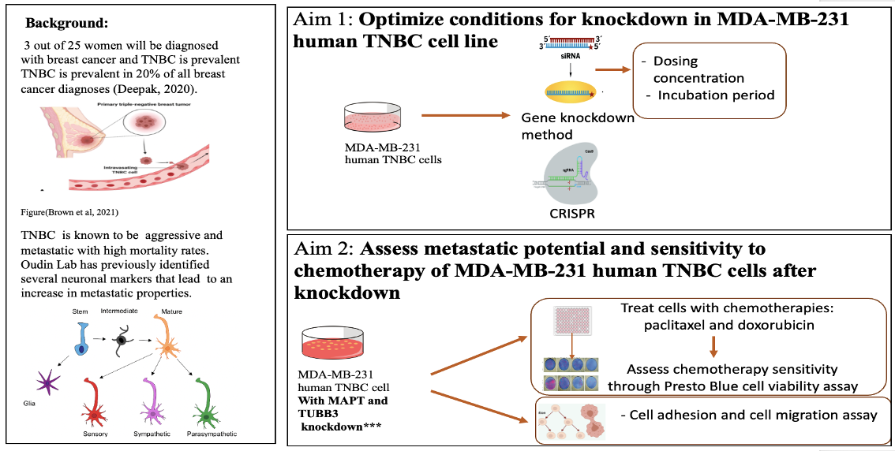

*The figure outlines our project's background, aims, experimental methods, and deliverables. The project has two main aims: 1) Optimize knockdown conditions in MDA-MB-231 TNBC cells, and 2) Assess metastatic potential and chemotherapy sensitivity of cells after knockdown.*

**Introduction:** *Kevin, Ariana, and Maia*

Triple-negative breast cancer (TNBC) is a subtype of breast cancer that lacks the expression of estrogen receptor (ER), progesterone receptor (PR), and human epidermal growth factor receptor 2 (HER2). Approximately 20% of all breast cancers are classified as TNBC, and unfortunately, TNBC has a poor prognosis with a 5-year survival rate of 40% [3](https://www.zotero.org/google-docs/?sjg9gh). Metastasis, the process by which cancer cells spread to distant organs and tissues, is a major cause of cancer-related mortality in TNBC patients [4](https://www.zotero.org/google-docs/?Yi5dJc). Targeted therapies, which inhibit malignant signaling pathways associated with cancer expression, can reduce metastasis and could be a possible therapeutic approach for TNBC to improve treatment outcomes[4](https://www.zotero.org/google-docs/?o7tSTi). However, effective therapeutic intervention relies on a detailed understanding of gene expression and its effects on cell behavior which is poorly understood in TNBC cells. The current standard of care for TNBC is using taxane-based chemotherapies (docetaxel or paclitaxel) with/or anthracycline-containing chemotherapies (like doxorubicin). In combination, these chemotherapies can reduce mortality by a further 10-15%[5](https://www.zotero.org/google-docs/?LAqaWi). However, this use is still not optimal as there are many risks and side-effects that may not outweigh the benefits. As a result, there is a clear need for further investigation of the cellular and molecular pathways that drive growth and metastasis to identify potential targets for future treatments.

Recently, genes that are abundant in the brain and known to regulate neuronal function have been correlated with metastasis in epithelial tumors like lung cancer and more interest has been growing in the role of neuronal genes in cancer as a whole. In TNBC specifically, certain neuronal genes have been identified to be upregulated. The Oudin lab has previously identified that neuronal genes for β3-tubulin (TUBB3) and microtubule-associated protein tau (MAPT) are upregulated in triple-negative breast cancer tumors. TUBB3 promotes microtubule dynamics, while MAPT has a stabilizing effect on microtubules through the Tau protein's attachment to tubulin subunits[6](https://www.zotero.org/google-docs/?SHKJm2). Microtubules exhibit dynamic instability, which means they constantly grow and shrink at a rapid rate, allowing cells to explore space and rapidly adapt to changing conditions[6](https://www.zotero.org/google-docs/?broken=m282LO). Microtubules are also responsible for chromosome segregation during cell division, allowing for cells to proliferate[7](https://www.zotero.org/google-docs/?m5tP0u). Despite their opposing roles in microtubule dynamics[8](https://www.zotero.org/google-docs/?oGKUj8), both genes have similar effects on regulating cell morphology, cell proliferation, and migration. All of these properties have an impact on metastasis. Furthermore, data mining has revealed a correlation between these genes and poor patient survival, indicating their significant role in TNBC progression[1,9](https://www.zotero.org/google-docs/?jsyeAd).

In this context, we aimed to investigate the role of neuronal gene expression of TUBB3 and MAPT in TNBC cells and their impact on cellular metastatic potential. To achieve this, we created a knockdown platform using CRISPR and siRNA techniques to study the genes' effects on proliferation rate, migratory behavior, and cell morphology. Furthermore, we investigated how chemotherapy affects the viability and morphology of cancer cells after the knockdown of these genes. Morphology of cancer cells has been proven to be indicative of invasive capacity. We tested one taxane-based chemotherapy (paclitaxel) and one other common chemotherapy (doxorubicin) to note differences in responses to drugs that target different pathways. Taxane-based chemotherapies target microtubules, which are regulated by TUBB3 and MAPT, so this is a significant avenue of exploration.

The present study is a step towards elucidating the molecular mechanisms of TNBC metastasis and identifying potential targets for therapeutic interventions. The investigation of TUBB3 and MAPT gene expression and their effects on TNBC cells' behavior and response to chemotherapy may provide insights into new approaches for the treatment of this aggressive cancer subtype.

**Background:** *Ariana, Kevin, Maia*

Breast cancer is caused by genetic mutations in epithelial cells of the breast. These mutations dysregulate the proliferative or apoptotic signaling pathways which create aggregates of harmful nonfunctional cells called tumors. The tumors disrupt normal cell function and can be fatal if left untreated. Classification of breast cancers is based on the surface receptors that the cell line expresses. Surface receptors tend to make the cancer more aggressive, but they can also serve as therapeutic targets. There are four molecular subtypes of breast cancer: luminal A, luminal B, HER2+, and triple-negative. This study specifically uses TNBC, which does not express any surface receptors.

Cancer cells spread in metastasis throughout the body via the lymphatic system, the bloodstream, or through perineural invasion, a process dependent on cell migration, which is the leading cause of death in cancer patients[10](https://www.zotero.org/google-docs/?8ckzxU). Metastatic triple negative breast cancer is fatal [11](https://www.zotero.org/google-docs/?HL3IQJ). Chemotherapy remains the only FDA-approved treatment for TNBC; however, it has significant negative side effects including hair loss, appetite loss, and anemia. This treatment does not prevent metastasis, as roughly 30% of early-stage breast cancers become metastatic regardless of chemotherapy[12](https://www.zotero.org/google-docs/?egibUS). Research is currently being performed to seek out potential targets for new therapies for TNBC[13,14](https://www.zotero.org/google-docs/?tcrKju).

A recent study by Yang et al found upregulated neuronal genes, TUBB3 and Tau, in small cell lung cancer leading to elongated cell shape and saltatory movement, increasing metastatic potential[15](https://www.zotero.org/google-docs/?O3foNw). Complementary, publicly available transcriptome data of triple negative breast cancer cells has shown upregulation of neuronal genes. Thanh Le et al. did a mRNA study on patient samples with inductive ductal carcinoma, the most common type of breast cancer, which showed increased mRNA expression of neuronal genes TUBB3, CNTNAP2, SEMA4D and MAPT in human invasive ductal carcinoma versus normal breast tissue **(Figure 1A)**[6,8](https://www.zotero.org/google-docs/?m8li6q)**.**

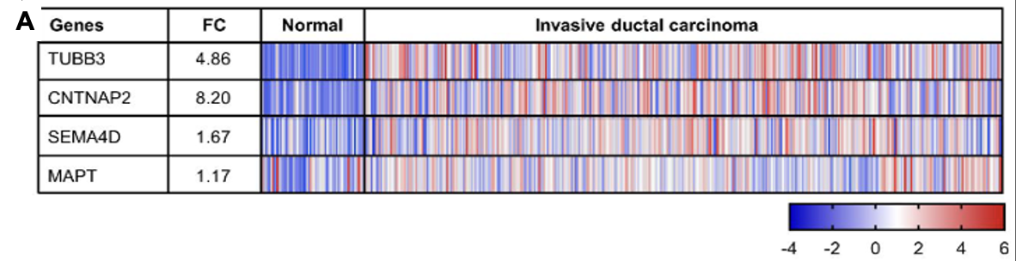

***Figure 1:*** *A) mRNA expression of neuronal genes TUBB3, CNTNAP2, SEMA4D and MAPT in human invasive ductal carcinoma versus normal breast tissue, each column represents a patient*[*6*](https://www.zotero.org/google-docs/?DfnDRi)

Two neuronal genes, TUBB3 and MAPT, have been identified as highly expressed in breast cancer and biomarkers for poor prognosis. TUBB3 has been previously considered to promote microtubule dynamics and MAPT to have a stabilizing effect on microtubules[16,17](https://www.zotero.org/google-docs/?xOLrKp). MAPT and TUBB3 therefore have opposite roles on microtubule dynamics but at the same time induce similar effects in cell morphology and migration[8](https://www.zotero.org/google-docs/?gCyej3). Clinical data indicates a correlation between resistance to taxane-based chemotherapies and overexpression of MAPT and TUBB3[1,2](https://www.zotero.org/google-docs/?FjUJtJ). Taxane-based chemotherapies, like paclitaxel, are able to induce cell death by stabilizing microtubules. Since TUBB3 and MAPT play roles in microtubule dynamics, they likely impact the effectiveness of these types of chemotherapies. Doxorubicin, on the other hand, induces apoptosis through DNA damage and it does not affect microtubule dynamics.

Preliminary research in the Oudin Lab revealed that knockdown of TUBB3 and MAPT in MDA-MB-231 breast cancer cell line led to increased cell speed, saltatory movements, and migration, indicating their potential role in metastasis[8](https://www.zotero.org/google-docs/?dsmSlO). Investigating the effects of gene knockdown on TNBC cells may reveal new therapeutic avenues for exploiting higher chemotherapy sensitivity while limiting metastasis potential and identifying these genes as biomarkers for breast cancer.

**Elements of Engineering Design:** *Ariana, Maia, and Kevin*

The objective of the project was to further our knowledge on the effects of neuronal gene expression in TNBC. Specifically, we planned to investigate the effects of chemotherapy on sensitivity and cell morphology. The focus of the project's design work was to first optimize the platform to perform gene knockdown that was needed to study these effects. This project fulfilled a research need on better understanding the mechanisms behind metastasis. Expanding this knowledge provided avenues for new and more effective treatments. The hypothesis was that gene knockdown would lead to higher sensitivity to chemotherapy treatments and lower the metastatic potential of the cells.  
 To optimize the platform, we first tested two different gene knockdown methods: siRNA and CRISPR. It was necessary to perform both methods since their efficacies were dependent on factors such as cell line and the target gene. These neuronal genes, β3-tubulin (TUBB3) and microtubule-associated protein Tau (MAPT), had yet to be knocked down in TNBC cells, which was why both methods needed to be evaluated to determine which was more efficacious in gene knockdown.We then evaluated the effects of each type of knockdown with biochemical assays and experimental lab methods such as imaging and immunostaining to measure cell migration, cell morphology, and cell speed. Furthermore, to analyze the results, we mathematically determined the differences in cell proliferation, movement, morphology, and viability using advanced statistical analysis. Their most notable constraint was time.  
 The original plan consisted of a third aim to assess the applicability of their findings in two other cell lines. Nevertheless, due to challenges with the siRNA, we decided to focus on optimizing the methods on the first cell line: MDA-MB-231. The first quantitative milestone was the extent of gene knockdown. In every case, at least 70% knockdown of the gene had to be achieved, as this was the standard used in literature. A study from 2015 had shown that 70% knockdown was sufficient to produce significant changes in breast cancer cells[18](https://www.zotero.org/google-docs/?jPU8Au). If the gene was not sufficiently knocked down, it introduced confounding variables to the study. We assessed the efficiencies of knockdown with the use of immunohistochemistry with TUBB3 and qPCR for MAPT. These methods were chosen given that TUBB3 had a very common antibody used for staining while MAPT did not. A limitation of this was that resources were limited in the lab, so we quantified knockdown for each gene through different means.We were only able to gauge gene expression of MAPT via qPCR. We had to use immunohistochemistry, which assessed protein expression instead of gene expression, to quantify knockdown of TUBB3.  
 We used a one-way ANOVA t-test between two groups to assess the significance of the effect of knockdown on migration, proliferation, and morphology. Each group (MAPT and TUBB3 knockdown) was compared to control cells (Scramble). Additionally, their goal was that the control and knockdown groups would demonstrate a differential dose-dependent response to paclitaxel and doxorubicin. We used a two-way ANOVA t-test between two groups to assess for significant differences in viability when exposed to chemotherapy. Each group (MAPT and TUBB3 knockdown) was compared to control cells (Scramble). This same test was also used to determine significant changes in cell morphology after chemotherapy exposure. All of these statistical analyses were chosen as these are standard in the Oudin Lab.

**Design Flow Chart:** *Ariana*

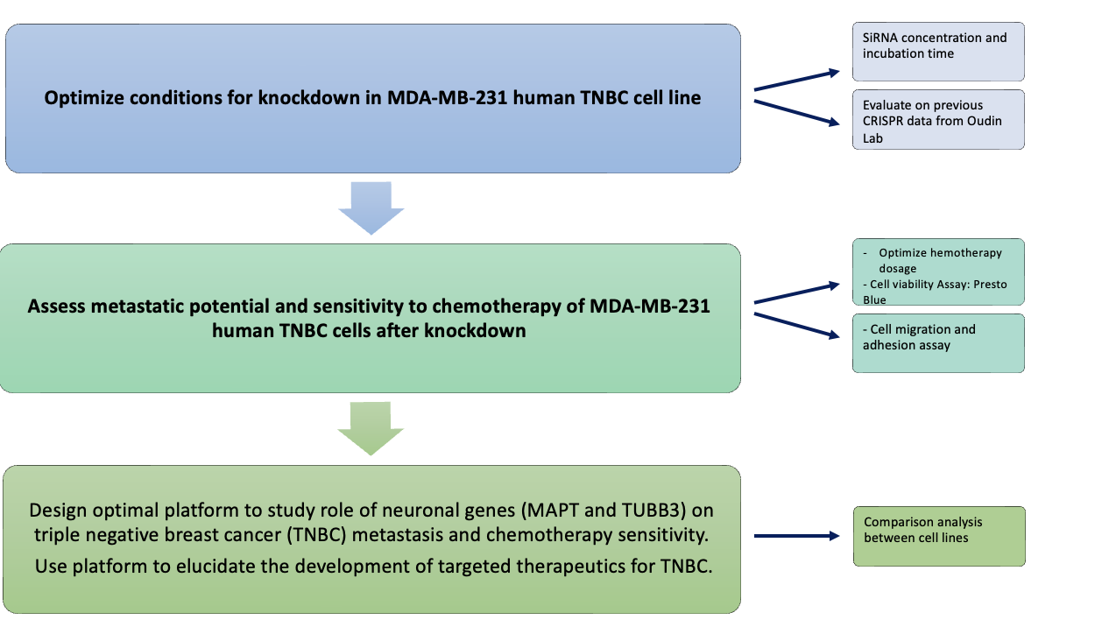

*The design flow chart of our project illustrates our three main objectives and our ultimate goal. On the right hand side we have arrows pointing towards the methods and parameters to accomplish each corresponding goal.*

**Specific Aims:** *Maia*

**Aim 1: Optimize conditions for knockdown in MDA-MB-231 human TNBC cell line**

The goal of this aim is to compare the efficacies of knockdown of TUBB3 and MAPT using two different strategies: using siRNA and using CRISPRi. These knockdowns will be performed in the MDA-MB-231 human TNBC cell line. This cell line will be used because of its availability in the Oudin Lab. It is not feasible to perform this Aim in more than one cell line due to time constraints of the project. It is already known that both methods offer different advantages. Knockdown using siRNA is more time efficient as it can significantly alter the gene expression in just 24 hours. However, it is only able to temporarily reduce gene function. On the other hand, CRISPRi is able to edit the genetic code and completely knockout a gene of interest. The efficacy of the two methods depends on many factors such as the target gene and the cell type used. Besides the assessment of method of knockdown, optimization of dosing and timing parameters while using siRNA is also required. After optimization of both knockdown methods, we will ensure knockdown has consistent behavioral effects on the cells through migration assays. To perform migration assays, cells were seeded onto a Collagen I-coated plate and imaged overnight in a migration chamber to track their movements. We analyzed cell speed to compare the effects of knockdown. Knockdown must lead to significant and consistent effects for the method to be an optimal platform to study these genes. From these experiments, we will understand the conditions and efficacy of knockdown using each method. From there, we will be better equipped to assess the best method of knockdown in other TNBC cell lines in future directions. Once optimized, this platform can be used by other researchers to further investigate the role of these genes in TNBC metastasis.

**Aim 2: Assess effects of chemotherapy on viability and cell morphology of MDA-MB-231 human TNBC cells after gene knockdown**

This aim of the study was to investigate the effects of chemotherapy on cell viability and morphology of TUBB3 and MAPT knockdown cells. We investigated the effects of TUBB3 and MAPT knockdown on chemotherapy sensitivity using cell viability assays. We used a Presto Blue assay to measure cell viability after treatment with paclitaxel and doxorubicin at four different concentrations, ranging from 5nM to 0.625nM for paclitaxel and 500nM to 62.5nM for doxorubicin. These concentration ranges were previously optimized in the Oudin Lab. Furthermore, an adhesion assay was performed to evaluate chemotherapy-induced effects on cell morphology, which allowed us to assess changes in the invasive capacity of cells. The cells were seeded onto Collagen I, fixed, stained, and imaged, and CellProfiler was used to perform morphological analysis to assess aspect ratios, form factor, and cell area. By carrying out this aim, we gained a better understanding of the effects of TUBB3 and MAPT knockdown in TNBC cells. We also were able to investigate consistencies and differences across knockdown methods to further characterize the best method for knockdown in TNBC cells.

**Methods:** *Ariana and Maia*

***Cell Culture:*** MDA-MB-231 human triple-negative breast cancer cell lines were all grown in Dulbecco’s Modified Eagle’s Medium (DMEM) with 10% fetal bovine serum (FBS) and

antibiotics. Cells are cultured with standard sterile tissue culture technique.

***CRISPR Protocol:*** Cells used for the analysis of the first cell line (MDA-MB-231 human TNBC cells) were thawed from a previous graduate student at the Oudin lab who, along with one of us (Maia), had performed the CRISPR gene knockdown. This involved creating MDA-MB-231-Cas9 cells, lentiviral transduction of gRNAs, and then the cells were expanded for use.

***Cell Viability Assay:***To test the effect of gene knockdowns of MAPT and TUBB3 in chemotherapy sensitivity, cell viability experiments were performed. 5000 cancer cells were seeded in each well of a 96 well plate, then treated with chemotherapy drugs at varying concentrations. Cell viability was measured on day 1 and day 3 using Presto Blue reagent (P50200) according to manufacturer recommendations. Viability was normalized with blank and control samples, then displayed as fractions of the no drug control.

***siRNA Infection***

For the initial viability evaluation of MAPT and TUBB3 knockouts, siRNA-TUBB3 and siRNA-MAPT Silencer will be used from provider ThermoFisher with code 4392420 and 9854367. The protocol for infection was followed as instructed by the provider. Three experimental groups were tested to evaluate the best siRNA concentration for knockouts: 5μM, 2.5μM, and 1.25μM. MAPT gene expression was measured with qPCR and TUBB3 with immunostaining given the accessibility of the well-known antibody for this gene.

***Migration Assay*:** On day one, a glass-bottom 24 well plate was coated with 0.1mg/mL Collagen I for 1 hour at 37C. 300 μL cells were seeded at 12k/well in media and incubated for 2 hours at 37C. The migration chamber was set up with image acquisition settings using Brightfield and TXRed to image the cells. Multipoint settings were used to select 4-5 POVs for each well, and a 10-minute interval between image acquisitions for a total of 97 times.

***Cell adhesion assay:*** 24h after culture was established, cells were fixed and stained with DAPI. Images were taken at 20x with approximately 30 field of views per condition. CellProfiler v3.1.8164 was used to identify cell shape: DAPI was used to identify individual cells then mCherry was used to determine cell shape parameters.

***Statistical analysis:*** GraphPad Prism v8.4.3 was used for generation of graphs and statistical analysis. To compare between two groups, unpaired two-tailed Student’s t-test was used and a p-value of ≤ 0.05 is considered significant. To compare between multiple groups, one-way ANOVA with Tukey’s multiple testing correction was used with a corrected p-value of ≤ 0.05 is considered significant. For RNA-seq, adequately expressed genes passing a fold change threshold of 1.2 and with p value ≤ 0.05 in edgeR analysis were considered differentially expressed. Pathways with p value ≤ 0.05 and FDR ≤ 0.01 were considered differentially regulated.

**RESULTS:** *Kevin, Ariana, and Maia*

**Optimal concentration and incubation time for siRNA knockdown found**

To create a platform to study the effects of these genes, siRNA knockdown was optimized and compared to the previous method of CRISPR knockdown. To optimize this method of knockdown, three concentrations of siRNA will be tested: 5μM, 2.5μM, and 1.25μM. These concentrations were chosen based on the recommendations from Horizon Discovery Biosciences, where the siRNA came from. Incubation times of 24 hours and 72 hours were tested for MAPT knockdown, and 24 hours and 48 hours were tested for TUBB3 knockdown. 48 hours was assessed for TUBB3 knockdown since the cells appeared to be too confluent to wait to be assessed at the 72 hour time point. As stated before, the metric for successful knockdown is at least 70% knockdown.

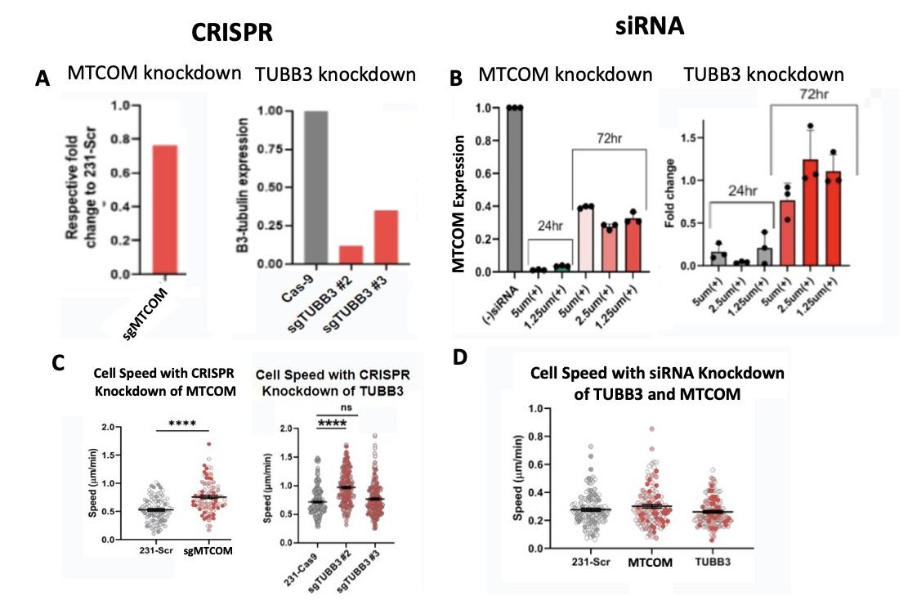

***Figure 2: Comparison of CRISPR and siRNA knockdown methods.*** *A) CRISPR knockdown quantification for MAPT using qpcr (left) and for TUBB3 using Western blot (right). B) SiRNA knockdown quantification for MAPT using qpcr (left) and for TUBB3 using immunostaining (right).**C) 2D migration speed of 231-Scr control and CRISPR MAPT knockdown cells (left) and CRISPR TUBB3 knockdown cells (right). D) 2D migration speed of 231-Scr control and siRNA MAPT and TUBB3 knockdown cells. Significance was determined by one-way ANOVA (***p<0.001, ****p<0.0001).*

Previously in the lab, MAPT and TUBB3 had successful knockdowns. MAPT mRNA expression level was about 75% of the MDA-MB-231 control cells and TUBB3 expression level dropped to approximately 10 and 30% of the 231-Cas9 control cells (Figure 2A). MAPT siRNA knockdown results show that there is almost 100% knockdown after incubation with siRNA for 24 hours at all concentrations (Figure 2B). Data that tested the siRNA concentration of 2.4μM could not be obtained due to a reading error by the thermal cycler. At the 72 hour time-point, there is about 60-70% MAPT knockdown across all concentrations (Figure 2B). TUBB3 siRNA knockdown results show about 80-95% knockdown after incubation with siRNA for 24 hours across the different concentrations. After incubation with the siRNA for 48 hours, there was about 25% knockdown at 5μM siRNA. There was no knockdown of TUBB3 at the two lower concentrations of siRNA (Figure 2B).

To compare knockdown methods, migration assays were carried out on both sets of cells (Figure 2C and Figure 2D). MAPT and TUBB3 CRISPR knockdown cells moved significantly faster than control cells. However, no differences in cell speed were seen when the siRNA knockdown platform was used.

To test the effect of siRNA knockdown in the MDA-MB-231 cell line, we additionally performed an adhesion assay to assess the effects of siRNA knockdown on cell morphology. However, we encountered challenges in accurately analyzing the cells due to excessive confluency, as seen in **Appendix 1**. Consequently, we were unable to perform the adhesion assay analysis for these cells.

Due to siRNA knockdown being an inefficient platform to study these genes, we proceeded to investigate the effects of knockdown only using the CRISPR cells in the following experiments.

**Gene knockdown leads to susceptibility to chemotherapy at 48 hour time point**

In order to assess the effectiveness of chemotherapy after gene knockdown, we performed Presto Blue viability assays after administering chemotherapy to CRISPR knockdown cells. Viability was assessed 48 hours after chemotherapy exposure. This time point was optimized after preliminary tests were performed at various time points.

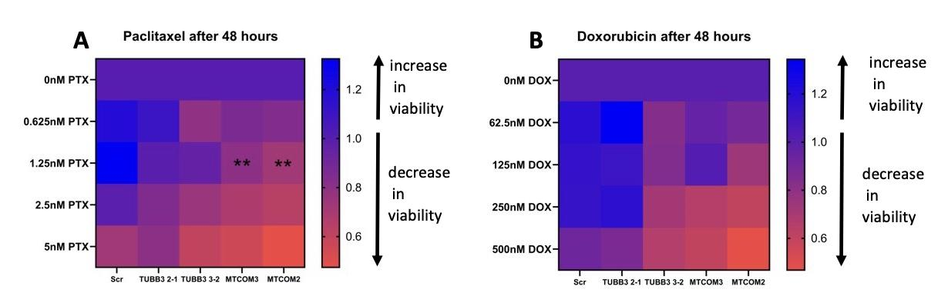

***Figure 3: MAPT knockdown sensitizes MDA-MB-231 cells to taxane chemotherapy.*** *A) Day3/Day1 viability fold change of CRISPR MAPT and TUBB3 knockdown cells after paclitaxel treatment and B) doxorubicin treatment. Each group (MAPT and TUBB3 knockdown) was compared to control cells (Scramble-Scr). Significance was determined by two-way ANOVA (**p<0.01).*

Upon exposure to paclitaxel, both replicates of MAPT knockdown demonstrated a statistically significant decrease in viability compared to the control after 48 hours. TUBB3 knockdown cells had no significant difference in viability. Knockdown did not affect viability of the cells after doxorubicin exposure.

**Gene knockdown leads to morphological changes due to chemotherapy exposure**

Besides effects of chemotherapy on viability, effects on morphology should be analyzed as well. Morphology indicates the metastatic potential of the cell. To assess this, the cells were incubated with pacitaxel and doxorubicin and adhesion assays were performed.

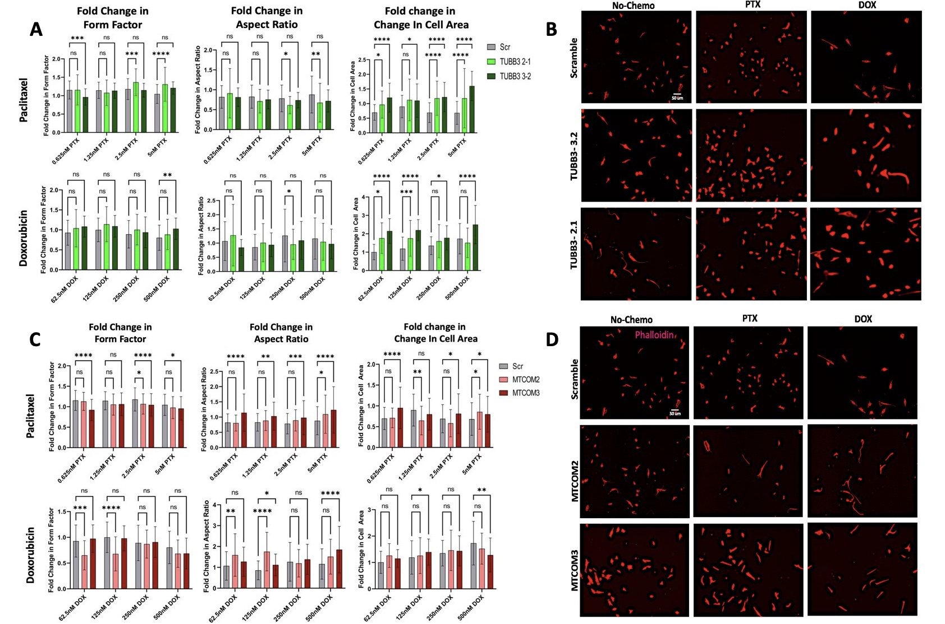

***Figure 4: Effects of chemotherapy treatment on cell morphology of TUBB3 and MAPT CRISPR knockdown cells.*** *A) Graphs show fold change in form factor, aspect ratio, and cell area of TUBB3 knockdown cells after paclitaxel and doxorubicin treatment. B) Images obtained of TUBB3 knockdown cells with no treatment, paclitaxel treatment, and doxorubicin treatment. C) Graphs show fold change in form factor, aspect ratio, and cell area of MAPT knockdown cells after paclitaxel and doxorubicin treatment. D) Images obtained of MAPT knockdown cells with no treatment, paclitaxel treatment, and doxorubicin treatment. Significance was determined by two-way ANOVA (*p<0.05, **p<0.01, ***p<0.001, ****p<0.0001).*

One replicate of TUBB3 knockdown had significantly smaller average aspect ratio when subjected to one concentration of doxorubicin (250nM) and to two concentrations of paclitaxel (2.5nM and 5nM). The results also indicate that chemotherapy leads to a larger form factor for one concentration of doxorubicin (500nM) and three concentrations of paclitaxel (0.625nM, 2.5nM, and 5nM). Lastly, both replicates of TUBB3 knockdown had larger cell areas across all concentrations of both chemotherapies. Overall, the trends seen were that TUBB3 knockdown cells had slightly smaller aspect ratios, larger form factors, and larger cell areas when subjected to chemotherapy.

Knockdown of MAPT led to larger aspect ratios of the cells for ¾ of the concentrations of doxorubicin, and for all four concentrations of paclitaxel. In addition, it leads to smaller form factors for ½ of the concentrations of doxorubicin, and for ¾ of the concentrations of paclitaxel. In terms of changes in cell area after doxorubicin treatment, one replicate of MAPT knockdown had an increase in cell area at 125nM, and it had a decrease in area at 500nM. MAPT knockdown cells had an increase in cell area after being subjected to 0.625nM, 2.5nM, and 5nM of paclitaxel. However, it had a decrease in cell area when subjected to 1.25nM of paclitaxel. Overall, these results suggest that MAPT knockdown leads to larger aspect ratios and smaller form factors when exposed to chemotherapy. No conclusions can be drawn about fold changes in cell area due to contradicting data.

**DISCUSSION:** *Kevin, Ariana, and Maia*

Our preliminary results suggest that using CRISPR for knockdown is a more effective platform to study these genes in triple-negative breast cancer cells. CRISPR knockdown led to sufficient, permanent knockdown of MAPT and TUBB3, which led to significant differences in the cells themselves (Figure 1A). SiRNA knockdown was sufficient for the first 24 hours, but the cells started to proliferate quicker than normal, and the genes quickly became un-silenced. For TUBB3 specifically, the gene was already fully expressed again only 72 hours after knockdown (Figure 1B). This is an issue, since many assays that evaluate metastatic potential can take up to four days. To see if these two knockdown methods induced consistent effects in the cells, migration and adhesion assays were performed on both. Knockdown of MAPT and TUBB3 using CRISPR led to faster cell speed (Figure 1C). Faster cell speed indicates it is more likely for the cells to migrate and metastasize. No significant differences in cell speed were seen when siRNA was used for knockdown (Figure 1D). This suggests siRNA knockdown is not a sufficient method to analyze knockdown effects due to the heterogeneity among the cells and the quick regeneration of gene expression. Adhesion assay data could not be obtained after siRNA knockdown due to excessive proliferation. This can be seen since siRNA controls vital processes like cell proliferation, also rendering it a less desired method of knockdown. These findings support our belief that CRISPR may be a more effective method for analyzing neuronal genes in TNBC. This study emphasizes the importance of carefully considering appropriate experimental methods to ensure accurate and meaningful results. SiRNA knockdown led to heterogeneity in our data that could not be analyzed, so CRISPR cells were used in the following experiments.

The rest of our experiments involved characterization of the effects of CRISPR knockdown on metastatic potential and chemotherapy sensitivity. We first explored the effects of knockdown on chemotherapy sensitivity through Presto blue viability assays (Figure 2). The motive behind this exploration is that clinical data indicates a correlation between resistance to taxane based chemotherapies and an overexpression of MAPT and TUBB3[2](https://www.zotero.org/google-docs/?6Yo2rl). This is likely through their mechanism of action: taxane-based chemotherapies are able to induce cell death by stabilizing microtubules. Since TUBB3 and MAPT play roles in microtubule dynamics, they likely have an impact on the effectiveness of taxane-based chemotherapies like paclitaxel. Another chemotherapy, doxorubicin, kills cells by inducing DNA damage. This drug will also be tested as a control to see if knockdown affects only chemotherapies that target microtubules.

Our results indicate that MAPT knockdown sensitizes cells to 1.25nM paclitaxel, and this was consistent across both replicates. TUBB3 knockdown appeared to have no significant effect on sensitivity to chemotherapy. Knockdown had no significant effect on sensitivity to doxorubicin. These findings are consistent with a previous study that found overexpression of these genes is correlated with taxane-based chemotherapy resistance. Overall, our data suggests that upregulation of MAPT causes resistance to taxane-based chemotherapies.

We also explored the effects of knockdown on morphological changes due to chemotherapy exposure. In addition to chemotherapy playing a role in cell viability, chemotherapy can induce morphological changes that allow the cells to migrate, thus metastasize, more invasively. It is important to not only consider the effects on viability, but also the changes in metastatic potential itself. Many studies have shown that cell morphology is indicative of invasive capacity. Three parameters were assessed: form factor, aspect ratio, and cell area. TUBB3 knockdown cells gained larger form factors and larger cell areas after both chemotherapies were administered, both of which are correlated with higher invasive capacity (Figure 4A). So, our study has indicated that TUBB3 knockdown does not sensitize cells to chemotherapy, and it appears the chemotherapy actually may make the cells more susceptible to metastasize according to their morphological changes.

MAPT knockdown cells had significantly smaller form factors after they are subjected to chemotherapies. This suggests that they have decreased invasive capacity after chemotherapy is administered. Therefore, MAPT knockdown leads to higher sensitivity to taxane-based chemotherapy, and the cells themselves become less likely to metastasize. MAPT knockdown also leads to faster cell speeds, but knockdown in combination with chemotherapy appears to kill the cells while minimizing the risk of metastasis.

These preliminary results suggest that there’s correlation between neuronal genes MAPT and TUBB3 and the effectiveness of chemotherapy. If the differences seen in the above figures are true, MAPT may serve as a potential therapeutic target for TNBC. Overall, this data may also motivate the progression of further research in the neuronal identity of TNBC. We were able to design and optimize the conditions of the best platform to study these genes: CRISPR. The platform we designed will be utilized by other researchers to continue to study these genes and further characterize this subtype of triple-negative breast cancer. Characterization is important, because many patients with mild tumors can receive chemotherapy unnecessarily, which subjects them to significant side effects and a decrease in quality of life. By performing genetic screening, the severity of the tumor can be determined by looking at the relative expression levels of genes like MAPT and TUBB3. Since MAPT and TUBB3 are correlated with higher malignancy[1,16](https://www.zotero.org/google-docs/?hBnVYM), a physician may be more inclined to start a chemotherapy regimen. Conversely, if a tumor lacks malignant biomarkers, the chemotherapy treatment can be deemed unnecessary. This gives physicians more comprehensive information to improve their clinical decisions and tailor their treatment more specifically to each individual’s illness. Before this can happen, the physician’s decision has to be contextualized to understand the complex effects of neuronal genes on TNBC cell behavior. Knowing how patients with upregulated TUBB3 and MAPT respond to different chemotherapies, how likely the cancer is to recur, and how these genes affect the pathways involved with metastasis will allow physicians to treat their patients with the best treatment and care. These genes themselves may be the targets of new and more effective therapeutic treatments. So, our findings suggest that MAPT plays a critical role in chemotherapy sensitivity and metastatic potential. The platform we designed will allow the cancer community to further this understanding and eventually improve patient outcomes with this subtype.

**FUTURE WORK**: *Ariana, Kevin*

In future work, the focus will be on assessing the applicability of the findings on other human TNBC cell lines. This will involve using the optimized knockdown method from Aims 1 and 2 to investigate the effects of knockdown on cell behavior and chemotherapy sensitivity in two other TNBC cell lines. The purpose of using other cell lines is to control for heterogeneity in cancer cells. The experiments are expected to yield the same result as the same gene knockdowns will be performed. The preferred knockdown method will be used, and three biological replicates will be tested in duplicate within each cell line. The comparative analysis of the collected data is expected to be completed in six months, and the subsequent months will be used to analyze the data. If results are consistent in other human TNBC cell lines, the findings will be further validated, while inconsistent results will open new avenues of investigation. Overall, these future aims will contribute to a better understanding of the mechanisms behind the role of neuronal genes in triple-negative breast cancer and develop better therapies.

**PARTICIPATION** –

Lab work and written work has been distributed evenly between Ariana, Kevin, and Maia.

**APPENDIX:**

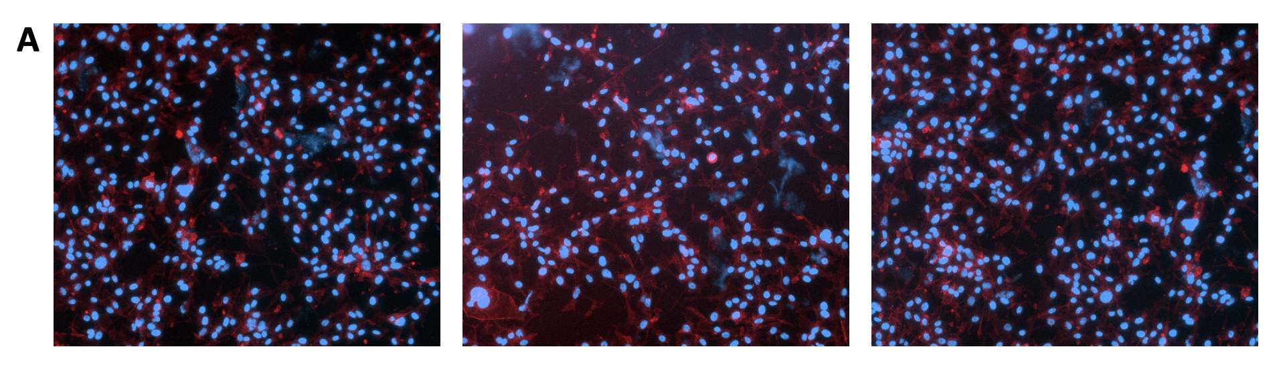

**Appendix 1:** Representative image of cells after siRNA knockdown in an adhesion assay. The cells were too confluent to accurately analyze cell morphology.

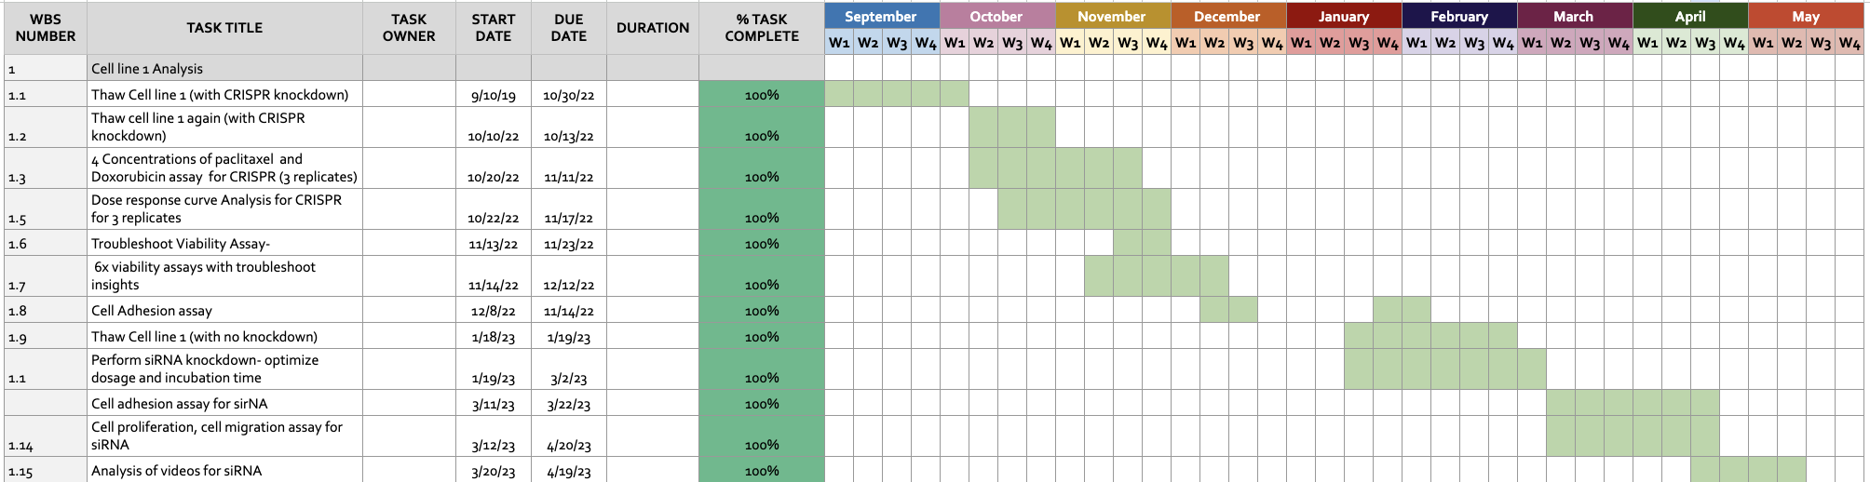

**Appendix 2:** The above gantt chart is our completed timeline for managing our project from September 2022 through May 2023. Overall, we did an excellent job of achieving both of our aims in the corresponding expected timeline.. Each completed task is shown in green.

**REFERENCES:**

[1. Ikeda, H. *et al.* The estrogen receptor influences microtubule-associated protein tau (MAPT) expression and the selective estrogen receptor inhibitor fulvestrant downregulates MAPT and increases the sensitivity to taxane in breast cancer cells. *Breast Cancer Res. BCR* **12**, R43 (2010).](https://www.zotero.org/google-docs/?zMHR8l)

[2. Wang, K. *et al.* Tau expression correlated with breast cancer sensitivity to taxanes-based neoadjuvant chemotherapy. *Tumour Biol. J. Int. Soc. Oncodevelopmental Biol. Med.* **34**, 33–38 (2013).](https://www.zotero.org/google-docs/?zMHR8l)

[3. Yavuz, B. B., Aktan, M. & Kanyilmaz, G. Prognostic Factors in Patients with Triple Negative Breast Cancer Undergoing Adjuvant Radiotherapy: A 10-Year Single Center Experience: Triple negative breast cancer. *Arch. Breast Cancer* 377–385 (2022) doi:10.32768/abc.202293377-385.](https://www.zotero.org/google-docs/?zMHR8l)

[4. Yao, Y., Li, J., Hu, H., Xu, T. & Chen, Y. Ultrasound-guided serratus plane block enhances pain relief and quality of recovery after breast cancer surgery: A randomised controlled trial. *Eur. J. Anaesthesiol.* **36**, 436–441 (2019).](https://www.zotero.org/google-docs/?zMHR8l)

[5. Early Breast Cancer Trialists’ Collaborative Group (EBCTCG). Anthracycline-containing and taxane-containing chemotherapy for early-stage operable breast cancer: a patient-level meta-analysis of 100 000 women from 86 randomised trials - The Lancet. https://www.thelancet.com/journals/lancet/article/PIIS0140-6736(23)00285-4/fulltext (2023).](https://www.zotero.org/google-docs/?zMHR8l)

[6. Le, T. T. The Neuronal Identity of Triple Negative Breast Cancer - ProQuest. *Tufts University ProQuest Dissertations Publishing* https://www.proquest.com/openview/0285152ccf51e9a972961af568734406/1.pdf?pq-origsite=gscholar&cbl=18750&diss=y.](https://www.zotero.org/google-docs/?zMHR8l)

[7. Vicente, J. J. & Wordeman, L. The quantification and regulation of microtubule dynamics in the mitotic spindle. *Curr. Opin. Cell Biol.* **60**, 36–43 (2019).](https://www.zotero.org/google-docs/?zMHR8l)

[8. Le, T. T. *et al.* Sensory nerves enhance triple-negative breast cancer invasion and metastasis via the axon guidance molecule PlexinB3. *NPJ Breast Cancer* **8**, 116 (2022).](https://www.zotero.org/google-docs/?zMHR8l)

[9. Lebok, P. *et al.* High levels of class III β-tubulin expression are associated with aggressive tumor features in breast cancer. *Oncol. Lett.* **11**, 1987–1994 (2016).](https://www.zotero.org/google-docs/?zMHR8l)

[10. O’Reilly, D., Sendi, M. A. & Kelly, C. M. Overview of recent advances in metastatic triple negative breast cancer. *World J. Clin. Oncol.* **12**, 164–182 (2021).](https://www.zotero.org/google-docs/?zMHR8l)

[11. Harbeck, N. *et al.* Breast cancer. *Nat. Rev. Dis. Primer* **5**, 1–31 (2019).](https://www.zotero.org/google-docs/?zMHR8l)

[12. Metastatic Breast Cancer - Symptoms, Diagnosis & More. https://www.breastcancer.org/types/metastatic.](https://www.zotero.org/google-docs/?zMHR8l)

[13. Characteristics of triple-negative breast cancer - PMC. https://www.ncbi.nlm.nih.gov/pmc/articles/PMC3018596/.](https://www.zotero.org/google-docs/?zMHR8l)

[14. Lehmann, B. D. *et al.* Identification of human triple-negative breast cancer subtypes and preclinical models for selection of targeted therapies. *J. Clin. Invest.* **121**, 2750–2767 (2011).](https://www.zotero.org/google-docs/?zMHR8l)

[15. Yang, D. *et al.* Axon-like protrusions promote small cell lung cancer migration and metastasis. *eLife* **8**, e50616 (2019).](https://www.zotero.org/google-docs/?zMHR8l)

[16. Panda, D., Miller, H. P. & Wilson, L. Rapid treadmilling of brain microtubules free of microtubule-associated proteins in vitro and its suppression by tau. *Proc. Natl. Acad. Sci. U. S. A.* **96**, 12459–12464 (1999).](https://www.zotero.org/google-docs/?zMHR8l)

[17. Feinstein, S. C. & Wilson, L. Inability of tau to properly regulate neuronal microtubule dynamics: a loss-of-function mechanism by which tau might mediate neuronal cell death. *Biochim. Biophys. Acta* **1739**, 268–279 (2005).](https://www.zotero.org/google-docs/?zMHR8l)

[18. Fan, Y. & Guo, Y. Knockdown of eIF3D inhibits breast cancer cell proliferation and invasion through suppressing the Wnt/β-catenin signaling pathway. *Int. J. Clin. Exp. Pathol.* **8**, 10420–10427 (2015).](https://www.zotero.org/google-docs/?zMHR8l)