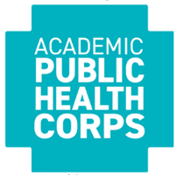
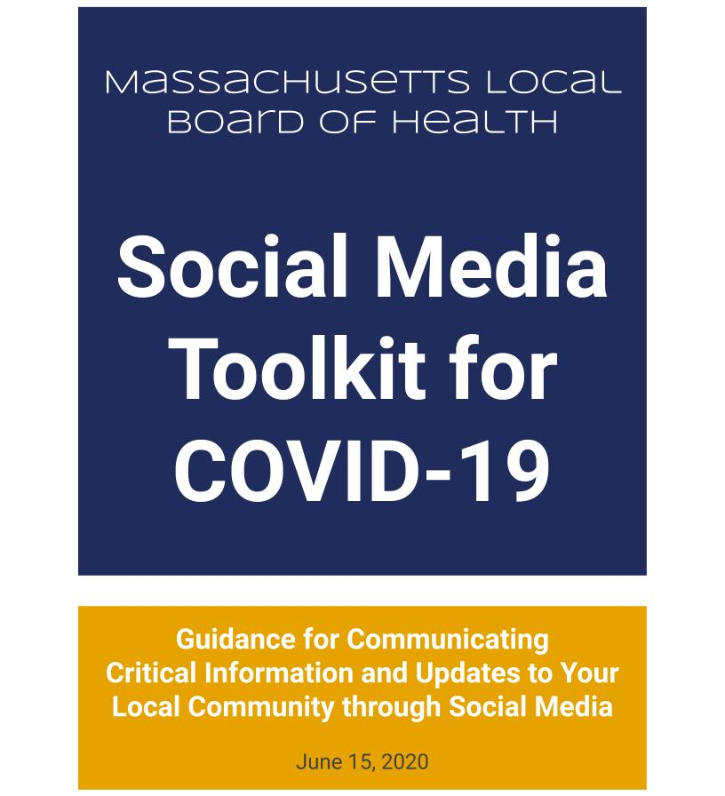
Updated November 20, 2021
Authors:

Lisa Gualtieri, PhD, ScM, Associate Professor
Department of Public Health and Community Medicine
Tufts University School of Medicine
:
Spurthi Bhatt, MD/MPH candidate, 2020
Tufts University School of Medicine

Ariella Shayani, MD/MPH candidate, 2020
Tufts University School of Medicine

Marina Komarovsky, MS, MPH Alumna, 2011
Department of Public Health and Community Medicine
Tufts University School of Medicine

Reviewers:

Margie Day MS, MHSc
Certificate Program in Digital Health Communication
Department of Public Health and Community Medicine
Tufts University School of Medicine

Alan Balsam PhD, MPH, Adjunct Associate Professor
Department of Public Health and Community Medicine
Tufts University School of Medicine
(previously Commissioner of Public Health in Brookline for over 20 years)

Risa Silverman, MPH, Director,
Office for Public Health Practice and Outreach
School of Public Health and Health Sciences
University of Massachusetts, Amherst

Jacqueline Dick, MS
Northern Essex Community College, Program Coordinator and faculty, Lawrence

Associations:

Massachusetts Department of Public Health
Academic Public Health Corps (APHC)

Feedback:

Please send any comments or feedback to Lisa Gualtieri, lisa.gualtieri@tufts.edu

Table of Contents

Introduction 4

Section 1: The Value of Social Media Use 4
Section 2: Selection of Social Media Platforms 4

Section 3: Adapting Messages for Multiple Platforms 5

Section 4: Best Practices for Message Creation 5

Section 5: Important Messages to Communicate During COVID-19 6

Section 6: How to Engage Student Volunteers in Social Media Communication 9

Section 7: Promoting Your Social Media Channels 9

Section 8: Maintaining and Evaluating Community Engagement 10

Section 9: Next Steps and Social Media Use Beyond COVID-19 11

Appendix A: Examples of Effective Posts in Massachusetts Towns 12

Appendix B: Social Media Cheat Sheet for Local Boards of Health 14

Introduction
This Social Media Toolkit for COVID-19 provides guidance for Local Boards of Health (LBOHs) in Massachusetts on communicating effectively about COVID-19 using social media to provide much needed local information, updates, and support to their communities. It is designed for:
- LBOHs in Massachusetts with populations of 60,000 or less
- Volunteers assisting LBOHs as part of the Academic Public Health Corps (APHC)
Using this toolkit, you will be able to:
- Select social media platforms
- Create messages based on
- Develop outreach strategies
- Leverage social media during COVID-19 and beyond
Section 1: The Value of Social Media Use
Today, people of all ages are turning to social media for both news and community support, and there is a widespread, unmet need for local communication about the pandemic. Social media is a valuable tool for LBOHs for communicating current, up-to-date information about COVID-19 with local communities.

“Plan ways to incorporate popular or topical social media platforms that can help you promote key messages and quickly update people with new information. Social media platforms also provide direct access to your target audiences, giving you opportunities to engage in real-time discussions for information gathering and evaluation purposes.” -- CDC Interim Guidance

The CDC suggests that organizations customize, localize, and redistribute CDC messaging on social media. The same can be done with messages from MDPH. In addition, social media presents a key opportunity for LBOHs to share locally relevant information with their communities. At a time when conflicting messages and misinformation are widespread, LBOHs are a trusted source of information during the rapidly changing situation.

Section 2: Selection of Social Media Platforms
In 2019 at least 72% of US adults used a social media platform, according to the Pew Research Center. Early research indicates that social media use has already been on the rise in response to the pandemic. Among US adults, 78.1% used Facebook, 49.5% used Instagram, and 34.9% used Twitter in March 2020, according to Statista. While YouTube is another popular platform, creating video content is labor-intensive. We recommend focusing social media efforts on Facebook, Twitter, and Instagram, which allow posts with text, images, and short videos.

The LBOH can leverage or open its own social media account(s) or create posts around COVID-19 for the municipality accounts. The best approach is one that allows you to get messages out quickly and maximize visibility. To reach a broad audience:
- Adapt posts across several platforms. (See Section 3)
- Cross-promote accounts across platforms and municipal departments to increase following. (See Section 7)
Section 3: Adapting Messages for Multiple Platforms
Facebook, Instagram, and Twitter have unique features. However, posts can be adapted for sharing across platforms. These platforms have several key characteristics in common:
- The city or LBOH can run an account, a page where you post text, image, or video updates.
- Community members can “follow” the account to subscribe to your updates. These updates will appear in their feeds and/or notifications.
- Community members can interact with your posts by “liking” and “commenting” on your posts, as well as sharing your posts with their networks.
- The city or LBOH can follow the pages of other users (such as the CDC, MDPH, and other local health departments) and re-post their content with custom messages for your community.
Facebook is the world’s largest social network, commonly used by municipalities in Massachusetts. There is no word count limit for posts, and long videos are allowed.

Twitter is a platform that enables the exchange of short status messages with a 280-character limit, which may be accompanied by an image or short video. Twitter is also commonly used by city governments in Massachusetts.

Instagram is a photo and video sharing app that allows users to share visual media with associated text. There is not a feature to share text-only posts. Posts can be synced with Facebook, so that Instagram posts appear automatically on your Facebook page.

These additional features are particularly useful for COVID-19 communication:
- Facebook and Twitter offer “backgrounds” and “pinned posts,” which allow you to share key information that stays at the top of your page, so that community members see it first.
- Facebook and Instagram both have a “story” feature for sharing multimedia content for only 24 hours. Stories are popular among users, so re-sharing your posts in stories can increase reach. Stories can also be used to create interactive polls that allow you to hear from the community.

Appendix B shows a table of features by social media platform.

Section 4: Best Practices for Message Creation
a. Best Practice Guidelines

When you create social media posts, follow these general best practice guidelines:
- Always give simple, credible, accurate, consistent, and timely information.
- Share the same content across platforms to maximize reach.
- Distribute audience-specific health messages and materials. When possible, customize information to make it specific to your local community.
- Use local images to make messages attention-grabbing and compelling. We suggest compiling a repository of images that you have consent to use and drawing from these media for posts.
- Tailor messages to the demographics and health literacy level of your community.
- Create messages that address the needs of diverse demographics and age groups.
- Provide messages in multiple languages, according to the demographics of your community. The text content of a post will be translated by social media platforms according to the user’s browser settings, but multimedia content will not.
- Post consistently. LBOHs and municipalities with effective COVID-19 communication strategies share 3-5 social media posts per day.

b. What Not to Do

While some tactics are highly effective, others can be counterproductive. These are practices to avoid:
- Does not use fear tactics in your messaging. Instead, focus on supportive and educational messages.
- Do not exclusively re-post external content. When you share external materials from trusted, personalize the post text to your community.
- Do not assign social media managers who cannot dedicate time every day. In order for social media to be effective, fresh messages need to be created and leveraged on a daily basis.
- Do not neglect to leverage cross-promotion. Post links to your social media accounts across platforms and on the municipality website, and coordinate to have them promoted on the municipal social media pages.
- Do not work in isolation from community organizations. Partnering with local organizations is one of the best ways to get messages out to your community, and partners can mutually support each other by re-posting each other’s relevant content.
Section 5: Important Messages to Communicate During COVID-19
An effective COVID-19 social media communication strategy can be constructed using the following types of posts and messages.
Appendix A shows examples of effective social media use by Massachusetts LBOHs and towns.
Appendix B is a Social Media Cheat Sheet that accompanies this section.
a. Share Local Updates
Sharing local COVID-19 updates should be an essential component of every LBOH’s social media presence. With the amount of uncertainty surrounding COVID-19, people are desperate for accurate, recent information that is pertinent to their daily lives and community. When polled informally about what kinds of information they want from their LBOHs, residents have expressed wanting local data and information on what specific resources are available in their city or town.

Public Advisories, Ordinances, and Restrictions
Due to COVID-19 restrictions, people may not be able to gather general information about their community through the means that they previously relied on (like word of mouth or radio during a commute to work). Protect the general public by educating the community about evolving restrictions (such as curfews, mask-wearing guidelines, and stay-at-home restrictions) and what they mean with regard to local businesses and institutions. Up-to-date state level information can be found here: https://www.mass.gov/info-details/covid-19-information-for-local-boards-of-health
Local Case Counts
Use Facebook or Twitter to give residents daily local updates about the number of suspected cases, the number of positive cases, the number of people hospitalized, the number of deaths related to COVID-19, and the number of people who have recovered.

Municipal Services
Update residents on municipal services such as trash and recycling collection, public works, and library services, as well as public event cancellations and rescheduling.

b. Local Resources

Tell People Where They Can Get Support
Provide information on local support for specific populations, like childcare for essential workers, pet care, resources for elderly community members, support for small businesses, and mental health resources.

Assistance with Basics
Tell people who are in need where they can get assistance with food and shelter.

Product Availability and What’s Open
Use either Twitter posts or create a pinned announcement on Facebook that tells residents what stores and restaurants are open or closed. Create a discussion thread on Facebook where residents can share what resources are available at different local grocery stores (ex: Shaw’s has hand sanitizer, Market Basket has restocked their flour). This allows for a “living document” for people to plan their grocery trips better and also find a sense of community when they are not able to communicate in person.

c. Public Health Guidelines

Share Current Facts about COVID-19
What we know about the virus is always evolving. Share up-to-date information on COVID-19 sourced from CDC and MDPH, accompanied by text customized for your community.

Provide Guidelines for Prevention
Guidelines about social distancing and hygiene practices are flooding public news sources. Within this climate, not only is it hard to determine what is credible information, but also what information applies to whom. Communities need timely, accurate information about local recommendations and policies for personal protective measures, such as masks and glove-wearing. The CDC provides general guidelines about how to isolate, sanitize, and prevent the spread of germs among your residents. Modify these materials or develop customized content for your local community to provide concrete guidelines based on your county’s current policies and regulations.

Instruct Individuals about What to Do If They Feel Sick
As many health clinics and hospitals are overwhelmed by patients, education is critical to ensuring that the use of resources is effective. Sharing medical guidance about COVID-19 on social media can help triage individuals towards the proper level of care, and this can ultimately reduce the burden on the health system and protect the community. Use social media to provide advice to residents about how to monitor and manage symptoms that may resemble COVID-19.

d. Community Strength
Show Community Supporting Each Other
Use Facebook, Twitter, and/or Instagram to share photos of how the community is coming together to help one another. For example, images of groceries being delivered to healthcare workers, church groups offering free childcare for essential workers, or homemade mask distribution.

Send Messages of Encouragement
Sending messages of encouragement to your local residents can foster a sense of community and solidarity. In this challenging time, many individuals are experiencing feelings of isolation, loneliness, and other emotional challenges. The use of social media is to be a tool to show care and concern for individuals in your community. Spreading messages of hope, such as individual stories of recovery, may help to raise morale. Social media is also an effective means of promoting services that are available for mental health.

Let People Know How They Can Help
Individuals who are healthy and have the capacity to help others during the COVID-19 outbreak may not know where to start. Use social media to share information about local service programs. Connect with local organizations to find out about service needs and opportunities to post these on your social media platforms. Your LBOH can also share general tips about how to help others during the pandemic.

e. External Content
Links to the Municipal Website and LBOH Web Page
Link to news and resources on the municipal website. Be sure to include explanatory text in the post itself, instead of just a link.
Share Relevant Content from Other Local Sources
Re-post relevant content from other municipal departments, municipal officials with a social media presence, and local organizations.
Cross-Promote Other Key Information Channels
Cross-promote your social media channels across platforms. Communicate ways to stay tuned for reliable information from your LBOH or municipality, like local text alerts or town meetings.
(See Section 7 for more on community outreach and cross-promotion.)
f. Engage Community Members in Dialogue

You can encourage engagement by creating Q&A posts that either ask a question or allow community members to post their questions in the comments. Monitoring comments and messages to reply in a timely manner is key. You can also use the “poll” function in Twitter posts or stories on Facebook and Instagram stories to assess community perspectives. You can also use social media posts to promote interactive events like virtual community meetings and conduct more detailed surveys on community needs.
g. Draw on Existing Communication Materials

These are ready-made communication materials on COVID-19 that you can share in addition to the original messages that you create for your local community:
- The COVID-19 Health Literacy Project allows you to download COVID-19 fact sheets in more than 30 languages.
- The CDC’s Coronavirus Communication Resources page has a video library, a photo library, materials in different languages, and a toolkit with specially designed social media images for COVID-19 communication.
- MDPH has a Communicating with the Public section on its COVID-19 Information for Local Boards of Health page with COVID-19 videos, images, and fact sheets.
- The APHA has additional videos and materials in multiple languages.
When you post content from other sources on social media, add a personal message to your post text to connect with your community and add relevance to what you’re sharing.

Section 6: How to Engage Student Volunteers in Social Media Communication

Social media curation is a timely responsibility. To expand the reach of your social media campaign and maintain user engagement over time, additional support will be beneficial. Academic Public Health Corps (APHC) volunteers are students and alumni who can support LBOH social media efforts by:
- Starting social media accounts for your LBOH.
- Serving as social media managers of new or existing accounts. For this arrangement, adequate supervision is essential. Students should report directly to a supervisor at your health department who is responsible for reviewing and approving all posts before they go up.
- Writing posts and submitting them to be posted by an LBOH staff member who manages them.
- Creating visuals for posts by customizing existing materials from other credible sources or developing new content. The Central Communications team of the Academic Public Health Corps (APHC) is also available to develop visual materials upon request.
- Networking with community partners to implement communication strategies for reaching high-risk and vulnerable people in your community (for example, people who are homeless, at-risk, or have limited English-language skills).
- Monitoring relevant social media accounts (such as the CDC and MDPH, other local government departments, and local community organizations) to identify opportunities for cross-promotion and re-posting relevant content with locally tailored messages.

Section 7: Promoting Your Social Media Channels

a. Promotion Strategies

Your LBOH’s social media communication can only be effective if people know about it and follow your social media channels. Developing strategies to promote your LBOH’s social media campaign is a critical step to reaching your audience. You can do this by:
- Promoting your social media channels across platforms, if your LBOH uses multiple platforms.
- Promoting LBOH social media accounts on existing municipal social media pages.
- Getting the word out through resident Facebook groups. Some cities and towns have active groups, where residents share local updates amongst themselves.
- Featuring links to social media accounts on the LBOH web page.
- Advertising social media accounts on local platforms, such as news channels and radio stations.
- Utilizing both online and print materials to spread awareness about social media accounts. Include information about how the LBOH plans to use social media to disseminate information during COVID-19.

b. Community Outreach

Outreach and relationship building with local groups can be one of the most effective ways to get the word out. There is a lot of opportunity in reciprocity -- ask local groups to help promote your social media channels and content on their accounts, and offer to promote their relevant messages on yours. Consider reaching out to:
- The town meeting listserv.
- Other municipal entities like the Fiscal Advisory Committee, the Park and Recreation Commission, the Planning Board, and/or the Council of Aging.
- The Fire Department, Police Department, and Public Works teams, which already have a strong social media presence in many towns.
- Members of the community emergency response team like community-based volunteers and the Medical Reserve Corps.
- Community partners such as churches, schools, and community organizations like the Elks, Lions, or Rotary Clubs.

Section 8: Maintaining and Evaluating Community Engagement

a. How to Maintain Engagement

Posting consistently is one of the main ways to maintain community engagement. LBOHs in Massachusetts that currently use social media post about 3-5 messages per day. Be proactive about updating the population with diverse content, but ensure post quality. Redundant messaging can be helpful for emphasizing important updates or recommendations. However, overutilization of social media platforms can overwhelm users and detract attention from critical information.

Two-way communication is an additional strategy for engaging the community. This can also help to combat the isolation that some residents are experiencing due to COVID-19.

Discussion threads on Facebook are also an effective means for community members to share information on local resources, so encourage those conversations. When community members comment on your posts, reply to engage in dialogue and answer questions.

You can also use social media platforms to publicize other platforms for two-way communication, such as weekly town hall meetings or live Twitter chats where people can ask questions.

b. How to Evaluate Engagement

Evaluate engagement on your social media posts to assess whether the dissemination of information is effective and understand what is working best. Given the rapidly changing nature of social media and the healthcare situation, keep in mind that the curation and evaluation of social media accounts is an iterative and continuous process.

Each social media platform has different mechanisms for users to engage with content. Tracking quantitative data on engagement allows you to understand the extent of your LBOH’s reach on social media. In the short term, the number of followers of your LBOH’s account is a key metric for how many people have heard about your social media presence. Ideally this number should include your community. In the long-term, engagement with content, such as the number of likes and comments on posts, will be more critical. Based on social media platform algorithms, posts with greater engagement should reach a wider audience. This table displays metrics for tracking engagement across platforms:

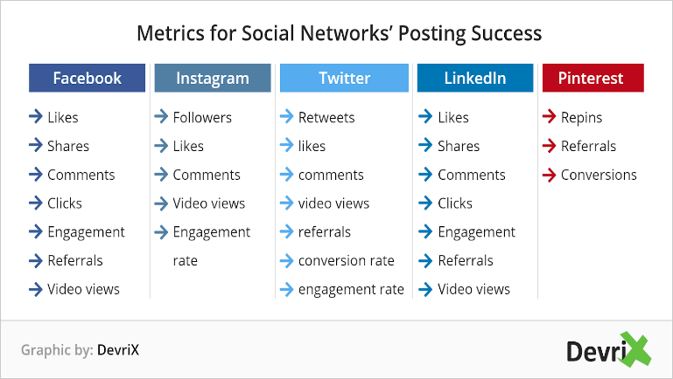

Qualitative data gathering can include surveys with open-ended questions to request feedback on your messaging and evaluate community information needs. Seek additional feedback from other professionals in public health and social media.

Section 9: Next Steps and Social Media Use Beyond COVID-19

Establishing a social media presence at this time will be beneficial for your LBOH beyond the period of the COVID-19 pandemic. Social media will continue to play a central role in communications, and these guidelines can enable your LBOH to build a robust network for disseminating information in the years to come. COVID-19 is transforming social interaction and compelling society to adopt new practices that are challenging and unfamiliar. Your LBOH can leverage the current situation as an opportunity to tap into modern and innovative methods of connecting with your community, starting with social media.
Appendix A: Examples of Effective Posts in Massachusetts Towns

These Massachusetts LBOHs and communities have many good examples of COVID-19 messaging on social media:

→ Arlington https://www.facebook.com/Arlington-Health-Human-Services-1503961206546404/
→ Boston https://www.facebook.com/HealthyBoston/ https://twitter.com/HealthyBoston
→ Framingham (city government) https://www.facebook.com/CityofFramingham/ https://twitter.com/Framingham_MA https://www.instagram.com/officialframinghamma/
→ Hudson https://www.facebook.com/HudsonBOH
→ Lowell (city government) https://www.facebook.com/cityoflowell https://twitter.com/cityoflowellma
→ Peabody https://www.facebook.com/PeabodyHealthDepartment
→ Provincetown https://www.facebook.com/PtownHD/
→ Somerville https://www.facebook.com/HealthySomerville
→ Springfield (city government) https://www.facebook.com/pg/CityofSpringfieldMA/ https://twitter.com/SpfldMACityHall

The following are examples and explanations of effective posts:

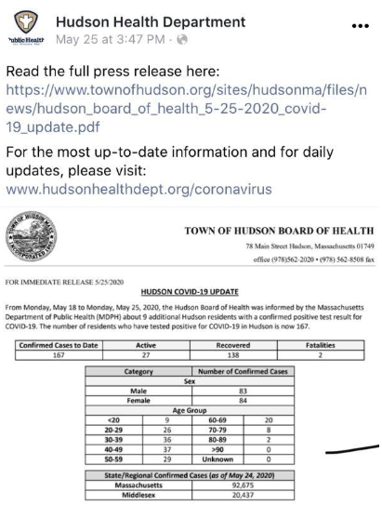 | 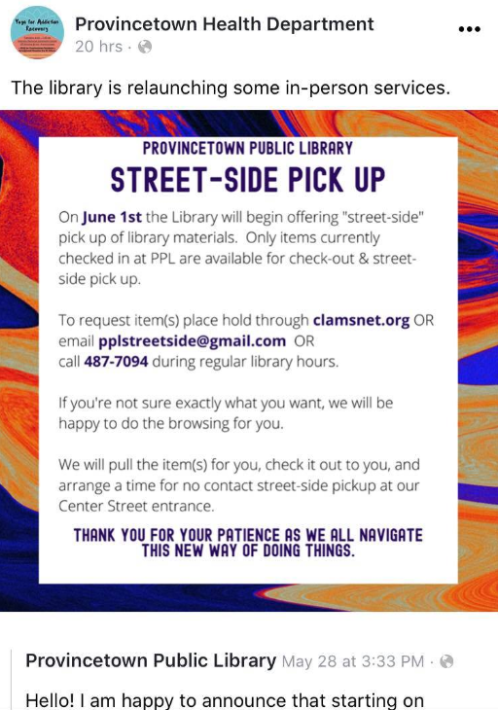
Hudson shares case updates and directs people to the town/local government website. | Provincetown is providing information about local library services by sharing a post from the library account.
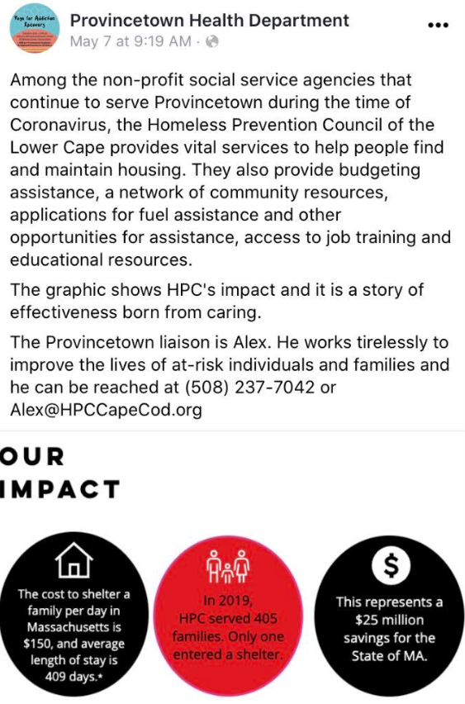 | 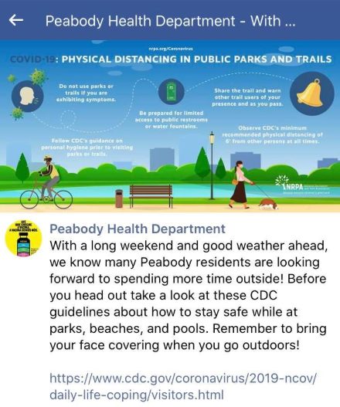
Provincetown uses an infographic visual to highlight a local organization while telling people in need where they can get help. | Peabody shares an image from the National Recreation and Park Association and CDC, but with a personalized message for its community in the text of the post.
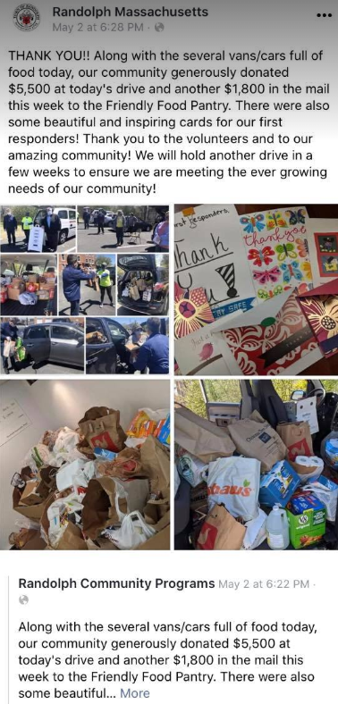 | 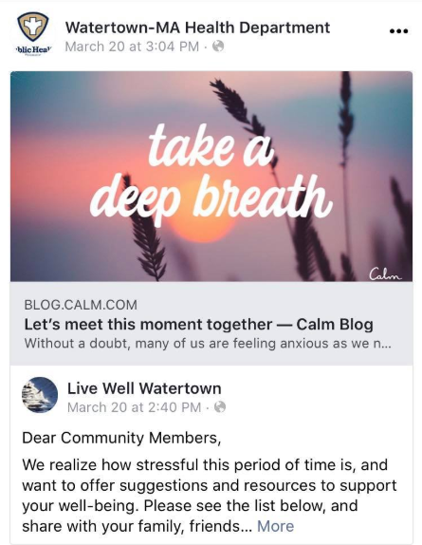
Randolph shows how the community is coming together with photos of food pantry donations. | Watertown shares a blog post from a local organization with resources for wellbeing.

Appendix B: Social Media Cheat Sheet for Local Boards of Health
