BME SENIOR CAPSTONE PROJECT

PROJECT TITLE: Characterization of Brain Metabolic State under Injury using Two-Photon Microscopy

TEAM MEMBERS: Arrietty Bui, Kerry Chen, Varshini Ramanathan, Ash Sze

PRINCIPAL INVESTIGATOR: Irene Georgakoudi

ABSTRACT: Traumatic brain injury (TBI) is a leading cause of death and disability worldwide. However, TBI remains difficult to identify and treat in the clinic due to a lack of known biomarkers that can be used as diagnostic and therapeutic targets. To this end, 3D-engineered brain tissues seeded with human-induced neuronal stem cells (hINSCs) are assessed using multimodal label-free two-photon excited fluorescence (TPEF). TPEF generates endogenous fluorescence from several metabolic co-enzymes and stress-associated cellular products, which are measured by spectral intensity and fluorescence lifetime imaging. We aim to correlate optical measurements with biochemical and metabolomic assays in the context of two major aspects of TBI, glutamate excitotoxicity and oxidative stress. This work will ultimately be used to develop a metabolic model that will use optical measurements to identify biomarkers that are implicated in TBI-associated pathways.

KEYWORDS: Traumatic brain injury, two-photon imaging, metabolic pathways, mass spectrometry, 3D-engineered brain tissue, metabolic computational model

ELEMENTS OF ENGINEERING DESIGN:
The design of this project is the characterization of optical readouts by mapping them to specific metabolic pathways affected by injury. This can be achieved with a 3-compartments system: cell culture, imaging, and computational model - each with a specific objective. A specific injury will be induced in monoculture and 3D co-culture and its impact will be examined via microscopy, metabolic assays, and mass spectrometry. Computational models will be created to identify affected metabolic pathways from biochemical data. These objectives can be tested and evaluated. Once a comprehensive cell culture protocol has been developed, we will consider our cultures as viable if they remain stable at passage 3 and are healthy as observed in baseline imaging readouts when compared to imaging readouts from validated cultures in the lab. Mass spectrometry and optical image acquisition will follow the validated protocols from the Lee lab and the Georgakoudi lab. Successful injury induction is indicated by the convergence of trends of optical readouts and mass spectral data. Additionally, results from metabolic assays should agree with data from mass spectrometry given both methods measure metabolomics concentrations.
Multiple engineering principles are applied in this project. First being two-photon microscopy (TPEF) - an imaging modality for injury assessment. Compared to standard fluorescence microscopy, TPEF utilizes a pulsed, non-linear excitation process where 2 photons are used to excite the fluorophore. By lowering the amount of energy needed per photon, TPEF uses a longer wavelength, which generates less tissue damage and penetrates deeper. Sufficient laser intensity for this excitation is only achievable in the focal plane, which restricts the volume of the signal generation and removes out-of-focus signals. These characteristics make TPEF depth-resolved, facilitating the imaging of thick and highly scattering specimens like engineered brain tissue (EBT) without the need for slicing or biopsy. For this project, endogenous fluorophores such as FAD and NADH will be used so the imaging process is label-free where samples can be live imaged.
There are 2 realistic constraints: ethical concerns and translatability of the computational model. There are ethical concerns about incurring TBI in human brains or postmortem samples. As a solution, we will use 3D-engineered brain tissues which show pathophysiology observed in an in-vivo model [15]. While there are ethical concerns due to the use of human cells, this is necessary to accurately determine if our results are clinically translatable. Additionally, we plan to use a model of brain metabolism at baseline derived from literature because there is no complete TBI metabolic model. Metabolic model source code is difficult to obtain, and models may be designed based on assumptions and conditions specific to the institution which published that model. It may be a non-trivial task to adapt existing models to assist our project. A solution would be to write our own model based on the key differential equations governing the metabolic processes of interest to us (central metabolism, glutamate-glutamine conversion, and oxidative stress). This would be outside the scope of our capstone but would be doable by masters students.

DESIGN FLOWCHART
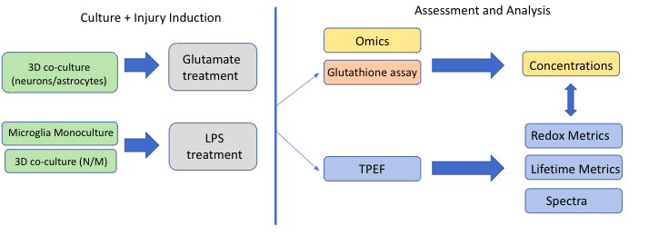

Figure 1. Schematic overview of experimental plan
DESIGN ELEMENT TABLE
Design Elements | Success Measures
LPS - microglia monoculture | Study 1: Optimize injury conditions  Optical readouts indicate decrease in free NADH and glycolysis shift  - Phasor shifts to bottom right  - Redox ratio increases  - Spectral constituents have an increased NADH concentration
Glutamate injury - neuronal monoculture | Study 1: Optimize injury conditions  Verify that, using statistical analysis, injury occurs  - Significant differences between short and long exposure, concentration differences  - Optical readouts are dose and exposure dependent on glutamate exposure  Study 2: Induce and assess injury  - Redox results trend towards oxidative metabolism  - Beta results trend towards increased mitochondrial fragmentation  - Phasor metrics are significantly different between treatment and control  - Glutathione assay indicates that glutathione is down-regulated in glutamate excitotoxicity
Computational Model  Differential Equations  MATLAB Functions | - Investigate the outline and syntax required to create differential equations and their associated graphs  - Establish a set of differential equations to model the concentration of upstream, TBI-related molecules using results from mass spec  - Create functions using the differential equations on MATLAB to simulate specific concentrations at specific times  - Analyze the simulated upstream pattern for TBI indicators  - Verify the output of our function with experimental results
Table 1. Table describing design elements and success measures to validate and verify them.
INTRODUCTION AND BACKGROUND
Traumatic brain injury is the leading cause of death among individuals under the age of 45 in the US, with an incidence of 1.5 million each year. Beyond fatality, TBI results in severe long-term disabilities, both mentally and physically. [3] Traumatic brain injury can be divided into 2 phases: a primary mechanical impact on the brain followed by secondary biochemical and inflammatory cascades of different types of brain cells. The two major biochemical cascades that we plan to characterize are oxidative stress and glutamate excitotoxicity [9]. Following the injury, an influx of excess calcium ions into the mitochondria triggers the production of reactive oxygen species (ROS) and free radicals. These molecules depolarize the mitochondrial inner membrane, disrupting the electron transport chain and inhibiting the oxidative phosphorylation process. This deprives the nerve cells of ATP and facilitates apoptosis. In junction with oxidative stress, glutamate and aspartate neurotransmitters accumulate at the synapses as the impaired glutamate transporters fail to recycle excess glutamate from injured neurons. These molecules bind to NMDA and AMPA receptors that promote calcium, potassium, and sodium uptake. Cell depolarization triggers downstream cascades that prolong the effect of oxidative stress. From these observations, it can be said that the biochemical pathways involved in secondary injury are highly complex. Despite ongoing research, the understanding of its mechanisms and consequences remains incomplete. Secondary injury can develop to a greater severity over a long period of time. Patients with mild TBI can suffer neurological problems and long-term disability months after the injury. For this reason, patients with mild TBI have no initial symptoms and are often undiagnosed, preventing early treatment. The long-term objective is to develop a technique that can diagnose TBI on a molecular level, which is the biochemical cascade of secondary injury.
To examine the long-term cellular effects of mild TBI, the 3D-engineered brain tissues (EBT) of neurons and glial cells (astrocytes and microglia) are injured using the controlled cortical impactor (CCI), mimicking a mild blast TBI. The EBT model, while a simplified human brain, still undergoes most of the complex secondary response following the impact and, thus, can be used to develop diagnostic and treatment frameworks for TBI. However, with CCI, it is challenging to completely characterize this model due to the evolving complex cellular environment and unpredictable changes arising from the interactions between multiple cell types. Thus, we propose to examine TBI via its constituents by introducing a specific secondary injury to 2D brain cell cultures and studying the cellular metabolic interactions and environments in a controlled manner.
Two-photon excited fluorescence (TPEF) can then be used to assess functional and morphological changes of the injured brain cells by obtaining the metrics of cellular metabolic function. TPEF detects autofluorescent signals from several key biomolecules: FAD, NADH, LipDH, and lipofuscin. The former three are metabolic coenzymes implicated in most metabolic perturbations, and lipofuscin is a complex of fluorescent proteins and lipids that accumulates under cellular stress. These endogenous fluorophores can be analyzed using computational techniques that reveal concentration-based and metabolic shifts in the samples: redox ratio, mitochondrial clustering, phasor analysis, and spectral deconvolution.
The redox ratio is the relative ratio of glycolytic to oxidative metabolism. It is computed by obtaining a “NADH image” (755ex/460em) and a “FAD image” (860ex/525em) and dividing them according to the formula (NADH/(NADH+FAD)). Mitochondrial clustering (beta value) is the extent of mitochondrial fractionation, which occurs in response to ROS accumulation. It is computed by segmenting and cloning mitochondrial regions in an image. Then, the power spectral density of the cloned image is computed, which determines the image frequency. Highly fractionated mitochondria will have a high frequency, and vice versa. Phasor analysis is a technique to obtain fit-free visualizations of FLIM images with overlapping concentrations of lifetimes over different pixels.
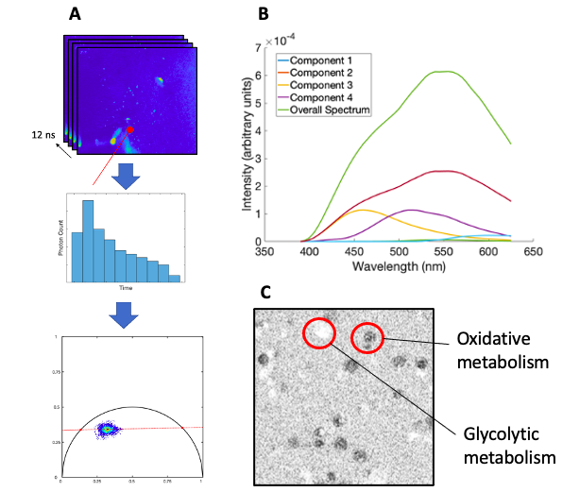
In brief, time-series fluorescence lifetime data is sine and cosine transformed, giving two coordinates g and s that correspond to the lifetime, tau, of the fluorescent decay. Any one tau localizes on a circular plot (see Fig. 2). The localization of the (g, s) coordinate pair for any given pixel is determined by the linear combination of different tau values constituent in the pixel. A fluorophore’s binding environment affects its lifetime, but its concentration does not (i.e. higher concentrations of a single fluorophore simply cause a shift in the phasor distribution towards that fluorophore’s lifetime). As such, by assessing the overall phasor distribution, conditions such as shifts in relative concentrations of fluorophores and shifts in fluorophore binding configuration can be observed. Spectral constituents are obtained from the overall spectral intensity curve via non-negative matrix factorization. In this method of spectral deconvolution, the user specifies the number of total constituents and the model computes optimal concentrations of non-negative vectors and weights that minimize the error (residual) from the overall spectrum. In this way, concentrations and emission spectra of constituent fluorophores are determined.
Figure 2. Description of lifetime phasor analysis (a), redox ratio (b), and spectral deconvolution (c).

Compared to state-of-the-art diagnosis procedures like MRI, TPEF is more sensitive to cellular-level metabolic shifts. However, TPEF fails to detect non-fluorescence metabolites such as lactate. While it is known that an increase in redox ratio correlates to an increase in glycolytic metabolism and vice versa, conducting redox ratio studies in conjunction with exact biochemical measurements will allow us to quantify how shifts in oxidative and glycolytic metabolism affect our optical readouts. This lack of specificity is a critical roadblock for using TPEF to study injured brain metabolism. Consequently, the specific goal is to characterize and map optical metrics to specific altered metabolic pathways predicted by a metabolic computational model. The central hypothesis for identifying the pathways is to input relevant biochemical metrics from assays and mass spectrometry to the computational model.
Two-photon imaging is a commonly used neuroimaging technique for neurodegenerative diseases due to its high-depth penetration and potential for metabolic sensitivity. Additionally, biological assay and mass spectrometric methods are well-investigated in the context of TBI [1-4]. Therefore, the novelty of this project lies in correlating a non-invasive, label-free method (TPEF) with invasive methods for the eventual use of optical methods alone for a diagnostic TBI model. A non-invasive, label-free platform for TBI assessment does not exist to our knowledge. The novelty of this study depends on the identification of TBI biomarkers, not just the development of a two-photon platform to study TBI.
We propose to formulate a relationship between output molecular concentrations from assays and optical readouts via a computational model. We hypothesize that, under different perturbed or injured conditions, the trend in optical readouts and molecular concentration will be different since different metabolic mechanisms are involved. Therefore, we can say that a specific trend in optical readouts will be characteristic of a set of output concentrations and from the computational mode, specific altered metabolic pathways. This will allow us to characterize the optical readouts for a specific injury condition.
This work fits within research performed by Ph.D. candidate Yang Zhang and postdoctoral scholar Maria Savvidou in the ODDET Lab. They have acquired multimodal (spectral, fluorescence lifetime, and intensity) two-photon images of the EBT model under injury and control conditions. Our work focuses on the specific characterization of aspects of TBI in a controlled culture and injury setting to better understand correlation between cellular shifts and optical readouts in the EBT data.

SPECIFIC AIMS, METHODS, AND RESULTS
Specific Aim 1 (SA1): Assessment of controlled secondary injury in monoculture
Injury to the 3D engineered brain tissue is induced in a non-specific manner via a stereotaxic impactor. To study a targeted TBI metabolic cascade (secondary injury) such as glutamate excitotoxicity, specific metabolic perturbations must be introduced and changes to relevant metabolic pathways can be detected. Since this study has not been done previously, it’s important that we perform a preliminary study on the monoculture to optimize treatment concentrations and refine detection methods.
Study 1: Induce secondary injuries to monoculture of microglia
Excess lipopolysaccharide (LPS) can be added to the microglia monoculture to trigger oxidative stress. LPS interacts with transmembrane signaling receptor toll-like receptor 4 which is expressed primarily on microglia. Our postdoc, Maria, has determined an optimal exposure time and concentration (1 ug/mL at 100 uL) which successfully induces LPS uptake in microglia. We will use 3 well replicates for each concentration at each time point, and one control set. To assess the cultures, we will use multimodal TPEF (see Data Acquisition) at 12 and 24 hours. At the last time point, mass spectrometry will be performed on the injured condition and the control condition.
The success measure is to validate that the optical readouts trend consistently toward glycolysis, as it is well-known that oxidative stress causes a shift to glycolytic metabolism. The phasor distribution should move to the bottom right to indicate increased free NADH, the redox ratio should increase, and spectral constituents should have an increased NADH concentration; all validations are based on previous ODDET lab work.
Data acquisition and analysis: The effect of the induced perturbations will be examined via TPEF. We will perform multimodal TPEF acquisition according to standard imaging protocols in the Georgakoudi lab. Redox ratio, mitochondrial clustering, lifetime phasor distributions, and spectral constituents are obtained by custom-written MATLAB code.
Potential Pitfalls and Alternatives:
It is possible that we will encounter difficulties inducing sufficient glutamate uptake or dealing with unprecedented reactions to the addition and removal of exogenous glutamate. Alternatively, a previous study has shown that 200 μM of DL-TBOA is sufficient to inhibit the NMDA glutamate receptor and, thus, induce glutamate excitotoxicity without extraneous glutamate [14].

Specific Aim 2 (SA2): Assessment of glutamate injury in neuronal monoculture.
Study 1: Optimize culture and injury (LPS and glutamate) conditions for 3D NA and NM
Cell culture: Due to death of available cells and 3D scaffolds due to contamination, we are expanding a neuronal monoculture from an aliquot from the Kaplan lab. We will assess that cell confluency is ~90% in at least 2 dishes (1 backup and 1 to use for the experiment) before proceeding with the injury.
Glutamate: We will test glutamate concentration at a short exposure (250 and 500 uM for 30 minutes) as well as a long exposure (10 and 50 uM for 24 hrs), as per papers summarized in the Appendix. We will replace the cell media with a magnesium-free minimal medium for one day prior to injury because magnesium can occupy AMPA receptors and prevent glutamate activation. After glutamate exposure, we will rinse scaffolds with minimal medium and replace with the normal neurobasal medium. We will image three regions on three wells for each experimental condition, as well as 1 region on 2 vehicle wells (media change only) and 1 non-treated well.
For a success measure, we will assess oxidative stress as successful if we observe an increased oxidized-reduced glutathione ratio, as determined through the glutathione redox assay, as glutathione’s antioxidant activity will be induced by the LPS activation.
Study 2: Induce glutamate injury and assess using imaging, mass spectrometry, and glutathione assay.
We will use our optimized conditions from Study 1 and induce glutamate excitotoxicity at one concentration and one exposure time with the media protocol described above. We will conduct a glutathione assay conducted at 12 and 24 hours and mass spectrometry conducted at 24 hours (performed by the Lee Lab). We will image and analyze images as described in SA1 for each injury condition.
We will assess glutamate uptake via a glutathione assay (Sigma Aldrich), as we expect glutathione to be down-regulated under glutamate excitotoxicity. We will assess the effectiveness of the mass spectrometry protocol by observing significantly different peak heights in glutamate and glutamine at 0h and 24h (Student’s T-Test).

Data acquisition:
Imaging: As in SA 1.
Mass Spectrometry: Relevant metabolites (based on previous research) – glutamate, glutamine, creatinine, and decanoic acid – will be tagged so that their concentration changes can be detected with mass spectrometry [13]. The goal of using mass spectrometry in both studies is to identify metabolites that are heavily upregulated or downregulated after injury induction and verify that the detection method is suitable. To achieve this, we will conduct mass spectrometry at the start and end time points.
Glutathione Assay: The assay will be performed according to the Sigma Aldrich protocol: after all imaging, the oxidized and reduced glutathione probes will be added to the wells and after incubation, levels can be measured via fluorescent imaging on a confocal or widefield microscope.
Data Analysis
Imaging: As in SA 1.
Glutathione Assay: Glutathione oxidation:reduction ratio as well as net glutathione production can be measured directly from the fluorescent assay.
Mass Spectrometry: ANOVA with a post-hoc Student’s t-test will be used to determine treatment concentration, for each study, that results in significant concentration change of desired metabolites.
Potential Pitfalls and Alternatives:
If no peaks are significantly different between baseline and injured mass spectrometry results, we will consider tagging different metabolites. We will have verified the LPS uptake by comparison with the previous benchmark, so we should not have to consider the lack of LPS uptake as a reason for failed results. However, we can perform Nile Blue staining of our scaffolds, which localizes to lysosomes and will stain the lipofuscin produced by oxidative stress, in order to ascertain that successful LPS uptake.

Specific Aim 3 (SA3): Develop a computational metabolic model that predicts injury pathway activation based on biochemical readouts.
Study 1: Develop a basic computational metabolic model for TBI cultures
We will obtain relevant brain metabolism computational models from the literature (neuron/astrocyte/microglia metabolism, oxidative stress models, and injury models) and modify them by adjusting concentration conditions based on our mass spectrometry results from SA 1 and 2. Molecules involved in the model but not present in our spectrometric results will be treated as assumed constants based on literature values. The completed model will include central metabolism, detoxification of reactive oxygen species, and the glutamate-glutamine cycle. It will be able to predict the relative level of pathway activation (ex. glycolytic vs. oxidative metabolism) based on the input concentrations of downstream metabolites obtained from mass spectrometry. We will validate the accuracy of our metabolic model by performing mass spectrometry on baseline cultures and assessing the similarity of our predicted pathway results with results obtained from the metabolic models from which our model was derived. This is to ensure that in integrating multiple models, we preserved the integrity of each individual model.
Study 2: Use the metabolic model to predict injury pathway activation
From SA 1 and 2, we will have imaging data from secondary injury at multiple time points and corresponding mass spectrometry data from the final time point. We can use the metabolite concentrations and the metabolic model to predict levels of pathway activation under injury conditions, and then correlate those pathway activations with the optical readouts from those same conditions. While the metabolic model does not output pathway activations, it predicts concentrations of upstream effectors that would cause observed downstream metabolite concentrations. By associating upstream effectors with particular injury pathways, we can estimate the pathway activations under different injury conditions.
​​There are a number of published models investigating brain metabolic injury pathways, including ODE-based modeling, flux balance analysis, metabolic diffusion analysis, multi-domain spatially distributed brain energy metabolism models, etc. Regarding microglia, a paper uses a flow cytometry-based analysis using a controlled cortical impact model after TBI injury on mouse microglial cells, where isolated microglia undergo morphological changes and expression of activation markers are examined [16]. Another paper discussed using cytokine assays on microglial cells to see their regulatory mechanisms of microglia-mediated neuroinflammation. Specifically, a cytokine signaling network is established for the regulation of TNFα, IL-6, IL-10, TGFβ, and CCL5 after introducing bacterial lipopolysaccharides (LPS) [17]. A 5-compartment model uses flux balance analysis to estimate the kinetic model parameters using the basis of glutamate concentration in the synaptic cleft and ATP hydrolysis. This model is governed by Michaelis-Menten equations on kinetic mass balance to see reaction rates and transport of the biomarkers [18].
Currently, there are no models that precisely cover our specific aims. However, the papers have a detailed outline of the differential equation sets that they used to derive their model, which we can replicate and modify. Our goal is to develop our own models for brain metabolite analysis using the existing models and mathematical equations.
Data Acquisition: This SA uses data obtained in SA 2.
Data Analysis: We will correlate optical readouts with pathway activations in LPS and glutamate conditions using a linear regression across time points. We will train on 4 out of the 5 replicates from SA 1 and test on the other using k-fold cross-validation. The regression will be validated based on a 0.85 Pearson correlation, and a statistically significant improvement for testing data from the wrong pathway to the correct pathway (i.e. glutamate optical readouts correlated against LPS concentrations should correlate significantly worse than glutamate readouts correlated against glutamate concentrations).
Potential Pitfalls and Alternatives: If the linear regression cannot separate the injury pathways, we will consider machine learning approaches. This will require much larger-scale data acquisition and would likely go beyond this project's scope. However, future students could improve replicates of this data across more concentrations. Then, they could use a logistic regression based on imaging and mass spectrometry raw data to directly classify imaging data as either glutamate-resultant or LPS-resultant.

PRELIMINARY RESULTS
Cell culture Workflow
Arrietty and Kerry have developed a cell passaging protocol for the HMC3 cell line and have successfully passaged cells independently. On the 20th of February, Arrietty, Varshini, and Kerry shadowed the postdoc in our lab, Maria, to complete the training on cell counting using Trypan Blye dye and cell seeding on the 12-well plate in preparation for the Lyso-tracker optimization. We performed cell counting twice to obtain an average of 1.26x10^6 cells per mL. To obtain 100000 cells per well, we used 1.27 mL of the 5mL of cell solution and the 16mL of cell media (1mL of media per well). Previous work done by Maria had narrowed down the range for optimal incubation timepoint so we will only test 2 incubation time points of 20 and 30 minutes. For each time point, there are 2 controls and 2 replicates for each of the 3 different treatment volumes: 20, 35, and 50 uL. On the 22nd of February, Lyso-tracker staining was performed to visualize lysosomes (which contain lipofuscin, a biomarker for oxidative stress - a hallmark of many secondary injuries) and analysis was done to determine the optimized Lyso-tracker volume.
New microglia cells were seeded prior to the LPS treatment on the 27th of February. The 16 wells were treated with 20 uL of LPS at 100 uM while 2 wells were left untreated. On the following day (i.e. after 24 hours), we performed label-free imaging using TPEF and then applied the lysotracker green and Nile blue dye. Lysotracker and Nile Blue were both added to 4 treated wells and 2 control wells. The remaining (2) control wells were left as a complete NT (no treatment, no dye). The remaining (4) wells were treated but not dyed. Currently, we are working on the analysis of the optical images. For the exact protocols, please see the Appendix.
Throughout the week, we also took turns to passage the cells twice a week so that we have healthy cells for future experiments.

Imaging Workflow
We have spent time observing and practicing with our postdoc as she acquires imaging datasets from neuron-astrocyte (NA) scaffolds for a different project on HSV and Alzheimer’s. Arri and Varshini have compiled an imaging protocol, which will be used to image the neuronal monoculture. For the exact protocol, please see the Appendix.
When we imaged the microglial cells 24 hours after the LPS induction, we used an excitation wavelength of 504 nm instead of 488 nm. We want to use 488 nm because it is the maximum excitation wavelength for lysotracker dye so that it will give us stronger signals. We re-imaged the same stained dish from the original LPS induction on March 31 using the correct excitation wavelength.

LPS Induction
After inducing the LPS injury, we analyze the images of the microglia cells before and after staining them with Nile blue and Lysotracker green. TPEF was used to obtain autofluorescence intensity images and Confocal imaging was used to visualize the Lysotracker green dye. Given that lysotracker was used to stain lysosomes (which contains lipofuscin), it is important that we cross-check the TPEF intensity and confocal images to verify that the fluorescence detected by TPEF was due to lipofuscin, which was generated as a product of oxidative stress following LPS induction. To perform co-registration, we identify a few characteristic cells presented in the corresponding ROIs of Confocal and Intensity, as shown by arrows in figure 4. From these cells, we then identify other cells depending on their relative positions to the characteristic cells, as shown by the white double-arrows in figure 4b. We can see from the coregistered images that the lipofuscin was produced after LPS induction, which contributes/correspond to the fluorescence signal that we detected using TPEF.
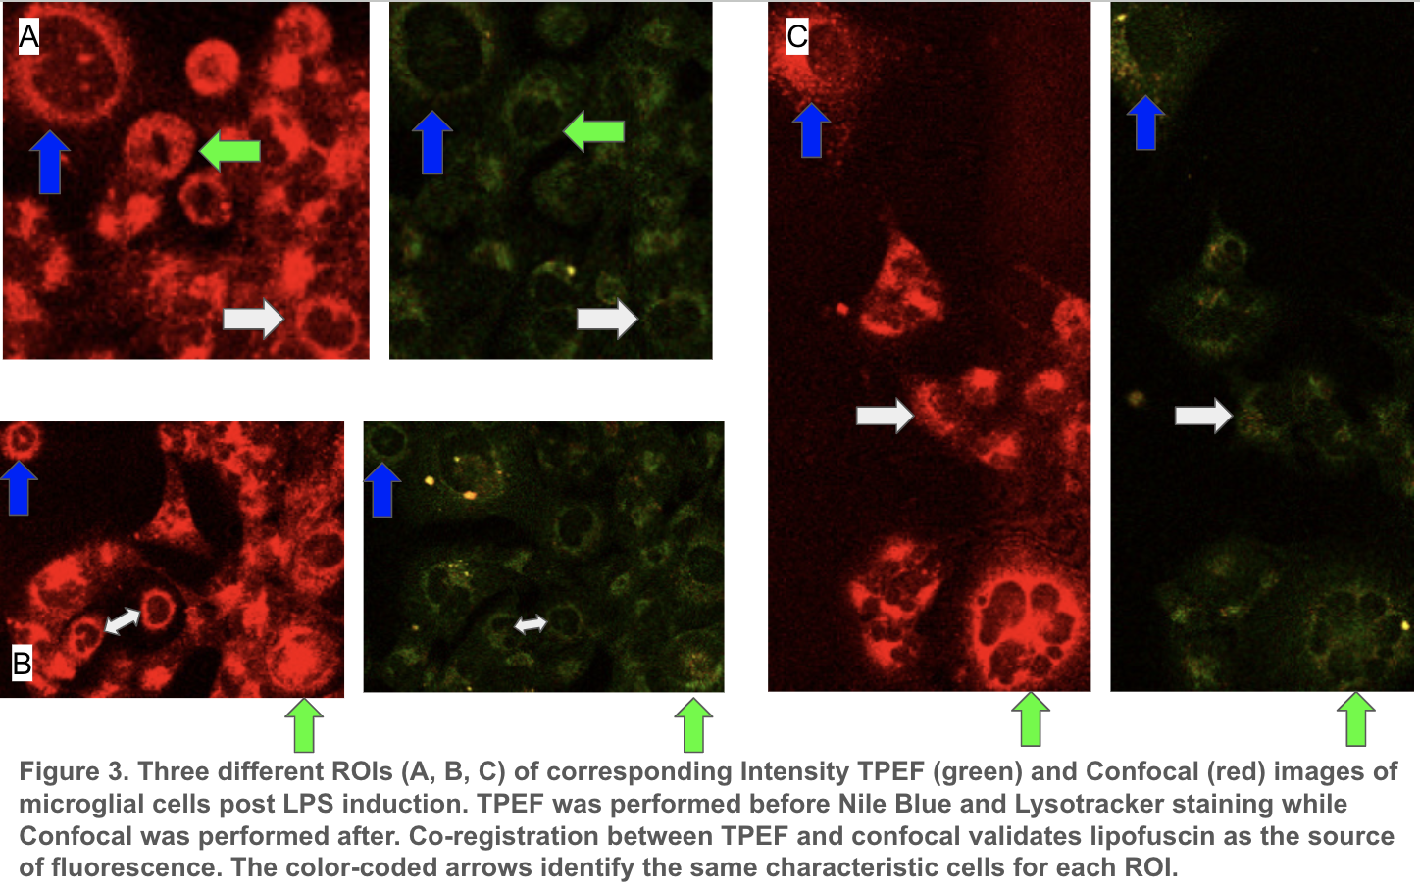
After confirming the induction of oxidative stress via the presence of lipofuscin, we carried out image analysis as described in the specific aims. We are still working on generating results for the redox ratio and mitochondrial fragmentation (beta value), but show in Fig. 4 the fluorescence lifetime phasor results. These are representative control and LPS-treated ROIs; we are working on determining the differences in quantitative phasor metrics (the phasor’s centroid location and slope) between control and experimental conditions.

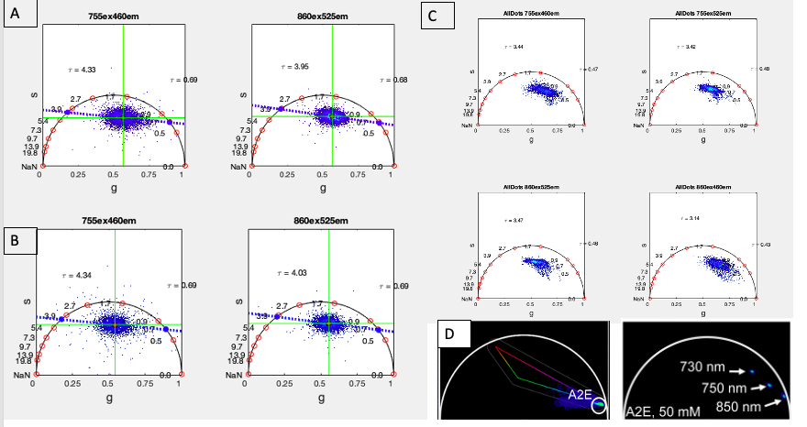

Figure 4. Phasor representation of FLIM data acquired from 2D microglial monoculture subject to LPS induction. (a) Control well not subject to LPS treatment. (b) LPS-induced representative well. (c) Phasor of specifically bright regions identified as lysosomal lipofuscin from the co-registration analysis depicted in Fig. 3. (d) References of phasor distributions of lipofuscin lifetime; here from Palczewska et. al’s study of lipofuscin found in the retina.

Figure 4 describes the qualitative findings obtained from the phasor FLIM representation of the LPS induction experiment. Phasor distributions were not different when comparing whole ROIs from treated and non-treated wells. However, phasor distributions from the bright regions segmented according to the co-registration with the stained lysosomes described previously, a distinct phasor distribution from the cellular distribution can be seen. These bright regions are predominantly found in the LPS-treated wells and are assumed to correspond to lysosomal lipofuscin. 4d shows Palczewska et al’s description of two-photon lifetime phasors of A2E, the major constituent of lipofuscin in the retina, at multiple excitation wavelengths (shown in the panel) in solution as well as in vivo. [19] This is our primary literary reference for the lifetime signature of lipofuscin. Similar to Palczewska et al, we observe a trend towards longer lifetimes (bottom right corner of the phasor plot) at longer excitation wavelengths, which is likely because lipofuscin is a complex of proteins and fats that has a wavelength-dependent lifetime. Therefore, our lifetime results clearly show the presence of lifetime, but there is not a clear difference in its metabolic effects on the whole cell due to the similar whole-cell phasors shown in 4a vs. 4b.

Existing Computational Models
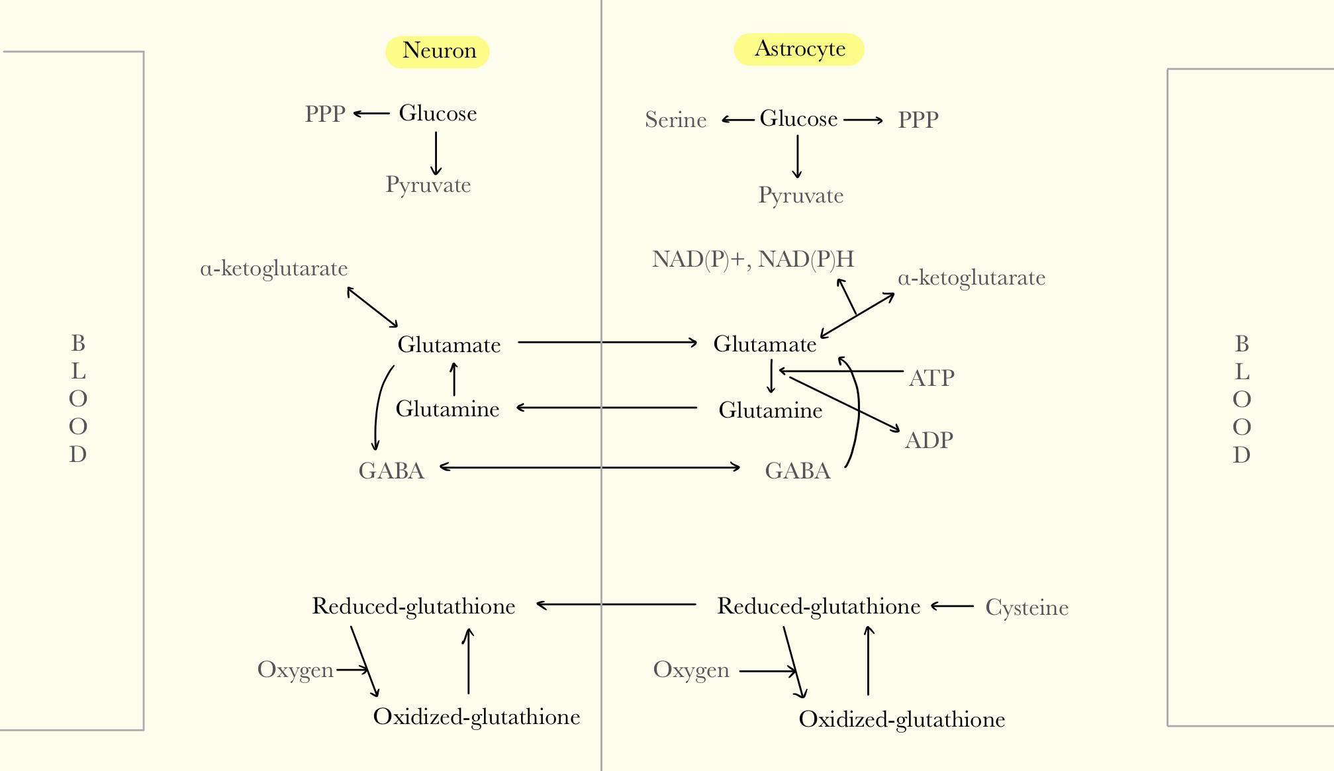
We found computational models through Github and on papers that include the neurotransmitter glutamate. Instead of building our model from scratch, we hope to gain an understanding of the equations used in these models and possibly combine them to suit our experiments.
A challenge of this step is that the existing models contain too many complex intertwining pathways, with molecules like amino acid synthesis that are not relevant to our research. As a solution, we isolated the pathways that are important to our project, with a focus on reactions involving glutamate, glutamine, and glutathione, based on published literature on brain metabolic diagrams. The simplified diagram is represented in Figure 6.
Figure 4. Recreated and simplified version of brain metabolism in neurons and astrocytes.
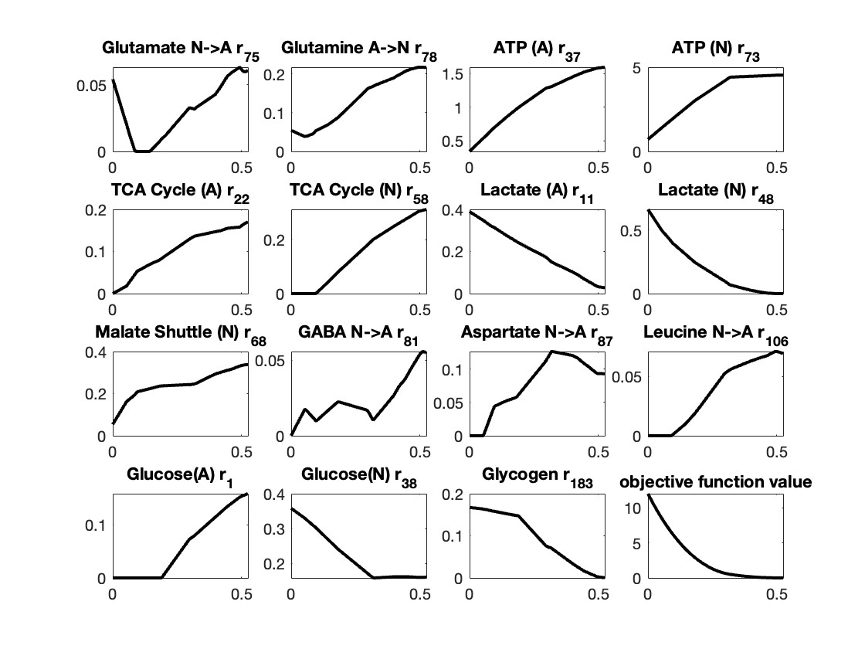Figure 5. Flux distributions for the indicated reactions and objective function value.

The current progress is that we successfully ran the code provided by Dr. Çakir and his research team, who reconstructed metabolic pathways between neurons and astrocytes using flux based analysis. The provided MATLAB code uses linear programming to find objective function value and set it as a constraint. Then quadratic programming is applied to find flux distributions. Finally, minimization of metabolic adjustment (MoMA) is performed to eliminate possible alternate optima. As a result, we obtained key fluxes for anoxic state and flux ratios of shuttle reactions between astrocytes and neurons. These parameters offer important insights in achieving the goal outlined in specific aim 3. We also obtained graphs of flux distributions for 15 reactions, and one on objective function value, which is shown in Figure 7. The next step is to understand more of the MATLAB model and design it in a way that we can put in concentrations specific to our measurements.

DISCUSSION AND FUTURE WORK
In the first semester, we read through papers relevant to TBI metabolism and TPEF imaging. We communicated with our post-doc and lab professor to start training for culturing microglia and using them for TPEF imaging. We developed a protocol for inducing and assessing secondary injury in co-culture models completely from scratch, which took significant efforts to rework and optimize given the constraints of the Georgakoudi lab in cell culture methods. We researched the computational model using papers that aimed to do the same using differential equations. We have prepared our cell culture and imaging to induce our first injury experiment next week. In the second semester, we hope to finish developing our mono- and co-cultures for imaging and metabolic analysis, and have a framework for the metabolic model. With monoculture data from the first semester, we will be able to link the optical readouts with the metabolic data using statistical tools on MATLAB. We can compare this correlation in data to our computational model framework and adjust it as needed.
The goal of our project is to correlate optical measurements with biochemical and metabolomic assays. Understanding this correlation will allow us to develop algorithms to predict biochemical and metabolomic data purely from optical readouts. This is valuable because it reduces the time and cost required to see the metabolic effects of TBI on brain cells. Culturing cells and completing assays can cost thousands of dollars over the span of many months. The development of this algorithm will make it possible to do TBI research in a shorter time span and a smaller budget. This broadens the availability of TBI research to labs that do not have the resources to do cell culturing long-term. This also helps address the morality of using engineered brain tissue because it reduces the need for handling it.

UNIFYING FIGURE
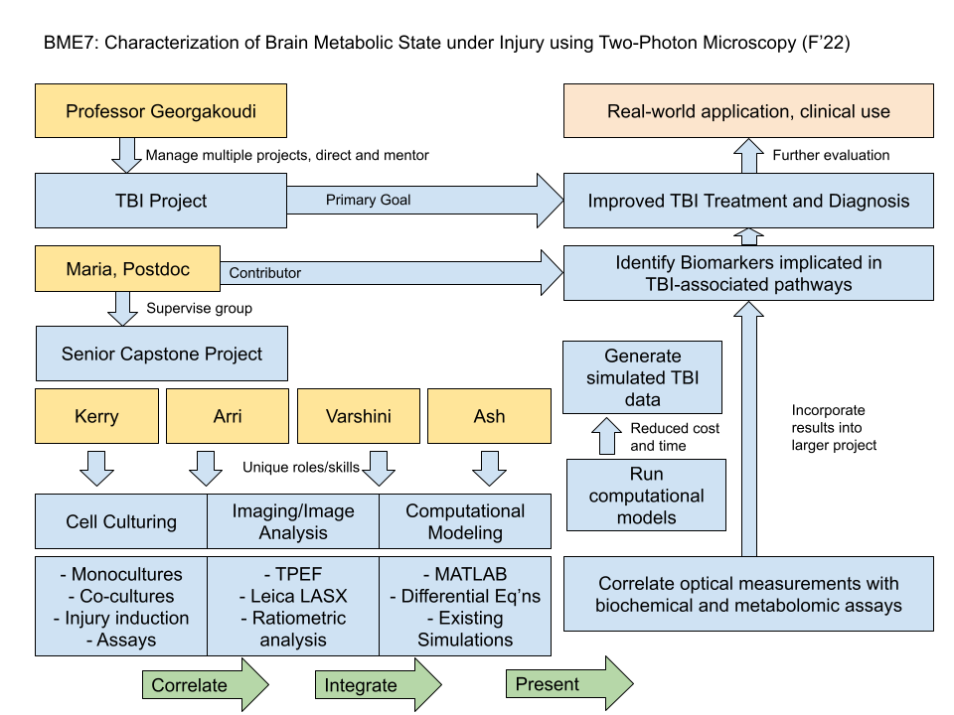
Supp. Figure 1. The unifying figure describes a hierarchy of the lab, roles and objectives of our project, the contribution of our project to the main project, and real world implications.

INDIVIDUAL CONTRIBUTIONS
Computational modeling includes compiling code on brain metabolic pathways affected by TBI, extracting valuable functions from external sources and writing code in MATLAB to analyze patterns in data found through cell culturing and imaging. Cell culturing includes developing co-cultures, writing the secondary injury protocol, and performing mass spectrometry analysis. Imaging includes using multi-modal two-photon microscopy to observe engineered brain cell activity after simulated concussions. Image analysis includes ratiometric analysis of different detector channels, phasor analysis, data processing, cellular segmentation and automatic annotation.
Ash will mainly be responsible for computational modeling and assisting with image analysis. The first task in computational modeling is to compile existing code that models glutamate excitotoxicity, lipofuscin, general brain metabolics and any other pathways relevant post TBI. These models will likely be used on MATLAB in the form of differential equations. Ideally, the models can successfully model chemical outputs given optical readouts. Varshini will mainly be responsible for guiding team members through higher-level computational work and performing imaging acquisition and analysis. Varshini will be the main point of contact with the post-doc, Maria and also connect relevant resources from the Georgakoudi lab to our project such as existing protocols and models. Kerry will mainly be responsible for cell culturing, under the guidance of our post-doc, Maria. She used available protocols and online papers to determine well numbers, replicates, time points, duration of chemical exposure, correlating measurements and number of trials for the draft protocol. Kerry has compiled many computational modeling papers, many of which contain useful ODEs for the model. Arrietty will be responsible for developing co-cultures and writing the secondary injury protocol. She will also be using her experience to help with image acquisition and analysis. Working closely with Varshini, Arri is also communicating with Maria and the professor about possible alternatives for our project and training.

REFERENCES
- Haenseler, W. et al. A Highly Efficient Human Pluripotent Stem Cell Microglia Model Displays a Neuronal-Co-culture-Specific Expression Profile and Inflammatory Response. Stem Cell Reports 8, 1727–1742 (2017).
- Chapman, G. A. et al. Fractalkine Cleavage from Neuronal Membranes Represents an Acute Event in the Inflammatory Response to Excitotoxic Brain Damage. J. Neurosci. 20, RC87–RC87 (2000).
- Dorsett, C. R. et al. Glutamate Neurotransmission in Rodent Models of Traumatic Brain Injury. J Neurotrauma 34, 263–272 (2017).
- Wu, Y.-H. et al. In Vitro Models of Traumatic Brain Injury: A Systematic Review. Journal of Neurotrauma 38, 2336–2372 (2021).
- Robertson, J. M. Astrocyte domains and the three-dimensional and seamless expression of consciousness and explicit memories. Medical Hypotheses 81, 1017–1024 (2013).
- Bylicky, M. A., Mueller, G. P. & Day, R. M. Mechanisms of Endogenous Neuroprotective Effects of Astrocytes in Brain Injury. Oxidative Medicine and Cellular Longevity 2018, 6501031 (2018).
- Kim, O. D., Rocha, M. & Maia, P. A Review of Dynamic Modeling Approaches and Their Application in Computational Strain Optimization for Metabolic Engineering. Frontiers in Microbiology 9, (2018).
- Oschmann, F., Berry, H., Obermayer, K. & Lenk, K. From in silico astrocyte cell models to neuron-astrocyte network models: A review. Brain Research Bulletin 136, 76–84 (2018).
- Ng, S. Y. and A. Y. W. Lee. "Traumatic Brain Injuries: Pathophysiology and Potential Therapeutic Targets." Front Cell Neurosci 13: 528, (2019).
- Shi, H., et al. "The in vitro effect of lipopolysaccharide on proliferation, inflammatory factors and antioxidant enzyme activity in bovine mammary epithelial cells." Anim Nutr 2(2): 99-104, (2016).
- Mark, L. P., et al. "Pictorial review of glutamate excitotoxicity: fundamental concepts for neuroimaging." AJNR Am J Neuroradiol 22(10): 1813-1824, (2001).
- Chapman, G. A., et al. "Fractalkine cleavage from neuronal membranes represents an acute event in the inflammatory response to excitotoxic brain damage." J Neurosci 20(15): RC87, (2000).
- Posti JP, Dickens AM, Orešič M, Hyötyläinen T, Tenovuo O. Metabolomics Profiling As a Diagnostic Tool in Severe Traumatic Brain Injury. Front Neurol. doi: 10.3389/fneur.2017.00398. (2017)
- Gupta, K., et al. "NMDA receptor-dependent glutamate excitotoxicity in human embryonic stem cell-derived neurons." Neurosci Lett 543: 95-100. (2013).
- Liaudanskaya, Volha et al. “Modeling Controlled Cortical Impact Injury in 3D Brain-Like Tissue Cultures.” Advanced healthcare materials vol. 9,12 (2020).
- Toledano Furman, N., Gottlieb, A., Prabhakara, K.S. et al. “High-resolution and differential analysis of rat microglial markers in traumatic brain injury: conventional flow cytometric and bioinformatics analysis.” Sci Rep 10, 11991 (2020).
- Anderson, W. D. et al. “Computational modeling of cytokine signaling in microglia.” Royal Society of Chemistry 12. (2015).
- Calvetti, D. et al. “Dynamic activation model for a glutamatergic neurovascular unit”. Journal of Theoretical Biology, Volume 274, Issue 1, 12-29 (2011).
- Palczewska, G., et al. “Noninvasive two-photon biopsy of retinal fluorophores.” Proceedings of the National Academy of Sciences, 117 (36) 22532-22543 (2020).
APPENDIX
- Transwell 2D co-cultures are not compatible for confocal/two-photon imaging:
  - https://www.corning.com/catalog/cls/documents/application-notes/CLS-AN-521-A4.pdf
  - https://www.researchgate.net/post/Can_transwell-cultured_Caco-2_monolayers_be_imaged_with_BD_Pathway_confocal_microscopy_while_keeping_them_in_transwell
- Glutamate Protocol Table
Arri has reviewed the relevant papers to identify different media compositions that were used. Using this information, we are working on refining the protocol for the glutamate excitotoxicity study. Additionally, given that most of the paper that we found were using 2D cultures, we plan to look at other papers that use 3D cultures to determine if a change of medium is required prior to the injury induction. The upper range of the glutamate concentration we use (300uM) is higher than that mentioned in the papers because, unlike the paper, we will use 3D culture, and 3D diffusion is worse than 2D diffusion.
Ref | Relevance | Glutamate Concentration | Exposure | Media/rinse | Notes
https://www.sciencedirect.com/science/article/pii/S0304394013002152 | HESCs treated with glutamate at physiological concentrations | 200 uM | 24h | DMEM (with supplements) first and then changed to Neurobasal-A (with supplements)  50uM DAPT was included in first medium change | Changed to trophically deprived, glutamate-free mimal medium (90% salt-glucose-glycine medium and 10% MEM) 1 day prior to injury
https://www.ncbi.nlm.nih.gov/pmc/articles/PMC6773069/ | NMDA and glutamate on rat cortical culture | 100 and 300 uM | 30 minutes | Control media = MEM + 0.01% BSA + 25mm Hepes + 10 um glycine  Rinse: MEM 200:1 dilution | Younger culture is less sensitive so use higher conc.  No change of medium prior to experiment  After toxicity assay: cells are exposed to control solution, NMDA, or glutamate for 30 mins and then rinse
https://www.nature.com/articles/cddis2012194 | rat derived hippocampal, cortical, midbrain neurons | 100 uM glutamate in 10 uM glycine, Mg2+ free medium | 15 minutes | HBSS (hippocampi)  Neurobasal medium (Gibco-Invitrogen) supplemented with B-27 (Gibco-Invitrogen) and 2 mM L-glutamine (culture) | No change of medium prior to experiment
https://onlinelibrary.wiley.com/doi/full/10.1046/j.1471-4159.2000.0751045.x | mouse cortical cultures | 100 to 500 uM | Didn’t remove, glutamate media because they were testing enzyme degradation | Medium: Neurobasal medium, 2% B27, 0.5 mM L-alanyl-L-glutamine, 100 U/ml penicillin, 100 μg/ml streptomycin, 0.25 μg/ml amphotericin (Life Technologies) + 1% horse serum | No change of medium prior to experiment
https://www.nature.com/articles/s41419-018-0351-1 | Rat hippocampal neurons from Wistar rat E18 embryos | 30 and 100 uM  (100 is most sig)  Also test at 1 and 10 uM but not sig | 30 mins | For low-astrocyte cultures: cytosine with AraC (Sigma-Aldrich) at conc. of 2 uM at DIV2-5 | No change of medium prior to experiment
https://journals.biologists.com/jcs/article/131/22/jcs214684/56996/Axonal-degeneration-induced-by-glutamate | (E18 Sprague-Dawley) Rat embryonic hippocampal neurons | 20uM | 6 hours | After 3 h, the plating media was changed to Neurobasal™ medium supplemented with 2% B27, 0.5 mM GlutaMAX™-I and P/S  After 3 days, a third of medium was replaced and treated with 5 uM AraC to inhibit glial cell proliferation | No change of medium prior to experiment
Table 2. Glutamate concentration, media composition, and injury exposure time for glutamate excitotoxicity induction of different cell lines from published literature.
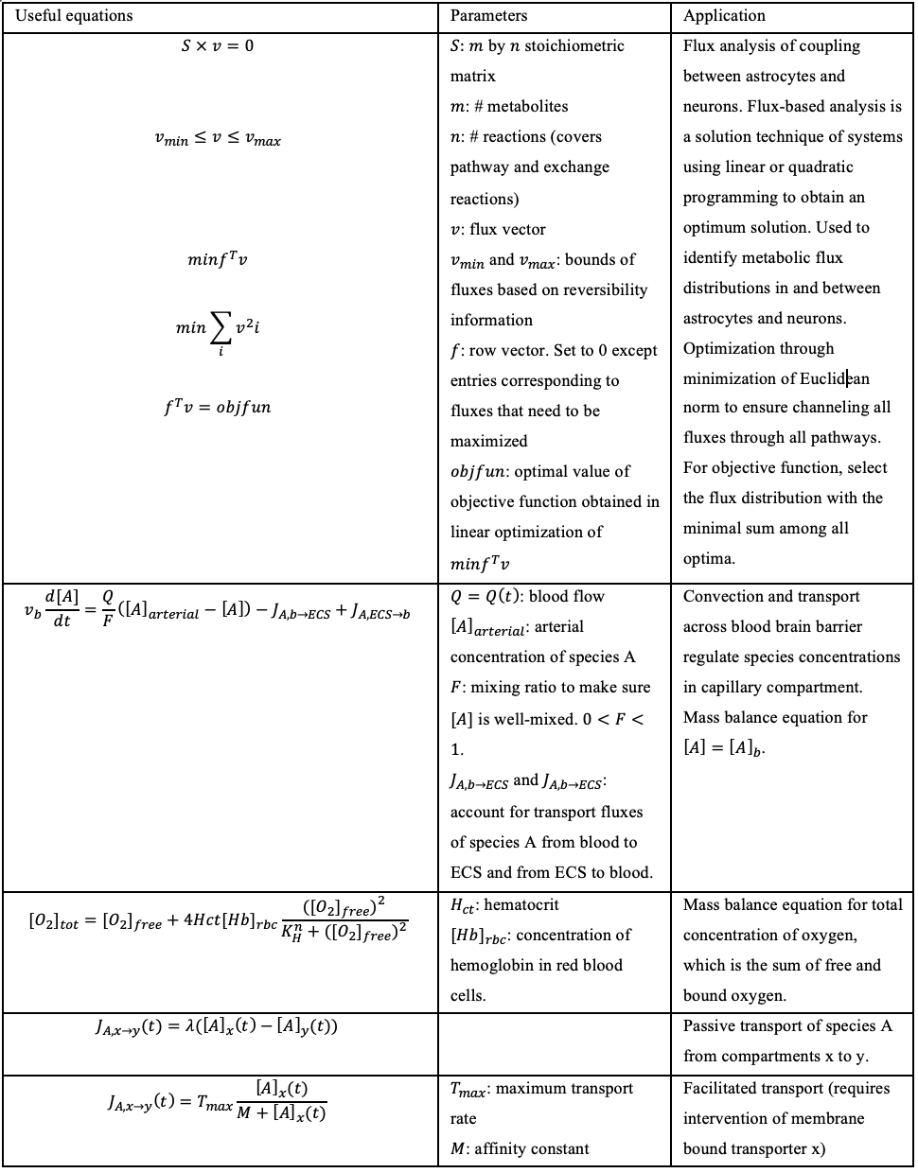
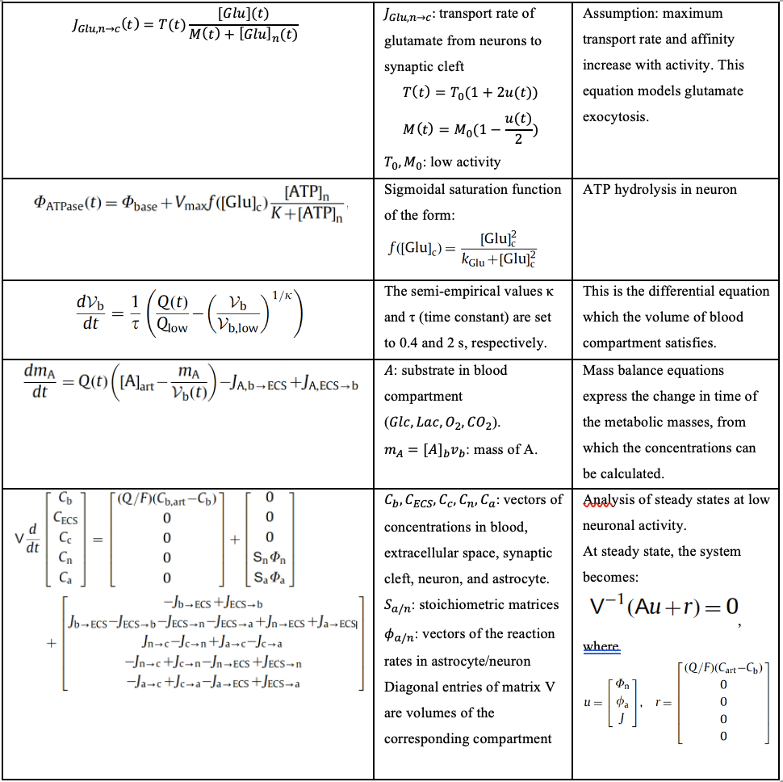
Table 3. List of differential equations involved in TBI which are relevant to our computational model and project.
Sources: (Çakir, 2007) and (Calvetti, 2010)

Cell passaging protocol
Materials needed: DMEM cell culture medium, trypsin, HMC3 cells in cell culture dish.
- Warm the DMEM and trypsin in a 37˚C water bath for 15~20 minutes.
- Spray the biohood workspace w/ 10% bleach, 75% ethanol and wipe surface with tissue paper.
  - Applicable to any items brought into the hood
- Aspirate old media from the cell culture dish
- Wash twice with 5 mL PBS
  - Aspiration of the PBS should not be in contact with cells attached to the dish bottom
  - After adding PPBS, shake disk gently to distribute PBS
- Add 1.5 mL of 0.25% trypsin-EDTA and put the dish in the 37˚C incubator for 2-3 minutes
  - After 2-3 minutes, use microscope to check confluency / cell suspension
- Add 8.5 mL of media to the cell culture dish
- Transfer the cells (with trypsin and cell culture media) into a 15 mL conical centrifuge tube
- Centrifuge at 1500 rmp for 3 minutes to pellet the cells
- Aspirate cell culture media in conical centrifuge tube and re-suspend the cell pellet in 5 mL of new cell culture media
  - Gently pipette to mix and avoid bubbles
- Calculate the desired seeding ratio and add the corresponding amount of cell suspension and media to the new cell culture dish
  - This depends on when the cells will be used
    - We plan to independently practice cell passaging in 5 days so we picked a ratio of 1:5 so that sufficient confluency is reached. This means that ⅕ of the cell suspension (0.5mL) and 9.5 mL of new medium are needed for a 10 mL dish
    - Extract 0.5 mL of the cell suspension from conical centrifuge tube and gently inject into the new cell culture dish with 9.5 mL of fresh media
  - Tilt the dish in north-west-south-east direction to distribute the cells
- Aspirate and discard the old cell suspension in the centrifuge tube to biohazard bin
- Put the new cell culture dish in the 37˚C incubator overnight

Optical image acquisition protocol
In general, we will measure spectral intensity at 755nm, 860 nm and 910nm excitation, detecting on a multi-wavelength PMT every 10 nm from 490 to 630 nm. We will measure fluorescence lifetime at the same excitations but detect only at 460 and 525 nm using a hybrid detector and a PicoQuant TCPSC module which allows for the high temporal resolution needed for fluorescence lifetime imaging.
- Maintain Excel spreadsheet from centralized code base (on Georgakoudi network drive) to auto-generate file names for control and injury scaffolds.
- Maintain plastic well plate with labeled control and injured scaffold sections and numbered wells to track each ROI throughout timepoints.
- For each scaffold, remove from its place in the well and secure it with a metal harp to a glass bottom dish. Place the smooth (non-cut) side up.
- Set the 40x water objective and add one drop of DI water. Lower the objective z stage fully and secure the dish in the sample stage.
- Search for cells using brightfield eyepiece viewing. Cells are transparent in this mode but the edges can be seen when adjusting the Z height. Once cells are found, turn off the microscope internal light and lower all coverings, then confirm the presence of cells in Live imaging mode
- Set the depth range based on the range of visible cells. Z slices are 4 microns apart.
- Begin with intensity acquisition mode (xyz). All settings (line average, frame average) are set to 1, except for 8 frame accumulation. Speed is 60, bidirectional. The pinhole is at 1 AU (airy units).
- Turn on the transmission PMT and both PMTs and HyDs.
- Set and tune the wavelength for 755 nm.
- Begin acquisition. Save name according to spreadsheet.
- Repeat for 860, changing the depth by +1 micron to adjust for laser co-registration.
- Change to FLIM acquisition mode. Set CFD (voltage) to 40 for 755, 60 for 860. Acquire and ensure that decay traces are smooth with no interruption. FLIM data is saved and renamed individually.
- Change to spectral acquisition mode (xy-lambda). Change detector to the wavelength-adjusting PMT. Open the pinhole to 7.77 AU (full opening).
- After spectral acquisition, change the pinhole back to 1 AU immediately to prevent photobleaching.
- Repeat for as many ROIs are acquired per scaffold.
- Retrieve the plastic well plate from the incubator. Return to the hood. Spray a tweezer with ethanol and dry in the hood. Pick up the scaffold from the edge and return to its original well. Retrieve the next scaffold and continue.

LysoTracker staining for microglia cells protocol
To prepare the HMC3 cell cultures, follow the same protocol for cell passaging, then measure the cells by adding 10 µL of the cell solution to 10 µL trypan blue to measure cell viability in the automatic cell counter. Calculate the volume needed to obtain from the 5 mL cell-medium solution. Add 1 mL of the cells to each well in the well plate with 1 mL medium, then incubate the cells at 37˚C and 5% CO₂ overnight.
For the Lysotracker staining, we need to optimize the concentration by the following steps:
- Discard the cell culture medium
- Add 2 mL pre-warmed medium, which contains 10 nM, 20 nM, 50 nM, 75 nM, and 100 nM LysoTracker that was previously mixed in a falcon. This step is to optimize the cell culture concentration.
- Incubate the cells for 30 minutes at 37˚C
- Discard the medium and add 2 mL pre-warmed fresh medium
Then, we proceed to the fixation step:
- Discard the medium and fix the cells by adding 200 µL 4% paraformaldehyde in pre-warmed medium (including FBS) for 15 minutes at 37˚C.
- Discard fixation medium and wash the cells 2 times with 2 mL PBS for 2 minutes each
- Discard PBS and add fresh PBS, then check the cells under the Confocal microscope
After optimizing the concentration, we need to optimize the incubation time. The purpose of optimization is to receive the best signal-to-noise ratio when imaging the cells.

LPS treatment of microglia protocol
Measure the cell number and calculate the volume using the same steps as the LysoTracker staining protocol.
- Add 1 mL of the cells to each well of the 12-well plate and 1 mL medium, then incubate the cells at 37˚C and 5% CO₂ overnight
- Add 20 µL LPS at a concentration of 100 µL/mL to each well and incubate for 0h, 24h, or 48h
To generate the LPS solution
- Dissolve 0.1 mg LPS powder in 10 mL sterilized distilled water and vortex for 1 minute to achieve 10,000 ng/mL stock solution (kept at -20˚C in aliquots)
- Based on the final concentration, calculate the volume needed to obtain from the LPS stock in order to stimulate the cells using the following equation
For 50 ng/mL, we need 2 mL * 50 ng/mL = 10,000 ng/mL * x, x = 10 µL
- We need 6 wells for each time point (2 untreated wells, 2 wells treated with 50 ng/µL, and 2 wells treated with 100 ng/µL LPS)

